Set-19
- Yaswanth - 192324179
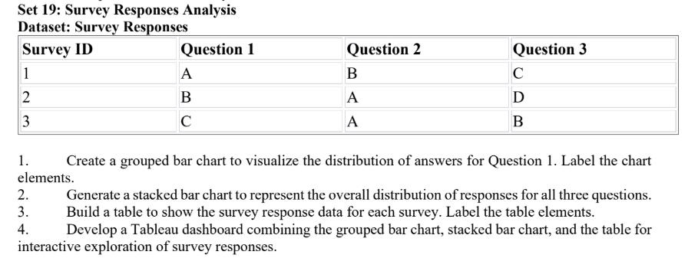

1.R-code:

library(ggplot2)

survey <- data.frame(
Survey_ID = c(1, 2, 3),
Question_1 = c("A", "B", "C"),
Question_2 = c("B", "A", "A"),
Question_3 = c("C", "D", "B")
)

ggplot(survey, aes(x = Question_1, fill = Question_1)) +
geom_bar() +
labs(
title = "Distribution of Answers for Question 1",
x = "Answer",
y = "Number of Responses",
fill = "Answer"
) +
theme_minimal()

Output:

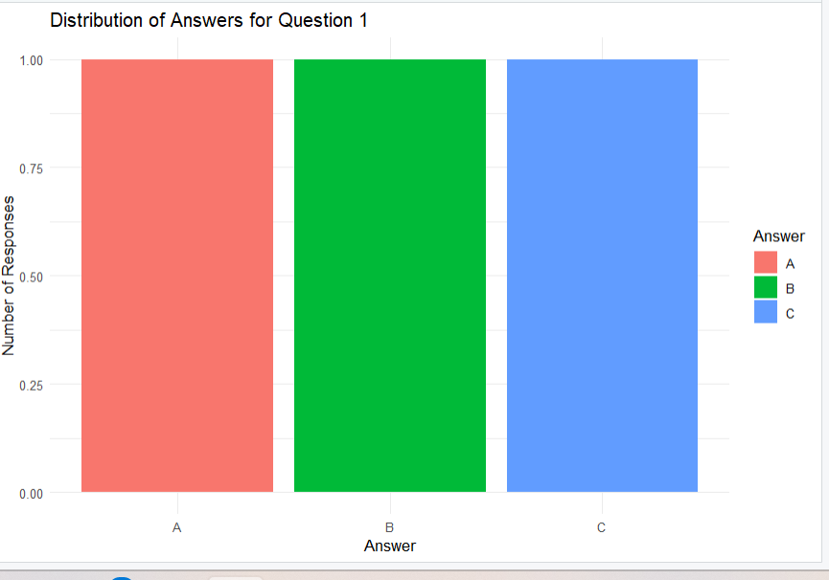

Result: The bar chart displays the frequency of answers A, B, and C. Each answer occurs once.
Question 2. Stacked bar chart for all three questions
R Program

library(ggplot2)

survey_long <- data.frame(
Question = rep(
c("Question 1", "Question 2", "Question 3"),
each = 3
),
Answer = c(
"A", "B", "C",
"B", "A", "A",
"C", "D", "B"
)
)

ggplot(survey_long, aes(x = Question, fill = Answer)) +
geom_bar() +
labs(
title = "Overall Distribution of Survey Responses",
x = "Survey Question",
y = "Number of Responses",
fill = "Answer"
) +
theme_minimal()

Output:
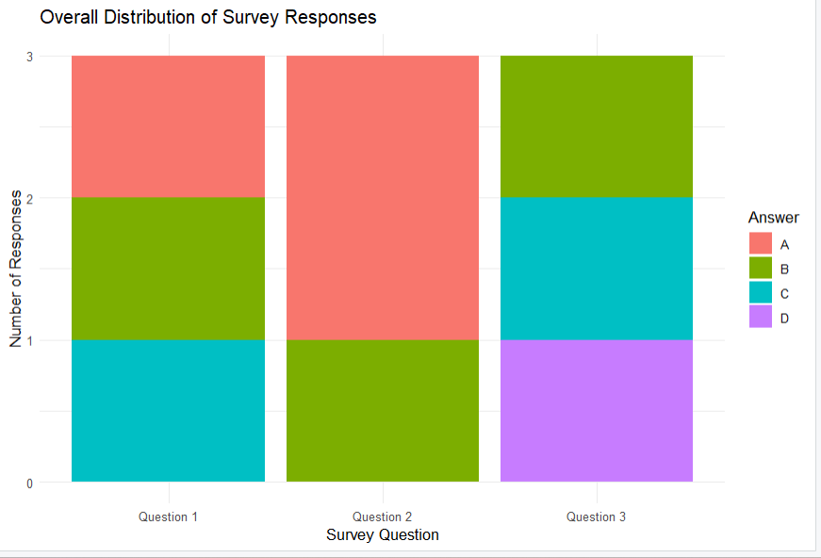

Result: The stacked bar chart compares the frequency of answers for all three questions.
Question 3. Create a table showing survey responses
R Program

library(gridExtra)

survey <- data.frame(
Survey_ID = c(1, 2, 3),
Question_1 = c("A", "B", "C"),
Question_2 = c("B", "A", "A"),
Question_3 = c("C", "D", "B")
)

grid.table(
survey,
rows = NULL,
theme = ttheme_default(
colnames = list(
fg_params = list(fontface = "bold")
)
)
)
Output:
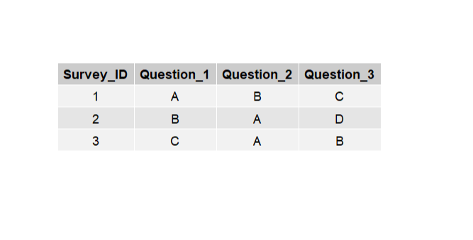
Result: The table displays the responses for each survey, with clearly labeled column headings.

Question 4. Tableau dashboard for interactive exploration
Procedure
- Enter the survey data into Excel and save it as Survey_Responses.xlsx.
- Open Tableau and connect to the Excel file.
- Create the Question 1 bar chart by placing Question 1 on Columns and the count of Survey ID on Rows.
- For the stacked bar chart, prepare the data in long format with columns Survey ID, Question, and Answer. Place Question on Columns, count of responses on Rows, and Answer on Color.
- Create the survey response table by displaying Survey ID, Question 1, Question 2, and Question 3 as text.
- Click New Dashboard and name it Survey Responses Analysis Dashboard.
- Drag the two charts and the table onto the dashboard.
- Enable Use as Filter on the stacked bar chart to support interactive exploration.
- Adjust the layout and display the chart titles, axis labels, and table headings.

Output:
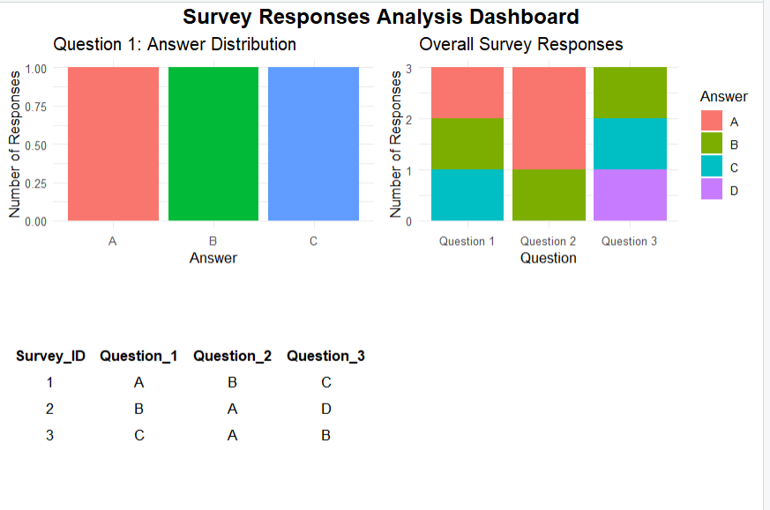
Result: The Tableau dashboard combines the grouped bar chart, stacked bar chart, and response table for interactive analysis of survey responses.

