A.  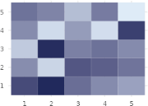 | 4. Shows magnitude across two categories using color intensity
B.   | 2. Shows part-to-whole composition across categories
C.  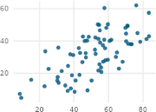 | 5. Shows the relationship between two continuous variables
D.  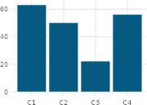 | 10. Compares amounts across separate categories
E.  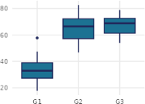 | 6. Compares distributions across groups and highlights outliers
F.  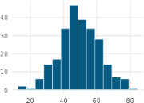 | 8. Shows the distribution of a single continuous variable
G.  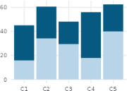 | 9. Shows how parts contribute to a whole
H.  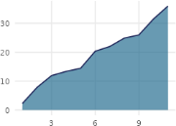 | 1.Shows how a cumulative total changes over time
I.  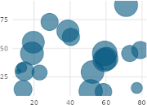 | 7. Shows three variables at once using position and size
J.  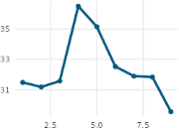 | 3. Shows how a value changes over time

