Set-22
A. Yaswanth - 192324179

Data:
Month | Sales ($)
January | 15,000
February | 18,000
March | 22,000
April | 20,000
May | 23,000

Question 1. Line chart for monthly sales
R-code:
library(ggplot2)

sales <- data.frame(
Month = c("Jan", "Feb", "Mar", "Apr", "May"),
Sales = c(15000, 18000, 22000, 20000, 23000)
)

sales$Month <- factor(
sales$Month,
levels = c("Jan", "Feb", "Mar", "Apr", "May")
)

ggplot(sales, aes(x = Month, y = Sales, group = 1)) +
geom_line(color = "blue", linewidth = 1) +
geom_point(color = "red", size = 3) +
labs(
title = "Monthly Sales Analysis",
x = "Month",
y = "Sales"
) +
theme_minimal()

Output:
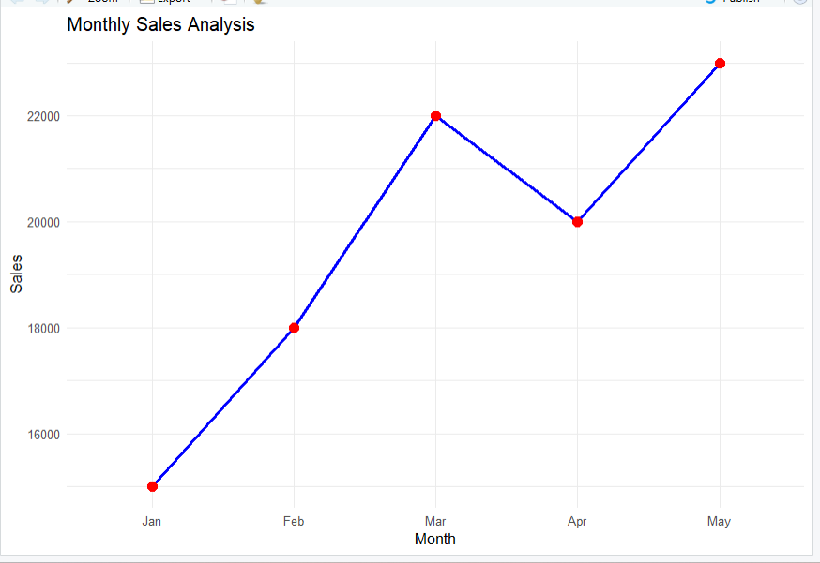
Result: The line chart displays monthly sales from January to May.

Question 2. Scatter plot and regression line for advertising budget and sales
R-code:

library(ggplot2)

advertising <- data.frame(
Advertising_Budget = c(2000, 2500, 3000, 2800, 3500),
Sales = c(15000, 18000, 22000, 20000, 23000)
)

ggplot(advertising,
aes(x = Advertising_Budget, y = Sales)) +
geom_point(color = "blue", size = 3) +
geom_smooth(method = "lm", se = FALSE, color = "red") +
labs(
title = "Advertising Budget vs Sales",
x = "Advertising Budget",
y = "Sales"
) +
theme_minimal()

Output:
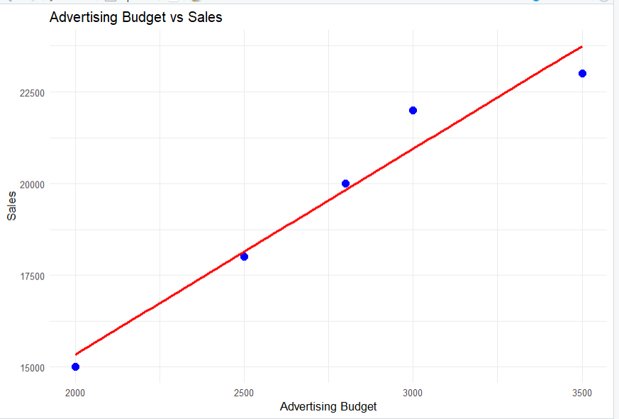

Result: The scatter plot displays the relationship between advertising budget and sales with a regression line.
Note: The advertising budget values are sample values because the original data was not provided.

Question 3. Create a Tableau dashboard for monthly sales
Procedure:
- Enter the monthly sales data into Excel and save it as Monthly_Sales.xlsx.
- Open Tableau and connect to the Excel file.
- Create a line chart by placing Month on Columns and Sales on Rows.
- Add markers and display the sales values as labels.
- Create a pie chart using product categories and sales values if product-level data is available.
- Click New Dashboard and name it Monthly Sales Dashboard.
- Drag the line chart and pie chart onto the dashboard.
- Add chart titles, axis labels, and adjust the layout.
Output:

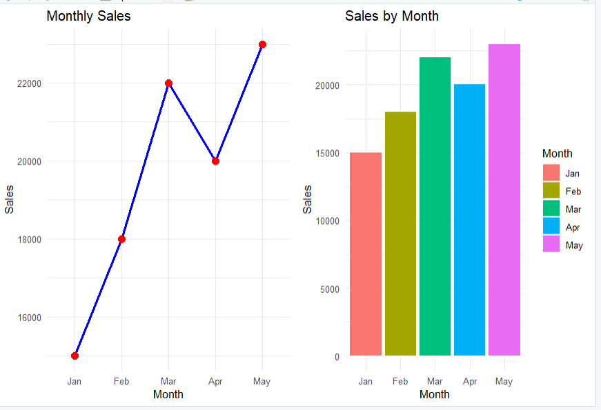
Result: The Tableau dashboard displays monthly sales and product-wise sales distribution.
Question 4. Time series analysis and autocorrelation
R-code:
sales <- c(15000, 18000, 22000, 20000, 23000)

sales_ts <- ts(
sales,
start = c(2026, 1),
frequency = 12
)

plot(
sales_ts,
type = "o",
col = "blue",
main = "Monthly Sales Time Series",
xlab = "Time",
ylab = "Sales"
)

acf(
sales_ts,
main = "Autocorrelation of Monthly Sales"
)

Output:
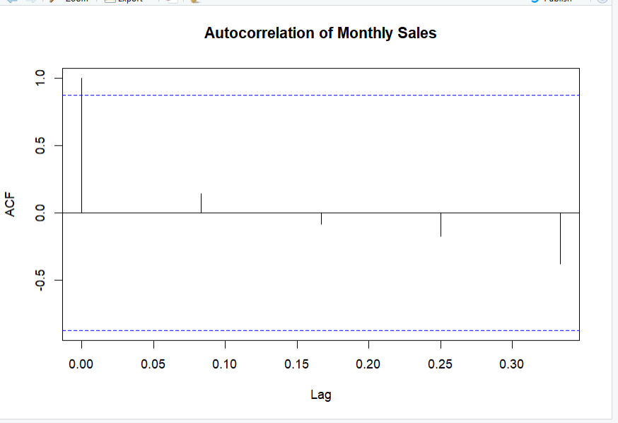
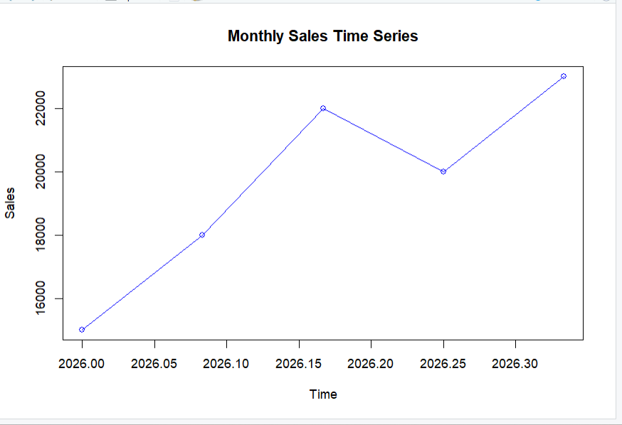
Result: The time-series plot displays monthly sales, and the ACF plot displays autocorrelation.

