Set-23
- Yaswanth – 192324179

Data:
Employee ID | Department | Years of Service | Performance Score
1 | Sales | 5 | 85
2 | HR | 3 | 92
3 | Marketing | 7 | 78
4 | Sales | 4 | 90
5 | HR | 2 | 76

Question 1. Bar chart for employee distribution by department
R-code:

library(ggplot2)

employees <- data.frame(
Employee_ID = c(1, 2, 3, 4, 5),
Department = c("Sales", "HR", "Marketing", "Sales", "HR"),
Years_of_Service = c(5, 3, 7, 4, 2),
Performance_Score = c(85, 92, 78, 90, 76)
)

ggplot(employees, aes(x = Department, fill = Department)) +
geom_bar() +
labs(
title = "Employee Distribution by Department",
x = "Department",
y = "Number of Employees"
) +
theme_minimal()
Output:
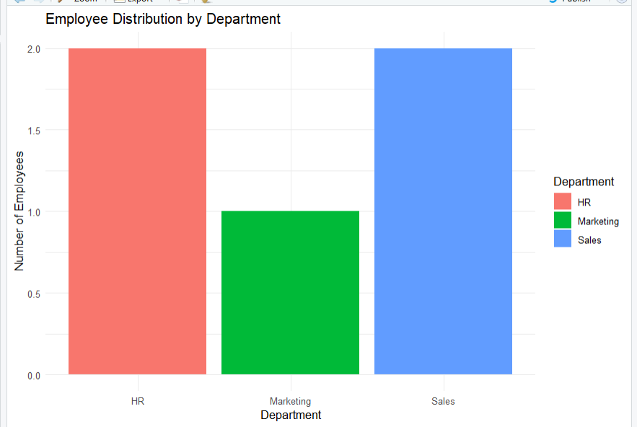
Result: The bar chart displays the number of employees in each department.

Question 2. Line chart for employee performance scores
R-code:

library(ggplot2)

employees <- data.frame(
Employee_ID = c(1, 2, 3, 4, 5),
Department = c("Sales", "HR", "Marketing", "Sales", "HR"),
Years_of_Service = c(5, 3, 7, 4, 2),
Performance_Score = c(85, 92, 78, 90, 76)
)

ggplot(employees,
aes(x = Employee_ID, y = Performance_Score, group = 1)) +
geom_line(color = "blue", linewidth = 1) +
geom_point(color = "red", size = 3) +
labs(
title = "Employee Performance Scores",
x = "Employee ID",
y = "Performance Score"
) +
theme_minimal()
Output:
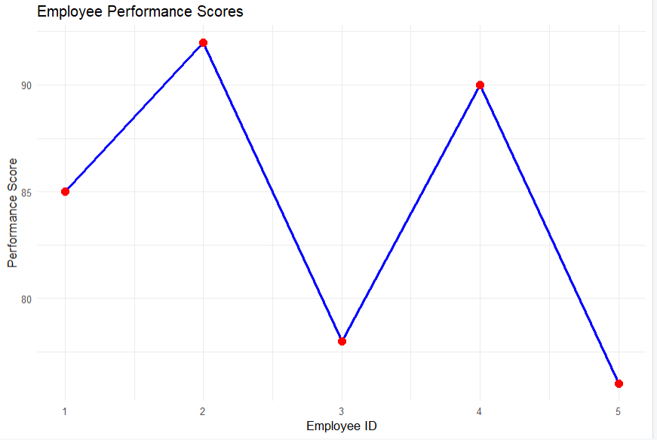
Result: The line chart displays the performance score of each employee.

Question 3. Create a Tableau dashboard for employee performance
Procedure:
- Enter the employee data into Excel and save it as Employee_Performance.xlsx.
- Open Tableau and connect to the Excel file.
- Create a bar chart by placing Department on Columns and Employee ID on Rows. Change the aggregation to Count.
- Create a scatter plot by placing Years of Service on Columns and Performance Score on Rows.
- Drag Employee ID to Detail in the scatter plot.
- Click New Dashboard and name it Employee Performance Dashboard.
- Drag both charts onto the dashboard.
- Add chart titles, axis labels, and adjust the layout.
Output:
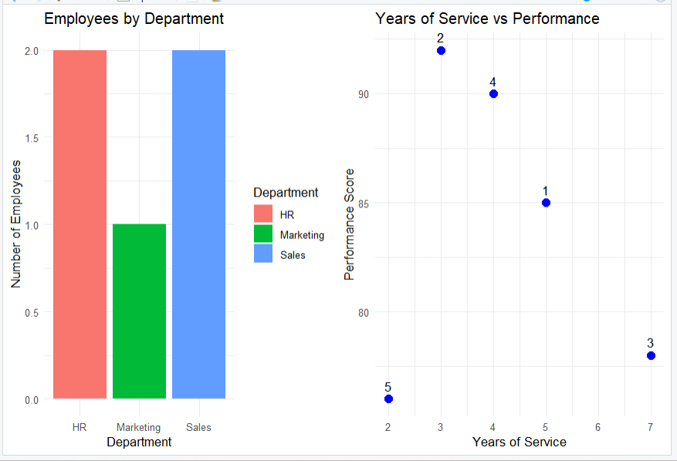
Result: The dashboard layout displays employee distribution and performance scores.

Question 4. Create a table showing employee details
R-code:

library(gridExtra)

employees <- data.frame(
Employee_ID = c(1, 2, 3, 4, 5),
Department = c("Sales", "HR", "Marketing", "Sales", "HR"),
Years_of_Service = c(5, 3, 7, 4, 2),
Performance_Score = c(85, 92, 78, 90, 76)
)

grid.table(
employees,
rows = NULL,
theme = ttheme_default(
colnames = list(
fg_params = list(fontface = "bold")
)
)
)

Output:
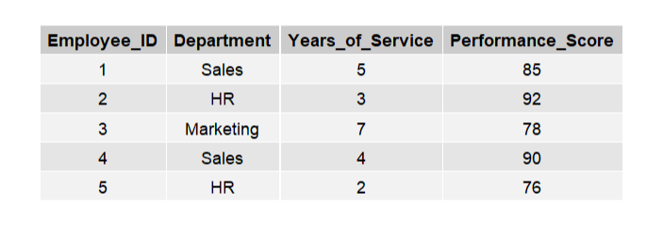
Result: The table displays employee IDs, departments, years of service, and performance scores.

