Set-24
- Yaswanth – 192324179

Data:
Product ID | Product Name | Quantity Available
1 | Product A | 250
2 | Product B | 175
3 | Product C | 300
4 | Product D | 200
5 | Product E | 220

Question 1. Bar chart for product inventory
R-code:

library(ggplot2)

inventory <- data.frame(
Product = c("A", "B", "C", "D", "E"),
Quantity = c(250, 175, 300, 200, 220)
)

ggplot(inventory, aes(x = Product, y = Quantity, fill = Product)) +
geom_col() +
labs(
title = "Product Inventory",
x = "Product",
y = "Quantity"
) +
theme_minimal()

Output:
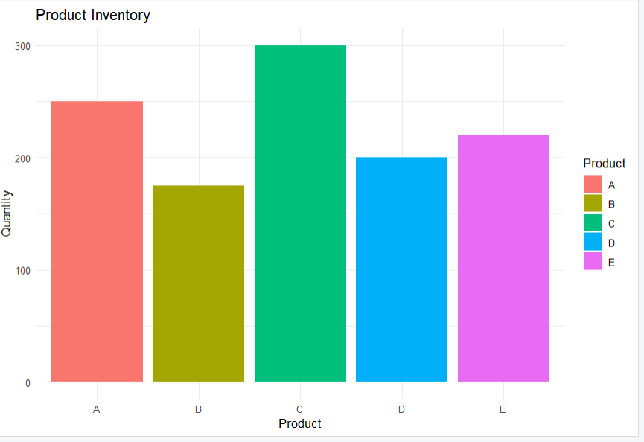
Result: The bar chart displays the quantity of each product in inventory.
Question 2. Stacked bar chart for product categories
R-code:

library(ggplot2)

inventory <- data.frame(
Product = c("A", "B", "C", "D", "E"),
Category = c(
"Electronics", "Electronics", "Furniture",
"Furniture", "Electronics"
),
Quantity = c(250, 175, 300, 200, 220)
)

ggplot(inventory, aes(x = Category, y = Quantity, fill = Product)) +
geom_col() +
labs(
title = "Product Inventory by Category",
x = "Category",
y = "Quantity",
fill = "Product"
) +
theme_minimal()

Output:
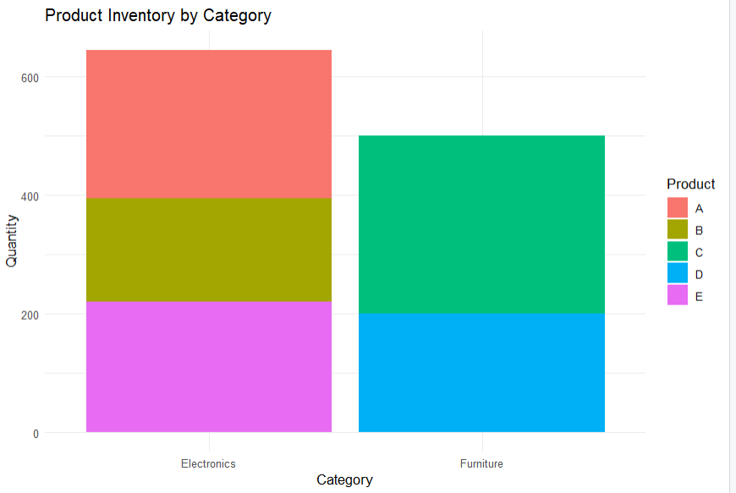
Result: The stacked bar chart displays product quantities across categories.
Question 3. Create a Tableau dashboard for product inventory
Procedure:
- Enter the product inventory data into Excel and save it as Product_Inventory.xlsx.
- Open Tableau and connect to the Excel file.
- Create a bar chart by placing Product on Columns and Quantity on Rows.
- Create a stacked bar chart by placing Category on Columns, Quantity on Rows, and Product on Color.
- Enable labels to display product quantities.
- Click New Dashboard and name it Product Inventory Dashboard.
- Drag both charts onto the dashboard.
- Add chart titles, axis labels, and adjust the layout.
Output:
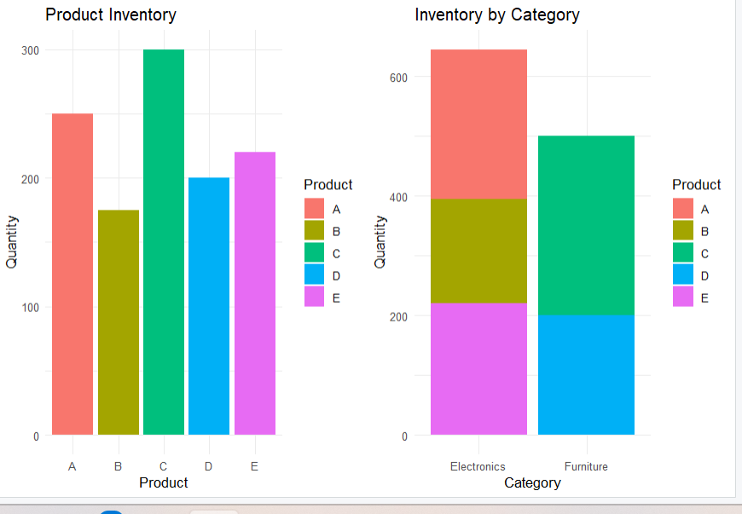
Result: The dashboard layout displays product quantities and category-wise inventory.

Question 4. Scatter plot for product price and quantity
R-code:

library(ggplot2)

inventory <- data.frame(
Product = c("A", "B", "C", "D", "E"),
Price = c(100, 150, 80, 120, 110),
Quantity = c(250, 175, 300, 200, 220)
)

ggplot(inventory, aes(x = Price, y = Quantity, label = Product)) +
geom_point(color = "blue", size = 3) +
geom_text(vjust = -0.8) +
labs(
title = "Product Price vs Quantity",
x = "Price",
y = "Quantity"
) +
theme_minimal()

Output:
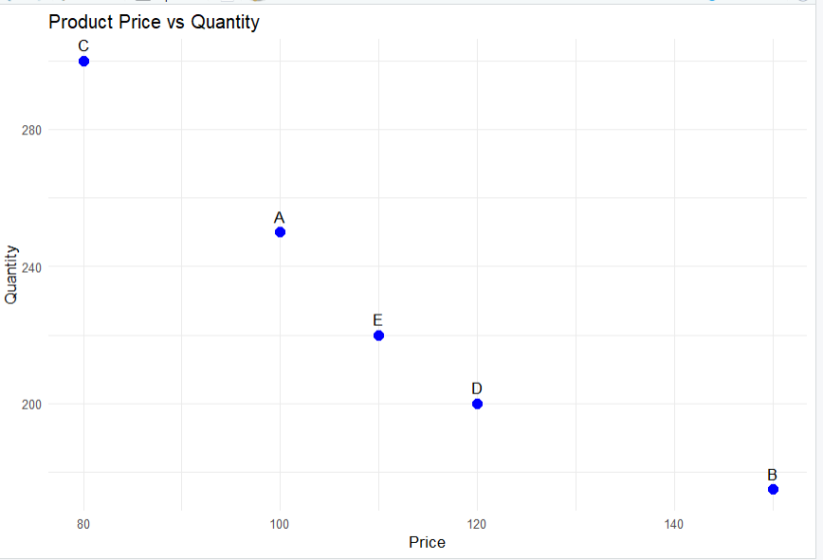
Result: The scatter plot displays product prices against inventory quantities.
Note: The category and price values are sample values because actual data was not provided.

