Class Activity 1
Department | AI&DS
Course Code / Course Name | ITA0407-Statistics with R Programming
Class Activity | Class Activity-1
Name | Addula Yaswanth
Register Number | 192324179
Date | 28 September 2026
Day | Monday

Give one example program for the below operators

1.Arithmetic operators
- Assignment operators
- Comparison operators
- Logical operators
- Miscellaneous operators

1.Arithmetic operators:

R-Code:
a <- 10
b <- 5

print(a + b)
print(a - b)
print(a * b)
print(a / b)
print(a %% b)
print(a ^ b)
Output:
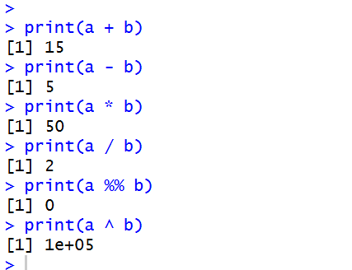

- Assignment operators

R-Code:

a <- 10
b = 20
30 -> c
print(a)
print(b)
print(c)
Output:
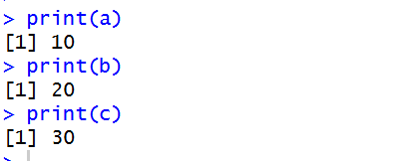

3.Comparison operators
R-Code:
a <- 10
b <- 5

print(a == b)
print(a != b)
print(a > b)
print(a < b)
print(a >= b)
print(a <= b)
Output:
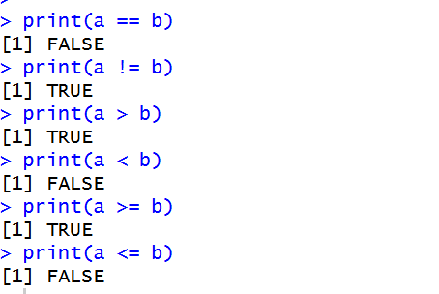
- Logical operators
R-Code:
a <- TRUE
b <- FALSE

print(a & b)
print(a | b)
print(!a)
Output:
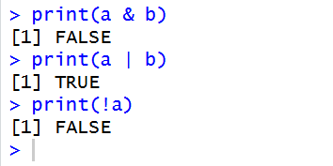
- Miscellaneous operators

R-Code:
x <- 1:5

print(3 %in% x)
print(10 %in% x)
Output:
