Activity-2
Department | AI&DS
Course Code / Course Name | ITA0407-Statistics with R Programming
Activity | Activity-2
Name | Addula Yaswanth
Register Number | 192324179
Date | 05 October 2026
Day | Monday

1. Sample Dataset (Student Marks)
RegNo | Name | Dept | Marks
101 | Arun | CSE | 78
102 | Bala | IT | 65
103 | Chitra | CSE | 82
104 | Deepa | ECE | 74
105 | Eshan | IT | 90
106 | Farah | CSE | 69
107 | Gokul | ECE | 85
108 | Hari | IT | 73
109 | Isha | CSE | 88

2. Create Dataset in R
RegNo <- c(101,102,103,104,105,106,107,108,109)
Name <- c("Arun","Bala","Chitra","Deepa","Eshan","Farah","Gokul","Hari","Isha")
Dept <- c("CSE","IT","CSE","ECE","IT","CSE","ECE","IT","CSE")
Marks <- c(78,65,82,74,90,69,85,73,88)
student <- data.frame(RegNo,Name,Dept,Marks)
student

Output:
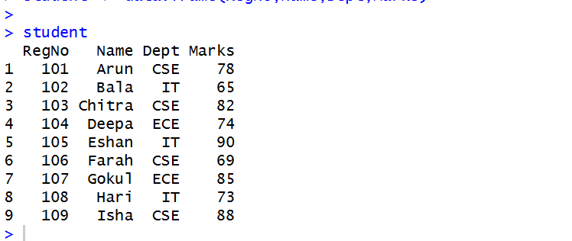

3. Mean, Median, Mode, IQR in R

Mean
mean(student$Marks)

Median
median(student$Marks)

Mode
table(student$Marks)
(No repeated value → No mode)

IQR
IQR(student$Marks)

Quartiles
quantile(student$Marks)

Output:
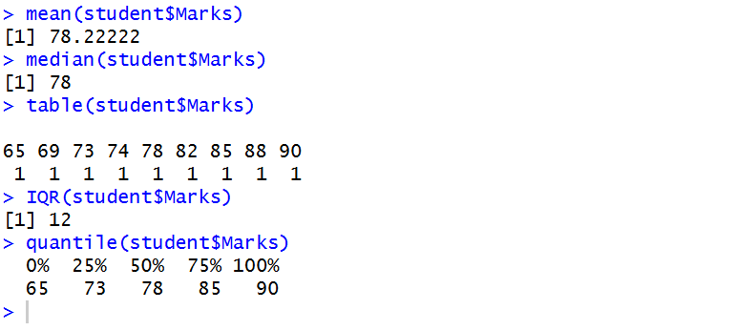

11. Practice Questions (Using Above Data)

(Draw Chart using R)

1. Department Strength Analysis
The college administration wants to see how many students belong to each department to plan classroom allocation.
Question:
Draw a suitable chart in R to show the number of students in each department.
dept_count <- table(student$Dept)
barplot(dept_count, main = "Department Strength", xlab = "Department", ylab = "Number of Students", col = "skyblue")
Output:
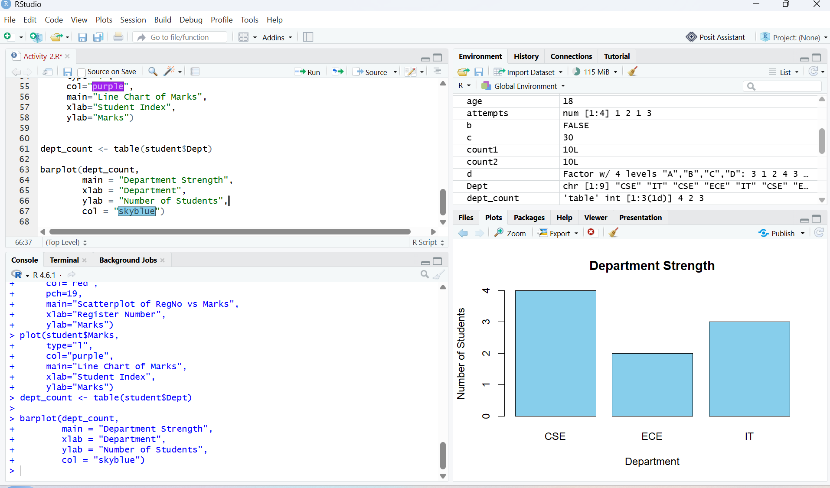

2. Marks Distribution Analysis
The examination committee wants to understand how marks are distributed among students to check whether the exam was easy or difficult.
Question:
Create a chart in R to display the distribution of marks.
R-Code:
hist(student$Marks,
main = "Distribution of Student Marks",
xlab = "Marks",
ylab = "Number of Students",
col = "skyblue",
border = "black")
Output:
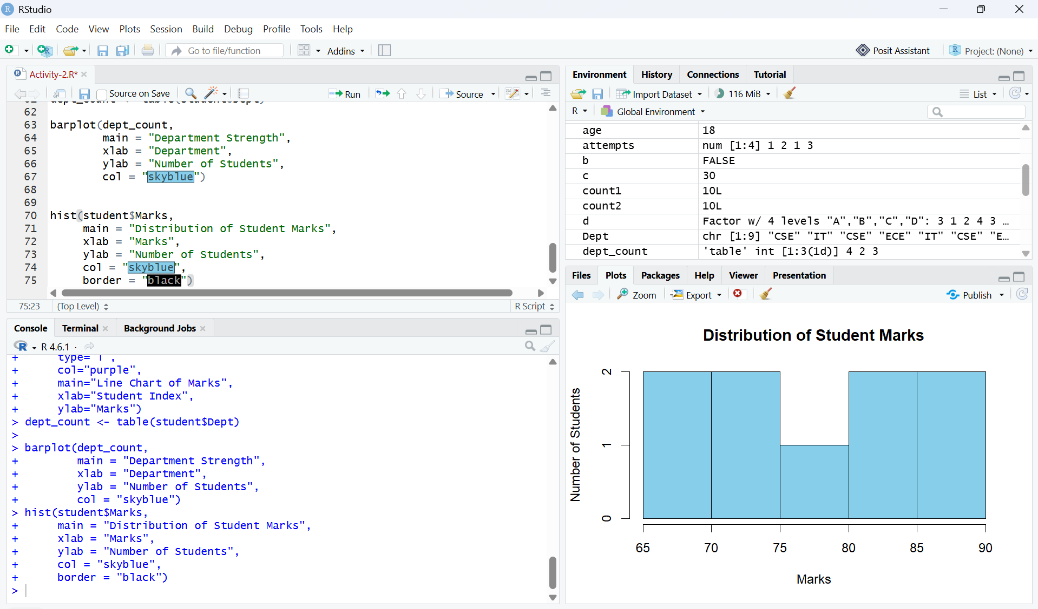

3. Marks Trend Monitoring
A teacher wants to observe how marks vary across student registration numbers to detect performance trends.
Question:
Draw a chart in R showing the trend of marks across students.
Expected Chart: Line Chart
R-Code:
plot(student$RegNo, student$Marks,
type = "o",
main = "Marks Trend Across Students",
xlab = "Registration Number",
ylab = "Marks",
col = "blue",
pch = 16)
Output:
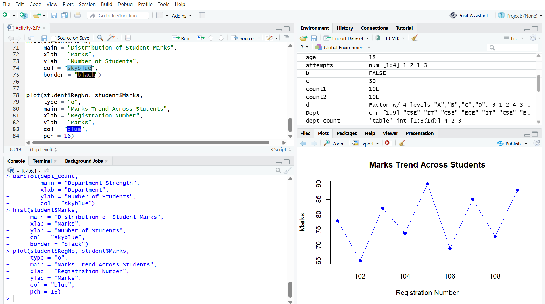

4. Outlier Detection
The academic coordinator wants to identify whether any student marks are unusually high or low compared to others.
Question:
Create a chart in R that helps detect outliers in marks.
R-Code:
boxplot(student$Marks, main = "Boxplot of Student Marks", ylab = "Marks", col = "skyblue", border = "black")
Expected Chart: Boxplot
Output:
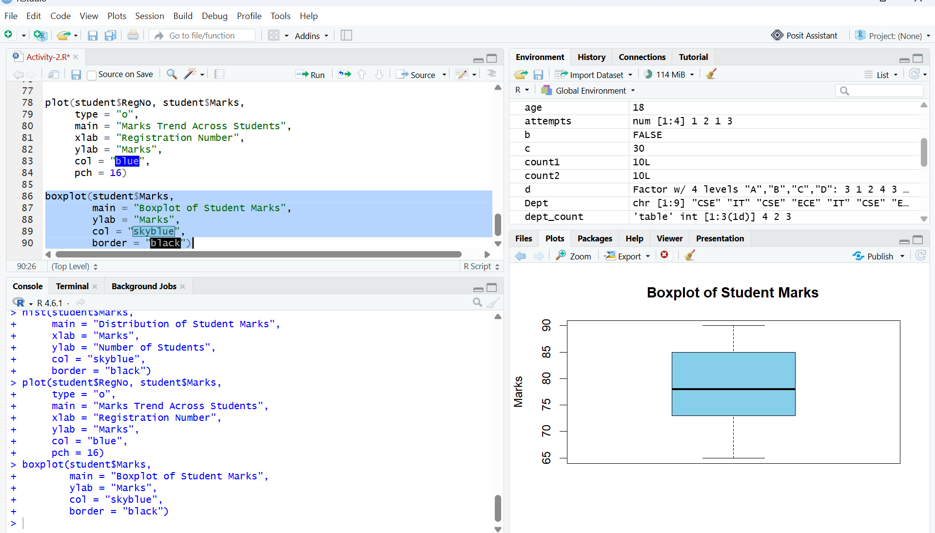

5. Relationship Analysis
The department wants to check if there is any pattern between student registration number and marks scored.
Question:
Plot the relationship between RegNo and Marks using R.
R-Code:
plot(student$RegNo, student$Marks, main = "Relationship Between RegNo and Marks", xlab = "Registration Number", ylab = "Marks", col = "blue", pch = 19)
Expected Chart: Scatter Plot
Output:
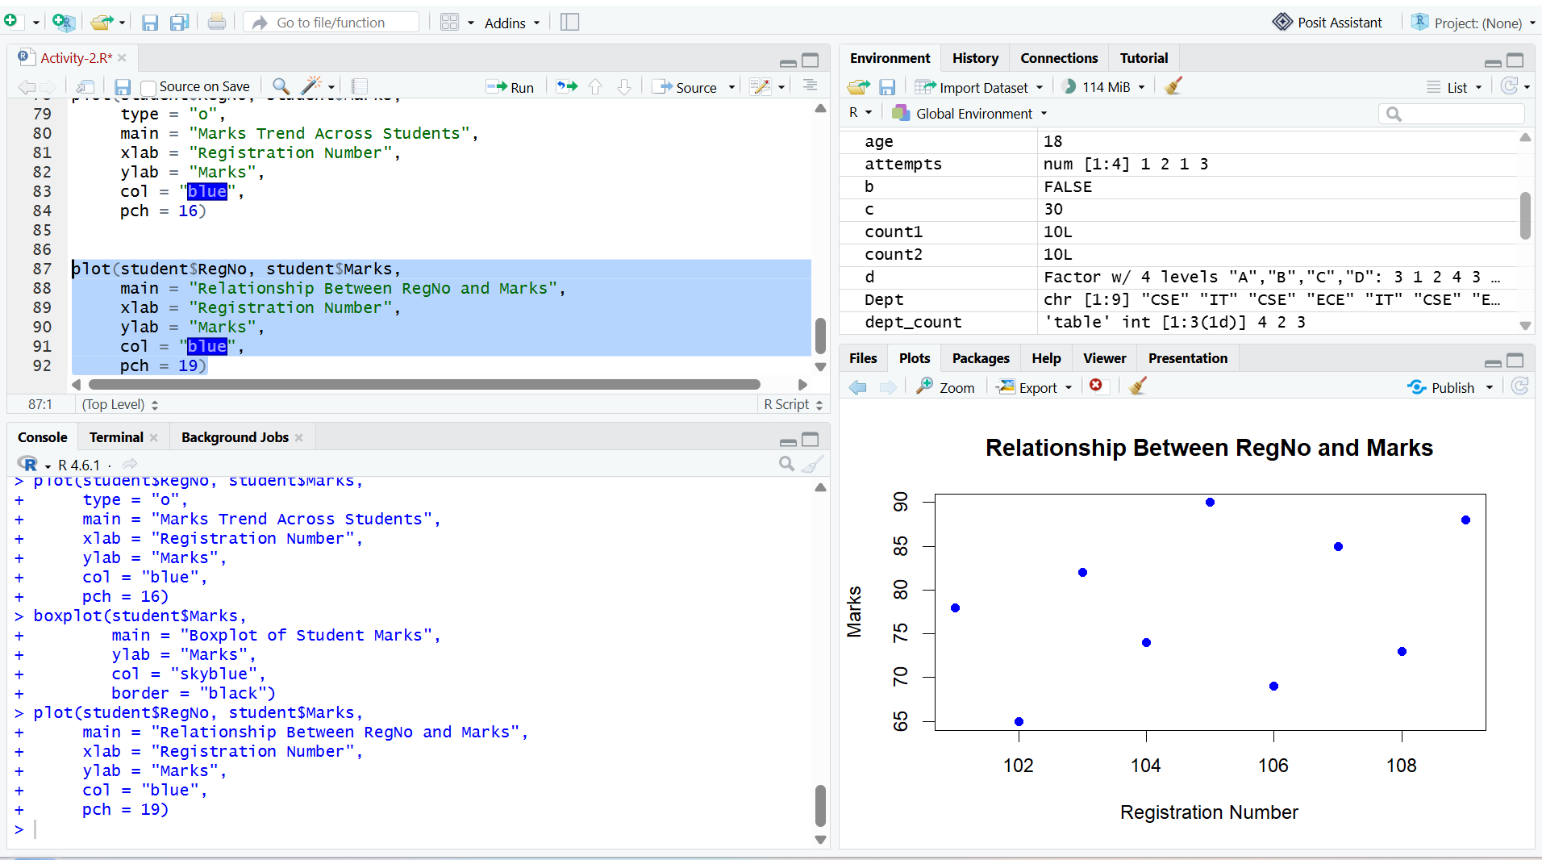

6. Department Percentage Analysis
The management wants to see the percentage contribution of each department in the class.
Question:
Create a chart in R to display the percentage of students in each department.
R-Code:
student <- data.frame(
Dept = c("CSE","IT","CSE","ECE","IT","CSE","ECE","IT","CSE")
)
dept_count <- table(student$Dept)
percentage <- round(dept_count / sum(dept_count) * 100, 1)
pie(dept_count,
labels = paste(names(dept_count), percentage, "%"),
main = "Department Percentage Analysis",
col = c("skyblue", "orange", "lightgreen"))
Expected Chart: Pie Chart
Output:
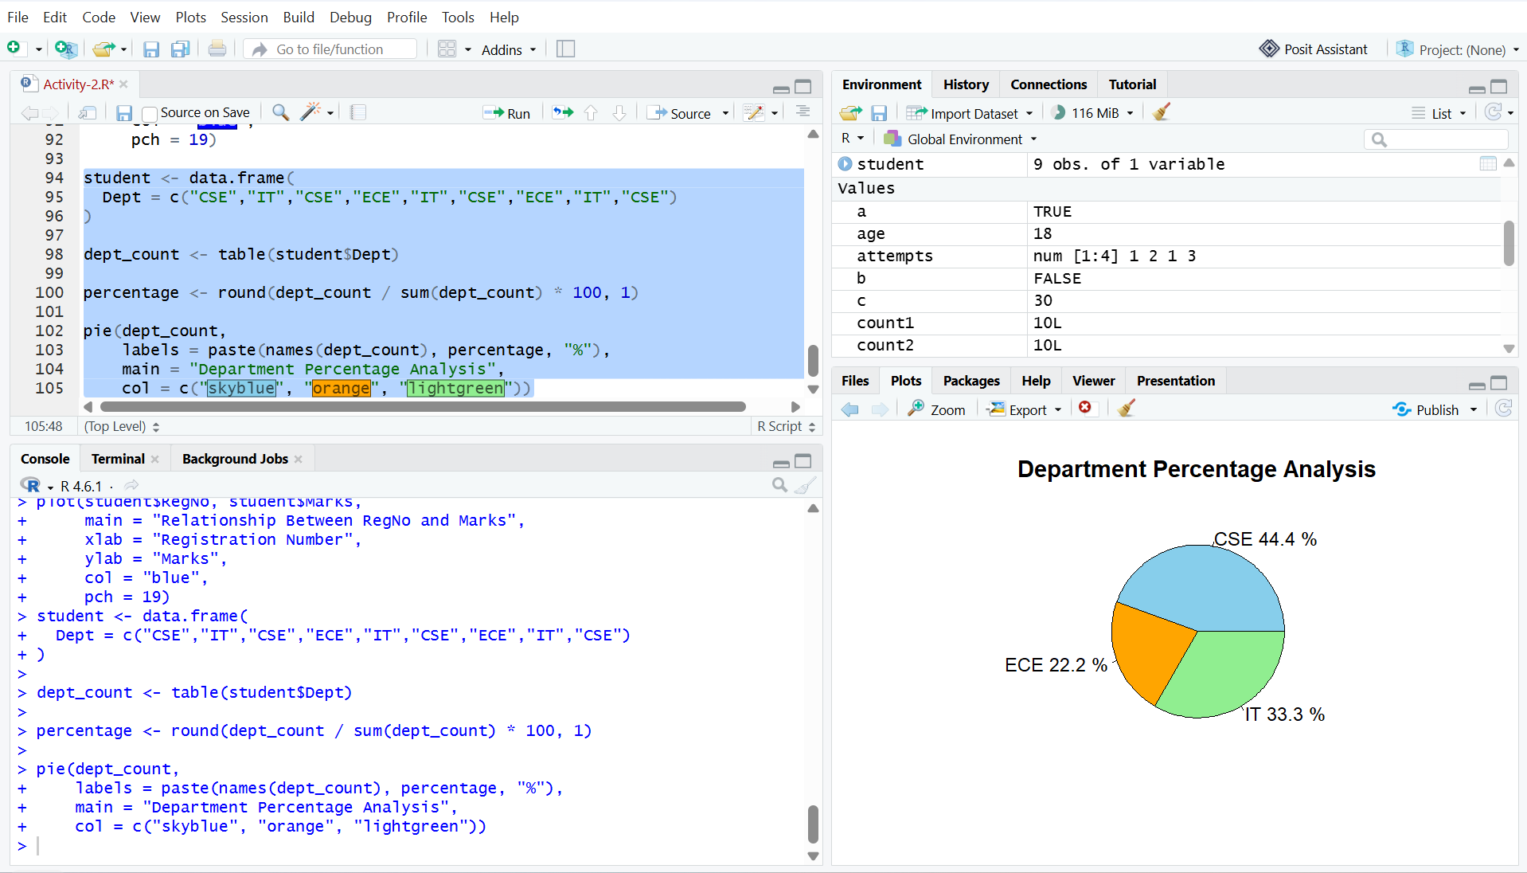

7. Performance Density Study
A data analyst wants to study the smooth distribution pattern of marks to understand the probability of student performance levels.
Question:
Draw a chart in R showing the density distribution of marks.
R-Code:
student <- data.frame(
RegNo = c(101,102,103,104,105,106,107,108,109),
Name = c("Arun","Bala","Chitra","Deepa","Eshan","Farah","Gokul","Hari","Isha"),
Dept = c("CSE","IT","CSE","ECE","IT","CSE","ECE","IT","CSE"),
Marks = c(78,65,82,74,90,69,85,73,88)
)

student$Marks <- as.numeric(student$Marks)

density_marks <- density(student$Marks)

plot(density_marks,
main = "Density Distribution of Student Marks",
xlab = "Marks",
ylab = "Density",
col = "blue",
lwd = 2)
Expected Chart: Density Plot
Output:
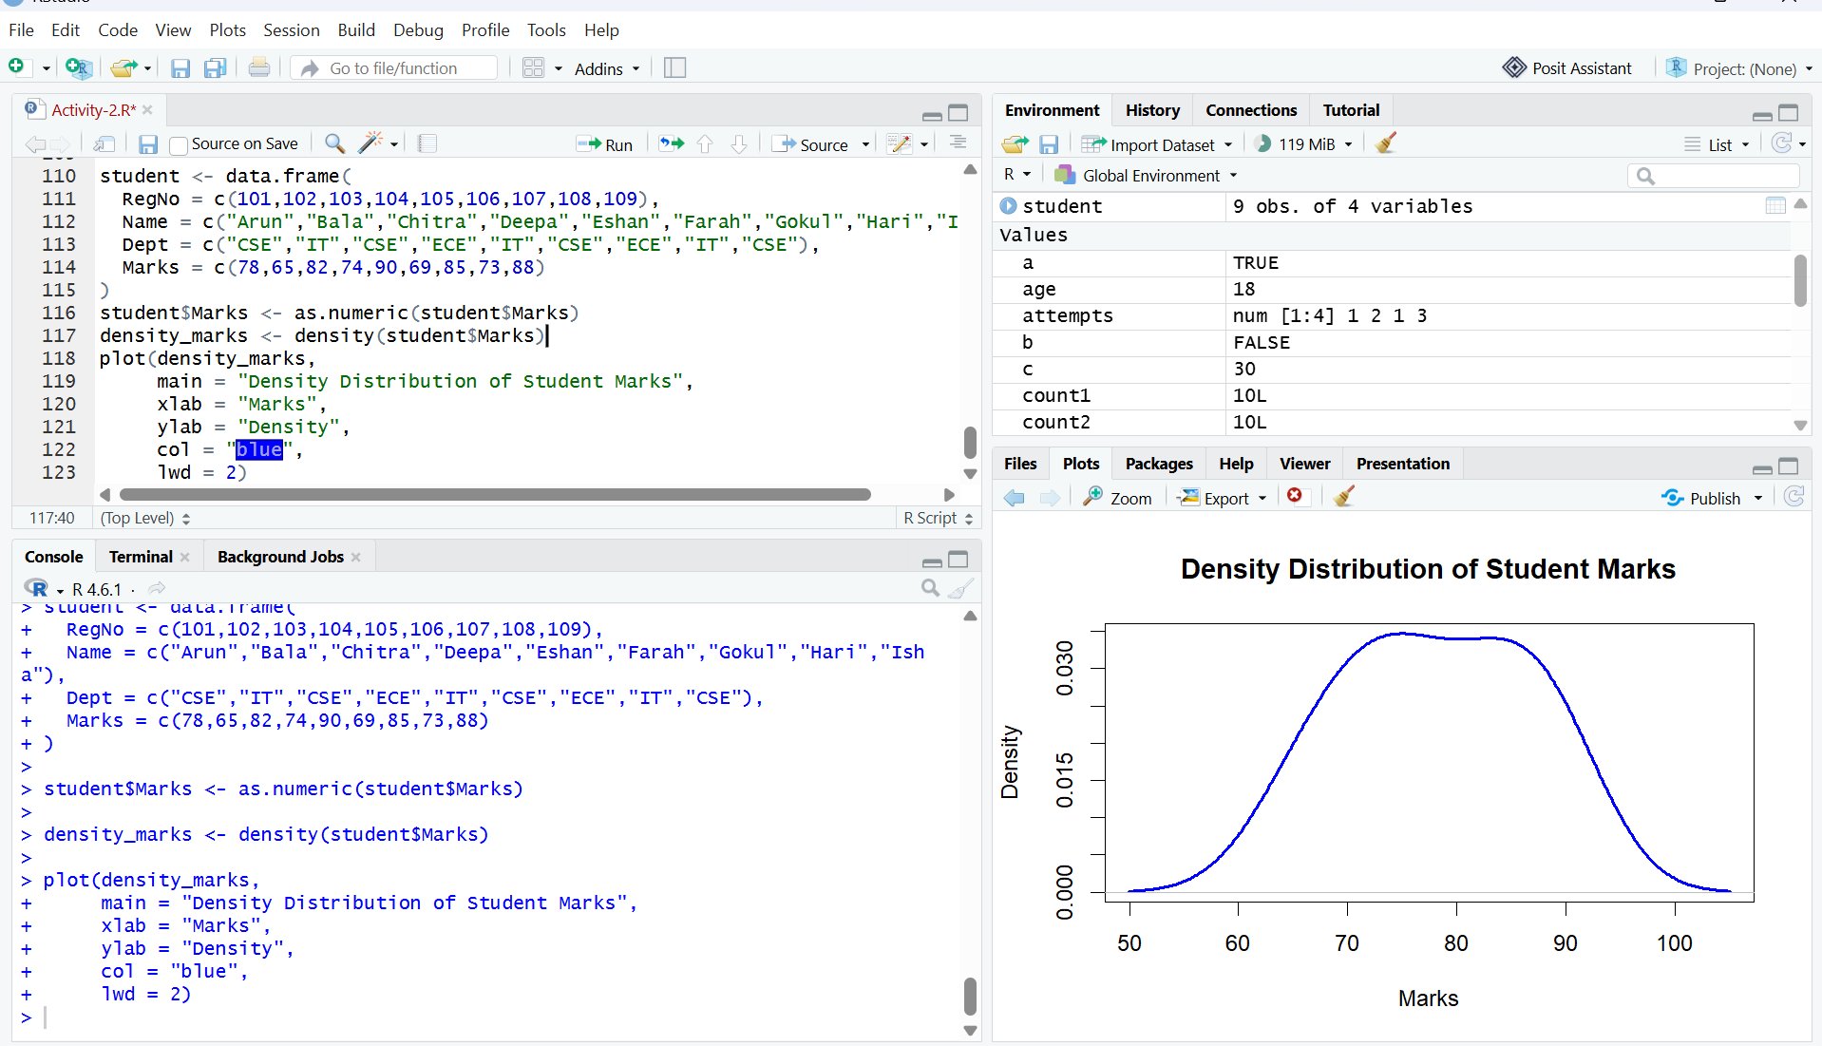

8. Comparative Performance Study
A teacher wants to compare student marks distribution visually to understand overall performance spread.
Question:
Create a suitable visualization in R to summarize the marks distribution using quartiles.
R-Code:
boxplot(student$Marks, main = "Comparative Distribution of Student Marks", ylab = "Marks", col = "skyblue", border = "black")
Expected Chart: Boxplot
Output:
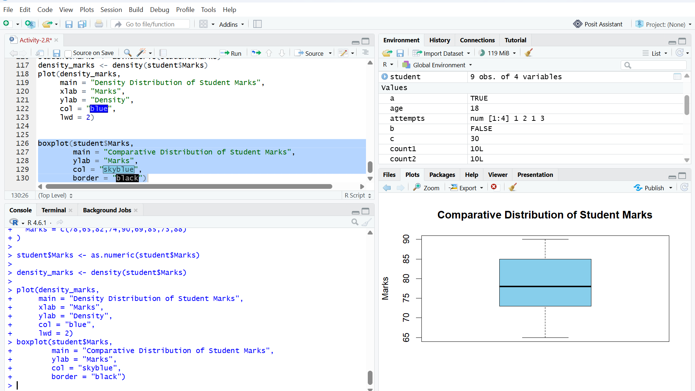

9. Department vs Marks Visualization
The HOD wants to compare marks scored by students across different departments.
Question:
Draw a chart in R that compares marks among departments.
R-Code:
boxplot(Marks ~ Dept, data = student, main = "Marks Comparison Across Departments", xlab = "Department", ylab = "Marks", col = "skyblue", border = "black")
Expected Chart: Boxplot by Department or Bar Chart
Output:
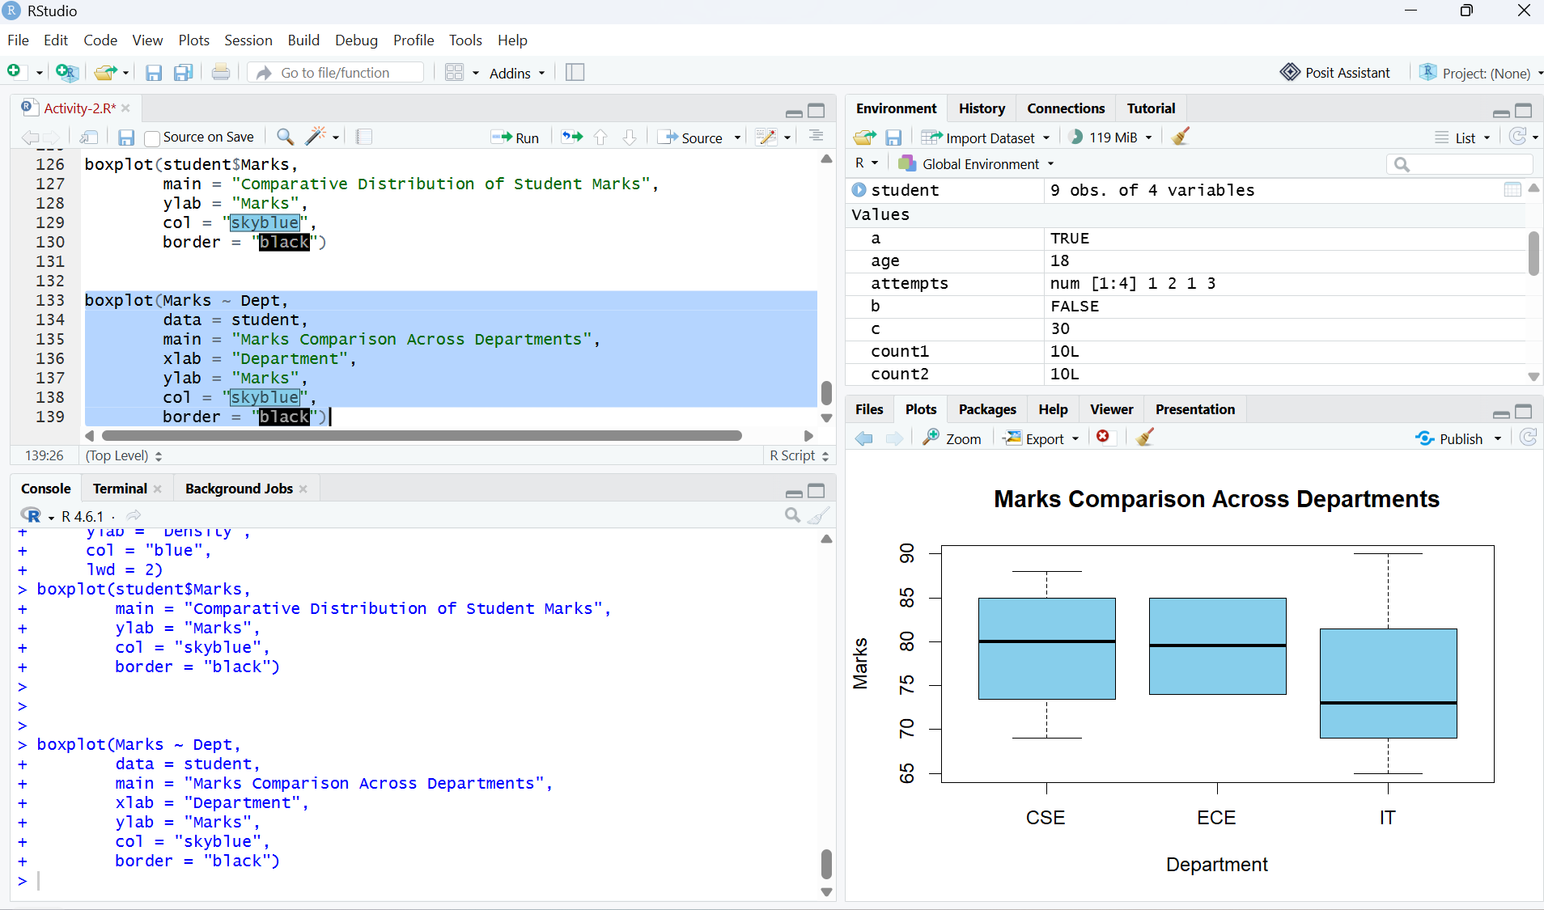

10. Student Performance Overview
The college principal wants a quick visual summary of student marks for a presentation.
Question:
Generate a simple visualization of student marks using R.
R-Code:
barplot(student$Marks, names.arg = student$Name, main = "Student Performance Overview", xlab = "Students", ylab = "Marks", col = "skyblue", ylim = c(0,100))
Expected Chart: Bar Chart
Output:
