Course Name: HTML5 - The Language

1-a:

Module Name: Case-insensitivity, Platform-independency, DOCTYPE Declaration, Types of Elements, HTML Elements - Attributes, Metadata Element

<!DOCTYPE html> <!-- DOCTYPE Declaration -->

<html>

<!-- Platform independency -->

<head>

    <!-- Metadata Elements -->

    <meta charset="UTF-8">

    <meta name="viewport" content="width=device-width, initial-scale=1.0">

    <title>Homepage </title>

</head>

<body>

    <!-- Attributes -->

    <a href="https://www.google.com">Google</a>

    <p>case sensitivity</P>

    Hello World!

    <DIV>It is a div tag</dIv>

</body>

</html>

OUTPUT:

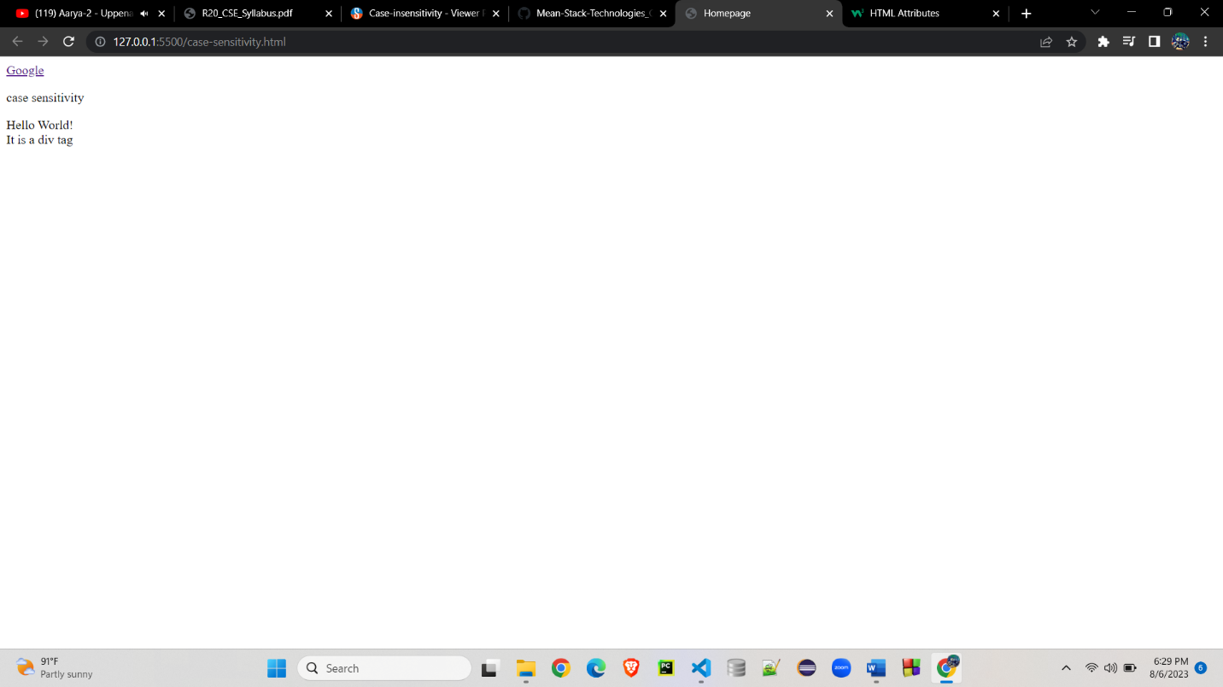

1-b: Module Name: Sectioning Elements

<!DOCTYPE html>

<html lang="en">

<head>

    <meta charset="UTF-8">

    <meta name="viewport" content="width=device-width, initial-scale=1.0">

    <title>Section elements</title>

</head>

<body>

    <header>

        <nav>login </nav>

    </header>

    <article>

        <section>

            <p>This is first paragraph</p>

            <p>This is paragraph</p>

        </section>

    </article>

    <aside>

        THis is aside tag

    </aside>

    <footer>

        <nav>About Us | Contact Us</nav>

    </footer>

</body>

</html>

Output:

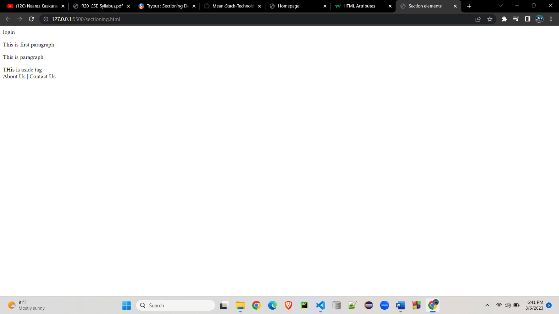

1-c Module Name: Paragraph Element, Division and Span Elements, List Element

<!DOCTYPE html>

<html lang="en">

<head>

    <meta charset="UTF-8">

    <meta name="viewport" content="width=device-width, initial-scale=1.0">

    <title>Grouping Elements</title>

</head>

<body>

    <!-- paragraph element -->

    <p>This is paragraph tag</p>

    <div>

        <p>This is the div tag</p>

        <p>Another paragraph in the div tag</p>

        <span>first section of paragraph</span>

        <span>second section of paragraph</span>

    </div>

    <!-- list elements -->

    <ul style="list-style-type: square;"> <!-- unordered list -->

        <li>HTML5</li>

        <li>CSS</li>

        <li>JS</li>

        <li>Bootstrap</li>

    </ul>

    <ol> <!-- Ordered List -->

        <li>HTML5</li>

        <li>CSS</li>

        <li>JS</li>

        <li>Bootstrap</li>

    </ol>

    <dl>

        <dt> HTML </dt>

        <dd> Hyper Text Mark up languague </dd>

        <dt> Description Term 2 </dt>

        <dd> Description Definition 2 </dd>

    </dl>

</body>

</html>

Output :

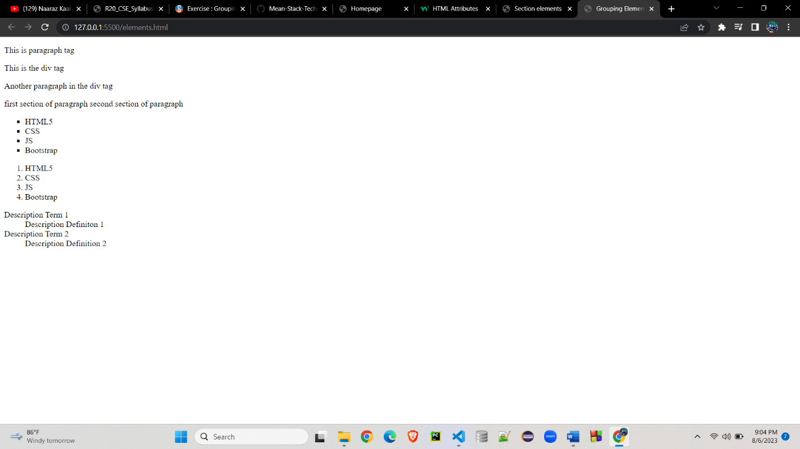

1-d Module Name: Link Element

<!DOCTYPE html>

<html lang="en">

<head>

    <meta charset="UTF-8">

    <meta name="viewport" content="width=device-width, initial-scale=1.0">

    <title>Link Attributes</title>

</head>

<body>

    <!-- link Attributes -->

    <h3>Google</h3>

    <a href="https://www.google.com/" target="_blank">new tab</a><br>

    <a href="https://www.google.com/" target="_parent">click here</a><br>

    <a href="https://www.google.com/" target="_self">click here</a><br>

    <a href="https://www.google.com/" target="_top">click here</a>

</body>

</html>

Output :

