Course Name: Javascript

1-a Module Name: Type of Identifiers

Write a JavaScript program to find the area of a circle using radius (var and let - reassign and observe the difference with var and let) and PI (const)

<html>

    <head>

        <title>Find the radius</title>

        <script>

            var radius=2;

            let Radius=2;

            const pi=3.14;

            let area=pi\*radius\*radius;

            //var area=pi\*radius\*radius;

            document.write('<h2> Given Radius is 2 </h2>');

            document.write('<h1>'+area+'</h1>');

        </script>

    </head>

    <body>

    </body>

</html>

Output:

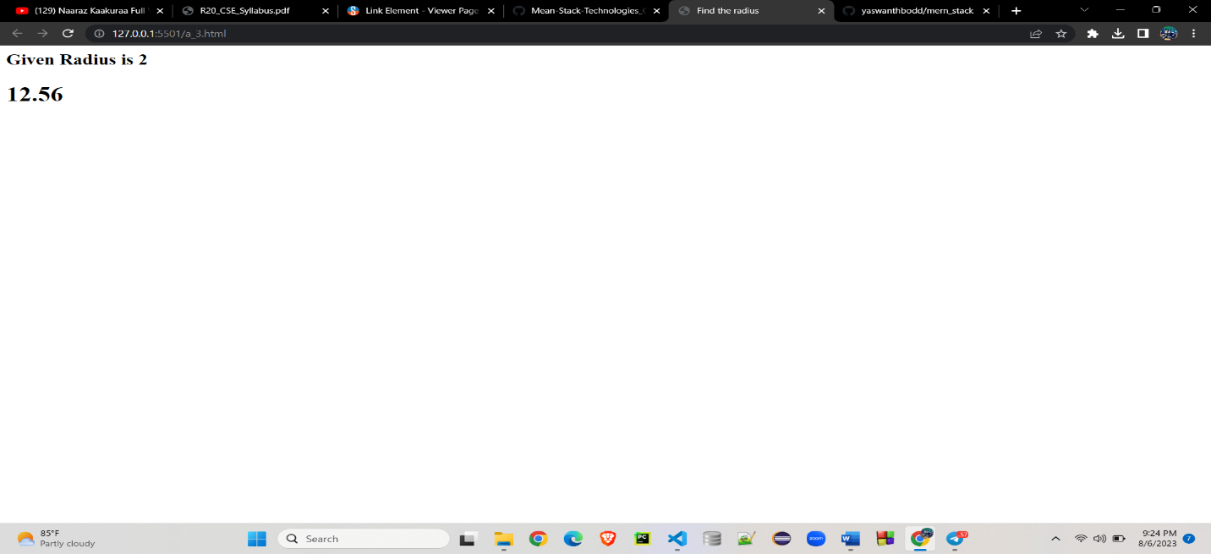

1-b Module Name: Primitive and Non Primitive Data Types

Write JavaScript code to display the movie details such as movie name, starring, language, and ratings. Initialize the variables with values of appropriate types. Use template literals wherever necessary

<!DOCTYPE html>

<html>

<head>

    <title>Movie Details</title>

    <style>

        div#maincontent {

            height: 100px;

            width: 500px;

            border: 1px solid #CEE2FA;

            text-align: left;

            color: #08438E;

            font-family: calibri;

            font-size: 20;

            padding: 5px;

        }

        div#heading {

            text-decoration: bold;

            text-align: center;

            margin-top: 80px;

            width: 500px;

            border: 1px solid #CEE2FA;

            text-align: center;

            color: #08438E;

            background-color: #CEE2FA;

            font-family: calibri;

            font-size: 20;

            padding: 5px;

        }

    </style>

</head>

<body>

    <center>

        <div id="heading">Movie Details</div>

        <div id="maincontent">

            <script>

                //Write the code to display the movie details

                var movieName='Bahubali';

                var language='Telugu';

                var starring='Prabhas';

                var Ratings=4.5;

                document.write(`Movie: ${movieName} </br>

                                Language: ${language} </br>

                                Starring: ${starring} </br>

                                Ratings: ${Ratings}`);

            </script>

        </div>

    </center>

</body>

</html>

Output:

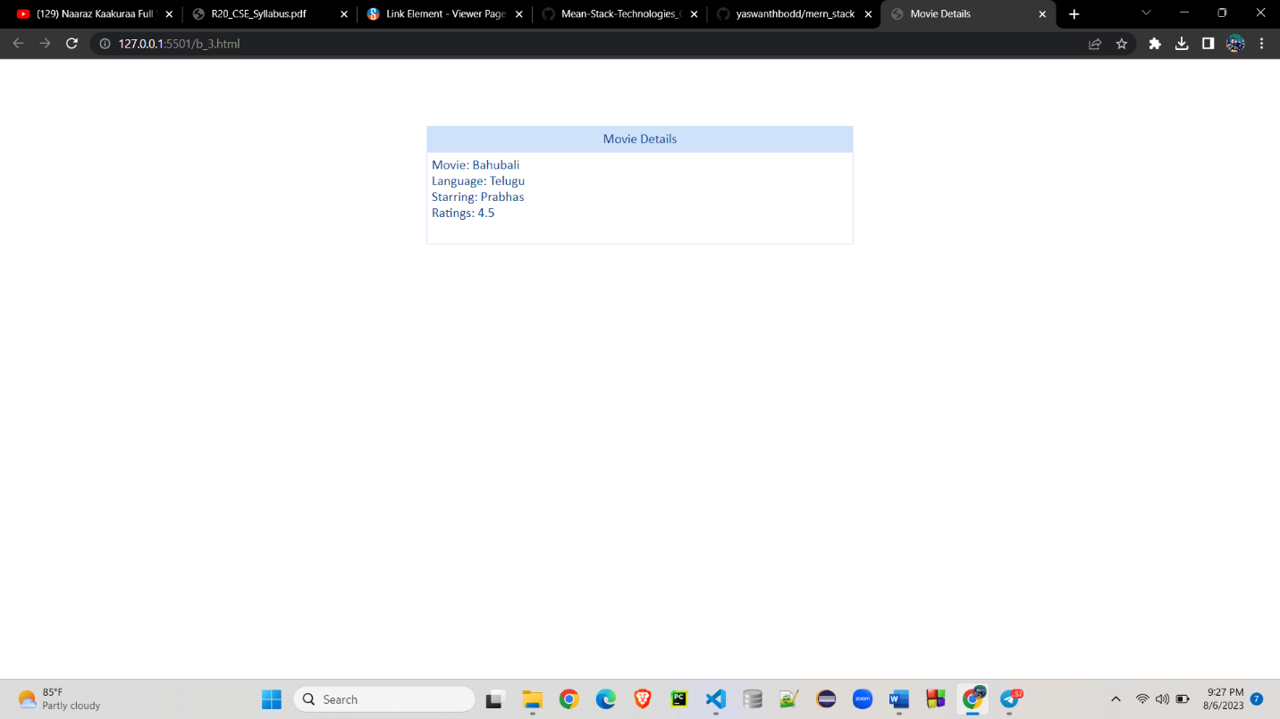

1-c Module Name: Operators and Types of Operators

Write JavaScript code to book movie tickets online and calculate the total price, considering the number of tickets and price per ticket as Rs. 150. Also, apply a festive season discount of 10% and calculate the discounted amount.

<!DOCTYPE html>

<html>

<head>

    <title>Ticket Details</title>

    <style>

        div#maincontent {

            height: 150px;

            width: 500px;

            border: 1px solid #CEE2FA;

            text-align: left;

            color: #08438E;

            font-family: calibri;

            font-size: 20;

            padding: 5px;

        }

        div#heading {

            text-decoration: bold;

            text-align: center;

            margin-top: 80px;

            width: 500px;

            border: 1px solid #CEE2FA;

            text-align: center;

            color: #08438E;

            background-color: #CEE2FA;

            font-family: calibri;

            font-size: 20;

            padding: 5px;

        }

        h4 {

            padding: 0;

            margin: 0;

        }

    </style>

</head>

<body>

    <center>

        <div id="heading">

            <b>Theatre Drama</b>

        </div>

        <div id="maincontent">

            <h4>Your Ticket Details:</h4>

            <br>

            <script>

                //Write the code to calculate the total price and discounted price for the tickets

                var tickets=window.prompt("enter");

                const ticketPrice=150;

                var totalCost=tickets \* ticketPrice;

                var discountCost=(totalCost\*90)/100;

                document.write(`Total number of seats booked: ${tickets} </br>

                                Total cost of ${tickets} tickets: &#8377;${totalCost} </br>

                                Festive season discount is: 10&#37; </br>

                                Total cost after discount is: &#8377;${discountCost}`);

            </script>

        </div>

    </center>

</body>

</html>

Output :

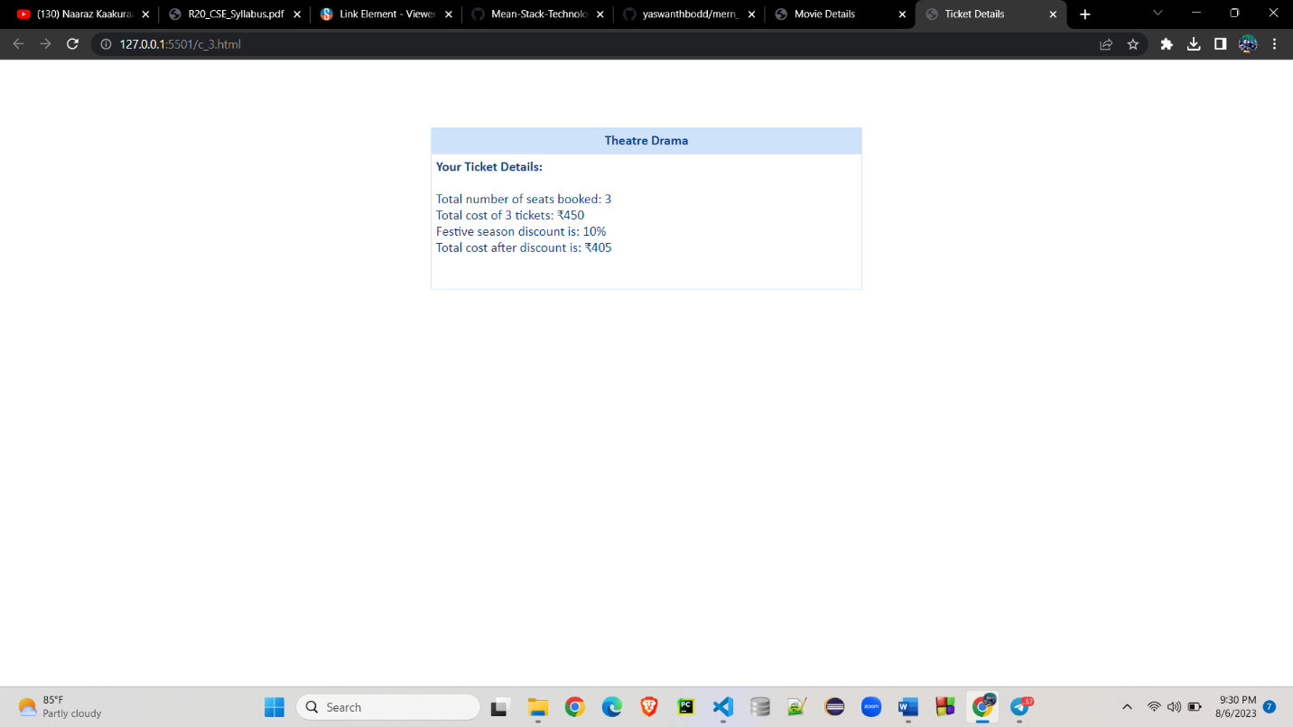

1-d Module Name: Types of Statements, Non - Conditional Statements, Types of Conditional Statements, if Statements, switch Statements

Write a JavaScript code to book movie tickets online and calculate the total price based on the 3 conditions: (a) If seats to be booked are not more than 2, the cost per ticket remains Rs. 150. (b) If seats are 6 or more, booking is not allowed. (c) If se

<!DOCTYPE html>

<html>

<head>

    <title>Booking Details</title>

    <style>

        div#maincontent {

            height: 200px;

            width: 600px;

            border: 1px solid #CEE2FA;

            text-align: left;

            color: #08438E;

            font-family: calibri;

            font-size: 20;

            padding: 5px;

        }

        div#heading {

            text-decoration: bold;

            text-align: center;

            margin-top: 80px;

            width: 600px;

            border: 1px solid #CEE2FA;

            text-align: center;

            color: #08438E;

            background-color: #CEE2FA;

            font-family: calibri;

            font-size: 20;

            padding: 5px;

        }

        h4 {

            padding: 0;

            margin: 0;

        }

    </style>

</head>

<body>

    <center>

        <div id="heading">

            <b>Theatre Drama</b>

        </div>

        <div id="maincontent">

            <h4>Your Ticket Details:</h4>

            <br>

            <script>

                var noOfTickets = parseInt(window.prompt("Enter number of tickets"))

                document.write("Price of each ticket : Rs. 150")

                document.write("<br>Number of Tickets : "+noOfTickets)

                var price = noOfTickets\*150

                if(noOfTickets<=2){

                document.write("<br>Price is : "+price)

                }else if(noOfTickets>=6){

                document.write("<br>You exceed maximum limit.")

                }else{

                document.write("<br>Price is : "+price)

                document.write("<br>10% Discount : "+price\*0.1)

                document.write("<br>Total Price : "+(price - (price\*0.1)))

                }

            </script>

        </div>

    </center>

</body>

</html>

Output:

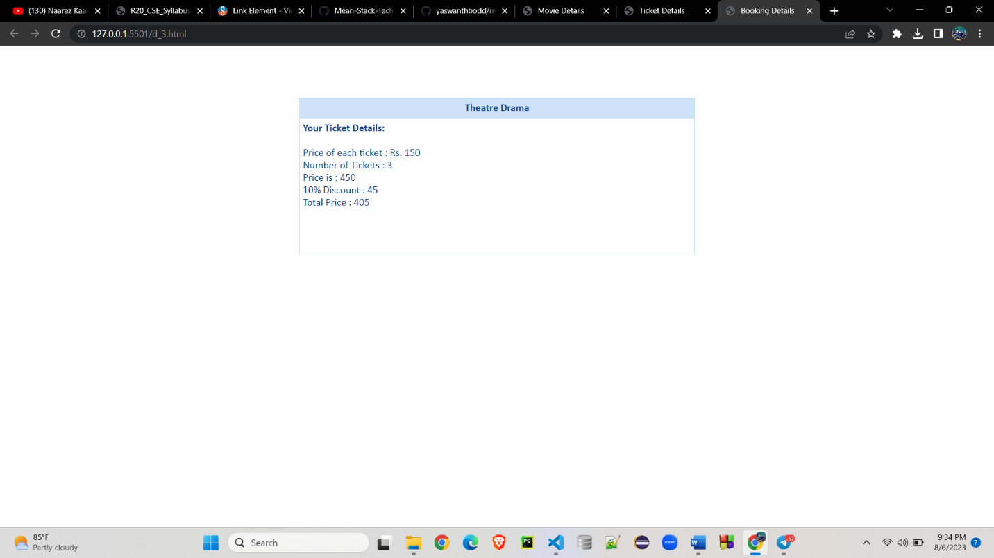

1-e Module Name: Types of Loops

Write a JavaScript code to book movie tickets online and calculate the total price based on the 3 conditions: (a) If seats to be booked are not more than 2, the cost per ticket remains Rs. 150. (b) If seats are 6 or more, booking is not allowed. (c) If

<!DOCTYPE html>

<html>

<head>

    <title>Booking Details</title>

    <style>

        div#maincontent {

            height: 200px;

            width: 600px;

            border: 1px solid #CEE2FA;

            text-align: left;

            color: #08438E;

            font-family: calibri;

            font-size: 20;

            padding: 5px;

        }

        div#heading {

            text-decoration: bold;

            text-align: center;

            margin-top: 80px;

            width: 600px;

            border: 1px solid #CEE2FA;

            text-align: center;

            color: #08438E;

            background-color: #CEE2FA;

            font-family: calibri;

            font-size: 20;

            padding: 5px;

        }

        h4 {

            padding: 0;

            margin: 0;

        }

    </style>

</head>

<body>

    <center>

        <div id="heading">

            <b>Theatre Drama</b>

        </div>

        <div id="maincontent">

            <h4>Your Ticket Details:</h4>

            <br>

            <script>

                let seats = 4;

                var cost = 9;

                var c1, c2 = 5, tc, s = 0;

                if (seats <= 2) {

                    cost = 9;

                    tc = seats \* cost;

                    document.write("For " + seats + ", you need to pay:" + tc);

                }

                else if (seats >= 6) {

                    document.write("Booking is not allowed");

                }

                else if (seats > 2 && seats < 5) {

                    for (let i = 1; i <= 4; i++) {

                        c1 = cost - ((cost \* c2) / 100);

                        s = s + c1;

                        document.write("Ticket for Customer" + i + " gets " + c2 + "% discount!, Cost is: $" + c1 + "<br>");

                        c2 = c2 + 2;

                    }

                    tc = seats \* 9;

                    document.write("For " + seats + ", you need to pay:$" + s + " instead of $" + tc);

                }

            </script>

        </div>

    </center>

</body>

</html>

Output:

