Exp no:9 Implement Dielectric free space boundary condition in Electric Field and find the relative
permittivity of the different medium.

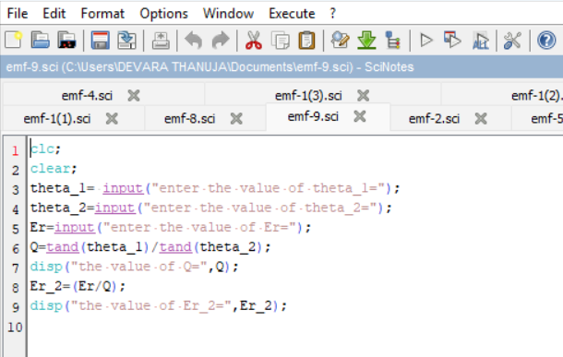
Program:

