EXP 1: Transformation between Cartesian, Cylindrical and spherical coordinate system
Transformation of Cartesian coordinate points into Cylindrical and spherical coordinate system
Code :
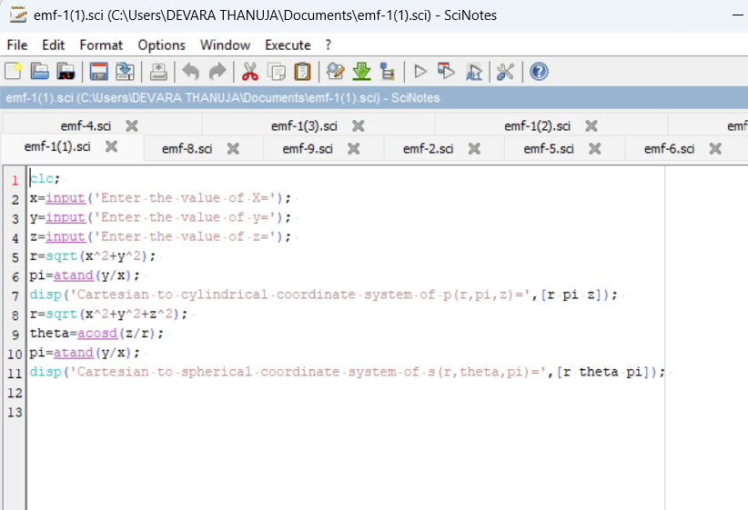
Output;
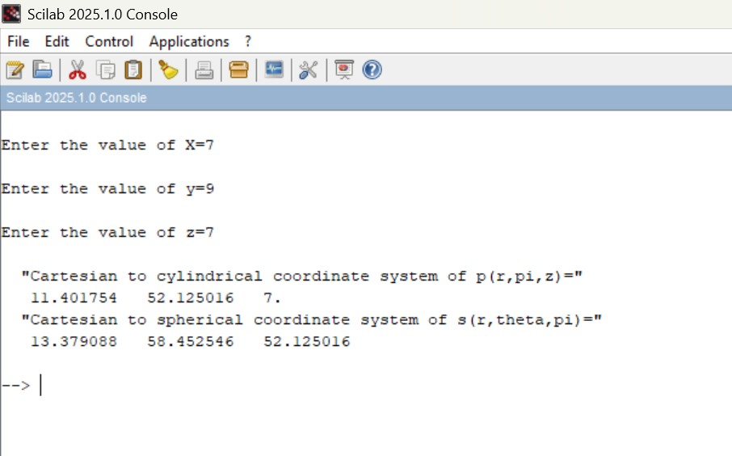

(ii) Transformation of Cylindrical coordinate points into Cartesian and spherical
coordinate system
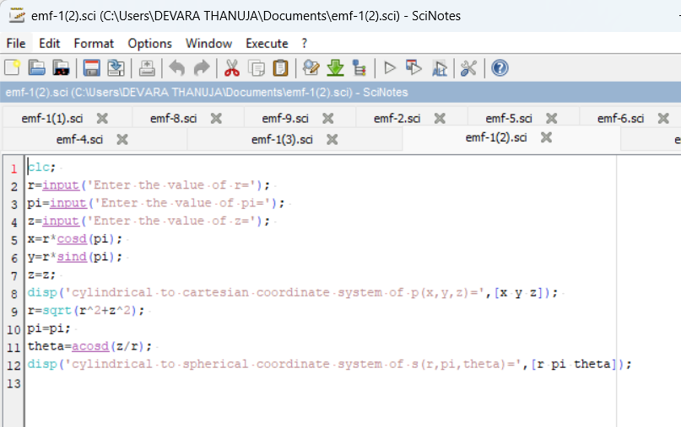
Output :
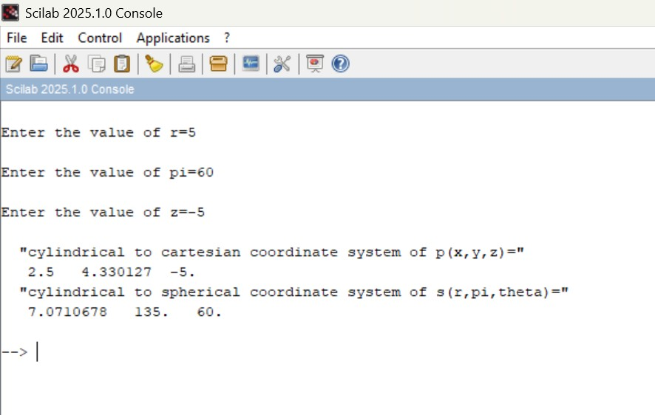

(iii) Transformation of spherical coordinate points into Cylindrical and Cartesian coordinate system
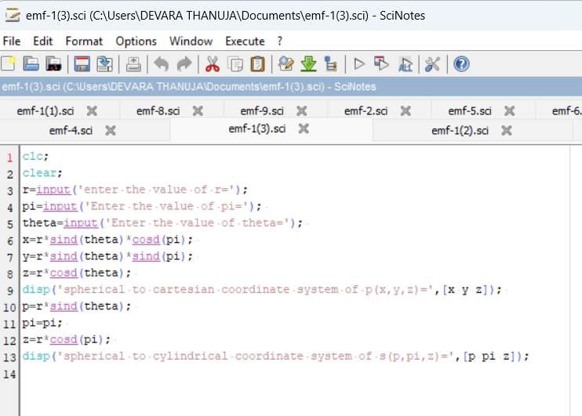
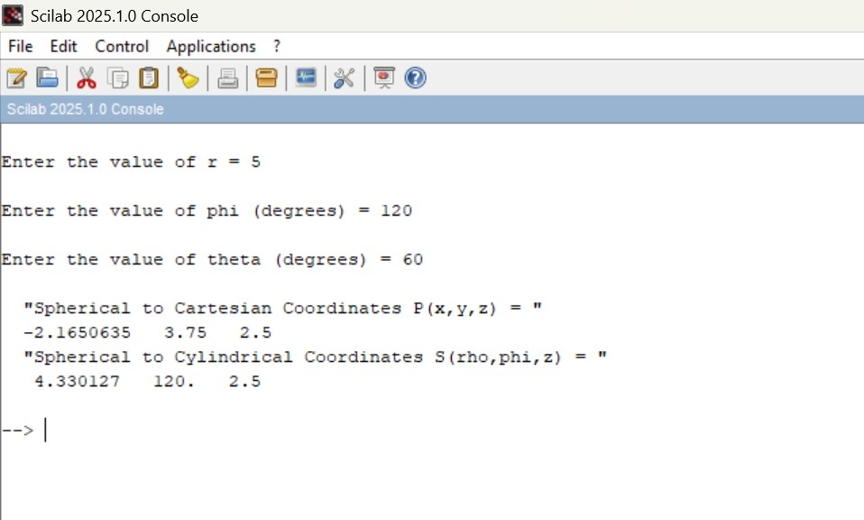
Output:

