**PROJECT 2: INSTAGRAM USER ANALYTICS**

SQL FUNDAMENTALS

NAME: K. Yaswanth

GMAIL: [kunayaswanth123@gmail.com](mailto:kunayaswanth123@gmail.com)

To provide best report for the Marketing team

and Investor Metrics using MySQL

SUBMITTING TO TRAINITY :)

SPECIAL THANKS TO TRAINITY TEAM

**Project Description:-** To help the marketing team and investor metrics.

1. Here, we have ig_clone database and it has comments, likes, users, photo_tags, tags, photos are tables. We do operations on this tables.
2. Doing correct analysis by giving correct suggestions for the questions they asked using MySQL.
3. By querying the data of marketing team and by giving correct suggestions to the team helps the Instagram grow.
4. Here, we find most loyal users, inactive users, declaring contest winner, hashtag researching, launching ad campaigning questions
5. And finding the query solutions of investor metrics i.e. user engagement and finding Bots and fake accounts in users table.

**Approach:-**

There is a Data set related to users which is given in the project. Taking

the data set and cloning the data set into MySQL workbench. By creating

database in MySQL. Creating the tables which were required and inserting

the values into that tables. With the help of the SQL fundamentals solving the

problems which were given in project.

There is a Data set related to users which is given in the project. Taking

the data set and cloning the data set into MySQL workbench. By creating

database in MySQL. Creating the tables which were required and inserting

the values into that tables. With the help of the SQL fundamentals solving the

problems which were given in project.

1. 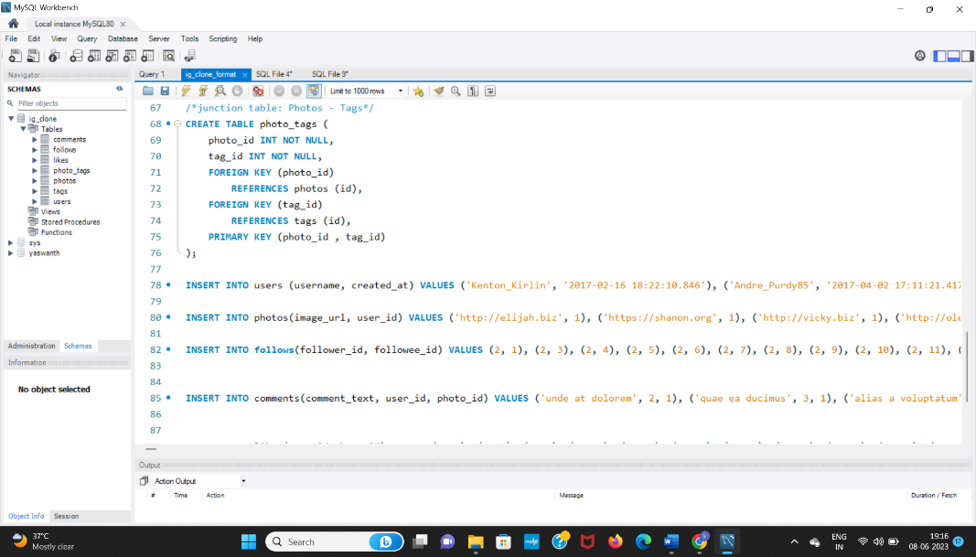The dataset provided in Instagram User Analytics in project 2. It is copied to MySQL workbench and execute each query.
2. We use required tables based on our requirement like using joins, subqueries
3. With the help of sql fundamentals and knowledge, we solve the problems which were given in the project.

**Tech-Stack Used:-** MySQL workbench Version 8.0.33

**Insights:-**

1. While, doing this project. I gained practical experience through by applying joins and writing sub queries
2. Gained pratical experience, by writing common term expressions.
3. Learnt practically, how to make the report very good.
4. Learnt dayname() function, limit keyword and their usage through this project.
5. Learnt to think deeply.

*Result : It is written at the EOF*

1. **To Help the Marketing Team:-**
2. **Rewarding Most Loyal Users:** People who have been using the platform for the longest time. Your Task: Find the 5 oldest users of the Instagram from the database provided

Ans: To find the oldest users of Instagram from users table. So, sort the date (order by created_at ) in ascending order which is ascending. We need to find the names of top 5 people. So, we use limit 5 and by default it is offset 0.

SQL QUERY :-

**select username**

**from users**

**order by created_at asc**

**limit 5**

**offset 0;**

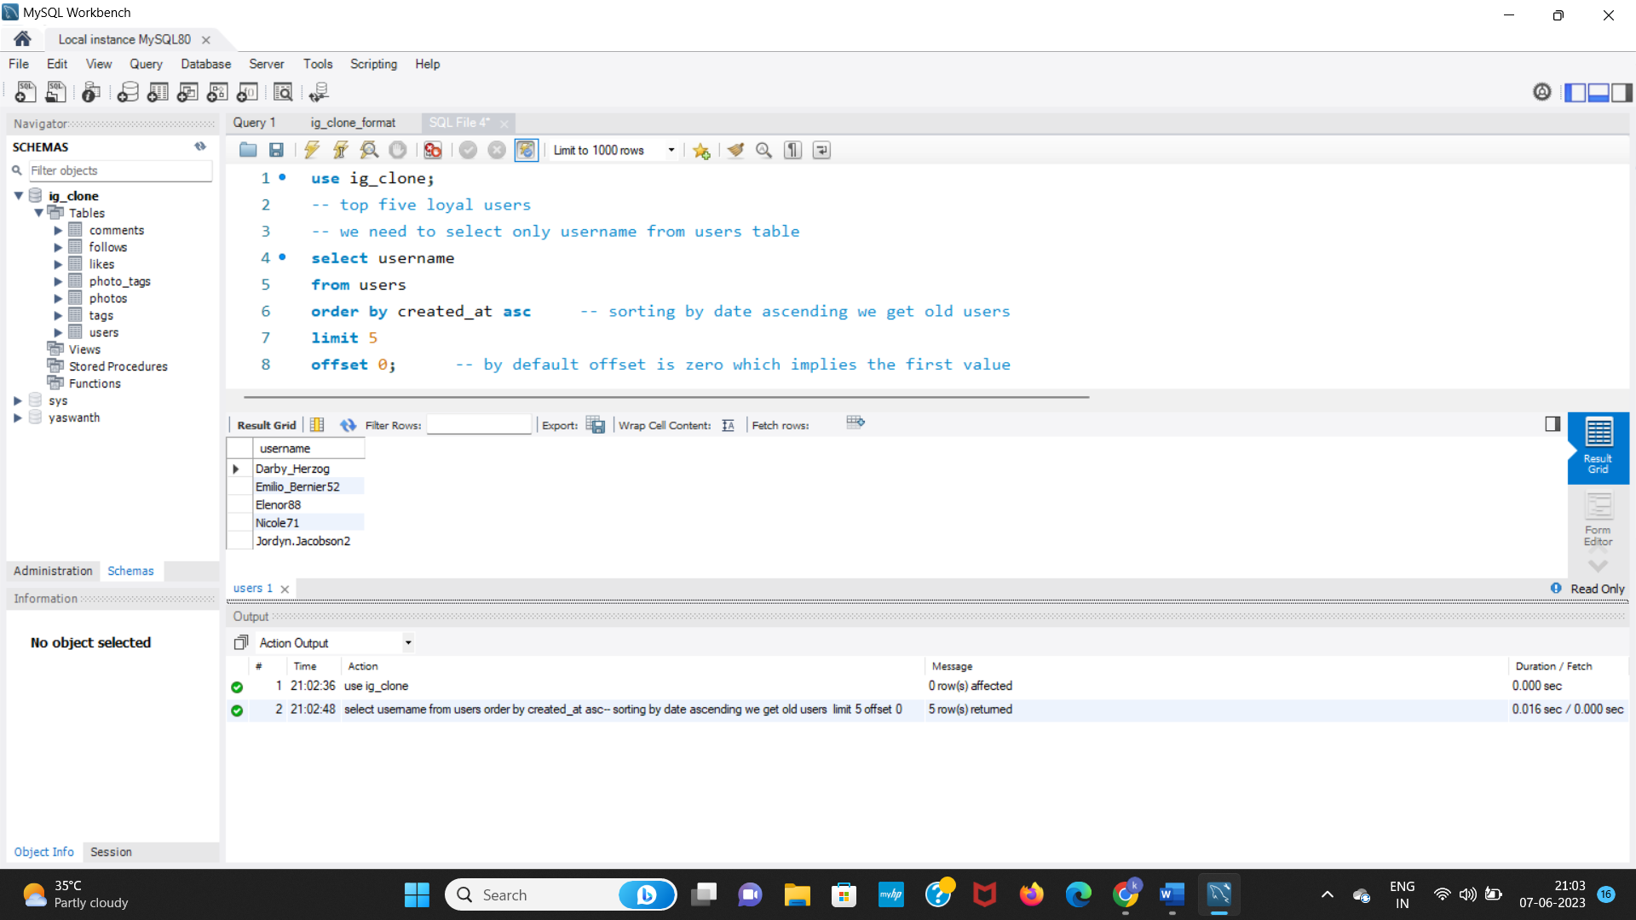

1. **Remind Inactive Users to Start Posting:** By sending them promotional emails to post their 1st photo. Your Task: Find the users who have never posted a single photo on Instagram

Ans. To find who don’t post even a single photo. We use left join users and photos have user ids as common, then find the photo urls as null and finally we select that names. If to count username we use count(username)

SQL QUERY: -

**select username -- to count the users = count(username)**

**from users left join photos**

**on users.id = photos.user_id**

**where photos.image_url is null;**

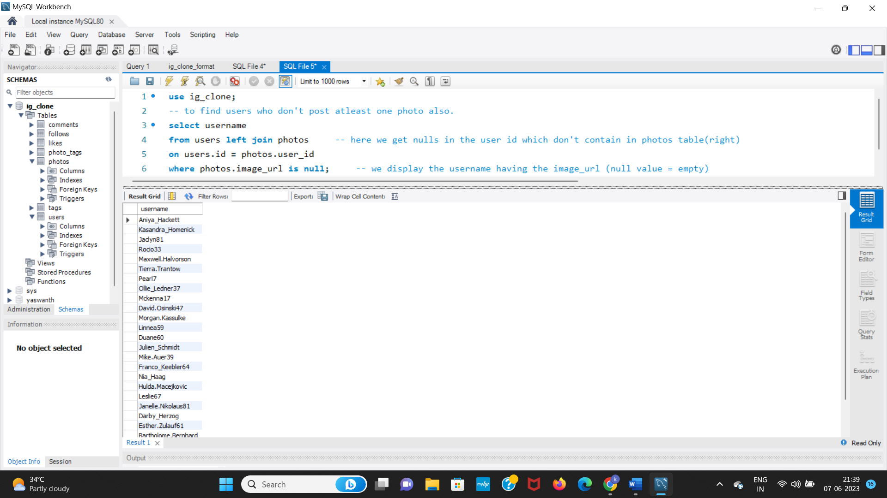

**3**. **Declaring Contest Winner:** The team started a contest and the user who gets the most likes on a single photo will win the contest now they wish to declare the winner. Your Task: Identify the winner of the contest and provide their details to the team

Ans. To find the winner(username) of contest

1. For single photo how many likes

To get that we join photos table and likes table then we get for every photo which user liked the photo. We group the photo_id then perform count (*) as total_likes aggregation then we get for every single photo how many likes are there.

1. We find each photo which user that belongs

So, we inner join with user table and equal the user id with photos.user_id

1. Then we add username in select column. We sort the table with total_likes descending. Then we get the first row with maximum likes of each photo, and preceding the username it.

**SQL QUERY:-**

**SELECT**

**username, photos.id, COUNT(*) AS total_likes**

**FROM**

**photos**

**INNER JOIN**

**likes ON photos.id = likes.photo_id**

**INNER JOIN**

**users ON users.id = photos.user_id**

**GROUP BY photos.id**

**ORDER BY total_likes DESC**

**LIMIT 1;**

*Note: use beautify option in workbench*

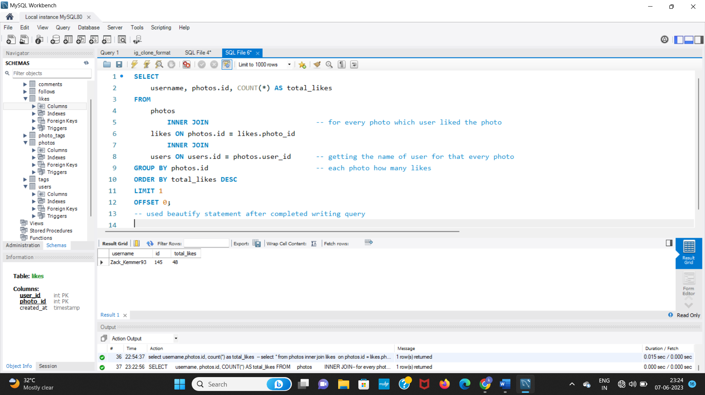

**Zack_kemmer93 user got most likes for the photo of id 145 he is the winner**

1. **Hashtag Researching:** A partner brand wants to know, which hashtags to use in the post to reach the most people on the platform. Your Task: Identify and suggest the top 5 most commonly used hashtags on the platform

Ans: To find most commonly used hashtags in the post

1. Firstly, join the tags table with photo_tags table on having same tag_id in each table, group by tag_id then perform aggregation count(*) to get total_tags used in all the posts.
2. Sort by total tags descending order, then we need top 5, so we use limit 5 (offset 0 which is first value).

SQL QUERY:-

**SELECT**

**tags.id, tags.tag_name, COUNT(*) AS total_tags**

**FROM**

**tags**

**INNER JOIN**

**photo_tags ON tags.id = photo_tags.tag_id**

**GROUP BY tags.id**

**ORDER BY total_tags DESC**

**LIMIT 5 OFFSET 0;**

*Note: use beautify option in workbench*

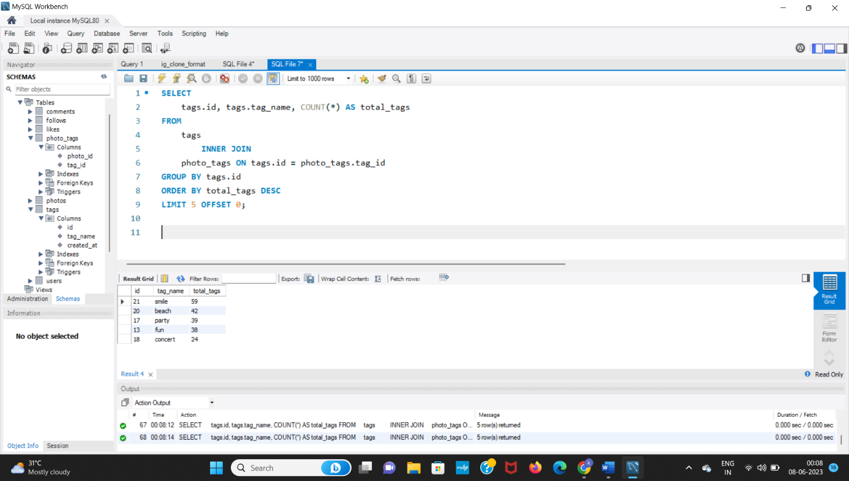

1. **Launch AD Campaign:** The team wants to know, which day would be the best day to launch ADs. Your Task: What day of the week do most users register on? Provide insights on when to schedule an ad campaign

Ans: To find the day where most users registered

1. From date we find which day it is, using dayname(created_at) function and find all the days
2. Then to find the single day we group the day and then perform aggregation count for each day how many users.

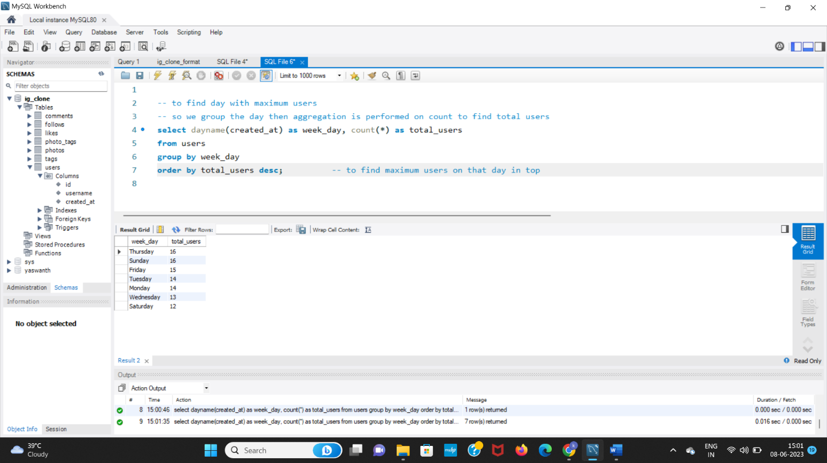

SQL QUERY:-

**select dayname(created_at) as week_day, count(*) as total_users**

**from users**

**group by week_day**

**order by total_users desc;**

Here, we get every day with total users on that day

We conclude that maximum users registered on Thursday and Sunday with maximum of each day 16.

So, we can start the ad campaign either Thursday or Sunday;

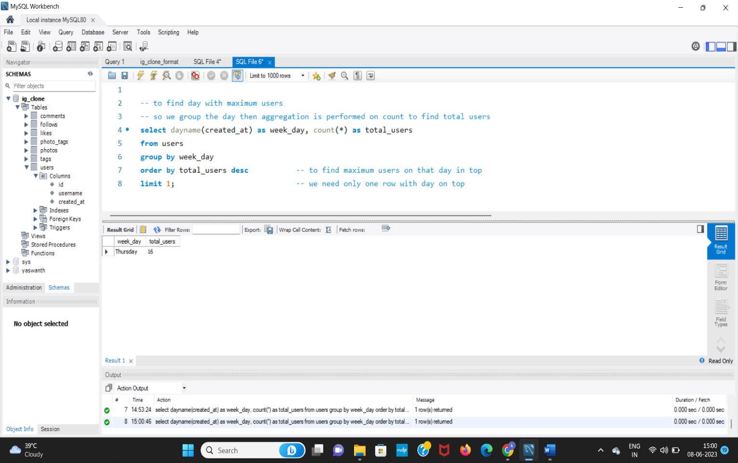

Using limit 1 we find the top result.

**B.  Investor Metrics:**

**1. User Engagement:**Are users still as active and post on Instagram or they are making fewer posts. Your Task: Provide how many times does average user posts on Instagram. Also, provide the total number of photos on Instagram/total number of users

Ans: Contains two answers.

1. **To provide how many times does average user posts on Instagram** to find 1 user on average post how many photos on Instagram.
2. Firstly, finding each user how many posts he posts on Instagram
3. To find average, summing the total posts divide by no of users which is average.

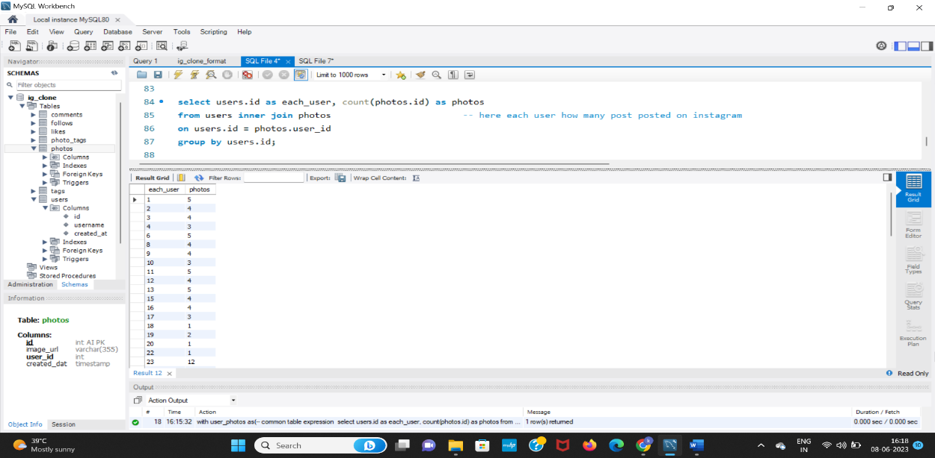(explanation screenshot)

Each user how many posts posted

*We create this table as common table expression as user_photos. Then find the average as*

*Sum(photos) / count(*) [each user] (no of users)*

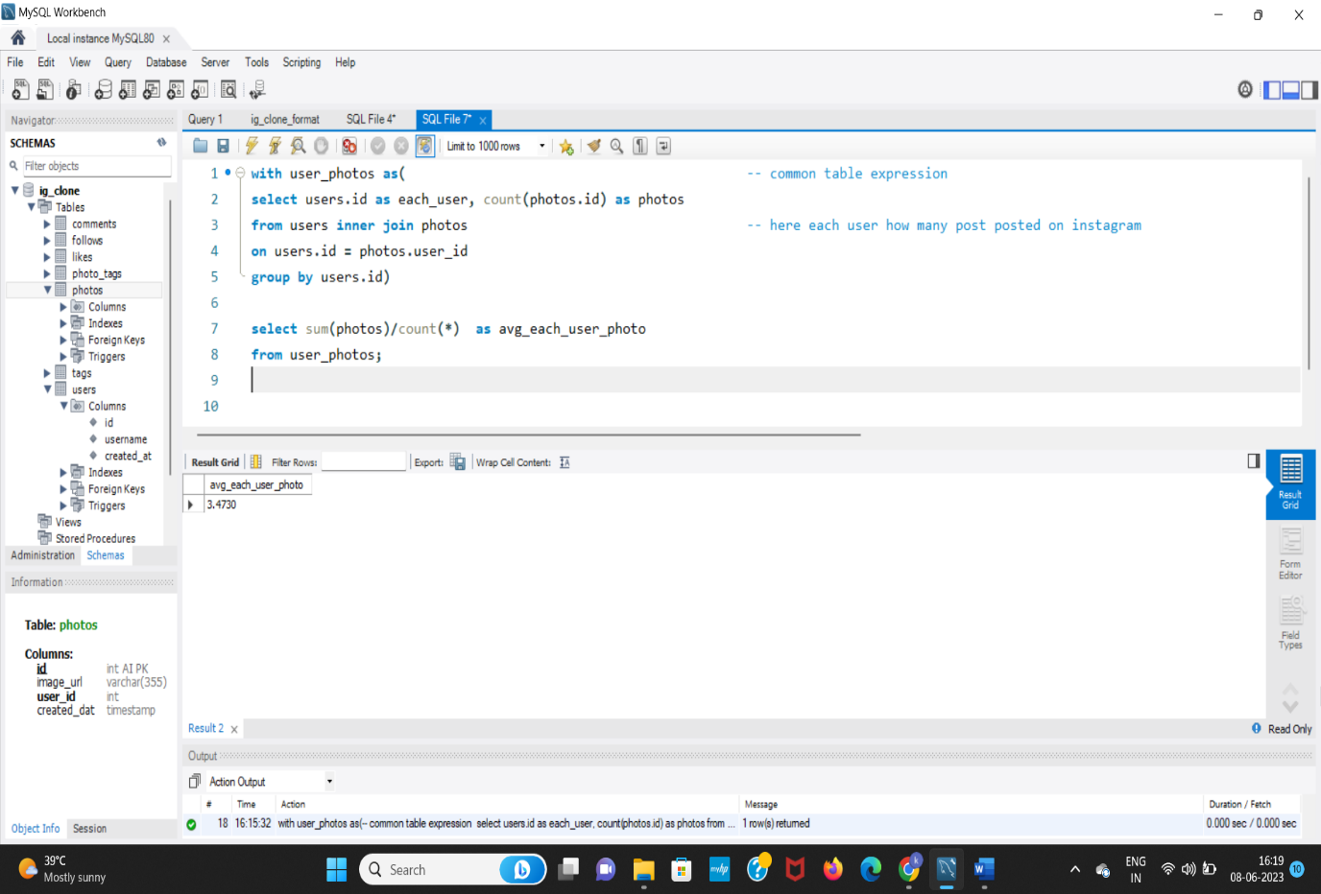Each user on average posts 3 photos posted. (original output)

1. **provide the total number of photos on Instagram/total number of users**

ans: select count(*) from photos -- total photos on photos table

select count(*) from users -- total users on users table

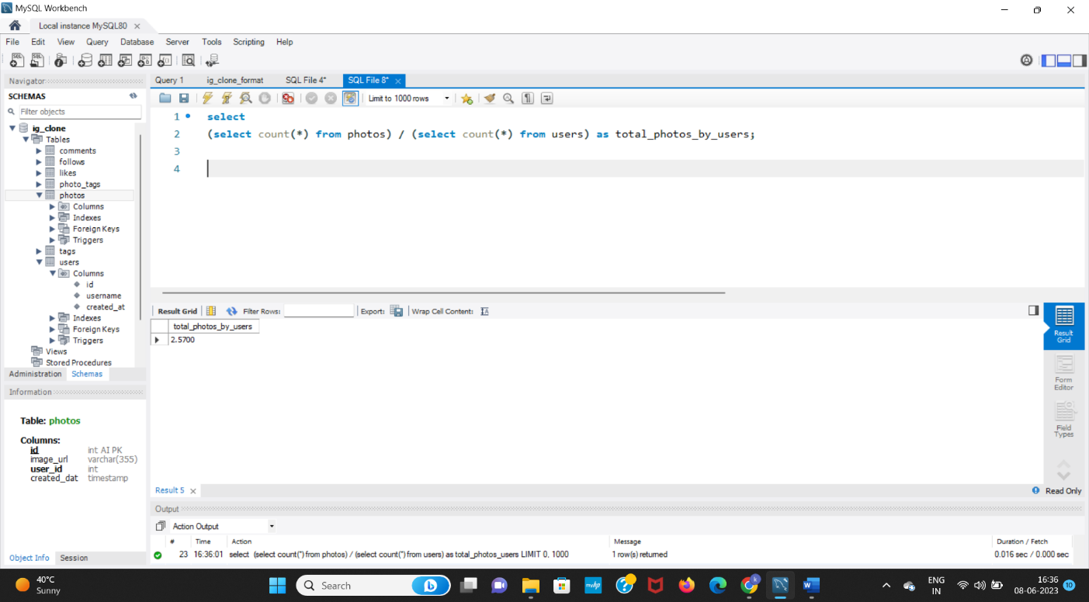

**2. Bots & Fake Accounts:** The investors want to know if the platform is crowded with fake and dummy accounts. Your Task: Provide data on users (bots) who have liked every single photo on the site (since any normal user would not be able to do this).

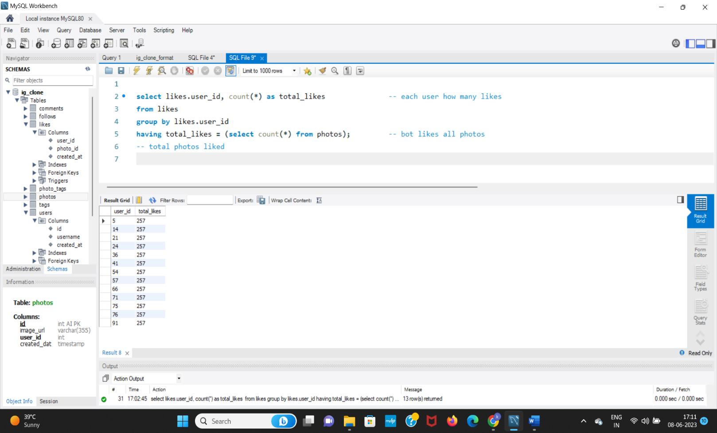**Ans:-**  Here, if the user likes all the photos that implies the user is having fake account.

This user_id are fake user_ids.

**Result:-**

By doing this project, I have gained knowledge on how to interact with the database and get our wanted information through sql. And how to write complex queries and make them in easily understandable format of humans.

Overall, through this steps I have successfully completed the project on marketing and Investor metrics.

**Thank you Trainity 😊**

**Happy Learning :>)**