##### PROJECT 4: Hiring Process Analytics

Statistics

NAME: K. Yaswanth

GMAIL: [kunayaswanth123@gmail.com](mailto:kunayaswanth123@gmail.com)

To provide the best report for the hiring team with the help of statistics knowledge and by using MS excel.

SUBMITTING TO TRAINITY :)

SPECIAL THANKS TO TRAINITY TEAM

**Project Description:**

1. Used MS Excel to analyse the data by creating pivot table by placing the pivot table fields in adequate places.
2. Learning all the concepts of pivot table and solving the below 5 questions.

**Approach:**

1. Downloading all the statistics file data provided. Understanding the data.
2. Clean the data, like removing outliers.
3. Creating necessary pivot tables and pivot charts.

**Tech – Stack Used:**

1. Microsoft Excel
2. Dataset statistics (given)

**Insights:**

Through this project, it became easy to learn the real life project experiences and learned how to create charts and help the company.

1. **Hiring:** Process of intaking of people into an organization for different kinds of positions.  
   **Your task:** How many males and females are Hired?

Ans: To find total number of male and female employee hired in to the organisation.

We complete this task by a creating pivot table. With help of pivot table, we summarise the data we want.

First, we create the table using the given statistics data using “CTRL+T”

Cleaning the data: “-“ with don’t say (here we replaced this kind of data)

Remove the null values by zero.

Now, we go to insert tab and select pivot table in new sheet.

1. To find total number of males and females are hired.

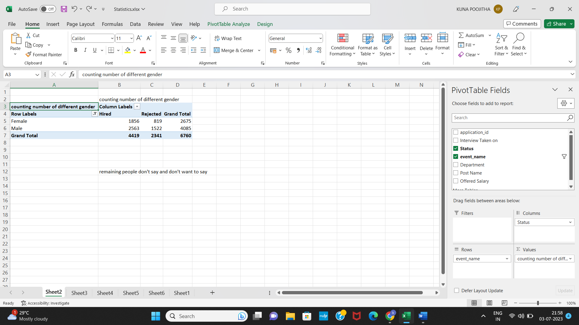

Here, we finally find total males and total females hired.

1. **Average Salary:** Adding all the salaries for a select group of employees and then dividing the sum by the number of employees in the group.  
   **Your task:** What is the average salary offered in this company ?

Ans: To find average for different groups of employees which implies (we need to find the different departments average.)

Here, we find the average by changing value field settings. (Or we can do by creating sum column and by creating count column, then by dividing both).

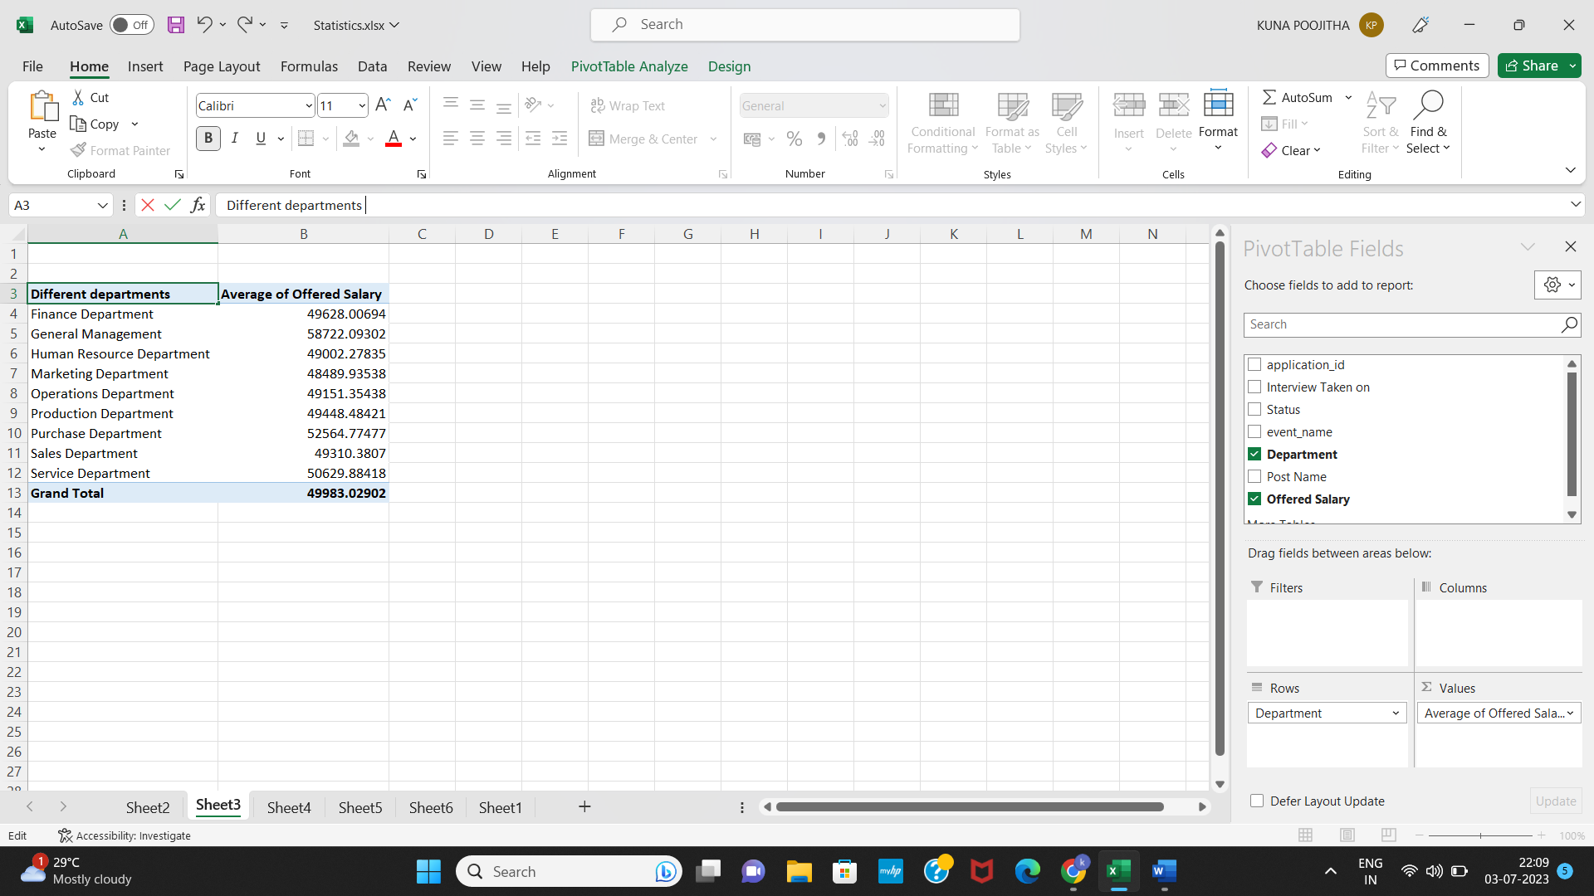

Average salary of all the departments.

1. **Class Intervals:** The class interval is the difference between the upper-class limit and the lower-class limit.  
   **Your task:**Draw the class intervals for salary in the company?

Ans: we select salary column then apply grouping in pivot table. We get class intervals. Then count of application id in values. We get exact result.

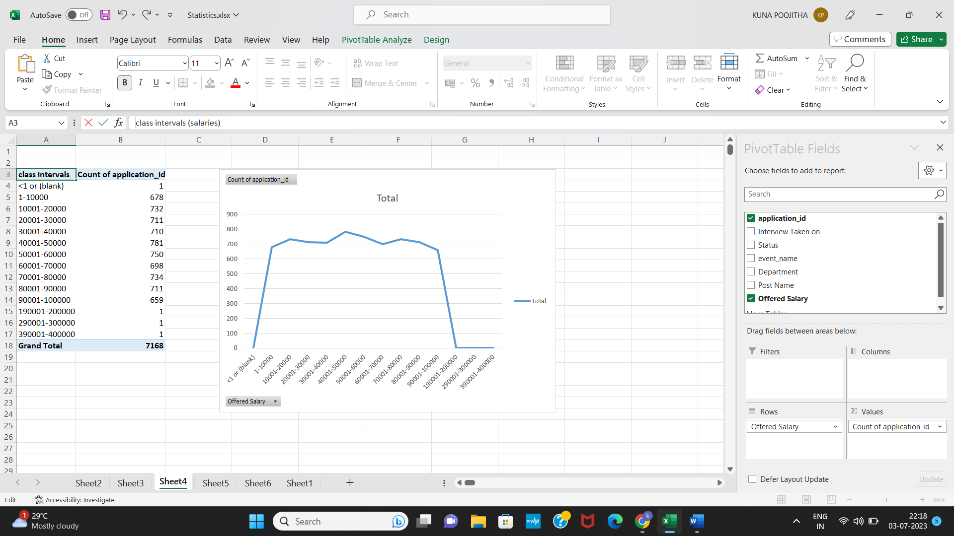

Class interval representation is shown above

(histogram option didn’t worked)

1. **Charts and Plots:**This is one of the most important parts of analysis to visualize the data.  
   **Your task:**Draw Pie Chart / Bar Graph (or any other graph) to show proportion of people working different department?

Ans: In pivot table we select different department and then count by application id. Then we select pivot chart then select pie graph to get the desired below output.

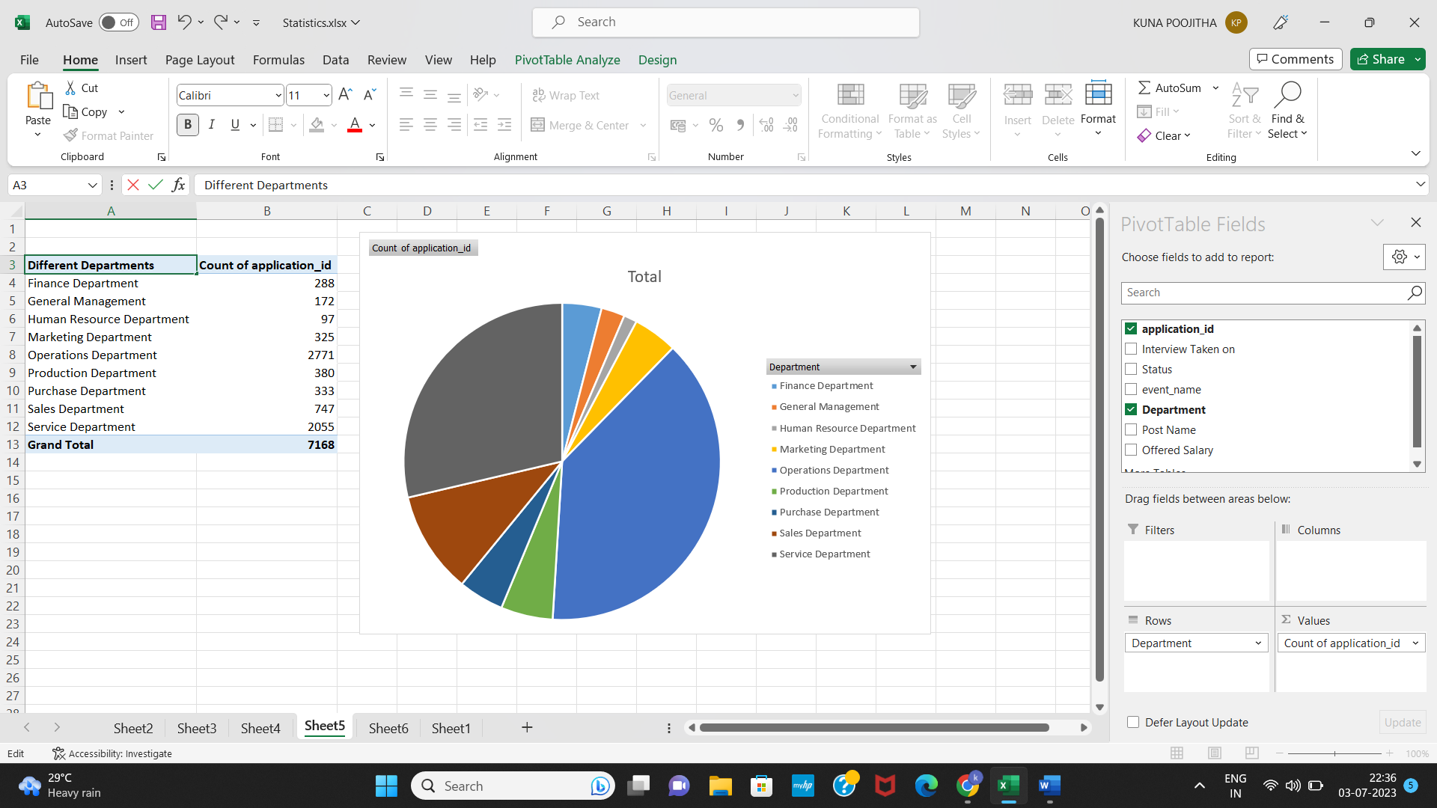

Major portion is operation department.

1. **Charts:**Use different charts and graphs to perform the task representing the data.  
   **Your task:**Represent different post tiers using chart/graph?

Ans: For every post tier listed we find the total number of applicants they belong to each tier.

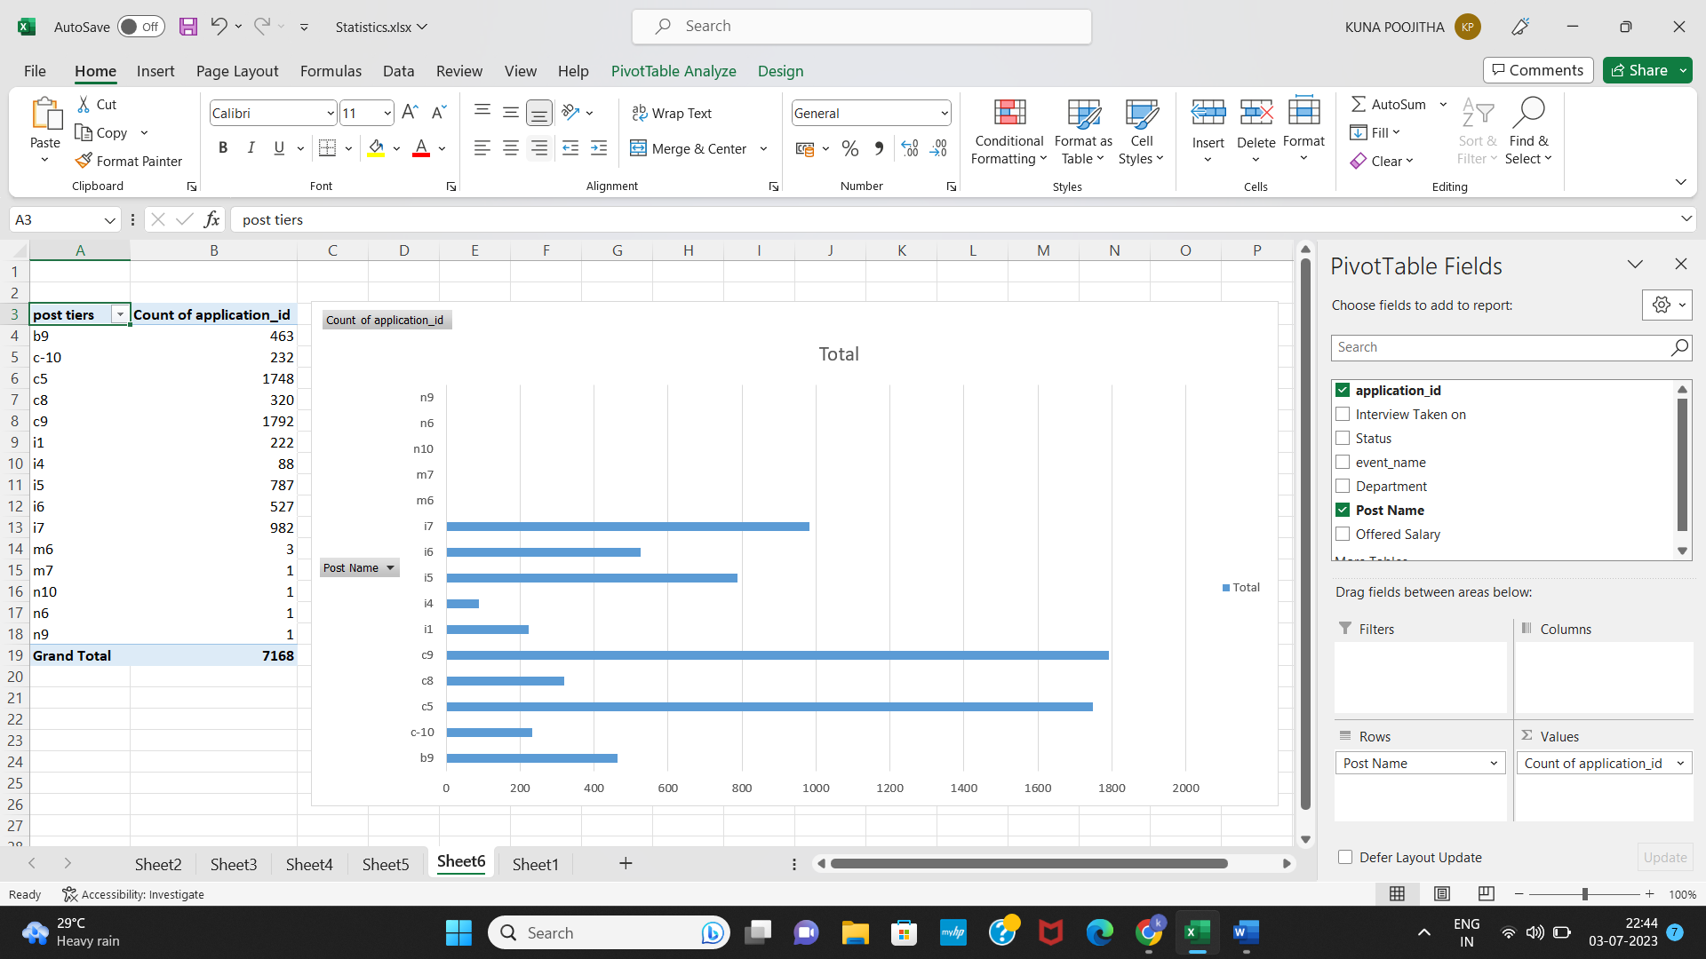Then we apply by pivot chart to visually analyse the data and selecting column bar chart.

**Here, highest number in post tiers is c9.**

**Result:**

With the help of the project learned how to use pivot tables and how to create pivot charts in very better manner. Here, we find the best answers for all the questions given above and will definitely benefit the company.

Thank you trainity 😊