MongoDB

**NODE SERVER SETUP**

CREATE SECURITY GROUP

We now need to create security group for Node servers:

|  |  |
| --- | --- |
| Security Group Name | Use |
| **smartwinnr_node_prd_sec_grp_ euwest1** |  |
|  | All MongoDB instances |
| **Inbound Ports** | HTTP: 80 (node_elb_security_group_euwest1)  Custom TCP: 1443 (node_elb_security_group_euwest1) |
| **Outbound Ports** | All open |

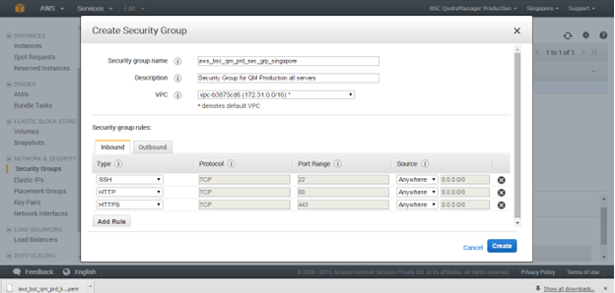

Create  a tag for this security group. All resources for the SmartWinnr Production will be having the name tag = smartwinnr_node_prd_sec_grp

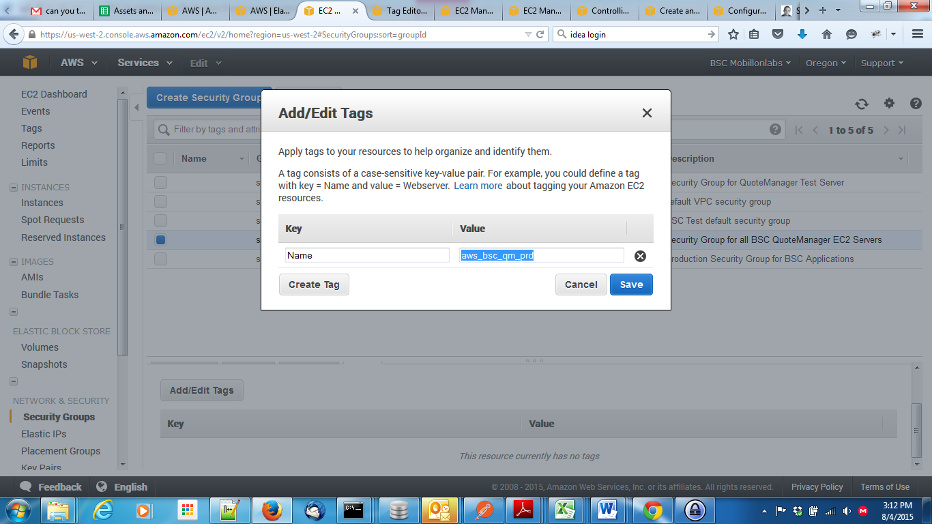

CREATE NODE EC2 INSTANCE

We will create 1 EC2 instance. Later on we will see how to create more instances from this one using autoscaling etc.

EC2 IAM ROLE

Since we want to spin other EC2 versions from this using autoscaling etc., we need to use an IAM role while creating the EC2 instance. Go to IAM->Roles. Create a new role EC2NodeUser. (No need to create for new Datacenter like Mumbai, already created). Attach “Mobillions3BackupPolicy” to this role. Now during EC2 instance creation, select this role.

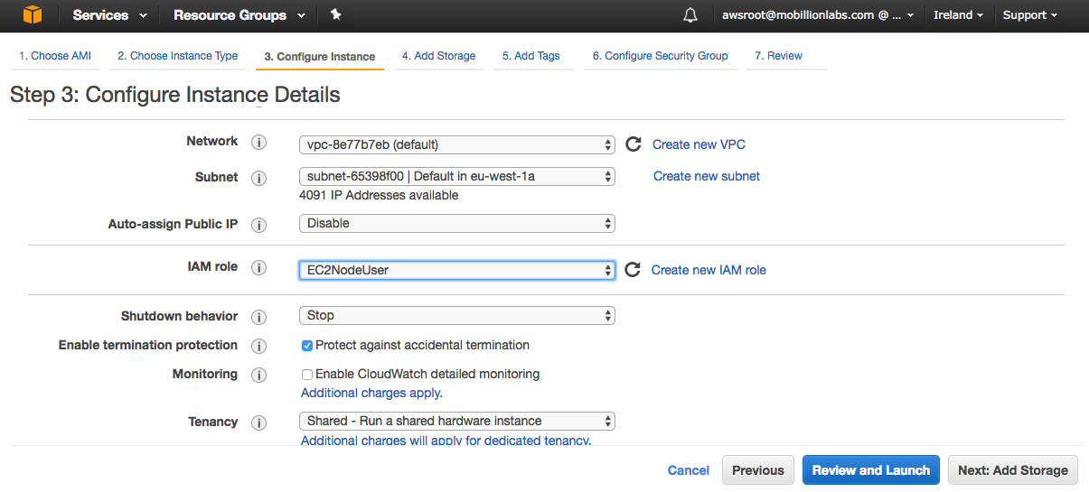

CREATE EC2 INSTANCE

Check out CREATE APPROPRIATE EC2 INSTANCE section from *Mobillion Amazon Deployment Guide*. We just provide the high-level information here:

1. Search and select CentOS7 from the Community AMI in Step 1 of launch instance.
2. Instance Details

|  |  |
| --- | --- |
| Instance Type (Step 2) | General Purpose, t3.medium (old m3.medium), 1 vCPUS, 3.75GB Memory, 1X4 SSD Storage, |
| Configure Instance Details (Step 3) | **No. of instances**: 1  **Purchasing option:** Leave Default value  **Network: Default value**  **Subnet: ap-south-east-1a (This will be set to ap-south-east-1b for the other instance. See architecture diagram)**  **Auto-assign Public IP: Default**  **IAM role:** EC2NodeUser  **Shutdown behavior: stop**  **Enable termination protection: Yes** |
| Storage (Step 4) | **Root: Volume**  Type: Root  Device: Default  Snapshot: Default  Size: 15 GB  Volume Type: General Purpose (SSD)  IOPS: Default  Delete on Termination: False  Encrypted: False    **App Volume**  Type: EBS  Device: Default  Snapshot: None  Size: 5 GB (old 20 GB)  Volume Type: General Purpose (SSD)  IOPS: Default  Delete on Termination: False  Encrypted: Yes |
| Tag Instance(Step 5) | Name: node_apsouth1_swinnr_prd ec2_1 (old smartwinnr_prd_node_1)  Group: smartwinnr_prd  Owner: MobillionLabs  Stack: Node  Environment: Production |

**Name the volumes**

Need to put tag in all the storages after EC2 creation. Go to the Volumes and give the following names:

|  |  |
| --- | --- |
| Root Volume | smartwinnr_` |
| App Volume | smartwinnr_prd_node_app_volume_1 |

Note: Tags with this names will automatically get created.

BASIC INSTANCE CONFIGURATION

NAME THE SERVER

Follow instructions from Mobillion Amazon Deployment Guide – Name the Server section.

UPDATE THE OS

Follow instructions from Mobillion Amazon Deployment Guide – Update the OS section

FORMAT NEWLY ATTACHED VOLUMES

Follow instruction from [Mongodb Format Newly Attached](bookmark://_Mongodb_Format_Newly) in this document

The volume where all node app folders will reside is /apps . Use that during formatting and mounting of volume.

Very important – the fstab for the app block should be like:

UUID=9ba9f73a-8c2d-4b39-b779-a5d5a90b2885 /apps xfs defaults,auto,noatime,exec 0 0

//Check Mail Not Going section in this document for explaination

INSTALL AWS CLI

Follow instructions from the Initial Setup section

INSTALL FFMPEG

Refer to <https://sysadminxpert.com/install-ffmpeg-on-centos-7/#Step_4_Verify_the_FFmpeg_version>

cd /opt

sudo wget https://johnvansickle.com/ffmpeg/builds/ffmpeg-git-amd64-static.tar.xz

Verify FFmpeg tar file using md5sum

sudo wget https://johnvansickle.com/ffmpeg/builds/ffmpeg-git-amd64-static.tar.xz.md5

md5sum -c ffmpeg-git-amd64-static.tar.xz.md5

//Untar

sudo tar xvf ffmpeg*.xz

cd ffmpeg-*-static

//Simlink

sudo ln -s "${PWD}/ffmpeg" /usr/local/bin/

sudo ln -s "${PWD}/ffprobe" /usr/local/bin/

//Check ffmpeg

ffmpeg