**PERFORMANCE TEST LIVE MONITORING**

**Summary/Overall Health of the Project:**

The Designed Application will continuously monitor the Performance Test live at any point of time and has the feature to analyze the results of the test at particular intervals of time and perform alert action to all the required members.

#### Facts on the Project Progress:

#### Core idea to create the application is to increase the performance test activities for the test to make it work as per our requirement

#### Target vs. Actual Accomplishments:

Application targets to decrease the time for identification of issue or breach of any important transaction and alerts immediately to the team. So that the team can respond earlier instead of completion of the whole performance test is completed, which we are performing manually now for specific brands

#### Analysis:

Once the Designed Application is triggered, it continuously checks with the spot instances whether any test is started in the machines. If the application finds the Live Running Test, it immediately starts it task of analyzing the reports of the test for every 30 minutes of time and send the reports of important observations, Breaches and Errors. Below is the example of the report generated for a sample test.

**Key Observations Sample Report**:

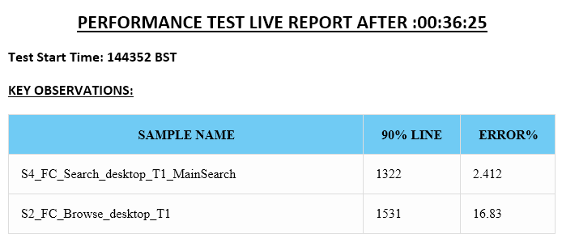

**Errors Observed Sample Report:**

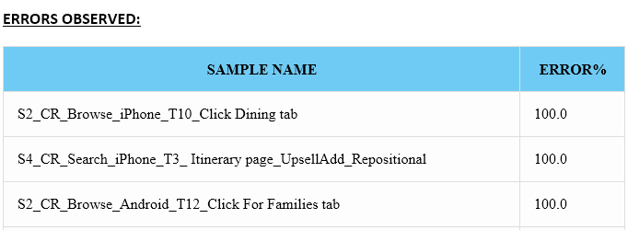

**Breaches Observed Sample Report:**

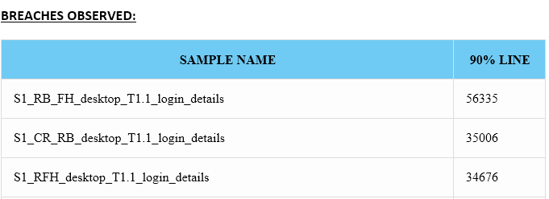

**Complete Mail Sample Report :**

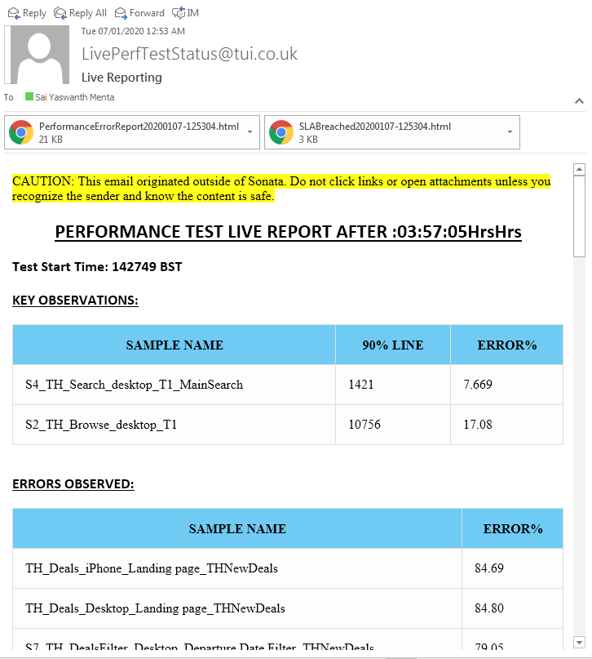

#### Working:

Designed Application is setup in 193 machine and Added to the Task Scheduler of the machine. Which will daily trigger the Job in the morning immediately after the Ec2 Machines are Started. Once the Application is triggered it looks like the below command prompt and starts the continuous process of observing the machines for any Live test Activity

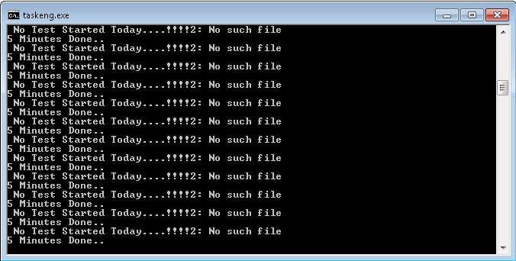

If the Application identifies any Live Activity it immediately notifies the user with a mail saying a Test is Triggered at and Start time of the Test as well. Below is the sample Test Start Alert

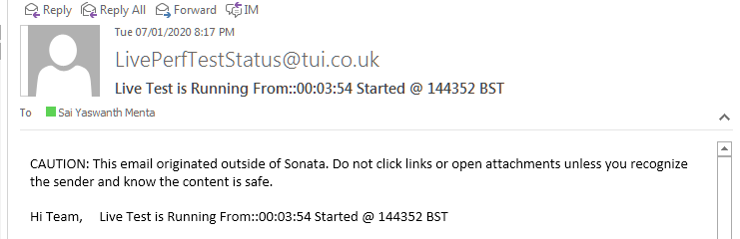

Live Test Start Mail Alert

Once the running application finds the Live test Activity from next 30 minutes It will pull the results from the Ec2-instances to the Local machine and Creates the report and it will send the report to the team members for verification.

**Advantages:**

* Application will send a mail Notification to Team whenever a Test is started and Test is completed.
* Monitor the Test for Every 30 Minutes Once the Test is Started and Identify Errors or Breaches
* Pulling of Results files from Various Ec2 Machines is Automated
* A HTML view is given to all the Key Observations, Errors and Breaches for Every 30 Minutes of the Test
* No Need to wait until test is completed to Identify Issues
* Quick Fixes can be given to Breaches or Error can be Possible

#### Schedule:

The designed application is scheduled in such a way that we can monitor the test at any point of time in day. Used Task Scheduler in the machine to start and stop the application.

#### Risks and Issues:

* Based on the Convince we frequently change the paths of the brands for the tests we run, which will influence the test results and may drive you to risk. To avoid the risk we have to provide the new paths in the **Filenames_Standalone.csv** file in the Application setup Folder.
* In the main script path we should not include any special characters (&, #, $, etc.) which may not be found in the background running application.

If there are any issues in the working of the Application, please refer the issue to

**Saiyaswanth.m@sonata-software.com**