## LAB EVALUATION-2

Yaswanth Ram Ponnada

CB.EN.U4CSE18243

1) T flip flop

Design:

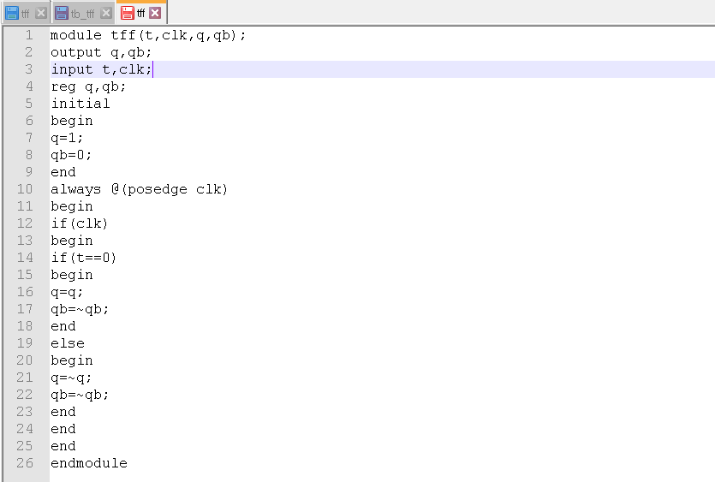

Test bench:

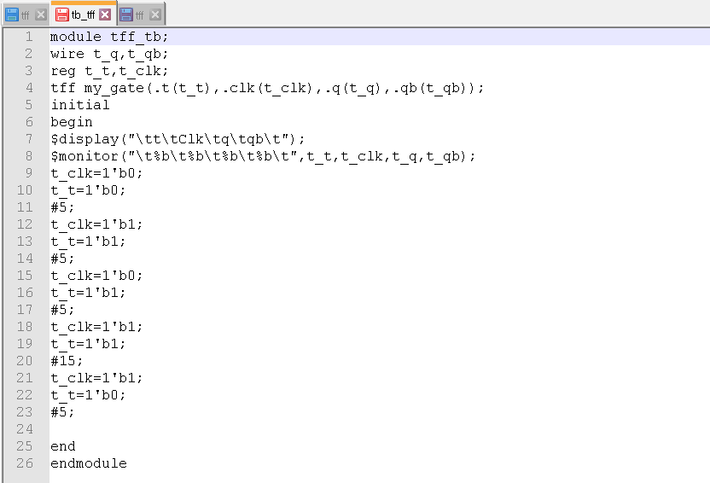

Output:

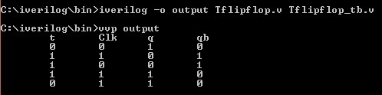

2) JK flip flop

Design:

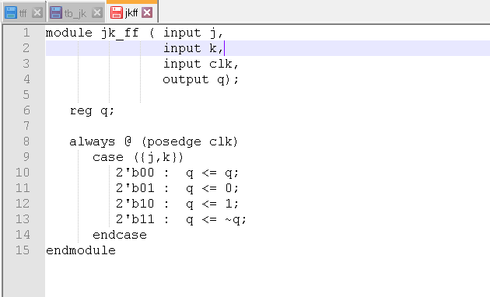

Test bench:

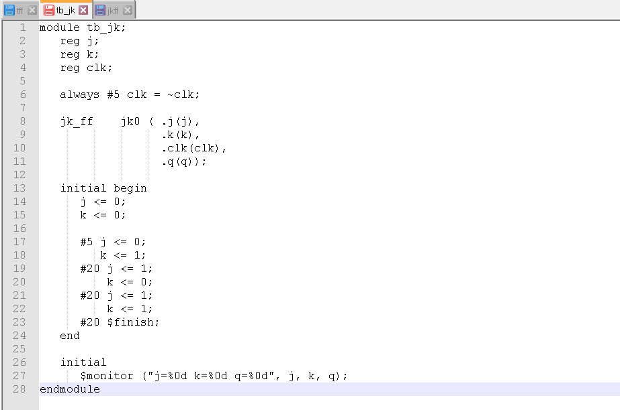

Output:

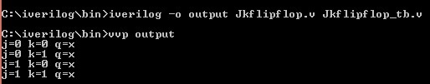

3) 3-bit ALU with addition, subtraction, AND & OR

Design:

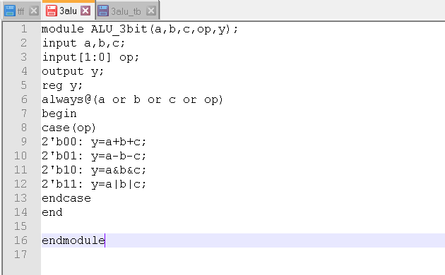

Testbench:

module ALU_3bit_tb;

reg t_a,t_b,t_c;

reg [1:0] t_op;

wire t_y;

ALU_3bit my_alu(.op(t_op),.a(t_a),.b(t_b),.c(t_c),.y(t_y));

initial

begin

$monitor(" a:%b b:%b c:%b | y:%b",t_a,t_b,t_c,t_y);

$display("Add");

t_a=0;

t_b=0;

t_c=0;

t_op=2'b00;

#20

t_a=0;

t_b=0;

t_c=1;

t_op=2'b00;

#20

t_a=0;

t_b=1;

t_c=0;

t_op=2'b00;

#20

t_a=0;

t_b=1;

t_c=1;

t_op=2'b00;

#20

t_a=1;

t_b=0;

t_c=0;

t_op=2'b00;

#20

t_a=1;

t_b=0;

t_c=1;

t_op=2'b00;

#20

t_a=1;

t_b=1;

t_c=0;

t_op=2'b00;

#20

t_a=1;

t_b=1;

t_c=1;

t_op=2'b00;

#20

$display("subtract");

#20

t_a=0;

t_b=0;

t_c=0;

t_op=2'b01;

#20

t_a=0;

t_b=0;

t_c=1;

t_op=2'b01;

#20

t_a=0;

t_b=1;

t_c=0;

t_op=2'b01;

#20

t_a=0;

t_b=1;

t_c=1;

t_op=2'b01;

#20

t_a=1;

t_b=0;

t_c=0;

t_op=2'b01;

#20

t_a=1;

t_b=0;

t_c=1;

t_op=2'b01;

#20

t_a=1;

t_b=1;

t_c=0;

t_op=2'b01;

#20

t_a=1;

t_b=1;

t_c=1;

t_op=2'b01;

#20

$display("AND");

#20

t_a=0;

t_b=0;

t_c=0;

t_op=2'b10;

#20

t_a=0;

t_b=0;

t_c=1;

t_op=2'b10;

#20

t_a=0;

t_b=1;

t_c=0;

t_op=2'b10;

#20

t_a=0;

t_b=1;

t_c=1;

t_op=2'b10;

#20

t_a=1;

t_b=0;

t_c=0;

t_op=2'b10;

#20

t_a=1;

t_b=0;

t_c=1;

t_op=2'b10;

#20

t_a=1;

t_b=1;

t_c=0;

t_op=2'b10;

#20

t_a=1;

t_b=1;

t_c=1;

t_op=2'b10;

#20

$display("OR");

#20

t_a=0;

t_b=0;

t_c=0;

t_op=2'b11;

#20

t_a=0;

t_b=0;

t_c=1;

t_op=2'b11;

#20

t_a=0;

t_b=1;

t_c=0;

t_op=2'b11;

#20

t_a=0;

t_b=1;

t_c=1;

t_op=2'b11;

#20

t_a=1;

t_b=0;

t_c=0;

t_op=2'b11;

#20

t_a=1;

t_b=0;

t_c=1;

t_op=2'b11;

#20

t_a=1;

t_b=1;

t_c=0;

t_op=2'b11;

#20

t_a=1;

t_b=1;

t_c=1;

t_op=2'b11;

end

endmodule

Output:

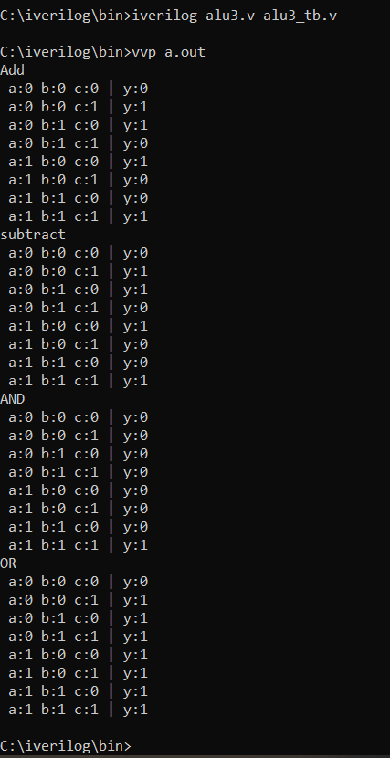

4) 1*4 demux:

Design:

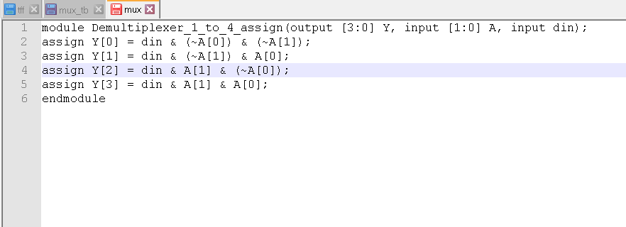

Testbench:

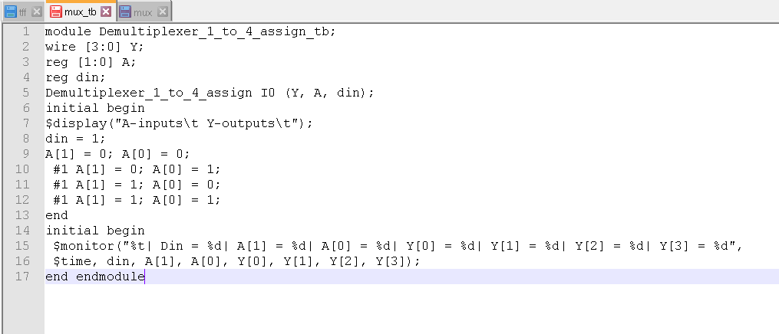

Output:

