**Evaluation Lab**

Yaswanth Ram Ponnada

CB.EN.U4CSE18243

1. select max(sal)-min(sal) from SCOTT."EMP";

SELECT * from q1;

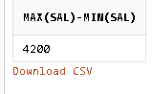

2. CREATE VIEW q2 AS SELECT ENAME,SAL FROM SCOTT."EMP" WHERE ENAME LIKE 'M%' AND SAL>(SELECT MIN(SAL) FROM SCOTT."EMP");

SELECT * from q2;

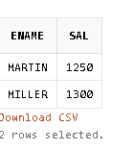

3. CREATE VIEW q3 AS SELECT SUM(SAL) AS AMT_SPENT_SAL FROM SCOTT."EMP";

select * from q3;

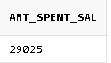

4. create view deptnotty as select ename from scott.emp where deptno = 20;

select * from deptnotty;



5. create view q5 as select ename from scott.emp where comm is null;

select * from q5;



6. create view q6 as select count(distinct deptno) as no_of_dept from scott.emp;

select * from q6;

