# Yaswanth Ram Ponnada

# Roll no:CB.EN.U4CSE18243

# Storage on cloud

1. Create a web page that that reads a sensor-id value from the user.
2. An s3 bucket has the details of sensor id with its specifications encoded in a text file.
3. S3 bucket has photos of sensors stored with sensorid as their file name.
4. Display sensor specifications and image details as response for the user.

Implement the above using AWS and GCP using storage features.

Creating a bucket & uploading images in Gcp:

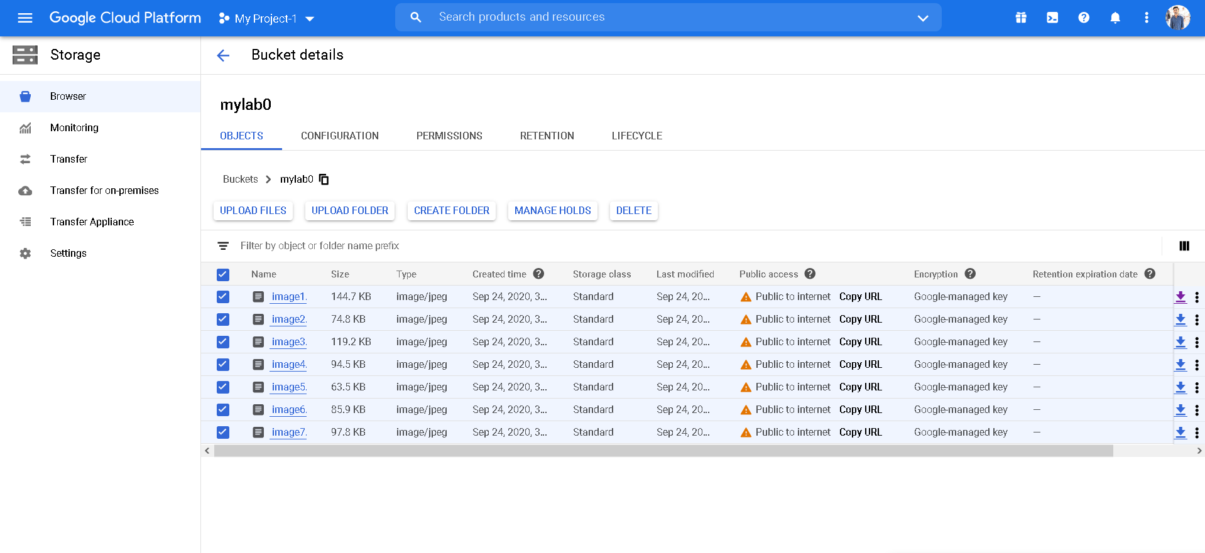

Object details in Gcp:

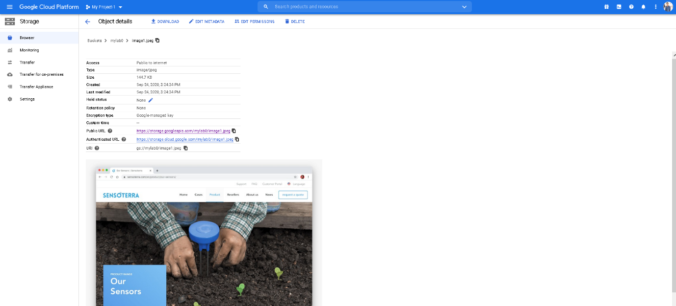

The public URL in Gcp will be redirected to the image:

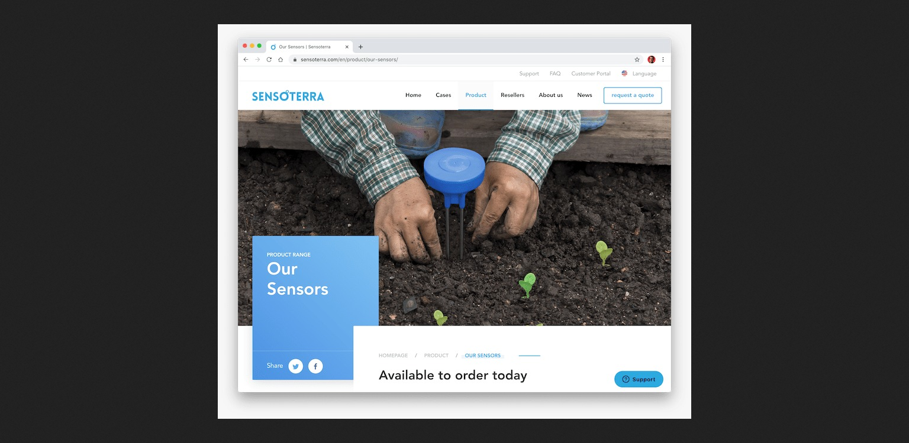

Creating a bucket & uploading images in aws:

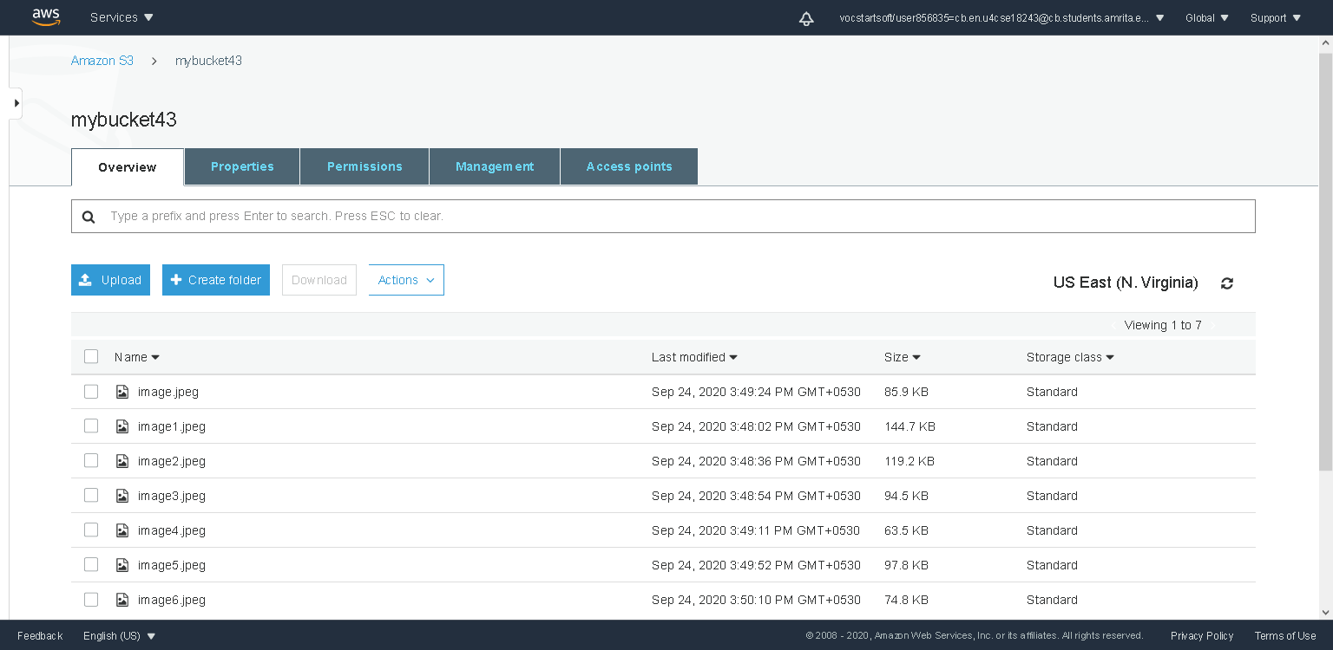

Object overview:

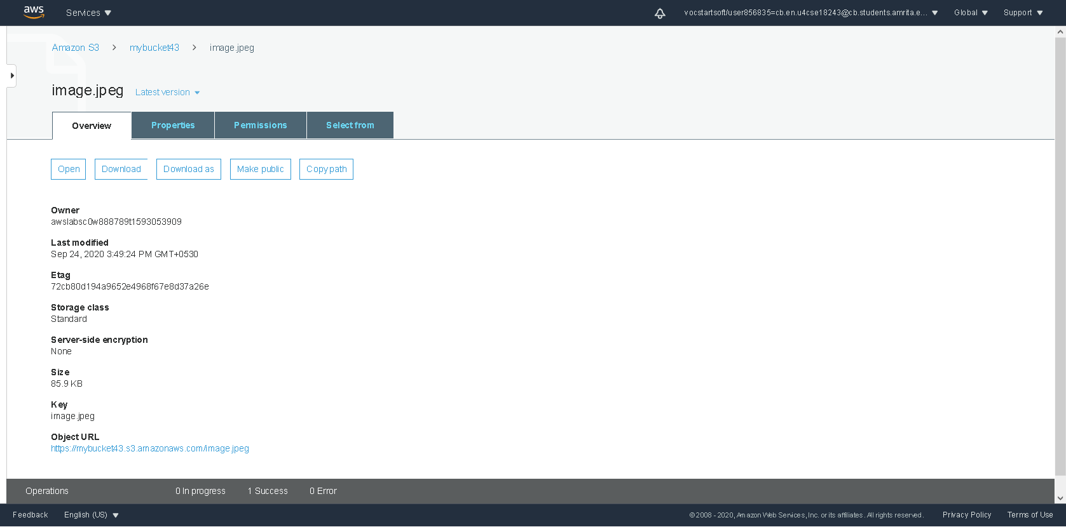

The public URL in aws will be redirected to the image :

