|  |  |  |
| --- | --- | --- |
| **Amrita Vishwa Vidyapeetham**  **Amrita School of Engineering, Coimbatore**  **Department of Computer Science and Engineering**  **2020 – 2021 Odd Semester**  **B.Tech/III Year CSE/V Semester L T P C**  **15CSE302/Database Management Systems 2 0 2 3**    **Evaluation Lab 1 (CO2) [BTL3] Date:4 Sept 2020**  **Rollno: CB.EN.U4CSE18243**  **Name: Yaswanthram Ponnada** | | |
|  | **LAB EVALUATION #1-** |  |

**SET 2 (Even roll numbers)**

* 1. Descriptions of 2 tables are given below. Identify the Primary key and **foreign key constraints** for each table and create the tables accordingly. (5 marks)
  2. Insert the records (2 marks)

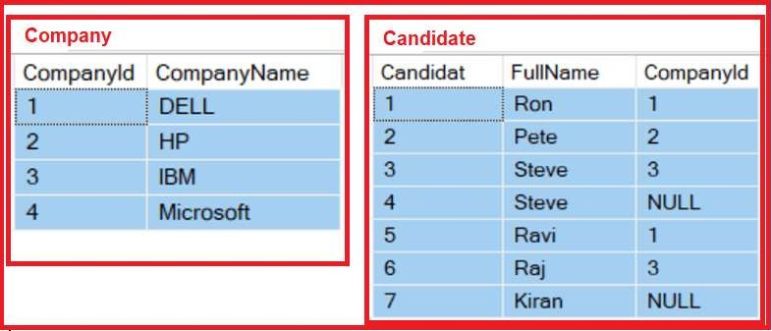

## 3 Write the SQL queries for the following using JOIN(3 marks)

1. Retrieve the list of names of candidates who applied for DELL

1. Retrieve the number of companies applied by each candidate

1. List all the name of candidates who applied for IBM

**Company Table:**

CREATE TABLE Company(

CompanyId NUMBER(3) NOT NULL,

CompanyName VARCHAR2(25),

PRIMARY KEY (CompanyId)

);

INSERT INTO Company VALUES('1','DELL');

INSERT INTO Company VALUES('2','HP');

INSERT INTO Company VALUES('3', 'IBM');

INSERT INTO Company VALUES('4','Microsoft');

SELECT * FROM Company;

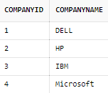

**Candidate Table:**

CREATE TABLE Candidate(

CandidateId NUMBER(8) NOT NULL,

FullName VARCHAR2(10),

CompanyId NUMBER(3),

PRIMARY KEY (CandidateId),

FOREIGN KEY (CompanyId) REFERENCES Company(CompanyId)

);

INSERT INTO Candidate VALUES('1','Ron','1');

INSERT INTO Candidate VALUES('2','Pete','2');

INSERT INTO Candidate VALUES('3','Steve','3');

INSERT INTO Candidate VALUES('4','Steve',Null);

INSERT INTO Candidate VALUES('5','Ravi','1');

INSERT INTO Candidate VALUES('6','Raj','3');

INSERT INTO Candidate VALUES('7','Kiran',NULL);

SELECT * FROM Candidate;

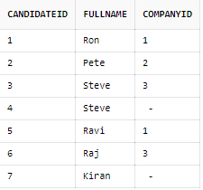

Queries:

**1)** **select Fullname from candidate INNER JOIN company on candidate.companyid=company.companyid AND compname like 'DELL';**

**2) select fullname, count(distinct compid) no_of_companies from candidate group by fullname;**

**3) select Fullname from candidate INNER JOIN company on candidate.companyid=company.companyid AND compname like 'IBM';**