Yaswanth Ram Ponnada

CB.EN.U4CSE18243

Q:

create table salesman(salesman_id int primary key, name varchar(20),

city varchar(20), commission number(5,2))

insert into salesman values(5001, 'Ram', 'New York', 0.15);

insert into salesman values(5002, 'Raj', 'Paris', 0.15);

insert into salesman values(5003, 'Manish', 'London', 0.15);

insert into salesman values(5004, 'Gurpreet', '', 0.15);

insert into salesman values(5005, 'Ritika', 'Rome', 0.15);

insert into salesman values(5006, 'Samir', 'Paris', 0.15);

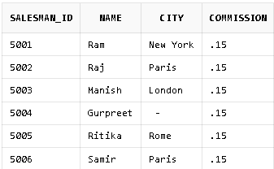

1) CREATE VIEW newyorkstaff

AS SELECT *

FROM salesman

WHERE city = 'New York';

select * from newyorkstaff;

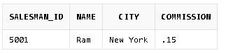

2) CREATE VIEW salesown

AS SELECT salesman_id, name, city

FROM salesman;

SELECT *FROM salesown;

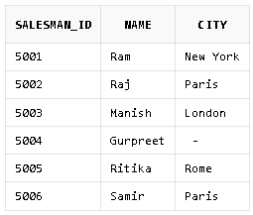

3) CREATE VIEW newyorkstaff

AS SELECT *

FROM salesman

WHERE city = 'New York';

SELECT *

FROM newyorkstaff

WHERE commission > .13;



4) UPDATE salesown

SET city = 'London'

WHERE salesman_id = 5003;

SELECT *

FROM salesown;

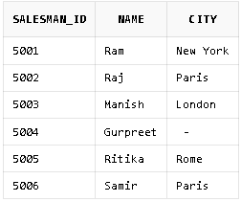

5) DELETE FROM salesown

WHERE salesman_id=5003;

SELECT *

FROM salesown;

