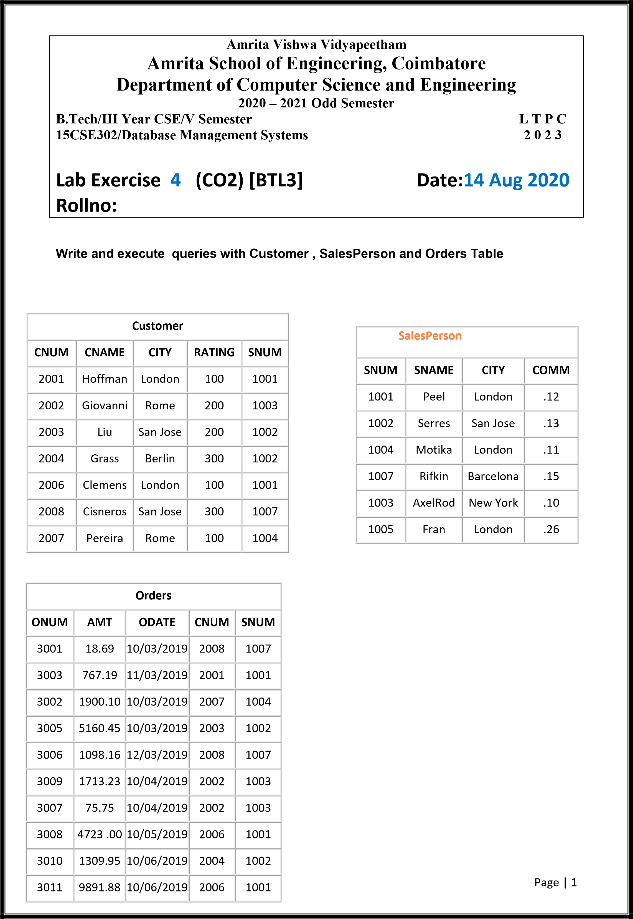

Name: Yaswanth ram Ponnada

Roll no:CB.EN.U4CSE18243

Queries (25 marks)

1. Find the largest orders for Serres and Rifkin.

select SalesPerson.SNAME,max(AMT) from Orders INNER JOIN SalesPerson on SalesPerson.SNUM=Orders.SNUM group by SalesPerson.SNAME having SalesPerson.SNAME='Serres' or SalesPerson.SNAME='Rifkin';

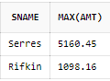

1. Select all orders that are greater than the average for October 4.

select \* from Orders where AMT > (select AVG(AMT) from Orders where ODATE='10/04/2019');

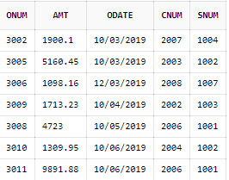

1. Write a select command using a correlated subquery that selects the names and numbers of all customers with ratings equal to the maximum for their city.

select CNAME,CNUM from Customer C1 where RATING = (select max(RATING) from Customer C2 where C1.city = C2.city);

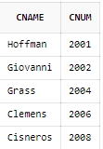

1. Find all orders with amounts smaller than any amount for a customer in San Jose.

select ONUM,AMT from Orders where AMT < any (select AMT from Orders,Customer where CITY='San Jose' and Orders.CNUM=Customer.CNUM);

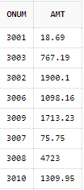

1. Find all orders with above average amounts for their customers.

select \* from Orders O1 where AMT > (select avg(AMT) from Orders O2 where O1.CNUM=O2.CNUM);

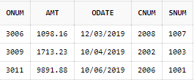

1. Write a query that calculates the amount of the salesperson’s commission on each order by a customer with a rating above 100.00.

select ONUM,AMT\*COMM,Orders.SNUM from Orders INNER JOIN Customer on Customer.CNUM=Orders.CNUM INNER JOIN SalesPerson on SalesPerson.SNUM=Orders.SNUM where Customer.RATING>100;

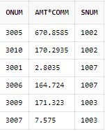

1. Count the customers with ratings above San Jose’s average.

select count(\*) from Customer C1 where rating > (select avg(rating) from Customer C2 where CITY='San Jose');

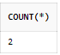

1. Write a query that produces all pairs of salespeople with themselves as well as duplicate rows with the order reversed.

select s1.SNAME,s1.SNUM,s2.SNAME,s2.SNUM from SalesPerson s1, SalesPerson s2 order by s1.SNAME DESC;

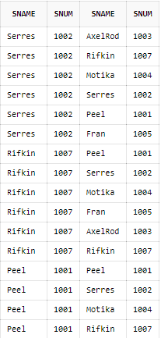 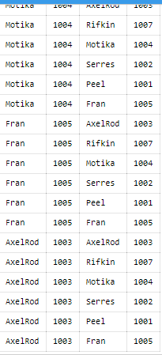

1. Find all salespeople with only one customer.

select SNUM from Customer group by SNUM having count(SNUM)=1;



1. Write a query that lists each order number followed by the name of the customer who made that order.

select Orders.ONUM,Customer.CNAME from Orders INNER JOIN Customer on Orders.CNUM = Customer.CNUM;

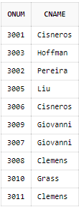

1. Write a query that selects all customers whose ratings are equal to or greater than ANY (in the SQL sense) of Serres’?

select \* from Customer where RATING >= any (select RATING from Customer where SNUM=1002);

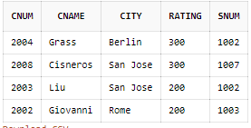

1. Write a query that produces all pairs of orders by a given customer. Name that customer and eliminate duplicates.

select a.CNAME,b.ONUM,c.ONUM from Orders b, Orders c, Customer a where b.CNUM=c.CNUM and b.ONUM>c.ONUM and a.CNUM=b.CNUM;

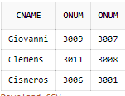

1. Find only those customers whose ratings are higher than every customer in Rome.

select \* from Customer where RATING > (select max(RATING) from Customer where CITY like 'Rome');

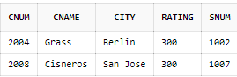

1. Write a query on the Customers table whose output will exclude all customers with a rating <= 100.00, unless they are located in Rome.

select \* from Customer where RATING<=100 and CITY like 'Rome';



1. Find all rows from the Customers table for which the salesperson number is 1001.

select \* from Customer where SNUM=1001;

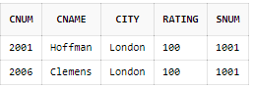

1. Find the total amount in Orders for each salesperson for whom this total is greater than the amount of the largest order in the table.

select sum(AMT),SNUM from Orders group by SNUM having sum(AMT) > (select max(AMT) from Orders);

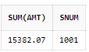

1. Write a query that selects all orders save those with zeroes or NULLs in the amount field.

select \* from Orders where AMT=0 OR AMT is NULL;

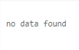

1. Produce all combinations of salespeople and customer names such that the former precedes the latter alphabetically, and the latter has a rating of less than 200.

select SalesPerson.SNAME,Customer.CNAME from SalesPerson,Customer where SalesPerson.SNAME<Customer.CNAME and Customer.RATING<200;

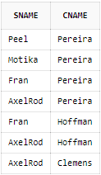

1. List all Salespeople’s names and the Commission they have earned.

select s.SNAME,count(s.SNAME)\*s.COMM from Customer c, SalesPerson s where c.SNUM=s.SNUM group by s.COMM,s.SNAME;

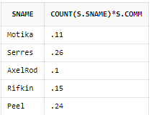

1. Find all salespeople for whom there are customers that follow them in alphabetical order.

select SNAME from SalesPerson where SNAME < any (select CNAME from Customer where SalesPerson.SNUM = Customer.SNUM);

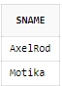

1. Write a query that produces the names and ratings of all customers of all who have above average orders.

select max(Customer.CNAME),max(Customer.RATING),Orders.CNUM from Orders,Customer where Customer.CNUM=Orders.CNUM group by Orders.CNUM having count(Orders.CNUM) > ( select avg(count(CNUM)) from Orders group by CNUM);

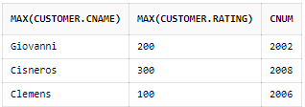

1. Find the SUM of all purchases from the Orders table whose amount is greater than 4000.

select sum(AMT) as SUMPURCHASES from Orders where AMT>4000.00 ;



1. Count the number of not NULL rating fields in the Customers table (including repeats).

select count(RATING) as NOTNULLRATINGS from Customer;

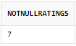

1. Write a query that gives the names of both the salesperson and the customer for each order after the order number.

select ONUM,CNAME,SNAME from Orders, Customer, SalesPerson where Orders.CNUM = Customer.CNUM and Orders.SNUM = SalesPerson.SNUM;

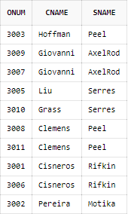

1. List the commissions of all salespeople servicing customers in London.

select SalesPerson.COMM from SalesPerson where SalesPerson.SNUM in (select SNUM from Customer where CITY='London' );



Page | 2