**Yaswanth ram Ponnada**

**CB.EN.U4CSE18243**

1) Write a query to display all the orders from the orders table issued by the salesman 'Paul Adam'.

**Query :**

SELECT *

FROM orders

WHERE salesman_id =

(SELECT salesman_id

FROM salesman

WHERE name='Paul Adam');

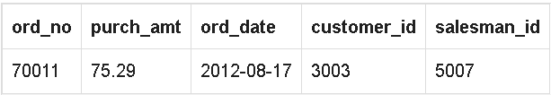

2) Write a query to display all the orders for the salesman who belongs to the city London

**Query:**

SELECT *

FROM orders

WHERE salesman_id =

(SELECT salesman_id

FROM salesman

WHERE city='London');

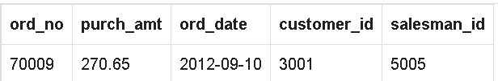

3) Write a query to find all the orders issued against the salesman who may works for customer whose id is 3007

**Query:**

SELECT *

FROM orders

WHERE salesman_id =

(SELECT DISTINCT salesman_id

FROM orders

WHERE customer_id =3007);

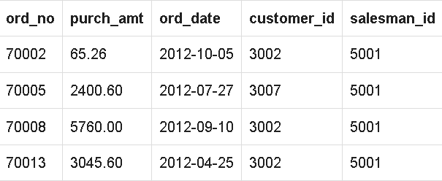

4) Write a query to display all the orders which values are greater than the average order value for 10th October 2012.

**Query:**

SELECT *

FROM orders

WHERE purch_amt >

(SELECT AVG(purch_amt)

FROM orders

WHERE ord_date ='10/10/2012');

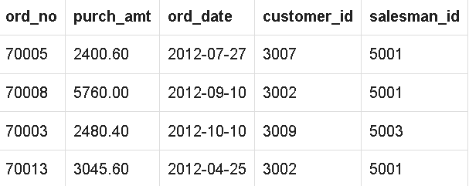

5) Write a query to find all orders attributed to a salesman in New york.

**Query:**

SELECT *

FROM orders

WHERE salesman_id IN

(SELECT salesman_id

FROM salesman

WHERE city ='New York');

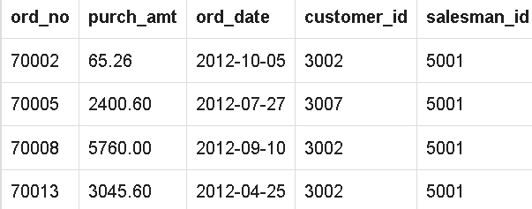

6) Write a query to display the commission of all the salesmen servicing customers in Paris.

**Query:**

SELECT commission

FROM salesman

WHERE salesman_id IN

(SELECT salesman_id

FROM customer

WHERE city = 'Paris');

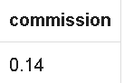

7) Write a query to display all the customers whose id is 2001 bellow the salesman ID of Mc Lyon.

**Query:**

SELECT *

FROM customer

WHERE customer_id =

(SELECT salesman_id -2001

FROM salesman

WHERE name = 'Mc Lyon');

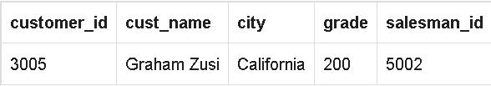

8) Write a query to count the customers with grades above New York's average.

**Query:**

SELECT grade, COUNT (*)

FROM customer

GROUP BY grade

HAVING grade >

(SELECT AVG(grade)

FROM customer

WHERE city = 'New York');

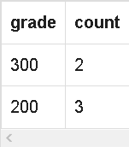

9) Write a query to extract the data from the orders table for those salesman who earned the maximum commission

**Query:**

SELECT ord_no, purch_amt, ord_date, salesman_id

FROM orders

WHERE salesman_id IN(

SELECT salesman_id

FROM salesman

WHERE commission = (

SELECT MAX(commission)

FROM salesman));

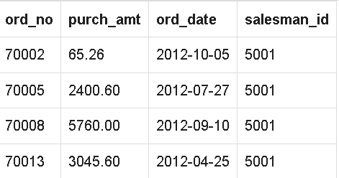

10) Write a query to display all the customers with orders issued on date 17th August, 2012.

**Query:**

SELECT b.*, a.cust_name

FROM orders b, customer a

WHERE a.customer_id=b.customer_id

AND b.ord_date='2012-08-17';

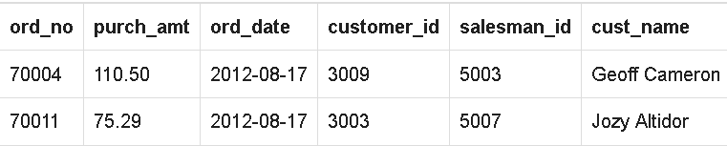

11) Write a query to find the name and numbers of all salesmen who had more than one customer.

**Query:**

SELECT salesman_id,name

FROM salesman a

WHERE 1 <

(SELECT COUNT(*)

FROM customer

WHERE salesman_id=a.salesman_id);

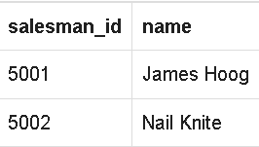

12) Write a query to find all orders with order amounts which are above-average amounts for their customers.

**Query:**

SELECT *

FROM orders a

WHERE purch_amt >

(SELECT AVG(purch_amt) FROM orders b

WHERE b.customer_id = a.customer_id);

