Page |

1

**Consider the EMP and DEPT tables:**

DEPT(DEPTNO, DNAME, LOC)

EMP(EMPNO, ENAME, JOB, MGR, HIRED, SAL, COMM, DEPTNO)

**DEPT table**

DEPTNO: department number. Unique ID of the department.

DNAME: department name. The name of the department

like ACCOUNTING.

LOC: location of the department.

of the employee.

**EMP table**

ENAME: employee name.

JOB: job of the employee, like CLERK

EMPNO: employee number. Unique ID

MGR: manager of the employee.

HIRED: hire date

SAL: salary

COMM: commission

DEPTNO: department

number. Unique ID of a departmen

t

**Create the tables**

**with**

**appropriate**

**keys and constraints**

**and execute the**

**queries on this table.**

**Populate the tables after going through the queries.**

**(8**

**marks)**

**Queries should not**

**ret**

**urn NULL value.**

**Amrita Vishwa Vidyapeetham**

**Amrita School of Engineering, Coimbatore**

**Department of Computer Science and Engineering**

**20**

**20**

**–**

**20**

**21**

**Odd Semester**

**B.Tech/III Year CSE/V Semester L T P C**

**15**

**CSE302/Database Management Systems**

**2**

**0 2**

**3**

**Lab**

**Exercise**

**6**

**(**

**CO2) [BTL**

**3]**

**Date:**

**2**

**8**

**Aug**

**20**

**20**

**Rollno:**

CB.EN.U4CSE18243

**CREATION OF TABLE :**

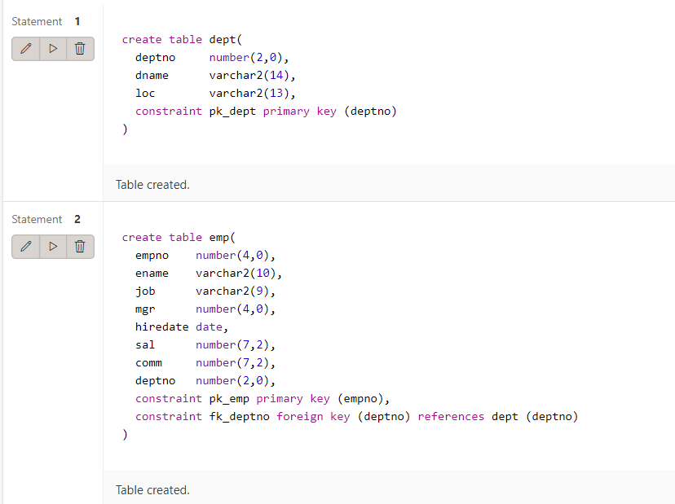

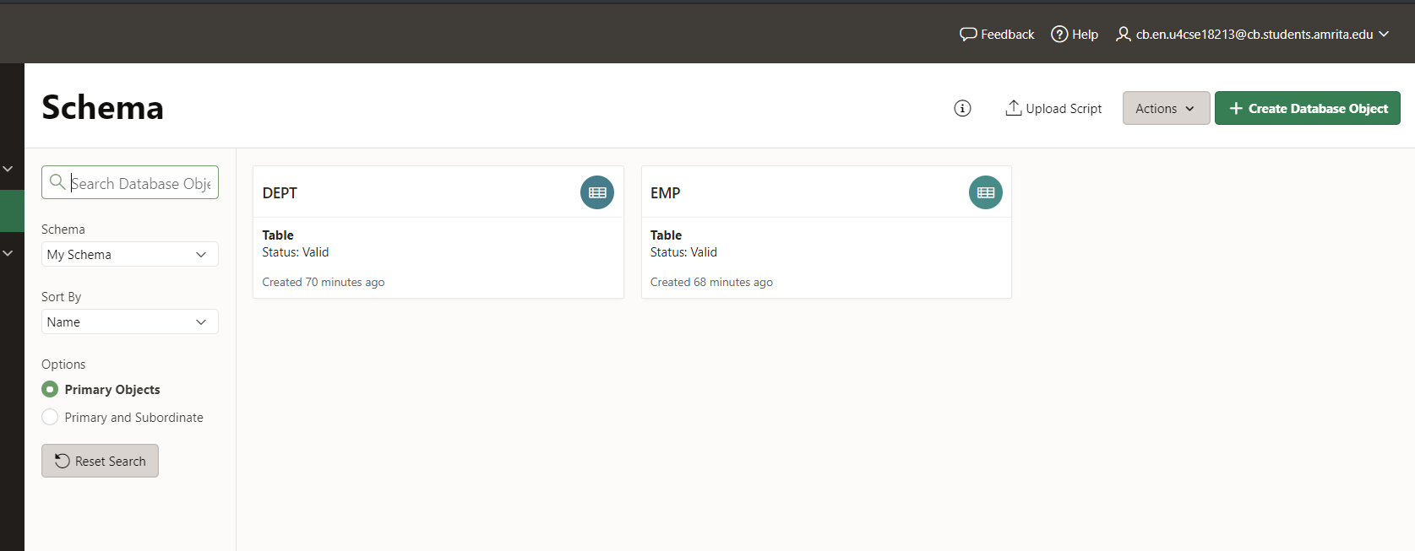

**INSERTION OF VALUES :**

**Dept Table :**

insert into dept values(10, 'ACCOUNTING', 'NEW YORK')

insert into dept values(20, 'RESEARCH', 'DALLAS')

insert into dept values(30, 'SALES', 'CHICAGO')

insert into dept values(40, 'OPERATIONS', 'BOSTON')

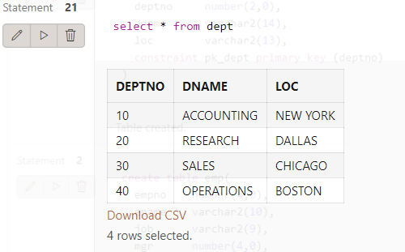

**Emp Table :**

insert into emp values (7839,'KING','PRESIDENT',NULL,'17-NOV-81',5000,0,10);

insert into emp values (7844,'TURNER','SALESMAN',7698,'08-SEP-81',1500,0,30);

insert into emp values (7876,'ADAMS','CLERK',7788,'23-MAY-87',1100,0,20);

insert into emp values (7900,'JAMES','CLERK',7698,'03-DEC-81',950,0,30);

insert into emp values (7902,'FORD','ANALYST',7566,'03-DEC-81',3000,0,20);

insert into emp values (7934,'MILLER','CLERK',7782,'23-JAN-82',1300,0,10);

insert into emp values (7369,'SMITH','CLERK',7902,'17-DEC-80',800,0,20);

insert into emp values (7499,'ALLEN','SALESMAN',7698,'20-FEB-81',1600,300,30);

insert into emp values (7521,'WARD','SALESMAN',7698,'22-FEB-81',1250,500,30);

insert into emp values (7566,'JONES','MANAGER',7839,'02-APR-81',2975,0,20);

insert into emp values (7654,'MARTIN','SALESMAN',7698,'28-SEP-81',1250,1400,30);

insert into emp values (7698,'BLAKE','MANAGER',7839,'01-MAY-81',2850,0,30);

insert into emp values (7782,'CLARK','MANAGER',7839,'09-JUN-81',2450,0,10);

insert into emp values (7788,'SCOTT','ANALYST',7566,'19-APR-87',3000,0,20);

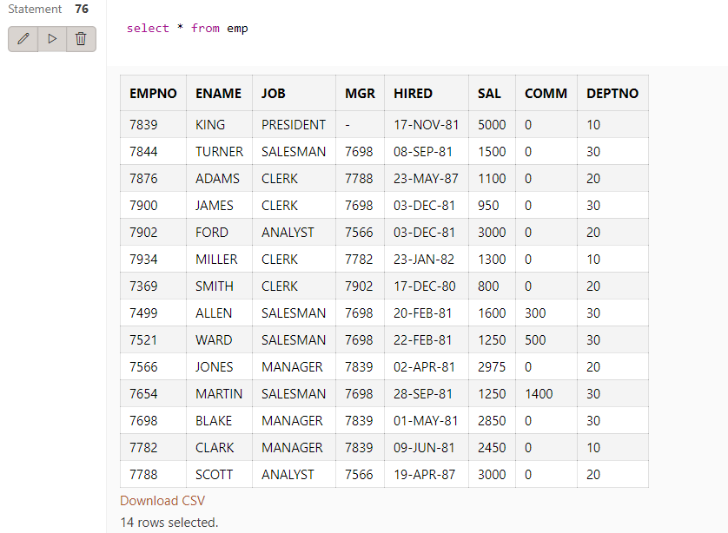

**Qn 1-17 17 marks.**

1. Determine the average salary of SALESMAN’s for every department (deptno) but only for those department where at least three SALESMAN work.

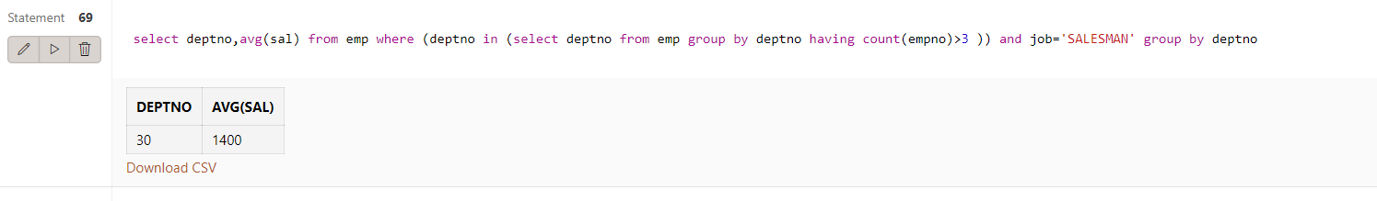

1. List the location of departments where the employee with highest salary works.

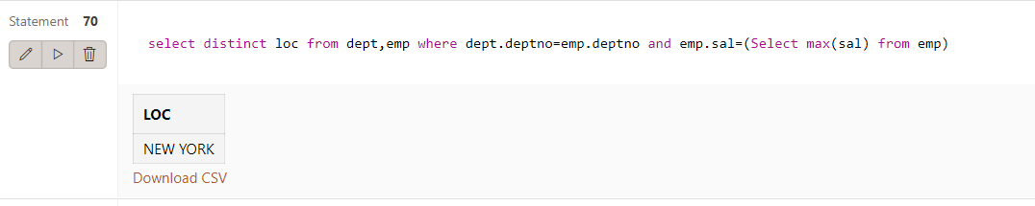

1. Find the employee who has the highest commission

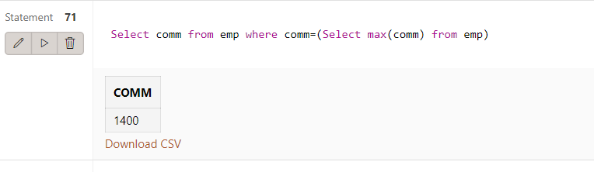

1. Find the departments where the average salary is at least the average salary of all employees

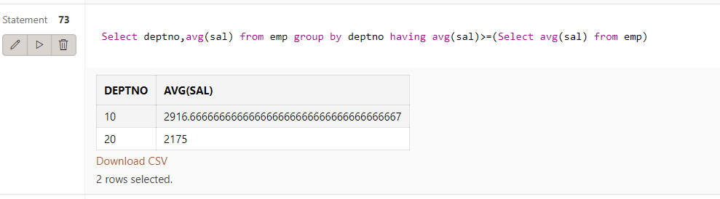

1. List the name, hire date, job of the employees of the department 20, sorted in descending by the names.

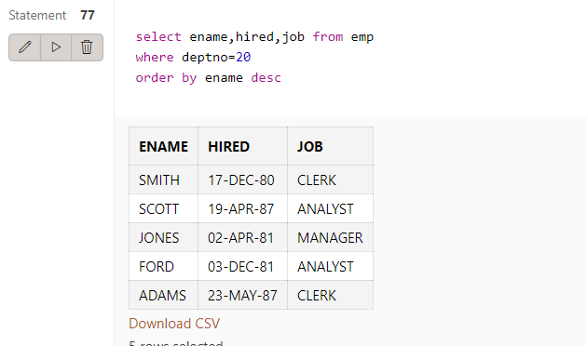

1. Make two lists, which contain all the information about the employees. The first should be sorted ascending, the second in descending by the salaries.

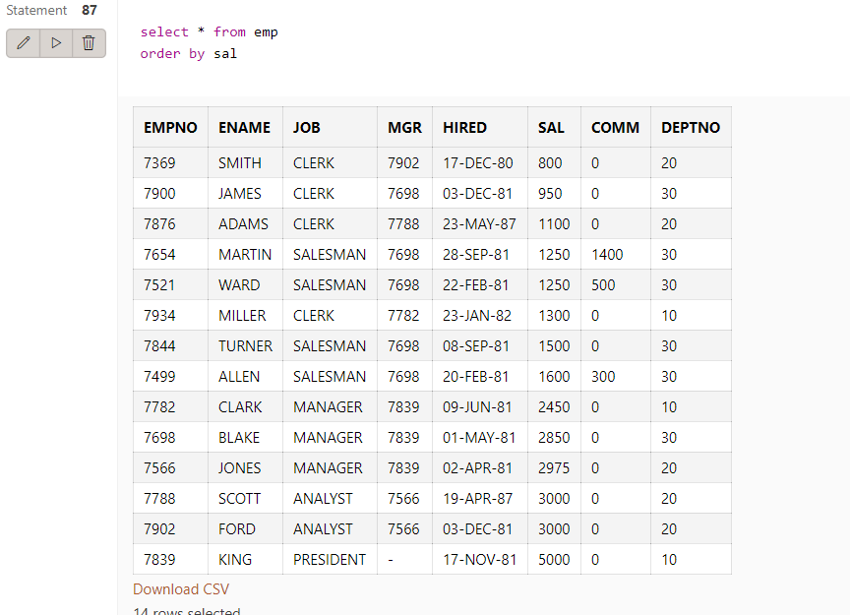

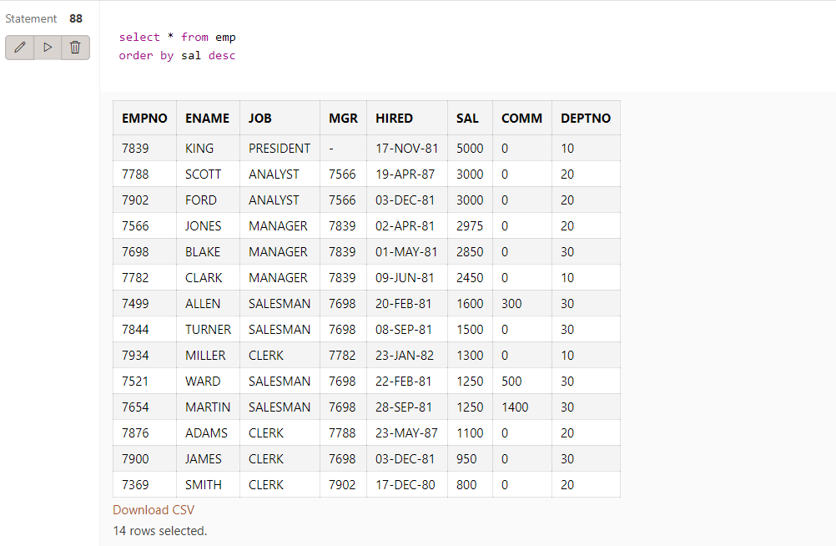

1. List the names, salaries, and income of the employees, sorted in descending by the income. The income is the sum of the salary and the commission.

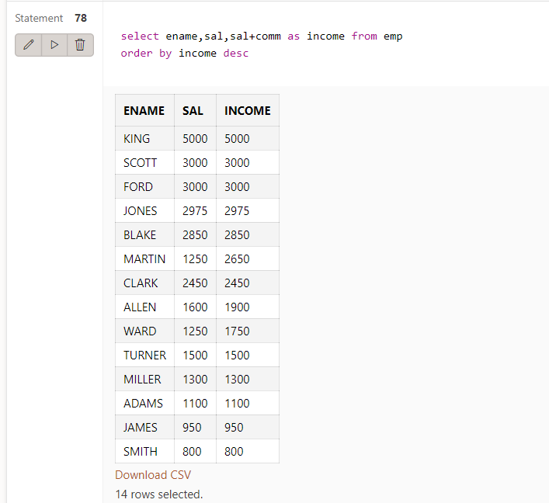

1. List the name, department number, income, and tax of the employees, sorted in descending by the tax. The tax is the 20% of the income.

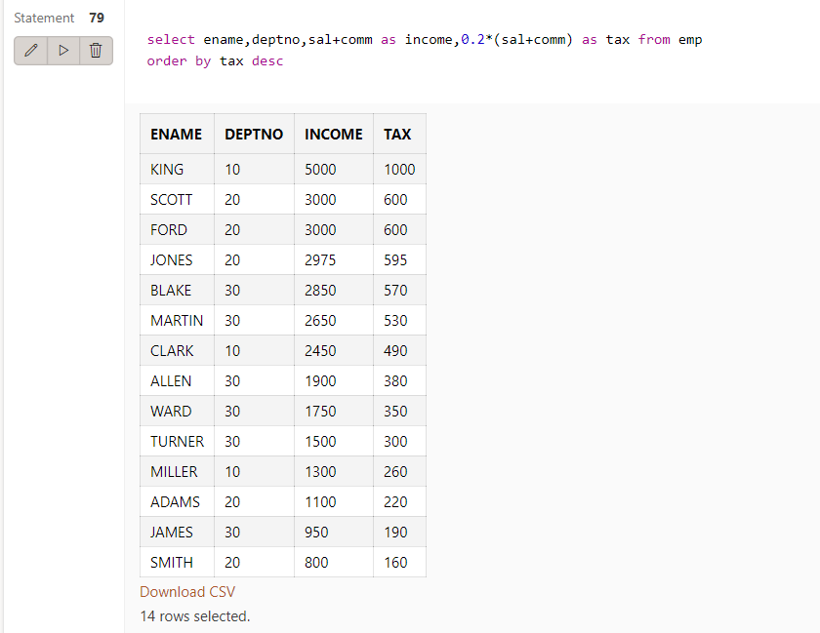

1. List the name, job, and salary of those employees, whose salary in not in the 1500-2850 interval. The headers of the list should be “Name”, “Job”, and “Salary”.

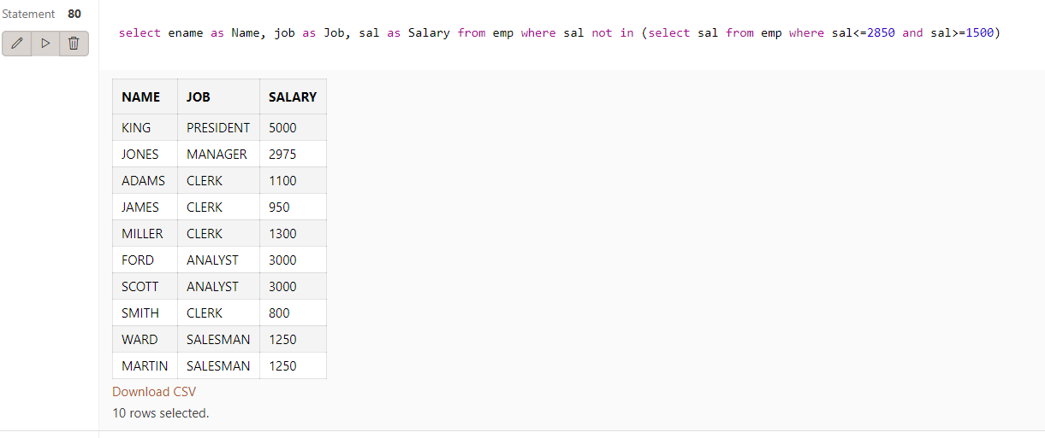

1. List the name, job, salary, commission, department number of those employees, whose salary is greater than 1000, and were hired between 1981.03.01. and 1981.09.30.

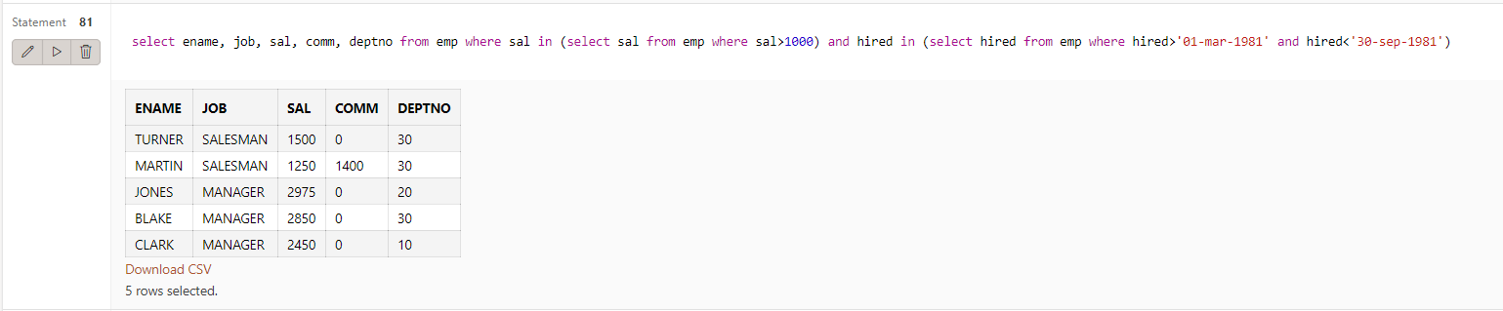

1. List the name, commission, manager number of those employees, who has a commission. Sort the list by the manager number first, then by the employee name.

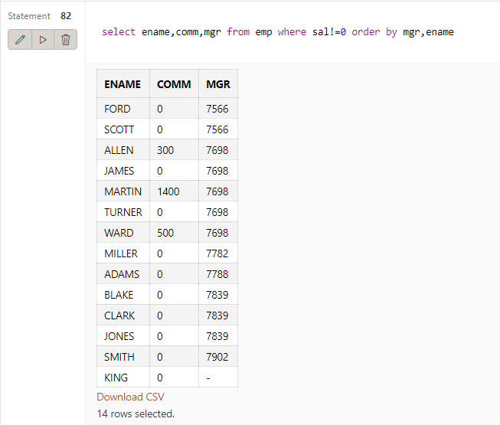

1. List the number, name, job, salary, and commission of those employees, whose commission is greater than the 50% of their salary.

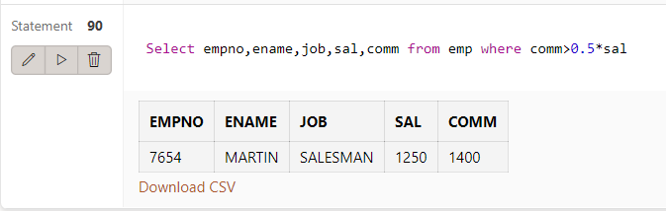

1. List the name, job, salary, and hire date of those employees, who was hired in 1981. Sort the list by the hire date.

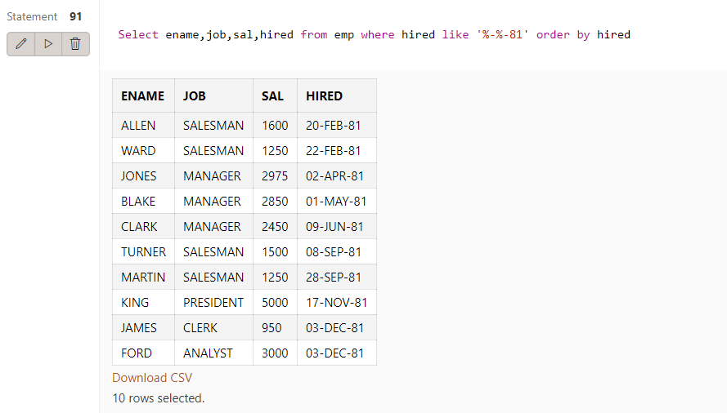

1. List the name, job, income of those employees, whose name contains two letter “L”s, or works for department 30, or his manager’s number is 7782.

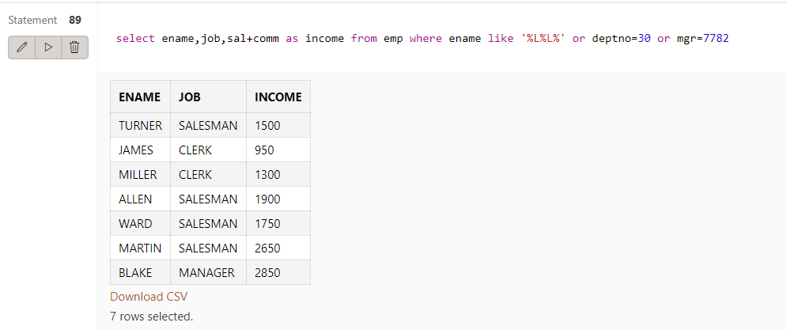

1. List the name, and yearly salary of the clerks, and the salesmen, sorted by department number.

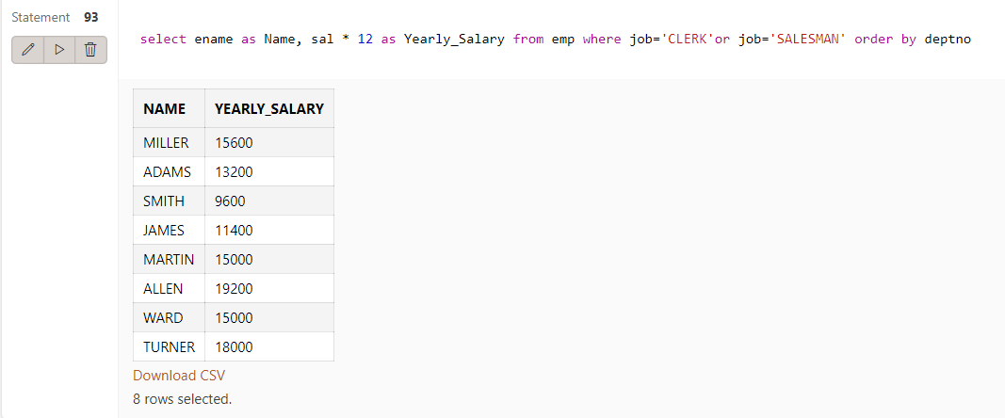

1. Which jobs are done by at least two different employees?

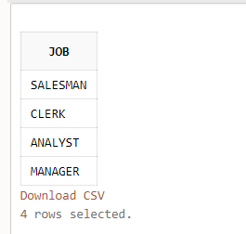

1. Determine the cities (LOC) where at least one CLERK works, whose salary less, than 2000

