**1. Create the following tables**

1. **Customer Master Table: cust**

|  |  |  |
| --- | --- | --- |
| **Attribute Name** | **Data Type** | **Constraints** |
| custid | varchar2(3) | Primary Key ,not null |
| Lname | Varchar2(15) |  |
| Fname | Varchar2(15) |  |
| area | Varchar2(2) |  |
| phoneno | Number(8) |  |

1. **Movies Master Table**: **movie**

|  |  |  |
| --- | --- | --- |
| **Attribute Name** | **Data Type** | **Constraints** |
| Mvno | Number(2) | Primary Key ,not null |
| title | Varchar2(25) |  |
| type | Varchar2(10) |  |
| star | Varchar2(25) |  |
| price | Number(8,2) |  |

1. **Invoice transaction Table : invo**

|  |  |  |
| --- | --- | --- |
| **Attribute Name** | **Data Type** | **Constraints** |
| Invno | Varchar2(3) | Primary Key ,not null |
| mvno | Number(2) | Foreign key movie(mvno) |
| custid | Varchar2(3) | Foreign key cust(custid) |
| star | Varchar2(25) |  |
| price | Number(8,2) |  |

1. **Insert the following data into the tables created**

**Table:Cust**

|  |  |  |  |  |
| --- | --- | --- | --- | --- |
| **custid** | **Lname** | **Fname** | **Area** | **PhoneNo** |
| A01 | Bayross | Ivan | sa | 6125467 |
| A02 | Saitwal | Vandana | mu | 5560379 |
| A03 | Jaguste | Pramada | da | 4563891 |
| A04 | Navindgi | Basu | ba | 6125401 |
| A05 | Sreedhar | Ravi | va |  |
| A06 |  | Rukmini | gh | 5125274 |

**Table:Movie**

|  |  |  |  |  |
| --- | --- | --- | --- | --- |
| **mvno** | **title** | **type** | **star** | **price** |
| 1 | Bloody Vengeance | action | Jackie Chan | 100.00 |
| 2 | The Firm | thriller | Tom cruise | 200.00 |
| 3 | Pretty Woman | romance | Richard Gere | 150.00 |
| 4 | Home Alone | Comedy | Macaulay Culkin | 150.55 |
| 5 | The Fugitive | Thriller | Harrison Ford | 200.00 |
| 6 | Coma | Suspense | Michael Douglas | 100.00 |
| 7 | Dracula | Horror | Gary Oldman | 150.25 |
| 8 | Quick change | Comedy | Bill Murray | 100.00 |
| 9 | Gone with the wind | Drama | Clarke Gable | 200.00 |
| 10 | Carry on Doctor | Comedy | Leslie Phillips | 100.00 |

**Table:Invo**

|  |  |  |  |  |
| --- | --- | --- | --- | --- |
| **invno** | **mvno** | **custid** | **issueDate** | **retDate** |
| i01 | 4 | A01 | 23-jul-93 | 25-jul-93 |
| I02 | 3 | A02 | 12-aug-93 | 15-aug-93 |
| I03 | 1 | A02 | 15-aug-93 | 18-aug-93 |
| I04 | 6 | A03 | 10-sep-93 | 13-sep-93 |
| I05 | 7 | A04 | 05-aug-93 | 08-aug-93 |
| I06 | 2 | A06 | 18-sep-93 | 20-sep-93 |
| I07 | 9 | A05 | 07-jul-93 | 10-jul-93 |
| I08 | 9 | A01 | 11-aug-93 | 14-aug-93 |
| I09 | 5 | A03 | 06-jul-93 | 09-jul-93 |
| I10 | 8 | A06 | 03-sep-93 | 06-sep-93 |

**3. Write Query statements for the following**

**Single Table Retrieval**

I. Find out the names of all title customers

select Fname,Lname from cust;

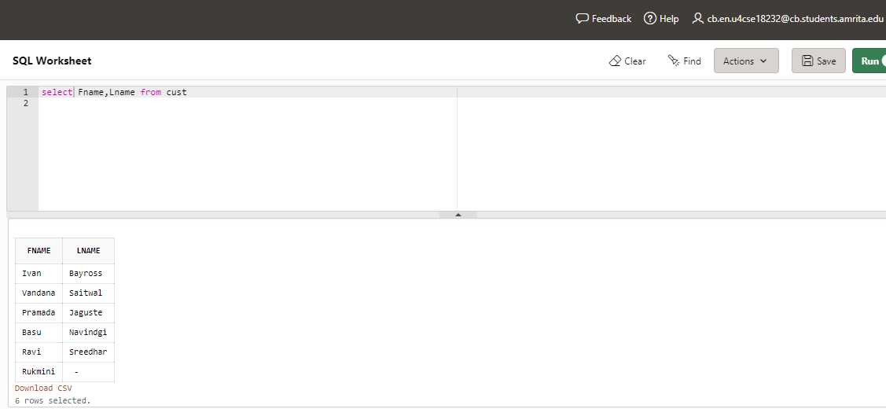

2. Print the entire customer table.

select * from cust;

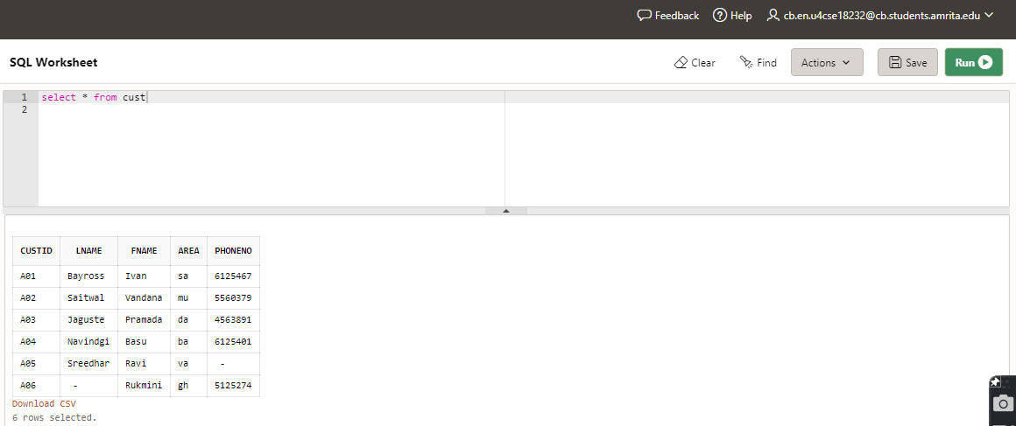

3. Retrieve the list of fname and the area of all the customers.

select Fname,area from cust;

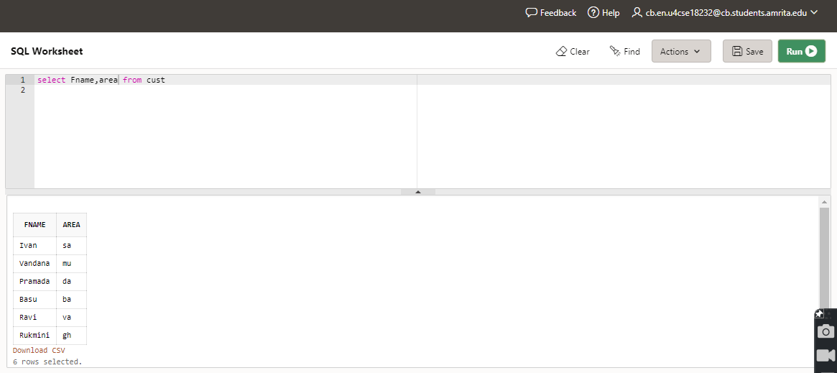

4. List the various movie types available from the movie title.

select title,movietype from movie

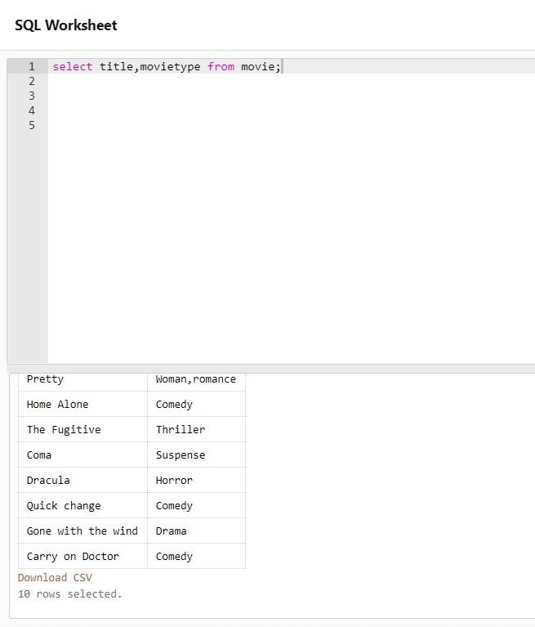

5. Find the names of all customers having 'a' in the second letter in their fname

select Fname,Lname from cust where Lname like '_a%’

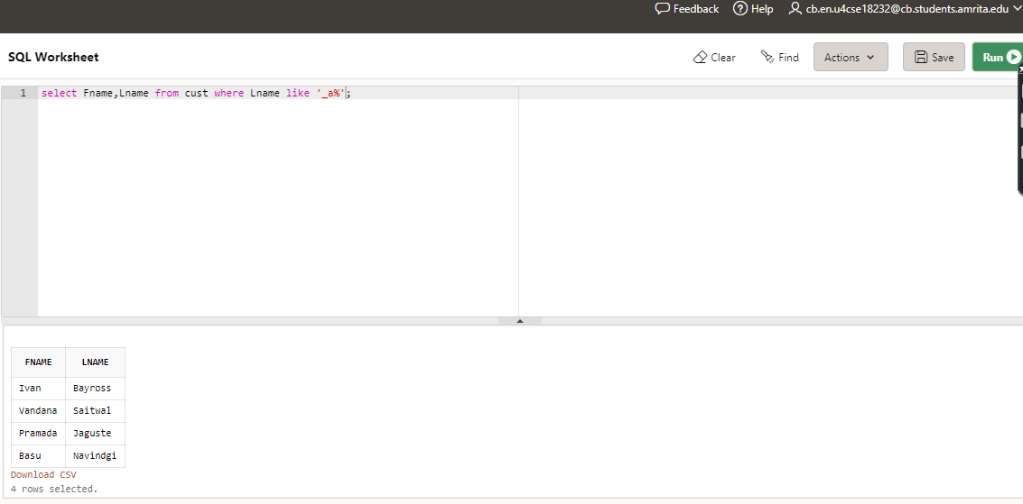

6. Find the Lname of all customers that begin with 's' or T.

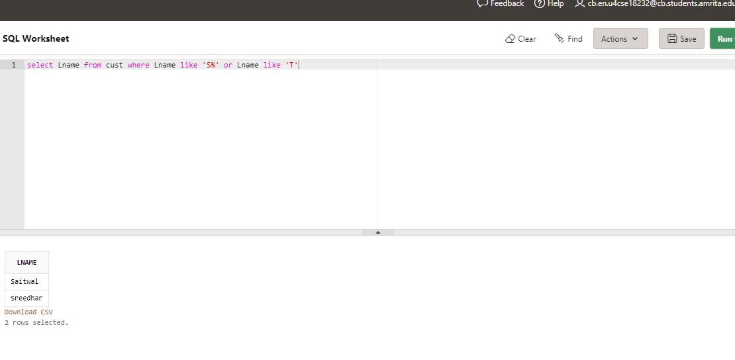

7. Find out the customers who stay in an area whose second letter is ‘a'

select Fname,Lname from cust where area like '_a%'.

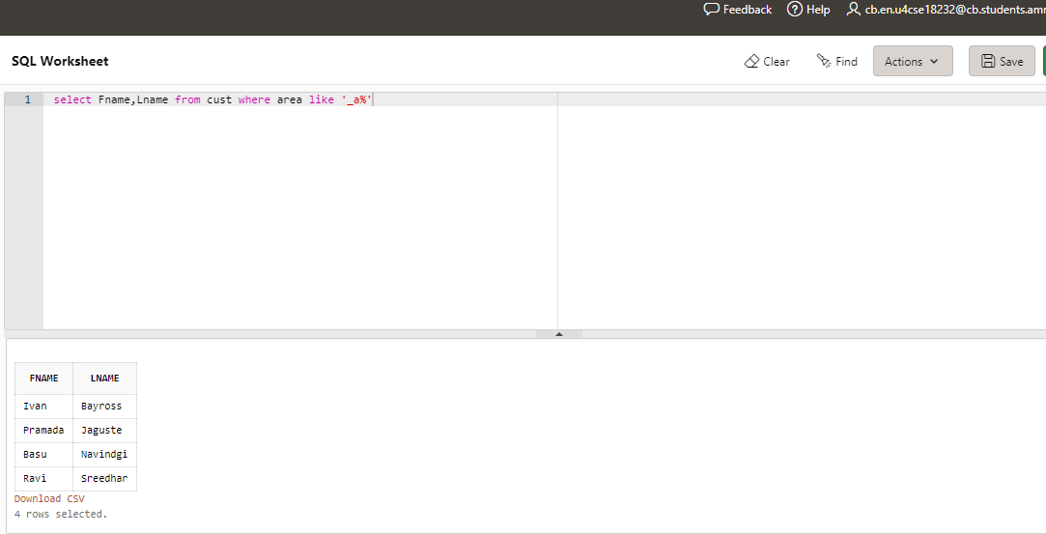

8. Find the List of all customers who stay in area 'fa’ or area °mu' or area 'gh".

select Fname,Lname from cust where area='sa' or area='mu' or area='gh'

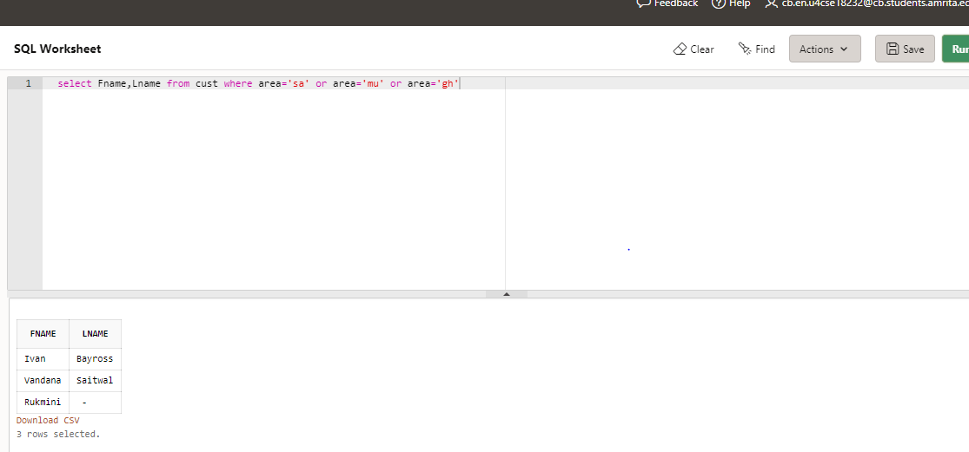

9. Print the list of customers whose phone 'numbers are greater than the value 5550000. '

select phoneno from cust where phoneno>5550000

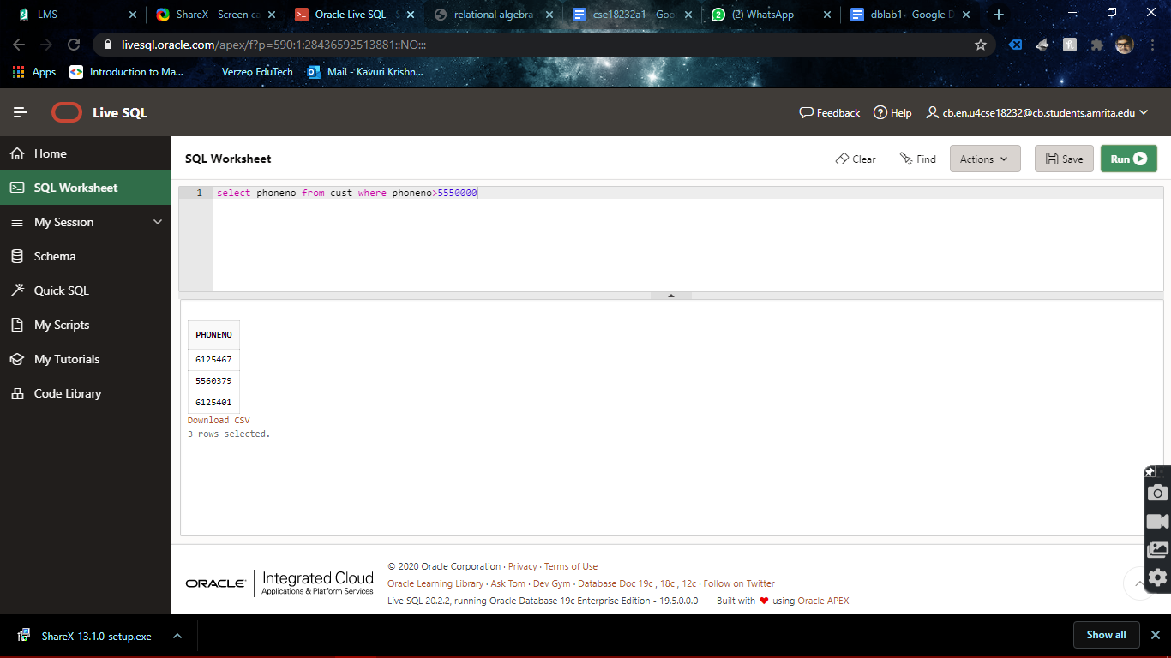

10. Print the information from invoice table of customers who have been issued movies in the month of september.

select * from invo where issuedate like '___sep%';

11. Display the invoice table information for custid 'A01' and 'A02'.

select * from invo where custid ='A01' or custid='A02'

12. Find the movies of type 'action" and "comedy'.

select title from movie where movieType='comedy' or movieType='action';

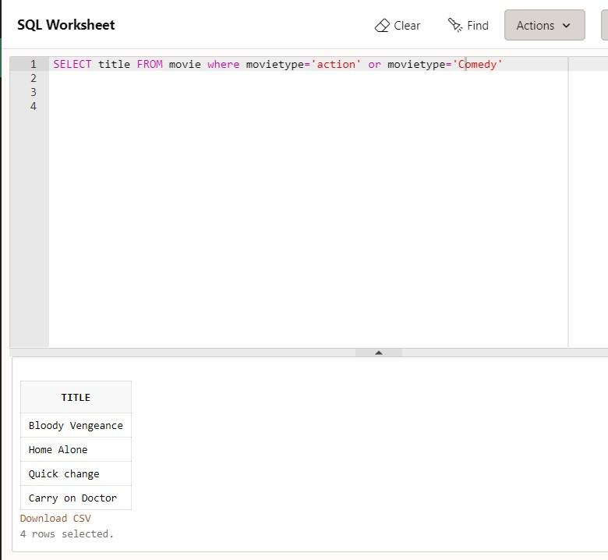

13. Find the movies whose price is greater than 150 and less than or equal to 200.

select title from movie where price>150 and price<=200;

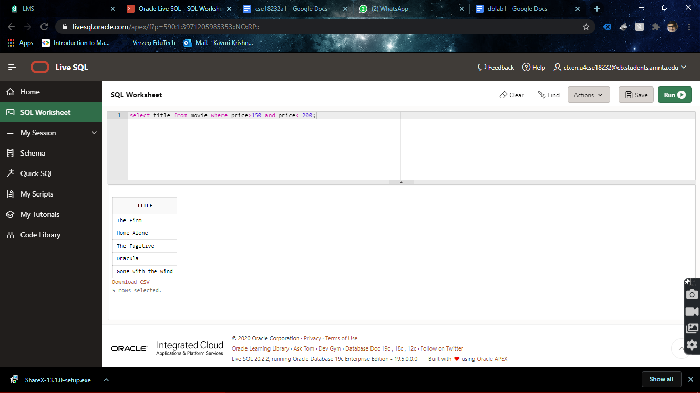

14. Find the movies that cost more than 159 and also find the new cost as original cost* 15

select price from movie where price>159

update movie set price = price * 15 where price>159

select title, price from movie

15. Rename the new column in the above query as new price,

alter table movie rename column price to newprice;

select* from movie

16. List the movies in sorted order of their titles.

select * from movie;

order by title;

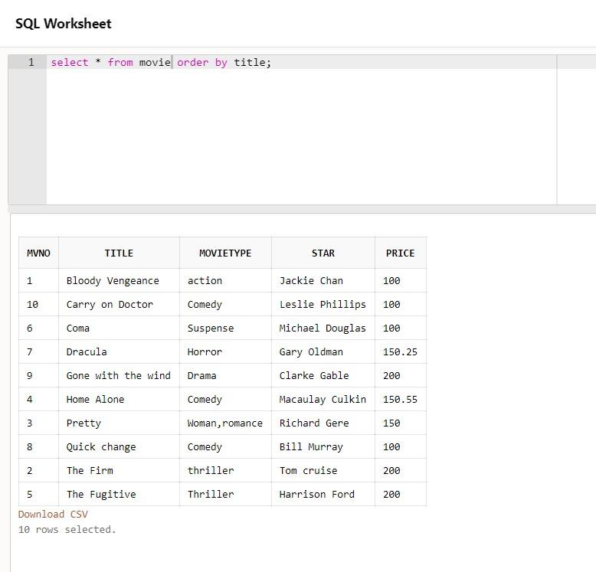

17. Print the names and types of all the movie except horror movies.

select title, movieType from movie where movietype!='horror';

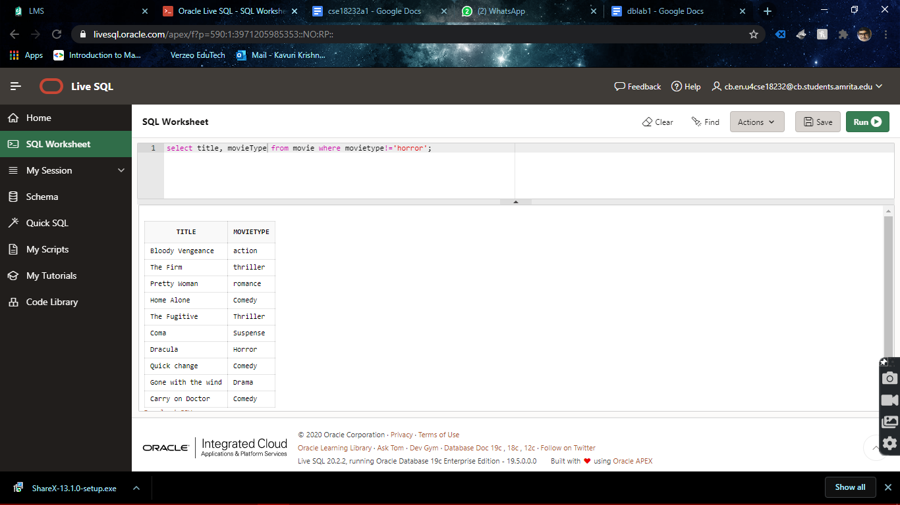

18. Calculate the square root of price of each movie

select Mvno,title,movieType,star,round(sqrt(price),2) from movie;

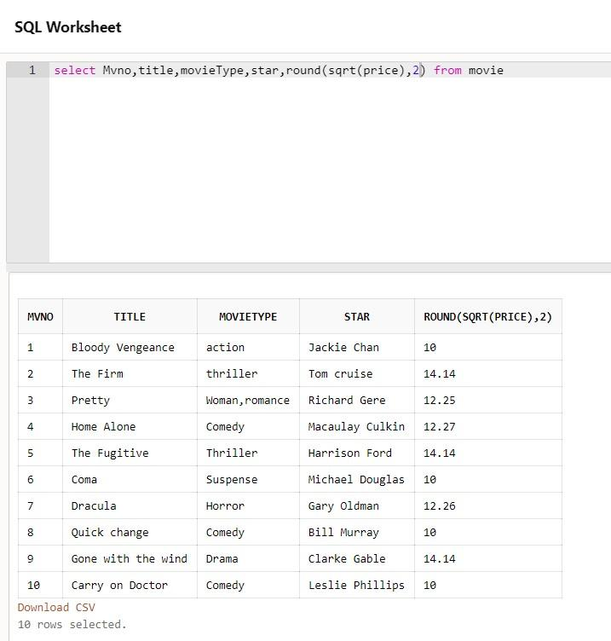

19. Divide the cost of movie "home alone’ by difference between its price and 100 .

select Mvno,title,movieType,star,round((price-100)/price,2) from movie where title='Home Alone'

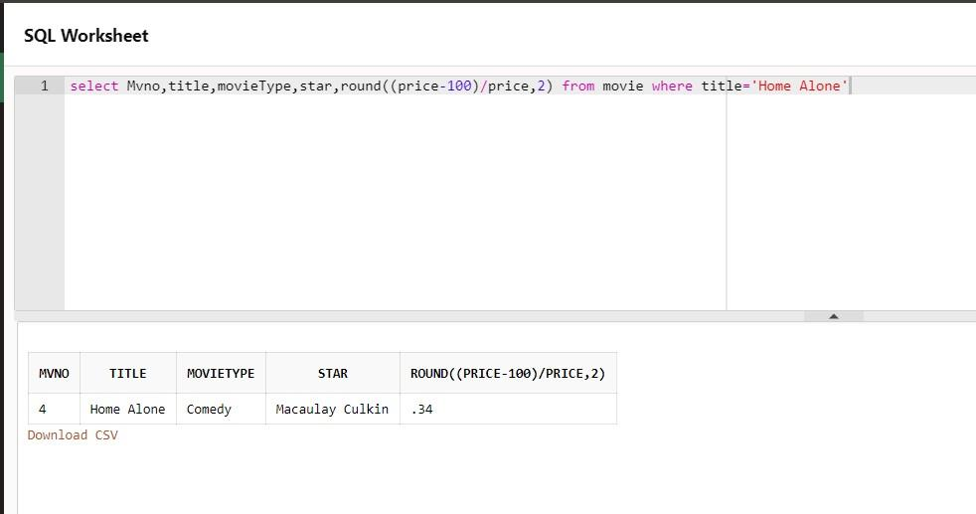

20. List the names. areas and custid of customers without phone numbers.

select * from cust where phoneno is null;

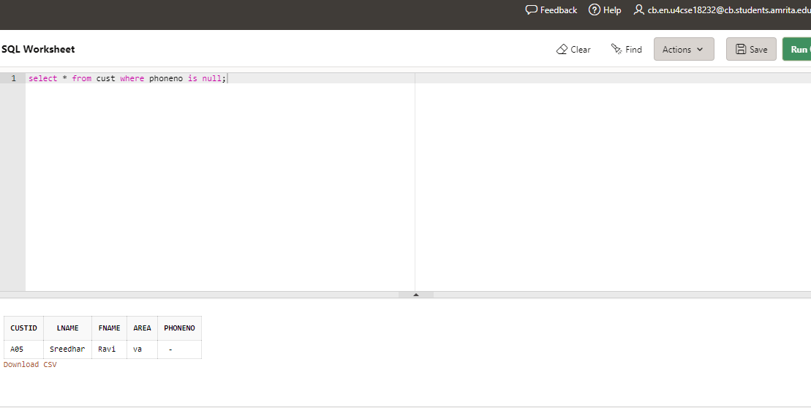

21. List the names of customers without Lname.

select * from cust where Lname is null;



22. List the myno, title, type of movies whose stars begin with letter m.

select mvno, title, movieType from movie where star like 'M%';

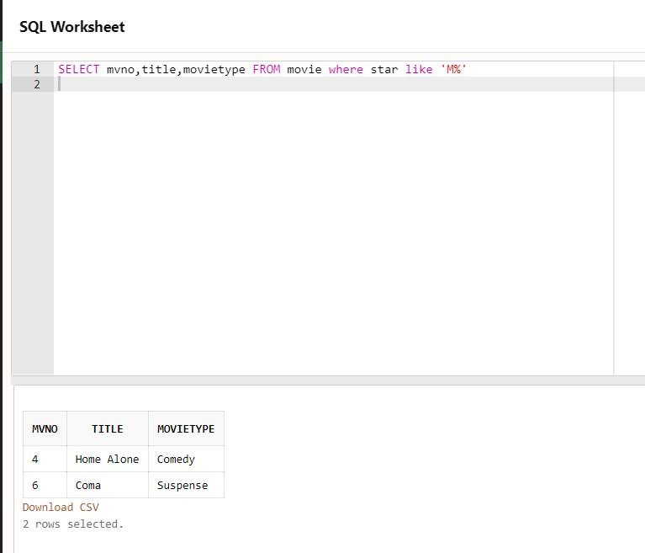

23. List the mvno and invno of customers having jnvno less than °i05" from the Invoice Transaction table.

select mvno, Invno from invo where Invno <'I05'

