“Library & Archives Mobile App for Member Self-Services”
A Project Report Submitted in the partial fulfillment of the requirements for the award of the degree of
BACHELOR OF TECHNOLOGY
In
DEPARTMENT OF COMPUTER SCIENCE AND INFORMATION TECHNOLOGY
By
VENKAT SAI 2520090034
KARTHEEK REDDY 2520090015
YASWANTH REDDY 2520080048

Under the Esteemed Guidance of
[Guide Name]
Assistant Professor
Department of Computer Science and Information Technology

K L (Deemed to be) University
DEPARTMENT OF COMPUTER SCIENCE AND INFORMATION TECHNOLOGY
Declaration
The Project Report entitled “Library & Archives Mobile App for Member Self-Services” is a record of bonafide work of VENKAT SAI – 2520090034, KARTHEEK REDDY – 2520090015, YASWANTH REDDY – 2520080048 submitted in partial fulfillment of the requirements of the course DATABASE SYSTEMS ENGINEERING AND DISTRIBUTED BACKEND DEVELOPMENT (25CS1302E), Section 10, Team 23, during 2026–2027, Trimester 4, at KLH University. The results embodied in this report have not been copied from any other student, department, or institution.

VENKAT SAI – 2520090034
KARTHEEK REDDY – 2520090015
YASWANTH REDDY – 2520080048

K L (Deemed to be) University
DEPARTMENT OF COMPUTER SCIENCE AND INFORMATION TECHNOLOGY
CERTIFICATE
This is to certify that the project report entitled “Library & Archives Mobile App for Member Self-Services” is a bonafide work done and submitted by VENKAT SAI – 2520090034, KARTHEEK REDDY – 2520090015, YASWANTH REDDY – 2520080048 in partial fulfillment of the requirements of the course DATABASE SYSTEMS ENGINEERING AND DISTRIBUTED BACKEND DEVELOPMENT (25CS1302E), Section 10, Team 23, at KLH University during 2026–2027, Trimester 4.

Signature of the Guide
Signature of the Course Coordinator Signature of the HOD

ACKNOWLEDGEMENT
The success of this project would not have been possible without the timely help and guidance of many people. We wish to express our sincere thanks to all those who assisted us in one way or the other in the completion of our project.
Our greatest appreciation goes to our Course Coordinator Dr and our guide Divya Priya Department of Computer Science and Information Technology, whose tremendous support, encouragement, and guidance cannot be expressed in words.
We express our gratitude to Dr. Kaja Shareef, Head of the Department of Computer Science and Information Technology, for providing us with adequate facilities, ways, and means by which we were able to complete this project-based lab.
We thank all the members of the teaching and non-teaching staff who have assisted us directly or indirectly in the successful completion of this project. Finally, we sincerely thank our parents, friends, and classmates for their kind help and cooperation during our work.
VENKAT SAI – 2520090034
KARTHEEK REDDY – 2520090015
YASWANTH REDDY – 2520080048

Abstract
The Library & Archives Mobile App for Member Self-Service is designed to modernize library operations by providing members with convenient access to library resources through a mobile application. In many libraries, users still rely on manual processes or limited web portals to search for books, reserve resources, track due dates, and manage fines. These traditional methods can be time-consuming, less accessible, and often require physical visits to the library.
To address these challenges, the proposed solution offers a mobile self-service platform that enables members to manage library activities anytime and anywhere. The application allows users to register, browse books and assets, reserve available resources, view borrowing history, monitor fines, and receive important notifications. It also supports offline access through local data caching, ensuring that users can access previously synchronized information even without an internet connection.
The system is built using Android (Kotlin) and Jetpack Compose for the mobile interface, with a Node.js REST API and MySQL database for backend operations. Room Database is used for offline storage, while Firebase Cloud Messaging provides real-time notifications for due dates, reservations, and library announcements. Background synchronization ensures consistency between local and server data.
By improving accessibility, reducing manual effort, and enhancing communication between libraries and members, the application provides an efficient, user-friendly, and scalable solution for modern library and archive management.

INDEX
S.No. | Chapters | Topics | Page No.
 | Acknowledgement |  | 4
 | Abstract |  | 5
1 | Chapter 1: Introduction | 1.1 Background of the Project  1.2 Problem Statement  1.3 Scope of the Project  1.4 Objectives  1.5 Importance of the Application  1.6 Target Users / Audience | 7
2 | Chapter 2: System requirements | 2.1 Hardware Requirements  2.2 Software Requirements  2.3 Development Tools and Frameworks | 9
3 | Chapter 3: Technology stack | 3.1 Frontend  3.2 Backend  3.3 Database  3.4 Version Control  3.5 Authentication and Security Libraries | 10
4 | Chapter 4: System architecture | 4.1 High-Level Architecture Diagram  4.2 Description of Each Layer  4.3 Deployment Architecture | 12
5 | Chapter 5: Design | 5.1 Database Design Principles  5.2 ER Diagram / Database Schema  5.3 Design Decisions and Assumptions | 14
6 | Chapter 6: Implementation | 6.1 Module-wise Implementation  6.2 Front-end Logic  6.3 API Integration  6.4 Authentication and Authorization | 16
7 | Chapter 7: Features | 7.1 List of Main Features  7.2 How Each Feature Works | 18
8 | Chapter 8: Testing | 8.1 Postman API Testing  8.2 Integration Testing  8.3 Tools Used for Testing  8.4 Test Cases and Results | 20
9 | Chapter 9: Deployment | 9.1 Steps to Deploy  9.2 Environment Configuration  9.3 Hosting of Frontend and Backend | 22
10 | Chapter 10: Challenges & limitations | 10.1 Issues Faced During Development  10.2 Solutions Applied  10.3 Current Limitations or Known Bugs | 23
11 | Chapter 11: Future enhancements | 11.1 Planned Features  11.2 Possible Integrations or Optimizations | 24
12 | Chapter 12: Conclusion | 12.1 Summary of the Project  12.2 What Was Achieved  12.3 Skills Learned | 25
13 | Chapter 13: References |  | 26
14 | Chapter 14: Appendices | Appendix A: Sample Code Snippets  Appendix B: Installation and Setup Instructions  Appendix C: Default Login Credentials  Appendix D: API Reference Summary  Appendix E: Screenshots  Appendix F: Glossary of Terms and Abbreviations | 27

CHAPTER 1: INTRODUCTION
1.1 Background of the Project
Libraries and archives remain the backbone of academic life on a college campus, yet the way members interact with them has changed very little. In many institutions, a student who wants to know whether a particular book is available must either visit the library in person, queue at the circulation desk, or use a browser-based catalogue that was designed for desktop screens and works poorly on a phone. Due dates are tracked on paper slips or remembered by the member, fines are discovered only when the book is returned, and reservations are made by speaking to a librarian. Archival material such as these, periodicals, manuscripts, and reading-room items is even harder to discover, because it is rarely listed in any searchable form that members can reach from outside the building.
At the same time, the smartphone has become the primary computing device for students and faculty. Members already use their phones to check timetables, pay fees, and message classmates, and they reasonably expect the same convenience from library services. A mobile self-service application closes this gap: it places the catalogue, the member's own borrowing record, and timely reminders directly in the member's pocket, available at any hour and from any place.
The Library & Archives Mobile App for Member Self-Services was built to provide exactly this capability. Members use an Android application to register, search and browse books and other assets, reserve available resources, review borrowing history, monitor fines, and receive push notifications. Because campus networks and mobile data connections are not always reliable, the app also keeps a local copy of the member's data so that previously synchronized information can still be read without an internet connection.
1.2 Problem Statement
Libraries still depend on manual processes or limited web portals for searching books, reserving resources, tracking due dates, and managing fines. These methods are time-consuming, less accessible, and often force members to make a physical visit to the library for tasks that could be completed remotely. Members are frequently unaware of an approaching due date, learn about fines only after they have accumulated, and cannot see whether a resource is available before travelling to the library. Librarians, in turn, spend a large share of their time answering routine enquiries and chasing overdue items.
The problem addressed by this project is therefore to design and implement a mobile self-service platform that lets a member perform every routine library activity on a phone, at any time and in any connectivity condition, while keeping the library's records consistent, accurate, and secure on the server.
1.3 Scope of the Project
The project covers the member-facing life cycle of library services, supported by a backend REST service and a relational database. The functionality in scope is:
- Member registration, login, and profile management with secure authentication.
- Searching and browsing books and other assets (journals, theses, archival items, and media) by title, author, category, and availability.
- Reserving an available resource, viewing active reservations, and cancelling a reservation.
- Viewing current loans, due dates, and the complete borrowing history.
- Viewing fines and their status.
- Receiving push notifications for due dates, reservation updates, and library announcements.
- Offline access to previously synchronized data through local caching, and background synchronization to keep local and server data consistent.
Online payment of fines, a native iOS application, RFID or barcode hardware integration, e-book reading with digital rights management, and a graphical librarian desktop console were treated as out of scope for this submission. Librarian-side operations such as issuing and returning items are exposed as protected API endpoints and exercised through Postman.
1.4 Objectives
- Give members anytime, anywhere access to the library catalogue through a responsive mobile interface.
- Allow members to reserve available resources without visiting the library, while preventing over-reservation of a limited number of copies.
- Present borrowing history, current loans, due dates, and fines clearly so that members can manage their own accounts.
- Deliver timely push notifications for due dates, reservation events, and library announcements.
- Keep the application useful without internet access by caching data locally in a Room database.
- Keep local and server data consistent through background synchronization.
- Protect member data with hashed passwords, token-based authentication, and role-based access control.
1.5 Importance of the Application
By moving routine library interactions onto the member's phone, the application reduces unnecessary physical visits, shortens queues at the circulation desk, and lets librarians concentrate on services that genuinely need a person. Reminder notifications reduce the number of overdue returns, which in turn reduces the fines members pay and the follow-up work librarians perform. Offline access makes the library usable in low-connectivity areas such as hostels and lecture halls, and the use of a central MySQL database ensures that every device sees one consistent version of the truth once it synchronizes.
1.6 Target Users / Audience
The system serves two roles. Members (students, research scholars, faculty, and staff) use the Android application to search the catalogue, reserve resources, track their loans and fines, and receive notifications. Librarians use protected backend endpoints to add and update catalogue entries, issue and return items, and publish announcements that are delivered to members as notifications.

CHAPTER 2: SYSTEM REQUIREMENTS
2.1 Hardware Requirements
The application has modest hardware requirements. Development and demonstration can be carried out on a single laptop that runs Android Studio, the Android emulator, the Node.js server, and the MySQL database together. The member's device only needs to run a recent version of Android.
Component | Minimum | Recommended
Development machine | Dual-core CPU, 8 GB RAM, 10 GB free disk | Quad-core CPU, 16 GB RAM, SSD with 20 GB free
Server (demo) | Dual-core CPU, 4 GB RAM, 500 MB free disk | Same machine as development, or a small cloud VM
Member device | Android 8.0 (API 26), 2 GB RAM, 100 MB free storage | Android 11 or later, 4 GB RAM
Network | Wi-Fi or mobile data for first synchronization | Stable campus Wi-Fi for push notifications

2.2 Software Requirements
- Android Studio (latest stable release) with Android SDK and an emulator image
- Kotlin 1.9 or later with Jetpack Compose enabled
- Node.js 18 or later with npm
- MySQL 8.0 or later
- A Firebase project with Cloud Messaging enabled
- Git and a GitHub account for version control
- Postman for API testing
- MySQL Workbench and Visual Studio Code (optional but recommended)
2.3 Development Tools and Frameworks
The mobile application is written in Kotlin and built with Android Studio, using Jetpack Compose for the interface, Room for local storage, and Retrofit for network calls. The backend is a Node.js service that uses the Express.js framework to expose REST endpoints and the mysql2 driver to access MySQL. Firebase Cloud Messaging (FCM) delivers push notifications. Postman is used to design, run, and document API tests, and GitHub hosts the source code for collaboration between team members.

CHAPTER 3: TECHNOLOGY STACK
3.1 Frontend
The mobile client is a native Android application written in Kotlin. The user interface is built entirely with Jetpack Compose, Android's declarative UI toolkit, which describes screens as composable functions that automatically redraw when their state changes. The app follows the MVVM pattern: each screen has a ViewModel that exposes immutable UI state through Kotlin Flows, and the ViewModel talks only to a repository, never to the network or database directly. Navigation Compose manages movement between screens. Retrofit with OkHttp performs network calls and converts JSON into Kotlin data classes, and Room provides the local SQLite database used for offline caching. WorkManager schedules the background synchronization job so that it survives app restarts and respects battery and connectivity constraints.
3.2 Backend
The backend is a REST API built with Node.js and Express.js. It is organized into routes, controllers, and models: routes declare the URL and the roles that may call it, controllers validate requests and apply business rules, and models contain the SQL. A scheduled job built with node-cron runs daily to send due-date reminders, expire unclaimed reservations, and update fines. The Firebase Admin SDK is used by the notification service to push messages to member devices through Firebase Cloud Messaging.
3.3 Database
MySQL 8 stores all persistent data in seven related tables: members, assets, loans, reservations, fines, notifications, and device_tokens. Referential integrity is enforced with foreign keys, uniqueness with UNIQUE constraints (for example one account per email address), and data validity with CHECK constraints (for example available copies can never be negative or exceed total copies). Multi-step operations such as creating a reservation are wrapped in database transactions.
3.4 Version Control
Git was used for version control with a single GitHub repository containing two top-level folders, one for the Android project and one for the Node.js server. Team members worked on feature branches and merged through pull requests, keeping the main branch in a runnable state. Secrets such as the database password, the JWT secret, and the Firebase service-account key are excluded through .gitignore.
3.5 Authentication and Security Libraries
Passwords are hashed with bcrypt before storage, so plain-text passwords never reach the database. After login the server issues a signed JSON Web Token (JWT) that carries only the member's ID and role. The Android app stores the token in encrypted shared preferences and an OkHttp interceptor attaches it to every request. Express middleware verifies the token on every protected route and enforces role-based access, so a member account can never reach librarian-only endpoints. All SQL uses parameterized queries to prevent injection.
Layer | Technology | Purpose
Mobile UI | Kotlin, Jetpack Compose | Declarative screens and navigation
Local storage | Room (SQLite) | Offline cache of member data
Networking | Retrofit, OkHttp | REST communication with the server
Background work | WorkManager | Periodic and on-reconnect synchronization
Backend | Node.js, Express.js | REST API and business rules
Database | MySQL 8, mysql2 | Persistent relational storage
Notifications | Firebase Cloud Messaging | Push alerts for due dates and announcements
Security | bcrypt, JWT | Password hashing and stateless sessions
Tooling | Android Studio, Postman, GitHub | Development, testing, collaboration

CHAPTER 4: SYSTEM ARCHITECTURE
4.1 High-Level Architecture Diagram
The system follows a client-server architecture with three tiers: the Android application on the member's device, the Express.js REST API, and the MySQL database, supplemented by Firebase Cloud Messaging for push delivery. Figure 4.1 shows the layers and how a request flows between them.
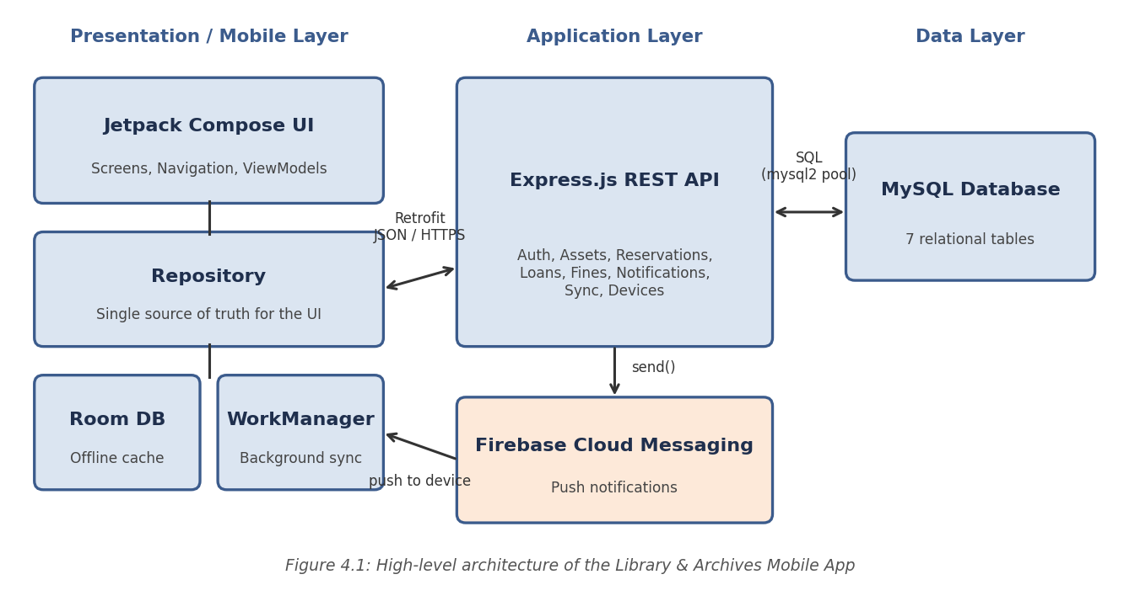
4.2 Description of Each Layer
Presentation layer. The Android application contains Compose screens and ViewModels. A screen never calls the network directly; it observes state exposed by its ViewModel and sends user actions to it. The ViewModel in turn calls the repository, which decides whether to answer from the local Room database, from the server, or from both.
Local data layer. The Room database holds a copy of the catalogue entries the member has viewed, the member's loans, reservations, fines, and notifications, and a small table recording the time of the last successful synchronization. Because the UI reads from Room first, screens render instantly and continue to work offline. WorkManager refreshes this cache in the background.
Application layer. The Express.js API receives requests over HTTPS. Each request passes through authentication middleware, which verifies the JWT and attaches the member's identity and role, then through a controller that validates input and applies business rules, such as checking that a resource still has an available copy before a reservation is created. Only after these checks does a model read or write data.
Data layer. MySQL is accessed through a connection pool provided by the mysql2 driver, so several requests can be served concurrently without opening a new connection each time. The database itself enforces keys and constraints, so invalid data is rejected even if the application code has a defect.
Notification service. When the server needs to alert a member, for example because a due date is one day away, it looks up that member's registered device tokens and asks Firebase Cloud Messaging to deliver the message. A copy of every notification is also stored in the notifications table so that it appears in the in-app list.
4.3 Deployment Architecture
For development and demonstration, the Express server listens on port 5000 and MySQL listens on its default port 3306 on the same machine. The Android emulator reaches the host machine through the special address 10.0.2.2, while a physical phone connects through the laptop's local network address. Firebase Cloud Messaging is a hosted Google service reached over the internet. No containerization or CI/CD pipeline was configured for this submission, since the course scope did not require cloud deployment; Chapter 11 outlines how the system could be extended to a hosted environment.

CHAPTER 5: DESIGN
5.1 Database Design Principles
The schema was normalized so that each fact is stored in exactly one place, and every relationship between entities is expressed through a foreign key rather than by duplicating data. Each table enforces its own invariants directly in the database using PRIMARY KEY, FOREIGN KEY, UNIQUE, and CHECK constraints. Invalid data, such as a negative number of copies or a second account with the same email address, is therefore rejected at the database level even if a bug elsewhere in the application tried to insert it.
5.2 ER Diagram / Database Schema
The database consists of seven related tables, shown in Figure 5.1 and summarized in the data dictionary that follows.
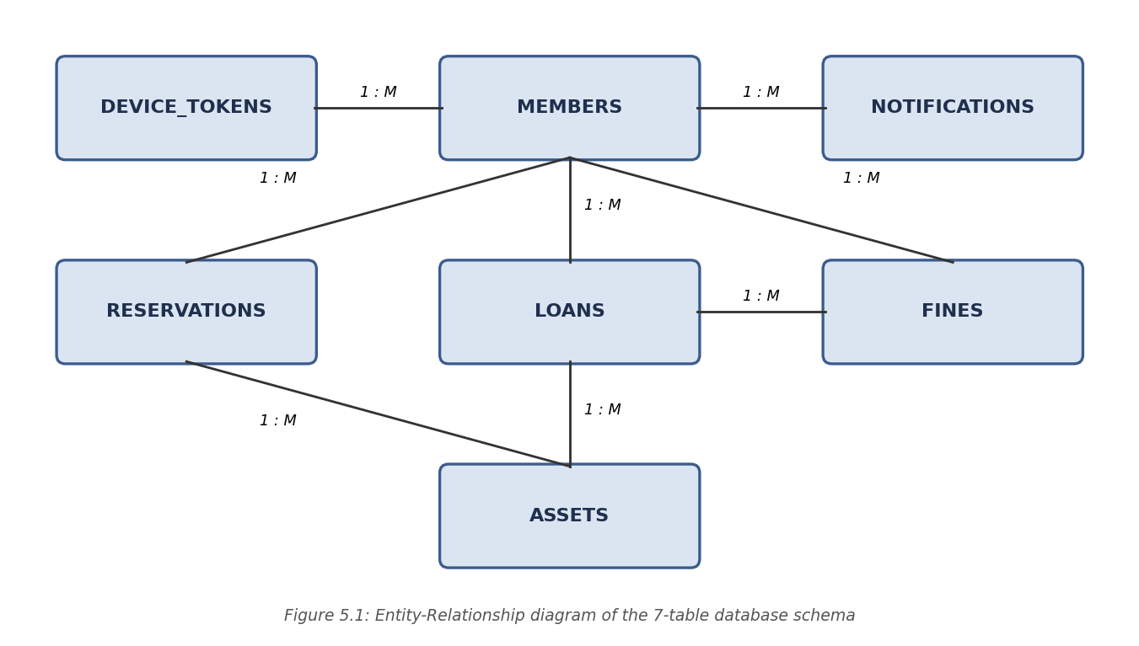
Table | Key columns | Important constraints
members | member_id (PK), name, email, password_hash, role, phone, status, created_at | UNIQUE email; role in (Member, Librarian)
assets | asset_id (PK), title, author, category, asset_type, isbn, total_copies, available_copies, updated_at | CHECK 0 <= available <= total
loans | loan_id (PK), member_id (FK), asset_id (FK), issue_date, due_date, return_date, status | CHECK due_date >= issue_date
reservations | reservation_id (PK), member_id (FK), asset_id (FK), reserved_at, expires_at, status | status in (Active, Fulfilled, Cancelled, Expired)
fines | fine_id (PK), loan_id (FK), member_id (FK), amount, reason, status, created_at | CHECK amount >= 0
notifications | notification_id (PK), member_id (FK), title, message, type, is_read, created_at | FK to members
device_tokens | token_id (PK), member_id (FK), fcm_token, platform, updated_at | UNIQUE fcm_token

The members table stores every account together with a bcrypt-hashed password and a role flag. assets holds the catalogue of books and other resources, including how many copies exist and how many are currently available. loans records each issue of an asset to a member with its due and return dates. reservations links a member to an asset they have asked to hold, with an expiry time. fines records charges raised against overdue loans. notifications keeps a server-side copy of every message sent to a member, and device_tokens stores the FCM tokens of the devices on which a member is signed in.
5.3 Design Decisions and Assumptions
The following decisions were made explicitly and are recorded here rather than left implicit in the code:
- Server is the source of truth. The Room database is a cache. Any conflict between local and server data is resolved in favour of the server at the next synchronization.
- Copy counts on the asset row. Each asset stores total_copies and available_copies. Creating a reservation decrements available_copies and cancelling or expiring a reservation restores it, both inside a single transaction, so two members can never reserve the last copy at the same time.
- Reservation hold period. A reservation holds a copy for 48 hours. A daily job marks unclaimed reservations as Expired and returns the copy to the pool.
- Loan rules. The default loan period is 14 days, a member may hold at most five active loans and three active reservations, and an overdue fine accrues at a configurable daily rate. These values are kept in server configuration so they can be changed without modifying code.
- Online-only writes. Reading works offline, but reserving or cancelling requires connectivity, because accepting these actions offline could lead to conflicting claims on the same copy.

CHAPTER 6: IMPLEMENTATION
6.1 Module-wise Implementation
The backend is organized into seven resource modules, each with its own routes, controller, and model file: Authentication, Assets, Reservations, Loans, Fines, Notifications, and Sync (with Devices). The most involved piece of logic is the reservation workflow. It runs four checks in sequence: the asset exists and is active, at least one copy is available, the member has not exceeded the reservation limit and has no active reservation for the same asset, and the member's unpaid fines are below the blocking limit. Only if all four pass does it decrement available_copies and insert a reservation row, inside a single transaction so that a failure part-way leaves no partial state behind.
START TRANSACTION;
SELECT available_copies FROM assets WHERE asset_id = ? FOR UPDATE;
-- application checks available_copies > 0 and member limits
UPDATE assets SET available_copies = available_copies - 1
WHERE asset_id = ? AND available_copies > 0;
INSERT INTO reservations (member_id, asset_id, reserved_at, expires_at, status)
VALUES (?, ?, NOW(), DATE_ADD(NOW(), INTERVAL 48 HOUR), 'Active');
COMMIT;
The fine rule is applied consistently by the daily job and by the return endpoint: a loan is overdue when its due date is earlier than today and it has not been returned, and the fine is the number of overdue days multiplied by the daily rate. Because both entry points use the same function, a member never sees two different fine amounts for the same loan.
6.2 Front-end Logic
The Android app uses the MVVM pattern. Each screen (Login, Register, Home, Catalogue, Asset Details, My Reservations, My Loans and History, Fines, Notifications, and Profile) has a ViewModel that holds a StateFlow of UI state. Compose collects this state and redraws automatically. State that is genuinely global, such as the logged-in member and the network status, is exposed by a small number of shared classes; everything else is kept local to the screen that needs it. Reusable components, including a loading indicator, an empty-state message, an error banner, and an offline banner, are written once and used across all screens so that the app loads, fails, and informs the user in a consistent way.
The repository follows a cache-first pattern: it returns the Room data immediately as a Flow and then refreshes it from the server when a connection is available (Figure 6.1).
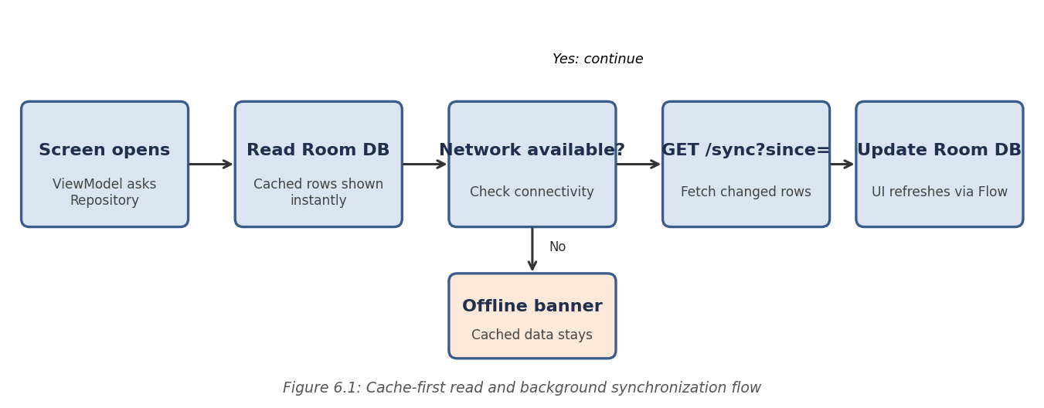
class LoanRepository(private val api: LibraryApi, private val dao: LoanDao) {
// UI observes Room; it updates automatically when the cache changes
val loans: Flow<List<LoanEntity>> = dao.observeLoans()

suspend fun refresh() {
try {
val remote = api.getMyLoans()
dao.replaceAll(remote.map { it.toEntity() })
} catch (e: IOException) {
// offline: keep showing cached data
}
}
}
6.3 API Integration
All network calls go through one Retrofit instance backed by a single OkHttp client. An interceptor attaches the member's JWT to every outgoing request, and an authenticator clears the stored session and returns the member to the login screen if the server answers 401 Unauthorized, for example after the token has expired. Each backend resource has a matching Retrofit interface and a repository, so no screen hard-codes a URL or repeats the same request logic. Network responses are mapped from data transfer objects to Room entities, which keeps the server format separate from the local schema.
Background synchronization is performed by a WorkManager task that runs periodically and again when connectivity returns. It calls the sync endpoint with the timestamp of the last successful synchronization; the server answers with only the rows that changed since then, and the task applies them to Room in one transaction and stores the new timestamp.
6.4 Authentication and Authorization
Registration always creates a Member account. There is deliberately no way to create a Librarian account through the public API, so a member cannot register their way into elevated access; librarian accounts exist only because they were inserted directly into the database. Every protected route runs a protect middleware that verifies the JWT, and librarian-only routes additionally run a librarianOnly middleware that checks the role claim and rejects any member token with a 403 Forbidden response.
const protect = (req, res, next) => {
const token = (req.headers.authorization || '').replace('Bearer ', '');
try {
req.user = jwt.verify(token, process.env.JWT_SECRET);
next();
} catch (err) {
res.status(401).json({ message: 'Invalid or expired token' });
}
};
const librarianOnly = (req, res, next) =>
req.user.role === 'Librarian'
? next()
: res.status(403).json({ message: 'Librarian access required' });

CHAPTER 7: FEATURES
7.1 List of Main Features
Member-facing features:
- Register and log in securely; view and edit a personal profile
- Browse, search, and filter books and assets by title, author, category, and availability
- View full asset details, including available copies
- Reserve an available resource and cancel a reservation
- View current loans with due dates and the complete borrowing history
- View fines with their reason and status
- Receive push notifications for due dates, reservation updates, and library announcements
- Use previously synchronized data without an internet connection
Librarian-facing and system features:
- Add, edit, and deactivate catalogue entries
- Issue and return items, with fines calculated automatically for late returns
- Publish announcements that are delivered as push notifications
- Daily scheduled job for due-date reminders, reservation expiry, and fine updates
- Background synchronization between the local Room cache and the server
7.2 How Each Feature Works
Registration and login. A new member enters a name, email, phone number, and password. The server validates the input, hashes the password with bcrypt, creates the account, and returns a JWT. At login the submitted password is compared with the stored hash; a wrong password produces a 401 response without revealing whether the email exists. After a successful login the app registers the device's FCM token with the server so notifications can be delivered.
Search and browse. The catalogue screen sends the search text and selected filters to the assets endpoint, which builds a parameterized SQL query and returns a page of results. Results are cached in Room, so recently viewed items remain searchable offline. Each result shows a coloured availability badge, so the member can see at a glance whether a copy can be reserved.
Reservation. From the asset details screen, a member taps Reserve. The server runs the checks described in Chapter 6 and either confirms the reservation with its expiry time or returns a clear message such as "No copies available" or "Reservation limit reached". A confirmed reservation appears immediately in My Reservations and triggers a notification. If the member does not collect the item within 48 hours, the daily job expires the reservation and releases the copy.
Loans, due dates, and history. The loans screen lists current loans sorted by due date, highlights items due within two days, and marks overdue items in red. A separate history tab lists returned items with their issue and return dates. Both lists are cached locally, so the member can check a due date without connectivity.
Fines. The fines screen shows each fine with the loan it relates to, the number of overdue days, the amount, and whether it is Pending or Paid, together with a total of pending fines. Fines are calculated on the server so that the member cannot alter them. Online payment is outside the scope of this version; payment is recorded by the librarian at the desk.
Notifications. Notifications arrive through FCM even when the app is closed. Tapping a notification opens the relevant screen, and the same message is saved in the in-app Notifications list, where unread items are highlighted. Typical messages are a reminder one day before a due date, a confirmation or expiry notice for a reservation, and general announcements from the library.
Offline access and synchronization. When the device has no connection, the app shows an offline banner and continues to display cached data. Actions that change server data, such as reserving or cancelling, are disabled with an explanation. When connectivity returns, WorkManager runs a synchronization that brings the cache up to date, and the banner disappears.
Screen | Purpose
Login / Register | Authenticate or create a member account
Home | Summary of due soon, active reservations, pending fines, and unread notifications
Catalogue and Search | Find books and assets with filters
Asset Details | Full details, availability, and the Reserve button
My Reservations | Active and past reservations with a cancel option
My Loans and History | Current loans, due dates, and returned items
Fines | Pending and paid fines with a total
Notifications | In-app list of messages and announcements
Profile | Member details and log out

CHAPTER 8: TESTING
8.1 Postman API Testing
A Postman collection was prepared covering all 22 REST endpoints, organized into folders for Auth, Assets, Reservations, Loans, Fines, Notifications, Devices, and Sync, plus a Health check. The Login request carries a small test script that saves the returned JWT into a collection variable, and requests such as Create Reservation, Issue Loan, and Return Loan are chained through variables so that a complete workflow can be exercised without copying any ID or token by hand.
8.2 Integration Testing
Beyond Postman, the application is tested end to end against a real, running MySQL database. Each backend module is verified against the actual database before the next module is built on top of it, rather than in isolation with mocked data. The Android client is run on the emulator and on a physical device against the local server. Offline behaviour is verified by switching the device to airplane mode, and push notifications are verified by triggering the scheduled job manually. As a final integration check, the database is dropped and rebuilt from schema.sql and seed.sql, and the full checklist is re-run against that fresh installation to confirm that the system works for a first-time setup.
8.3 Tools Used for Testing
- Postman – manual and scripted API testing
- curl (command line) – quick regression checks of individual endpoints
- MySQL command-line client and Workbench – direct verification of table contents and constraints
- Android Studio emulator and a physical Android device – manual testing of the app
- Android Studio Database Inspector – checking the Room cache contents
- Airplane mode and Wi-Fi toggling – offline and reconnection testing
8.4 Test Cases and Results
The table below lists the test cases designed for the system, with the behaviour that each must show. The Actual Result column is to be completed by the team as each case is executed and recorded in the project test log.
# | Test Case | Expected Result | Actual Result
1 | Login with a wrong password | 401 Unauthorized, login rejected
2 | Member token calls a librarian-only route | 403 Forbidden
3 | Register with an email that already exists | 409 Conflict with a friendly message
4 | Reserve an asset with no available copies | 409, message "No copies available"
5 | Reserve the same asset twice | Second attempt returns 409 Conflict
6 | Reserve beyond the reservation limit | 409, limit message with exact number
7 | Two members reserve the last copy at the same time | Exactly one succeeds; available_copies never negative
8 | Cancel a reservation | Status Cancelled; available_copies restored
9 | Reservation not collected for 48 hours | Daily job marks it Expired and restores the copy
10 | Return a loan three days late | Fine equals 3 days x daily rate
11 | Create an asset with negative copies | 400, rejected before reaching the database
12 | Open the app in airplane mode after a sync | Cached loans and catalogue shown with offline banner
13 | Reconnect after being offline | Background sync updates the cache and hides the banner
14 | Due date is tomorrow | Push notification received and stored in the app list
15 | Expired JWT used on any protected route | 401, app returns to the login screen

CHAPTER 9: DEPLOYMENT
9.1 Steps to Deploy
The system is deployed locally for development and demonstration as follows:
- Load the schema and seed data: mysql -u root -p < database/schema.sql, then ... < database/seed.sql
- Create the server .env file from .env.example and add the Firebase service-account key
- Start the backend: cd server, npm install, npm run dev (listens on port 5000)
- Add google-services.json from the Firebase console to the Android project's app folder
- Open the android-app folder in Android Studio and let Gradle sync
- Set the API base URL (10.0.2.2:5000 for the emulator, the laptop's LAN address for a physical phone)
- Run the app on the emulator or device and log in with a seeded account
9.2 Environment Configuration
All server configuration is kept in a single .env file that is never committed to version control. It covers the database connection (host, port, user, password, database name), the JWT signing secret and token expiry, the port the server listens on, the path to the Firebase service-account key, and the business-rule settings such as the loan period, reservation hold hours, and daily fine rate. A .env.example file with placeholder values is committed instead, so the required variables are documented without exposing real credentials. On the Android side, the base URL is defined as a build configuration field so that debug and release builds can point at different servers.
9.3 Hosting of Frontend and Backend
For this submission the backend runs as a local Node.js process, the database as a local MySQL instance, and the Android application is installed as a debug build on an emulator or a connected device. This is appropriate for development and in-class demonstration. A production deployment, with the API behind HTTPS on a cloud server, a managed MySQL instance, and a signed release build of the app, was not required for this course; Chapter 11 describes how the same codebase could be adapted.

CHAPTER 10: CHALLENGES & LIMITATIONS
10.1 Issues Faced During Development
- Keeping local and server data consistent. A cached copy can become stale, and two devices of the same member can show different information until each synchronizes.
- Preventing double reservation. Two members tapping Reserve for the last copy at the same moment could both succeed if the check and the update were separate steps.
- Reliable background work. Android restricts background execution to save battery, so a simple timer or service would not run reliably.
- Notification delivery. FCM tokens change when the app is reinstalled or data is cleared, and notifications sent to an old token are lost.
- Time zones. Due dates are stored in UTC on the server, but members expect to see them in local time.
10.2 Solutions Applied
For consistency, the server was designated the single source of truth, and synchronization uses an updated-since timestamp so that only changed rows travel over the network and the cache is replaced atomically. For double reservation, the check and the update were combined in one database transaction with a row lock on the asset, together with a CHECK constraint that makes a negative available_copies impossible even if the code has a defect. For background work, WorkManager was chosen because it persists scheduled tasks across restarts and honours connectivity constraints. For notifications, the app re-registers its FCM token at every launch and whenever Firebase reports a new token, and the server removes tokens that FCM reports as invalid. For time zones, a shared utility converts server timestamps using the device's local time zone before display.
10.3 Current Limitations or Known Bugs
- Reserving and cancelling require an internet connection; there is no offline action queue.
- Fines cannot be paid inside the app; payment is recorded by a librarian.
- There is no email verification or password-reset flow for member accounts.
- Librarian accounts can only be created by inserting a row directly into the database, by design.
- The application targets Android only; there is no iOS client.
- The system has been tested on a single local deployment and has not been deployed to a public cloud environment.

CHAPTER 11: FUTURE ENHANCEMENTS
11.1 Planned Features
- In-app payment of fines through a payment gateway
- Email-based password reset and account verification
- Loan renewal requests from the app, subject to library rules
- Barcode or QR scanning to look up a book or self-issue it at the shelf
- A wish-list and "notify me when available" alerts for fully borrowed items
- Personalized recommendations based on borrowing history
- A dedicated librarian dashboard for catalogue and circulation management
11.2 Possible Integrations or Optimizations
- Containerizing the backend with Docker and deploying it to a cloud host with a managed MySQL instance
- Adding caching for frequently requested catalogue searches to reduce database load
- Adding full-text search indexes in MySQL for faster and more tolerant searching
- Queueing offline actions locally and replaying them safely when connectivity returns
- Adding an automated test suite (JUnit and Espresso for Android, Jest and Supertest for the API) to complement manual testing
- Integrating with the institution's student information system for single sign-on

CHAPTER 12: CONCLUSION
12.1 Summary of the Project
This project set out to modernize library operations by giving members convenient access to library resources through a mobile application. A normalized seven-table MySQL schema, a 22-endpoint Express REST API, and a native Android application built with Kotlin and Jetpack Compose were designed to work together, with Room providing offline storage, FCM providing push notifications, and WorkManager keeping local and server data consistent.
12.2 What Was Achieved
The system lets members register, browse books and assets, reserve available resources, view borrowing history, monitor fines, and receive timely notifications. It enforces role-based access, prevents over-reservation of limited copies through transactional checks, calculates fines consistently on the server, and keeps previously synchronized information available without an internet connection. By improving accessibility, reducing manual effort, and enhancing communication between the library and its members, it offers an efficient, user-friendly, and scalable foundation for modern library and archive management.
12.3 Skills Learned
Working on this project provided practical experience in relational database design and normalization; enforcing constraints at the database layer instead of trusting application code alone; designing a REST API with consistent responses and meaningful HTTP status codes; using database transactions to keep related data consistent; building native Android interfaces with Jetpack Compose and the MVVM pattern; designing an offline-first mobile client with Room and WorkManager; integrating push notifications through Firebase Cloud Messaging; and systematic testing, including deliberately trying to break the system's own rules to confirm that they hold.

CHAPTER 13: REFERENCES
- Android Developers – Jetpack Compose documentation, https://developer.android.com/jetpack/compose
- Android Developers – Save data in a local database using Room, https://developer.android.com/training/data-storage/room
- Android Developers – WorkManager, https://developer.android.com/topic/libraries/architecture/workmanager
- Android Developers – Guide to app architecture, https://developer.android.com/topic/architecture
- Kotlin – Official Documentation, https://kotlinlang.org/docs
- Retrofit – Square, https://square.github.io/retrofit
- Firebase Cloud Messaging – Documentation, https://firebase.google.com/docs/cloud-messaging
- Node.js – Official Documentation, https://nodejs.org/en/docs
- Express.js – Official Documentation, https://expressjs.com
- MySQL 8.0 Reference Manual, https://dev.mysql.com/doc/refman/8.0/en/
- mysql2 (Node.js MySQL driver) – npm documentation, https://www.npmjs.com/package/mysql2
- jsonwebtoken – npm documentation, https://www.npmjs.com/package/jsonwebtoken
- bcrypt – npm documentation, https://www.npmjs.com/package/bcrypt
- Postman Learning Center, https://learning.postman.com
- GitHub Docs, https://docs.github.com

CHAPTER 14: APPENDICES
Appendix A: Sample Code Snippets
The Room entity and DAO used for the local loans cache:
@Entity(tableName = "loans")
data class LoanEntity(
@PrimaryKey val loanId: Int,
val assetId: Int,
val title: String,
val issueDate: String,
val dueDate: String,
val returnDate: String?,
val status: String
)

@Dao
interface LoanDao {
@Query("SELECT * FROM loans ORDER BY dueDate ASC")
fun observeLoans(): Flow<List<LoanEntity>>

@Insert(onConflict = OnConflictStrategy.REPLACE)
suspend fun upsertAll(items: List<LoanEntity>)
}
The overdue-fine query used by the daily job:
SELECT l.loan_id, l.member_id,
DATEDIFF(CURDATE(), l.due_date) * ? AS fine_amount
FROM loans l
WHERE l.return_date IS NULL
AND l.due_date < CURDATE();
Appendix B: Installation and Setup Instructions
- mysql -u root -p < database/schema.sql
- mysql -u root -p < database/seed.sql
- cd server && npm install && npm run dev (backend, port 5000)
- Open android-app in Android Studio, add google-services.json, and sync Gradle
- Set the base URL, then run the app on an emulator or device
Appendix C: Default Login Credentials
Sample development accounts (all seeded accounts use the password "password123"; replace with the actual values from the seed script):
Role | Email | Name
Librarian | librarian@college.edu | Library Admin
Member | venkat.sai@college.edu | Venkat Sai
Member | kartheek.reddy@college.edu | Kartheek Reddy
Member | yaswanth.reddy@college.edu | Yaswanth Reddy

Appendix D: API Reference Summary
22 endpoints across eight resources; full request and response examples are in the accompanying Postman collection.
Resource | Endpoints
Auth | POST /register, POST /login, GET /me
Assets | GET / (search and filter), GET /:id, POST / and PUT /:id (librarian)
Reservations | POST /, GET /my, DELETE /:id
Loans | GET /my, GET /my/history, POST / (issue), PUT /:id/return
Fines | GET /my, GET /my/summary
Notifications | GET /my, PUT /:id/read, POST /announcements (librarian)
Devices | POST / (register FCM token), DELETE /:token
Sync | GET /sync?since=timestamp
Health | GET /api/health

Appendix E: Screenshots
The following pages are left for the team to complete with actual screenshots taken from the running application before submission. Suggested screenshots, in order:
# | Screen | Insert screenshot here
1 | Login and Register
2 | Home
3 | Catalogue and Search
4 | Asset Details with Reserve button
5 | My Reservations
6 | My Loans and History
7 | Fines
8 | Notifications and offline banner

Appendix F: Glossary of Terms and Abbreviations
Term | Meaning
API | Application Programming Interface: the set of endpoints through which the app communicates with the server
REST | Representational State Transfer: a style of web API built on HTTP methods and resource URLs
JWT | JSON Web Token: a signed token that proves a member's identity on each request
FCM | Firebase Cloud Messaging: Google's service for delivering push notifications to devices
MVVM | Model-View-ViewModel: an architecture pattern that separates UI, state, and data access
Room | Android's persistence library that provides an object-mapping layer over SQLite
WorkManager | Android library for deferrable background work that must run reliably
Retrofit | HTTP client library that turns a REST API into a Kotlin interface
Asset | Any catalogue item a member can borrow or reserve: book, journal, thesis, archival item, or media
Sync | Process of updating the local Room cache with changes from the server
CRUD | Create, Read, Update, Delete: the four basic data operations
DTO | Data Transfer Object: a class that mirrors the JSON sent over the network

