WEEK-1

1. a) Install Flutter and Dart SDK.

Aim: To install Flutter and Dart SDK.

Dart SDK is a pre-compiled version so we have to download and extract it only. For this follow the below-given instructions:
Step 1: Download Dart SDK. Download Dart SDK from the Dart SDK archive page. The URL is: https://dart.dev/tools/sdk/archive

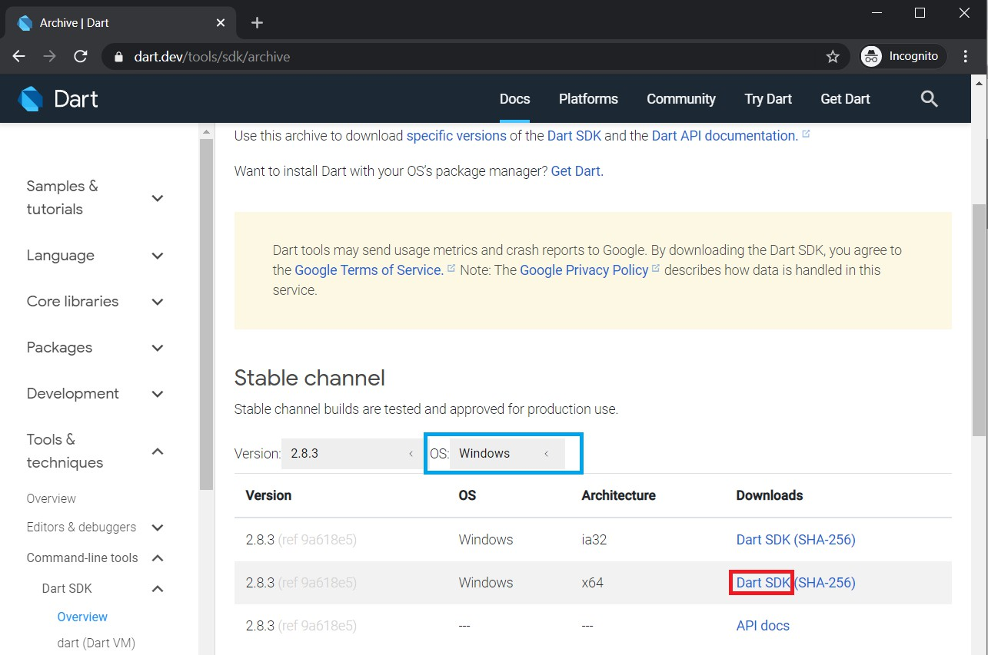

Click on DART SDK to download SDK for Windows 64-Bit Architecture. The download will start and a zip file will be downloaded. Note: To download SDK for any other OS select OS of your choice.
Step 2: Extract the downloaded zip file. Extract the contents of downloaded zip file and after extracting contents of zip file will be as shown:
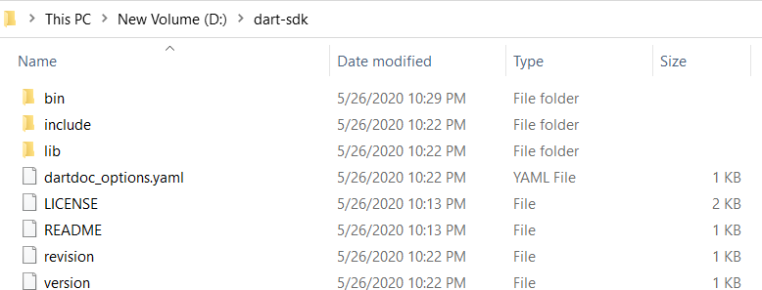

Step 3: Running Dart. Now open bin folder and type “cmd” as given below:
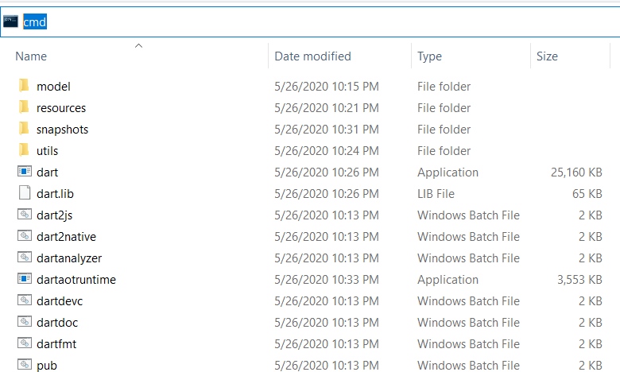

Command Prompt will open with our desired path of bin folder and now type dart.
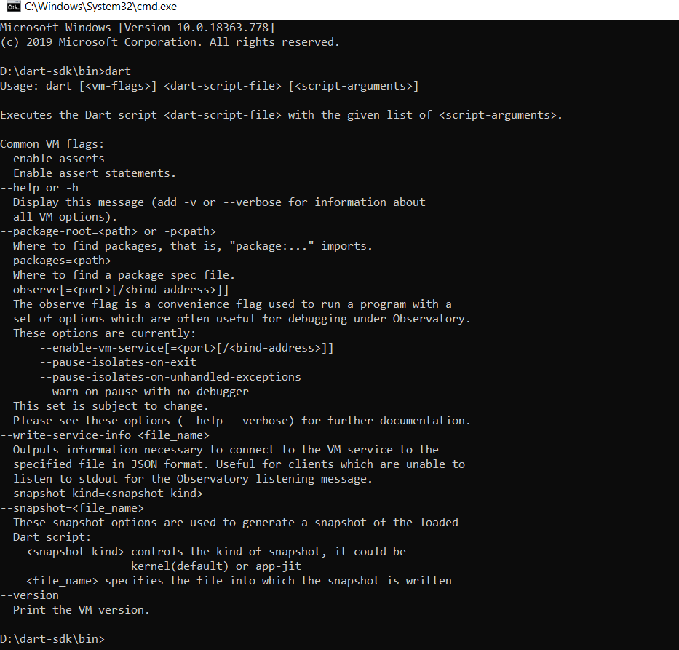

And now we are ready to use dart through bin folder but setting up the path in environment variables will ease our task of Step3 and we can run dart from anywhere in the file system using command prompt.

Step 4: Setting up path in environment variables. Open Environment Variables from advanced system settings and add Path in System Variables as depicted in image:
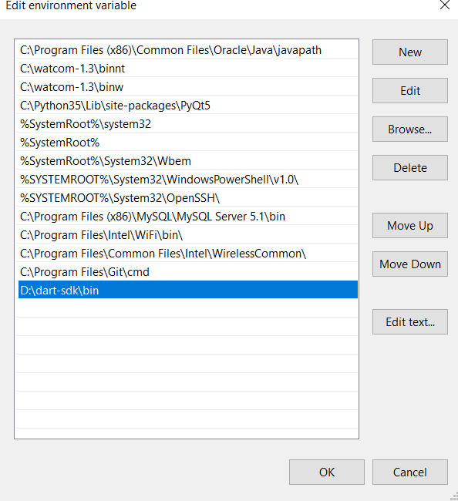

Now we are done to use Dart from anywhere in the file system.

Step 5: Run Dart Using cmd
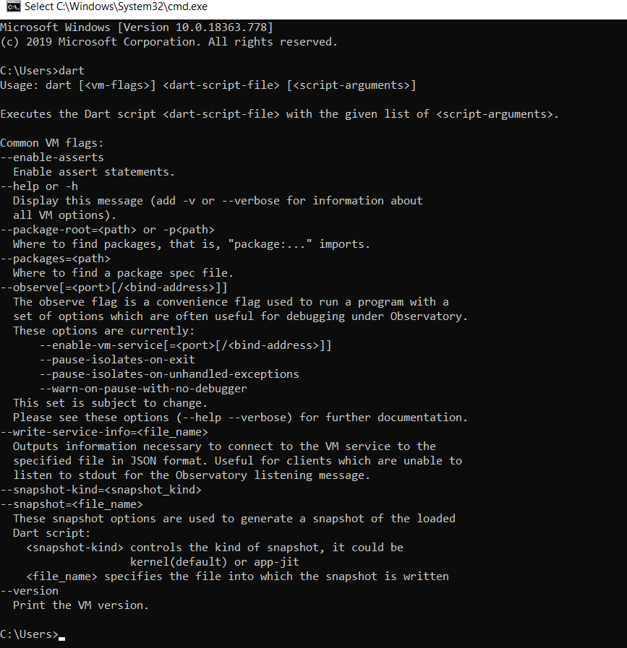

Result: Installation of Flutter and Dart SDK is successfully completed

1b) Write a simple Dart program to understand the language basics.
Aim: Write a simple Dart program to understand the language basics.
Description:
Dart is a modern, object-oriented programming language developed by Google, primarily used for building Flutter applications. It is statically typed, meaning variable types are checked at compile time, but it also supports type inference for simplicity. Dart combines features from many popular languages, offering clean syntax, strong typing, and asynchronous programming capabilities.

Key concepts in Dart include variables for storing data, functions for executing reusable logic, control flow statements like loops and conditionals for decision-making, and classes and objects for object-oriented programming. Dart also provides collections such as lists, sets, and maps for handling multiple values efficiently.

Dart is designed to be easy to learn, readable, and suitable for creating high-performance, cross-platform applications.

Program:
void main(){
var firstName = "John"; var lastName = "Doe";
print("Full name is $firstName $lastName");
}
Output: Full name is John Doe
void main() {
int num1 = 10;
int num2 = 3;
// Calculation
int sum = num1 + num2;
int diff = num1 - num2; int mul = num1 * num2;
double div = num1 / num2; // It is double because it outputs number with decimal.
// displaying the output
print("The sum is $sum");
print("The diff is $diff");
print("The mul is $mul");
print("The div is $div");
}

Output:
The sum is 13
The diff is 7
The mul is 30
The div is 3.3333333333333335

import 'dart:io';
void main() {
print("Enter number:");
int? number = int.parse(stdin.readLineSync()!);
print("The entered number is ${number}");
}

Output:
Enter number:
50
The entered number is 50

Result: A simple Dart program to understand the language basics is successfully completed.

WEEK-2
2. a) Explore various Flutter widgets (Text, Image, Container, etc.).

Aim: To explore various Flutter widgets (Text, Image, Container, etc.).

Description:
Flutter uses widgets as the fundamental building blocks of its user interface. Everything in Flutter, from text and images to buttons and containers, is a widget. Widgets can be stateless, which do not change over time, or stateful, which can update dynamically based on user interaction or data changes.
There are several types of widgets in Flutter:
- Structural Widgets: Define the UI structure, e.g., Scaffold, AppBar.
- Functional Widgets: Handle functionality, e.g., Button, TextField.
- Styling Widgets: Add visual styling, e.g., Container, Padding.
- Layout Widgets: Arrange other widgets, e.g., Row, Column, Stack, GridView.
- Interactive Widgets: Respond to user input, e.g., GestureDetector, InkWell.
By combining these widgets and layouts, developers can create flexible, responsive, and visually appealing interfaces for mobile, web, and desktop applications.

Program:
Text Widget:
import 'package:flutter/material.dart';
// function to trigger build process
void main() => runApp(const GeeksforGeeks());
class GeeksforGeeks extends StatelessWidget {
const GeeksforGeeks({Key? key}) : super(key: key);
@override
Widget build(BuildContext context) {
return MaterialApp(
home: Scaffold(
backgroundColor: Colors.lightGreen,
appBar: AppBar(
backgroundColor: Colors.green,
title: const Text("Welcome Screen"),
), // AppBar
body: Container(
child: const Center(
child: Text(
"Hello world!!",
style: TextStyle(
fontSize: 26,
color: Colors.white,
fontWeight: FontWeight.bold,
),
),
), // Center
), // Container
), // Scaffold
); // MaterialApp
}
}
Output:
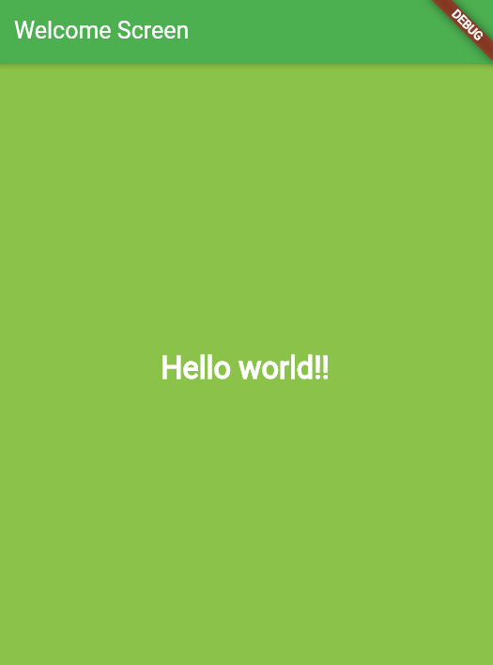

Image Widget:
import 'package:flutter/material.dart';
// function to start app building
void main() => runApp(const MyApp());
class MyApp extends StatelessWidget {
const MyApp({Key? key}) : super(key: key);
// This widget is the root of your application
@override
Widget build(BuildContext context) {
return MaterialApp(
home: Scaffold(
appBar: AppBar(
title: const Text('Insert Image Demo'),
),
body: Center(
child: Column(
children: <Widget>[
Image.asset(
'assets/images/output.gif',
height: 200,
scale: 2.5,
// color: Color.fromARGB(255, 15, 147, 59),
opacity: const AlwaysStoppedAnimation<double>(0.5),
), // Image.asset

Image.asset(
'assets/images/geeksforgeeks.jpg',
height: 400,
width: 400,
), // Image.asset
], //<Widget>[]
), // Column
), // Center
), // Scaffold
); // MaterialApp
}
}

Output:
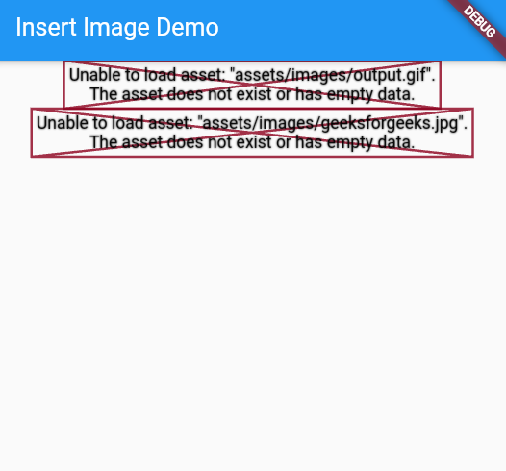

Container Widget:
import 'package:flutter/material.dart';
void main() => runApp(const MyApp());
class MyApp extends StatelessWidget {
const MyApp({Key? key}) : super(key: key);
@override
Widget build(BuildContext context) {
return MaterialApp(
home: Scaffold(
appBar: AppBar(
title: const Text("Container Example"),
),
body: Container(
height: 200,
width: double.infinity,
// color: Colors.purple,
alignment: Alignment.center,
margin: const EdgeInsets.all(20),
padding: const EdgeInsets.all(30),
decoration: BoxDecoration(
border: Border.all(color: Colors.black, width: 3),
),
child: const Text(
"Hello! I am inside a container!",
style: TextStyle(fontSize: 20),
),
),
),
);
}
}
Output:
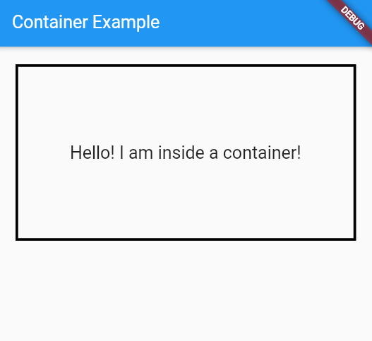

Result: Exploring various Flutter widgets (Text, Image, Container, etc.) is successfully completed.

2b) Implement different layout structures using Row, Column, and Stack widgets
Aim: Implement different layout structures using Row, Column, and Stack widgets
Description:
In Flutter, layout widgets are used to arrange other widgets on the screen. Three commonly used layout widgets are Row, Column, and Stack.
- Row arranges its child widgets horizontally in a single line. It is useful for creating horizontal menus, buttons, or icon layouts.
- Column arranges its child widgets vertically in a single column. It is commonly used for forms, lists, or stacking content from top to bottom.
- Stack allows widgets to be overlapped on top of each other. It is useful for creating complex UI designs like floating buttons, banners, or layered graphics.
By combining these layout widgets with properties like alignment, padding, and spacing, developers can design flexible, responsive, and visually appealing user interfaces in Flutter.
Program:
Row Widget:
import 'package:flutter/material.dart';

void main() {
runApp(MyApp());
}

class MyApp extends StatelessWidget {
@override
Widget build(BuildContext context) {
return MaterialApp(
home: MyHomePage(),
debugShowCheckedModeBanner: false,
);
}
}

class MyHomePage extends StatefulWidget {
@override
_MyHomePageState createState() => _MyHomePageState();
}

class _MyHomePageState extends State<MyHomePage> {
@override
Widget build(BuildContext context) {
return Scaffold(
appBar: AppBar(
title: const Text("Flutter Row Example"),
backgroundColor: Colors.green,
),
body: Center(
child: Row(
mainAxisAlignment: MainAxisAlignment.spaceEvenly,
children: <Widget>[
// First Container
Container(
margin: const EdgeInsets.all(12.0),
padding: const EdgeInsets.all(8.0),
decoration: BoxDecoration(
borderRadius: BorderRadius.circular(8),
color: Colors.green,
),
child: const Text(
"React.js",
style: TextStyle(
color: Colors.yellowAccent,
fontSize: 25,
),
),
),

// Second Container
Container(
margin: const EdgeInsets.all(12.0),
padding: const EdgeInsets.all(8.0),
decoration: BoxDecoration(
borderRadius: BorderRadius.circular(8),
color: Colors.green,
),
child: const Text(
"Node.js",
style: TextStyle(
color: Colors.yellowAccent,
fontSize: 25,
),
),
),

// Third Container
Container(
margin: const EdgeInsets.all(12.0),
padding: const EdgeInsets.all(8.0),
decoration: BoxDecoration(
borderRadius: BorderRadius.circular(8),
color: Colors.green,
),
child: const Text(
"Flutter",
style: TextStyle(
color: Colors.yellowAccent,
fontSize: 25,
),
),
),
],
),
),
);
}
}
Output:
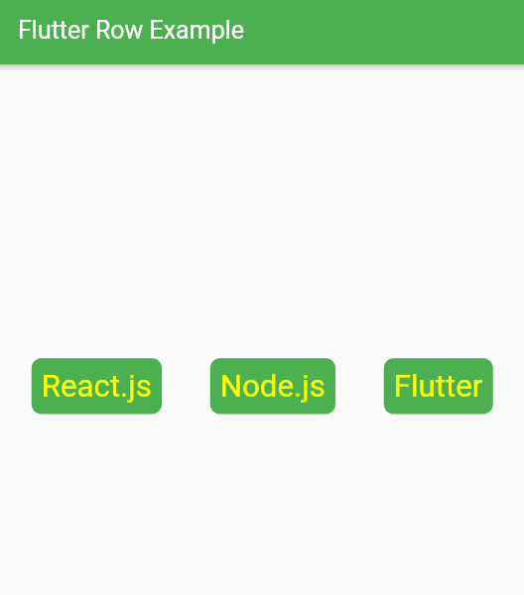

Column Widget:
import 'package:flutter/material.dart';

void main() {
runApp(MyApp());
}

class MyApp extends StatelessWidget {
@override
Widget build(BuildContext context) {
return MaterialApp(
home: MyHomePage(),
debugShowCheckedModeBanner: false,
);
}
}

class MyHomePage extends StatefulWidget {
@override
_MyHomePageState createState() => _MyHomePageState();
}

class _MyHomePageState extends State<MyHomePage> {
@override
Widget build(BuildContext context) {
return Scaffold(
appBar: AppBar(
title: const Text("Flutter Column Example"),
backgroundColor: Colors.red,
),
body: Center(
child: Column(
mainAxisAlignment: MainAxisAlignment.spaceBetween,
children: <Widget>[
// First Container
Container(
margin: const EdgeInsets.all(20.0),
padding: const EdgeInsets.all(12.0),
decoration: BoxDecoration(
borderRadius: BorderRadius.circular(8),
color: Colors.red,
),
child: const Text(
"MySQL",
style: TextStyle(
color: Colors.yellowAccent,
fontSize: 20,
),
),
),

// Second Container
Container(
margin: const EdgeInsets.all(20.0),
padding: const EdgeInsets.all(12.0),
decoration: BoxDecoration(
borderRadius: BorderRadius.circular(8),
color: Colors.red,
),
child: const Text(
"React.js",
style: TextStyle(
color: Colors.yellowAccent,
fontSize: 20,
),
),
),

// Third Container
Container(
margin: const EdgeInsets.all(20.0),
padding: const EdgeInsets.all(12.0),
decoration: BoxDecoration(
borderRadius: BorderRadius.circular(8),
color: Colors.red,
),
child: const Text(
"Flutter",
style: TextStyle(
color: Colors.yellowAccent,
fontSize: 20,
),
),
),
],
),
),
);
}
}
Output:
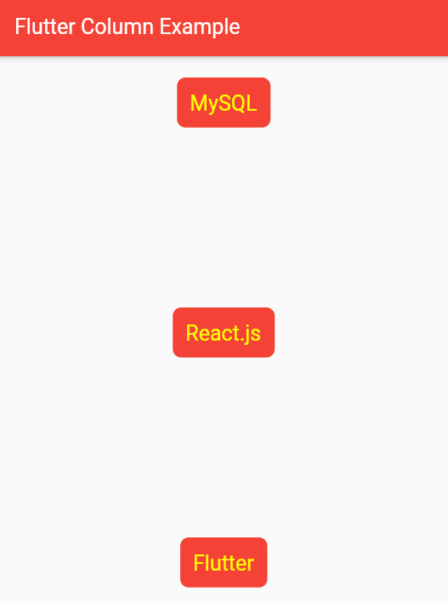

Stack Widget:
import 'package:flutter/material.dart';
void main() {
runApp(
MaterialApp(
home: Scaffold(
appBar: AppBar(
title: const Text('GeeksforGeeks'),
backgroundColor: Colors.greenAccent,
), // AppBar
body: Center(
child: SizedBox(
width: 300,
height: 300,
child: Center(
child: Stack(
children: <Widget>[
Container(
width: 300,
height: 300,
color: Colors.red,
), // Container
Container(
width: 250,
height: 250,
color: Colors.black,
), // Container
Container(
width: 200,
height: 200,
color: Colors.purple,
), // Container
], // <Widget>[]
), // Stack
), // Center
), // SizedBox
), // Center
), // Scaffold
), // MaterialApp
);
}
Output:
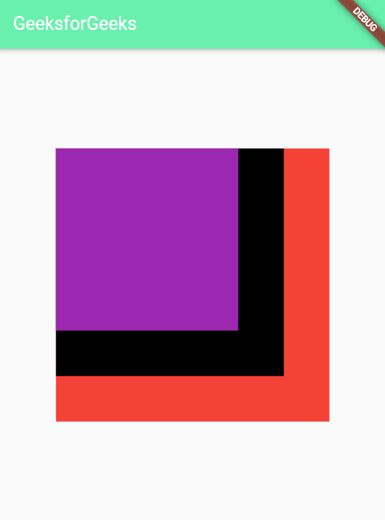
Result: Implementation of different layout structures using Row, Column, and Stack widgets is successfully completed.

WEEK-3
3. a) Design a responsive UI that adapts to different screen sizes.

Aim: Implement different layout structures using Row, Column, and Stack widgets
Description:
A responsive UI automatically adjusts its layout and content to fit different screen sizes and orientations, ensuring a consistent experience across devices like phones, tablets, and desktops.
In Flutter, you can achieve responsiveness using:
- MediaQuery to get information about screen size, orientation, and pixel density.
- Flexible and Expanded widgets to allow widgets to resize dynamically and fill available space.
- LayoutBuilder to adapt layouts based on the parent widget’s constraints.
- OrientationBuilder to modify UI when switching between portrait and landscape modes.
- AspectRatio and FittedBox to maintain proportions and scale content properly.
By combining these tools with scrollable widgets and relative sizing, developers can create flexible, adaptive, and user-friendly interfaces that look good on any device.
Program:
import 'package:flutter/material.dart';

void main() => runApp(const ResponsiveUIApp());
class ResponsiveUIApp extends StatelessWidget {
const ResponsiveUIApp({Key? key}) : super(key: key);
@override
Widget build(BuildContext context) {
return MaterialApp(
debugShowCheckedModeBanner: false,
title: 'Responsive UI Demo',
home: const ResponsiveHome(),
);
}
}
class ResponsiveHome extends StatelessWidget {
const ResponsiveHome({Key? key}) : super(key: key);
@override
Widget build(BuildContext context) {
// Get screen width
double screenWidth = MediaQuery.of(context).size.width;

// Determine device type based on width
bool isMobile = screenWidth < 600;
bool isTablet = screenWidth >= 600 && screenWidth < 1024;
bool isDesktop = screenWidth >= 1024;
// Set card width dynamically
double cardWidth = isMobile
? screenWidth * 0.9
: isTablet
? screenWidth * 0.45
: screenWidth * 0.25;

return Scaffold(
appBar: AppBar(
title: const Text("Responsive UI Example"),
backgroundColor: Colors.teal,
),
body: SingleChildScrollView(
child: Column(
children: [
const SizedBox(height: 20),
// Header
Container(
width: double.infinity,
padding: const EdgeInsets.all(16),
color: Colors.teal[100],
child: const Center(
child: Text(
"Welcome to Responsive Flutter UI",
style: TextStyle(fontSize: 24, fontWeight: FontWeight.bold),
textAlign: TextAlign.center,
),
),
),
const SizedBox(height: 20),
// Responsive cards using Wrap
Wrap(
spacing: 16,
runSpacing: 16,
alignment: WrapAlignment.center,
children: List.generate(
6,
(index) => Container(
width: cardWidth,
height: 150,
decoration: BoxDecoration(
color: Colors.teal[300],
borderRadius: BorderRadius.circular(12),
),
child: Center(
child: Text(
"Card ${index + 1}",
style: const TextStyle(
fontSize: 20,
color: Colors.white,
),
),
),
),
),
),
const SizedBox(height: 20),
// Footer
Container(
width: double.infinity,
padding: const EdgeInsets.all(16),
color: Colors.teal[200],
child: const Center(
child: Text(
"© 2025 Responsive UI Example",
style: TextStyle(fontSize: 16),
),
),
),
],
),
),
);
}
}
Output:

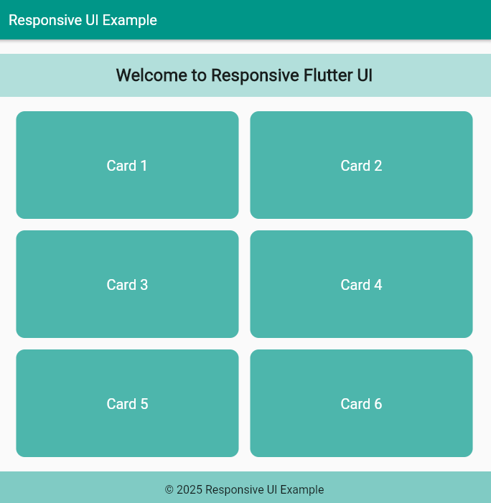

Result: Designing a responsive UI that adapts to different screen sizes is successfully completed.

3 b) Implement media queries and breakpoints for responsiveness.
Aim: To implement media queries and breakpoints for responsiveness
Description:
In Flutter, media queries and breakpoints are used to make user interfaces responsive across different screen sizes and orientations.
- MediaQuery provides information about the device’s screen dimensions, orientation, and pixel density. Using this, developers can dynamically adjust widget sizes, padding, margins, and font sizes to fit any screen.
- Breakpoints define thresholds for different screen sizes, such as mobile, tablet, or desktop. By checking the screen width against these breakpoints, you can implement adaptive layouts that change the UI structure or widget arrangement depending on the device.
Combining media queries and breakpoints ensures that the UI is flexible, readable, and user-friendly on all devices, providing a consistent and optimized experience.
Program:
import 'package:flutter/material.dart';

void main() => runApp(const ResponsiveBreakpointsApp());

class ResponsiveBreakpointsApp extends StatelessWidget {
const ResponsiveBreakpointsApp({Key? key}) : super(key: key);

@override
Widget build(BuildContext context) {
return MaterialApp(
debugShowCheckedModeBanner: false,
title: 'Responsive UI with Breakpoints',
home: const HomePage(),
);
}
}

class HomePage extends StatelessWidget {
const HomePage({Key? key}) : super(key: key);

@override
Widget build(BuildContext context) {
// Get screen width
double screenWidth = MediaQuery.of(context).size.width;

// Define breakpoints
bool isMobile = screenWidth < 600;
bool isTablet = screenWidth >= 600 && screenWidth < 1024;
bool isDesktop = screenWidth >= 1024;

return Scaffold(
appBar: AppBar(
title: const Text("Responsive UI Example"),
backgroundColor: Colors.teal,
),
body: Center(
child: Column(
mainAxisAlignment: MainAxisAlignment.center,
children: [
// Header
Text(
"Screen Width: ${screenWidth.toStringAsFixed(0)} px",
style: const TextStyle(fontSize: 20),
),
const SizedBox(height: 20),

// Adaptive Layout
if (isMobile)
buildBox("Mobile Layout", Colors.orange, screenWidth * 0.8)
else if (isTablet)
buildBox("Tablet Layout", Colors.blue, screenWidth * 0.6)
else if (isDesktop)
buildBox("Desktop Layout", Colors.green, screenWidth * 0.4),
],
),
),
);
}
Widget buildBox(String text, Color color, double width) {
return Container(
width: width,
height: 150,
decoration: BoxDecoration(
color: color,
borderRadius: BorderRadius.circular(12),
),
child: Center(
child: Text(
text,
style: const TextStyle(fontSize: 24, color: Colors.white),
),
),
);
}
}

Output:

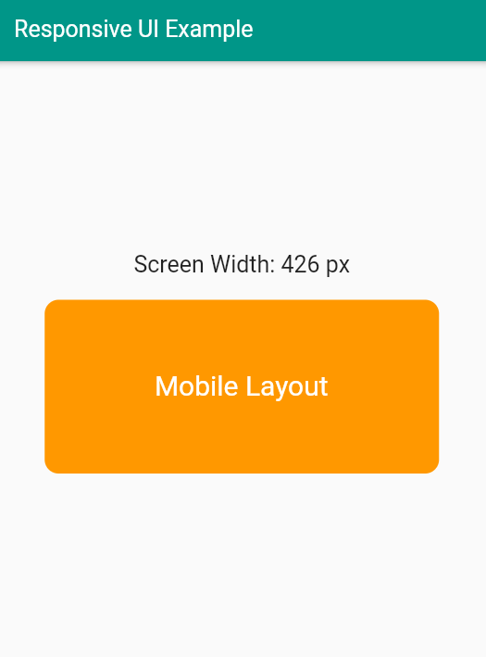

Result: Implementation of media queries and breakpoints for responsiveness is successfully executed.

WEEK-4
4 a) Set up navigation between different screens using Navigator.
Aim: Set up navigation between different screens using Navigator.
Description:
In Flutter, navigation between screens is managed using the Navigator widget, which maintains a stack of routes. Each screen in the app is represented by a route, and the Navigator allows you to move forward to a new screen or back to a previous one, maintaining the navigation history.
- Navigate to a new screen: Push a new screen onto the stack using:
Navigator.push(context, MaterialPageRoute(builder: (context) => SecondScreen()))
This displays the new screen on top of the current one.
- Return to the previous screen: Pop the current screen from the stack using:
Navigator.pop(context)
- Passing data between screens: Navigator also allows sending and receiving data when moving between screens, which helps in dynamic content updates and interactive UIs.
Using Navigator, developers can build multi-screen applications with smooth transitions, structured navigation flow, and intuitive user experiences. It is a foundational tool in Flutter for managing screen flows, handling back actions, and creating both simple and complex navigation patterns.
Program:
import 'package:flutter/material.dart';
void main() => runApp(const NavigationDemoApp());
class NavigationDemoApp extends StatelessWidget {
const NavigationDemoApp({Key? key}) : super(key: key);
@override
Widget build(BuildContext context) {
return MaterialApp(
debugShowCheckedModeBanner: false,
title: 'Navigator Demo',
home: const HomeScreen(),
);
}
}
// ------------------- Home Screen -------------------
class HomeScreen extends StatelessWidget {
const HomeScreen({Key? key}) : super(key: key);
@override
Widget build(BuildContext context) {
return Scaffold(
appBar: AppBar(
title: const Text("Home Screen"),
backgroundColor: Colors.teal,
),
body: Center(
child: Column(
mainAxisAlignment: MainAxisAlignment.center,
children: [
const Text(
"Welcome to Home Screen",
style: TextStyle(fontSize: 24),
),
const SizedBox(height: 20),
ElevatedButton(
onPressed: () {
// Navigate to Second Screen
Navigator.push(
context,
MaterialPageRoute(builder: (context) => const SecondScreen()),
);
},
child: const Text("Go to Second Screen"),
),
],
),
),
);
}
}
// ------------------- Second Screen -------------------
class SecondScreen extends StatelessWidget {
const SecondScreen({Key? key}) : super(key: key);
@override
Widget build(BuildContext context) {
return Scaffold(
appBar: AppBar(
title: const Text("Second Screen"),
backgroundColor: Colors.orange,
),
body: Center(
child: Column(
mainAxisAlignment: MainAxisAlignment.center,
children: [
const Text(
"You are on the Second Screen",
style: TextStyle(fontSize: 24),
),
const SizedBox(height: 20),
ElevatedButton(
onPressed: () {
// Go back to previous screen
Navigator.pop(context);
},
child: const Text("Go Back"),
),
],
),
),
);
}
}

Output:
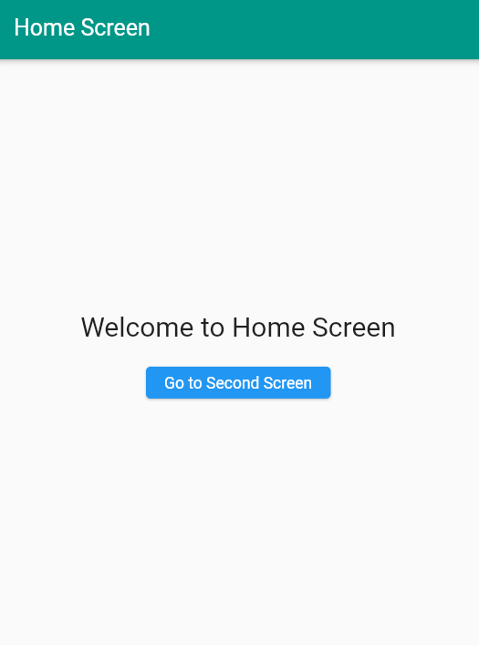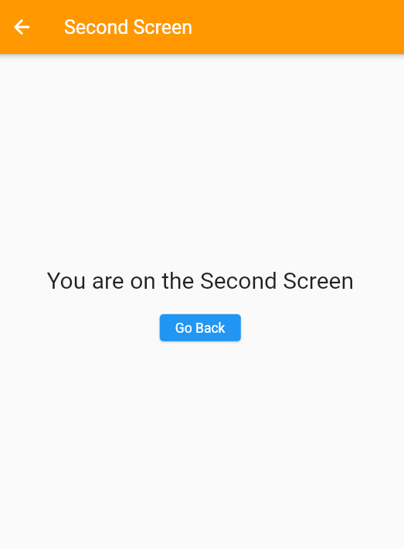

Result: Setting up navigation between different screens using Navigator is successfully executed.

4 b) Implement navigation with named routes.
Aim: Implement navigation with named routes.
Description:
In Flutter, named routes provide a convenient way to navigate between screens using string identifiers instead of directly passing widget instances. Named routes make navigation more organized, maintainable, and scalable, especially for apps with multiple screens.
- Defining routes: All routes are declared in the MaterialApp widget using the routes property. Each route maps a string name to a corresponding screen widget.
- Navigating to a screen: You can navigate to a screen using Navigator.pushNamed(context, '/routeName').
- Returning to the previous screen: Use Navigator.pop(context) as usual to go back.
- Passing arguments: Named routes can also receive data through the arguments property, allowing dynamic content on the destination screen.
Using named routes makes it easier to manage complex navigation flows, ensures consistency across the app, and separates route definitions from widget logic, improving code readability and maintainability.

Program:
import 'package:flutter/material.dart';
void main() => runApp(const NamedRoutesApp());

class NamedRoutesApp extends StatelessWidget {
const NamedRoutesApp({Key? key}) : super(key: key);
@override
Widget build(BuildContext context) {
return MaterialApp(
debugShowCheckedModeBanner: false,
title: 'Named Routes Demo',

// Define routes
initialRoute: '/',
routes: {
'/': (context) => const HomeScreen(),
'/second': (context) => const SecondScreen(),
},
);
}
}

// ------------------- Home Screen -------------------
class HomeScreen extends StatelessWidget {
const HomeScreen({Key? key}) : super(key: key);

@override
Widget build(BuildContext context) {
return Scaffold(
appBar: AppBar(
title: const Text("Home Screen"),
backgroundColor: Colors.teal,
),
body: Center(
child: Column(
mainAxisAlignment: MainAxisAlignment.center,
children: [
const Text(
"Welcome to Home Screen",
style: TextStyle(fontSize: 24),
),
const SizedBox(height: 20),
ElevatedButton(
onPressed: () {
// Navigate to Second Screen using named route
Navigator.pushNamed(context, '/second');
},
child: const Text("Go to Second Screen"),
),
],
),
),
);
}
}

// ------------------- Second Screen -------------------
class SecondScreen extends StatelessWidget {
const SecondScreen({Key? key}) : super(key: key);

@override
Widget build(BuildContext context) {
return Scaffold(
appBar: AppBar(
title: const Text("Second Screen"),
backgroundColor: Colors.orange,
),
body: Center(
child: Column(
mainAxisAlignment: MainAxisAlignment.center,
children: [
const Text(
"You are on the Second Screen",
style: TextStyle(fontSize: 24),
),
const SizedBox(height: 20),
ElevatedButton(
onPressed: () {
// Go back to previous screen
Navigator.pop(context);
},
child: const Text("Go Back"),
),
],
),
),
);
}
}

Output:
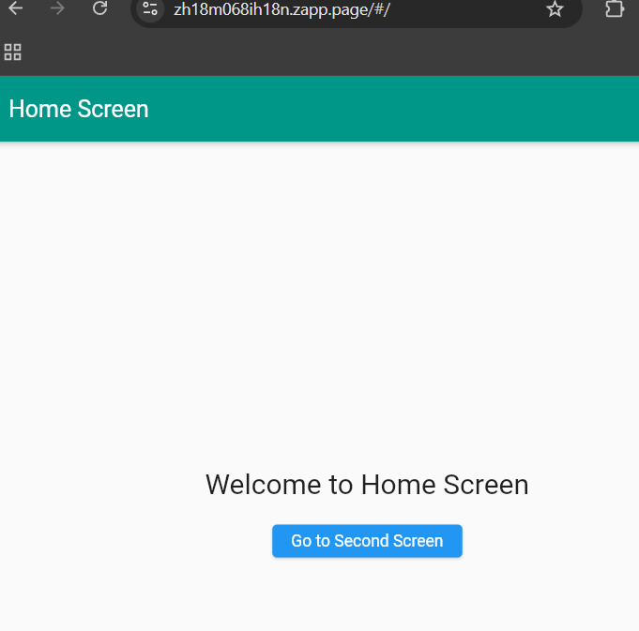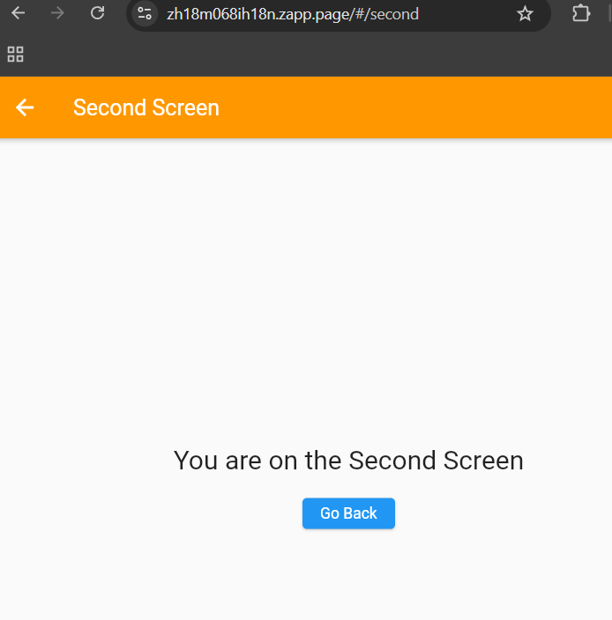

Result: Implementation of navigation with named routes is successfully executed.

WEEK-5
5.a) Learn about stateful and stateless widgets.
Aim: Learn about stateful and stateless widgets.
Description:
In Flutter, widgets are the fundamental building blocks of the user interface, and they come in two main types: stateless and stateful.
- Stateless Widgets
  - Definition: A stateless widget is immutable, meaning its properties cannot change once it is built.
  - Use Case: Ideal for static UI elements that do not depend on user interaction or dynamic data, such as labels, icons, or fixed images.
  - Example Behavior: When the app’s state changes, stateless widgets do not rebuild automatically.
- Stateful Widgets
  - Definition: A stateful widget can change its internal state over time, and the UI updates automatically when the state changes.
  - Use Case: Suitable for dynamic UI components like counters, forms, checkboxes, sliders, and animations that respond to user interaction.
  - Example Behavior: Uses a State object to manage the widget’s state, and calling setState() triggers a rebuild of the UI.
Understanding the difference between stateless and stateful widgets is crucial for building efficient Flutter applications. Stateless widgets are lightweight and simple, while stateful widgets provide interactivity and dynamic behavior, allowing developers to create responsive and interactive user interfaces.

Program:
import 'package:flutter/material.dart';
void main() {
runApp(MyApp());
}
class MyApp extends StatelessWidget {
@override
Widget build(BuildContext context) {
return MaterialApp(
title: 'Stateful and Stateless Example',
theme: ThemeData(
primarySwatch: Colors.blue,
),
home: MyHomePage(),
);
}
}

// ------------------- Stateful Widget -------------------
class MyHomePage extends StatefulWidget {
@override
_MyHomePageState createState() => _MyHomePageState();
}

class _MyHomePageState extends State<MyHomePage> {
int counter = 0;
void incrementCounter() {
setState(() {
counter++;
});
}
@override
Widget build(BuildContext context) {
return Scaffold(
appBar: AppBar(
title: const Text('Stateful and Stateless Example'),
),
body: Center( // Center the entire column
child: Column(
mainAxisSize: MainAxisSize.min, // Center vertically
children: <Widget>[
CounterDisplay(counter),
const SizedBox(height: 20),
CounterButton(incrementCounter),
],
),
),
);
}
}

// ------------------- Stateless Widget for Display -------------------
class CounterDisplay extends StatelessWidget {
final int count;
const CounterDisplay(this.count, {Key? key}) : super(key: key);

@override
Widget build(BuildContext context) {
return Text(
'Counter Value: $count',
style: const TextStyle(fontSize: 24, fontWeight: FontWeight.bold),
);
}
}

// ------------------- Stateless Widget for Button -------------------
class CounterButton extends StatelessWidget {
final VoidCallback onPressed;
const CounterButton(this.onPressed, {Key? key}) : super(key: key);

@override
Widget build(BuildContext context) {
return ElevatedButton(
onPressed: onPressed,
child: const Text('Increment Counter', style: TextStyle(fontSize: 18)),
);
}
}

Output:
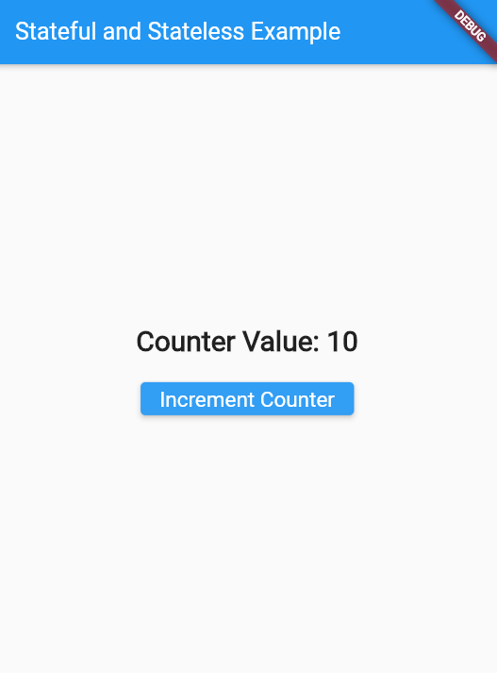

Result: Learning about stateful and stateless widgets is successfully completed.

5 b) Implement state management using set State and Provider.
Aim: Implement state management using set State and Provider.
Description:
In Flutter, state management is the process of handling data changes and updating the UI efficiently. Proper state management ensures that the app remains responsive, consistent, and easy to maintain.
- setState
  - Used in stateful widgets to manage local state.
  - Calling setState(() { /* update state */ }) rebuilds the widget to reflect the changes.
  - Best suited for simple or temporary state that only affects a single widget or its immediate children.
  - Limitation: Cannot easily share state across multiple screens or unrelated widgets.
- Provider
  - A state management library that allows global or shared state across the entire app.
  - Uses ChangeNotifier to hold state and notify listening widgets whenever changes occur.
  - Ideal for more complex scenarios where multiple screens or widgets need access to the same data, such as user authentication, shopping carts, or theme settings.
  - Helps keep code organized, scalable, and maintainable by separating UI from business logic.
By combining setState for local updates and Provider for shared or complex state, Flutter developers can create apps that are efficient, responsive, and scalable, providing a smooth and consistent user experience.

Program:
import 'package:flutter/material.dart';

void main(){
runApp(const MyApp());
}

class MyApp extends StatefulWidget{
const MyApp({super.key});

@override
State<MyApp> createState()=> MyAppState();
}

class MyAppState extends State<MyApp>{
//Default Theme is light
bool isDark = false;

@override
Widget build(BuildContext context){
return MaterialApp(
title: 'Theme Toggle Demo',
debugShowCheckedModeBanner: false,//Removes Debug debugShowCheckedModeBanner
theme: ThemeData(
brightness: Brightness.light,
primarySwatch: Colors.green,
),
darkTheme: ThemeData(
brightness: Brightness.dark,
primarySwatch: Colors.red,
),
themeMode: isDark ? ThemeMode.dark : ThemeMode.light,//Toggle
home:Scaffold(
appBar:AppBar(
title: const Text("Theme Toggle Demo"),
actions: [
Switch(
value: isDark,
onChanged: (value){
setState((){
isDark=value;
});
},
),
],
),
body: const Center(
child: Text(
"Hello, Flutter Themes!",
style: TextStyle(fontSize:24,fontWeight:FontWeight.bold),
),
),
),
);
}
}

Output:
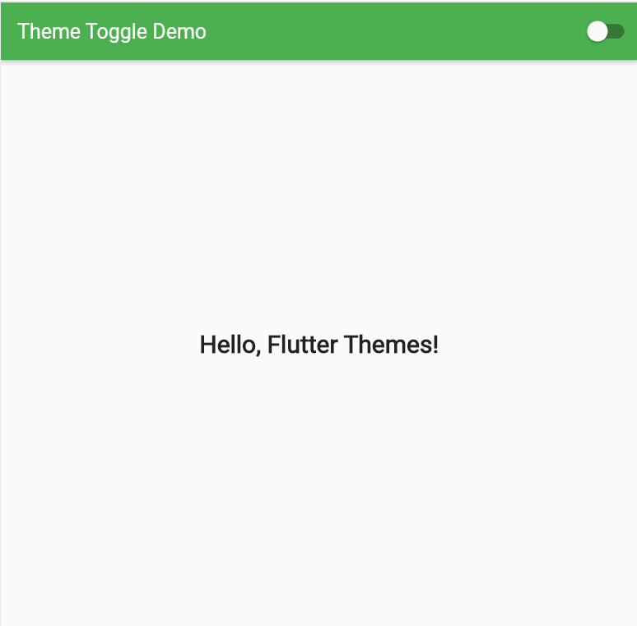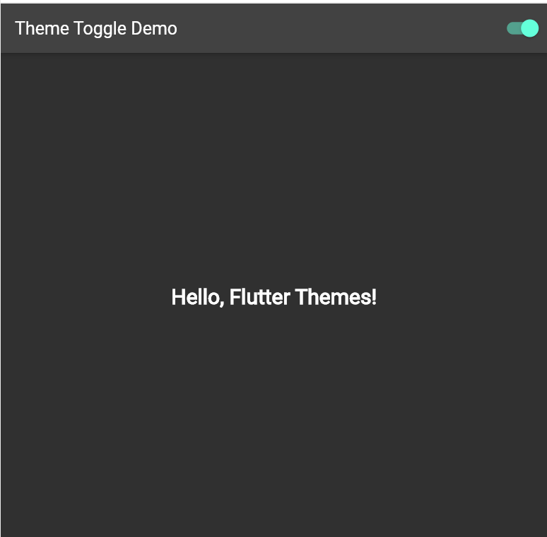

Result: Implementing state management using set State and Provider is successfully completed.

WEEK-6
6.a) Create custom widgets for specific UI elements.
Aim: Create custom widgets for specific UI elements.
Description:
In Flutter, custom widgets allow developers to create reusable, modular components for the user interface. Instead of writing the same code repeatedly, you can encapsulate design and functionality into a single widget that can be used throughout the app.
- Definition: A custom widget is a user-defined widget that combines Flutter’s built-in widgets, styling, and behavior to create a specific UI component.
- Benefits:
  - Reusability: Use the same widget in multiple places without rewriting code.
  - Maintainability: Changes to the widget automatically reflect wherever it is used.
  - Readability: Simplifies complex UIs by breaking them into smaller, manageable pieces.
- Use Cases: Buttons with custom styles, card layouts, input fields, alert dialogs, profile cards, and any consistent UI element across the app.
- Types: Custom widgets can be stateless (if they don’t change) or stateful (if they maintain internal state).
Creating custom widgets is essential for clean, organized, and scalable Flutter apps, allowing developers to maintain a consistent design system and improve development efficiency.
Program:
import 'package:flutter/material.dart';

// ------------------- Custom Button -------------------
class CustomButton extends StatelessWidget {
final String text;
final VoidCallback onPressed;
final Color buttonColor;
final Color textColor;

const CustomButton({
Key? key,
required this.text,
required this.onPressed,
this.buttonColor = Colors.blue,
this.textColor = Colors.white,
}) : super(key: key);

@override
Widget build(BuildContext context) {
return ElevatedButton(
onPressed: onPressed,
style: ButtonStyle(
backgroundColor: MaterialStateProperty.all<Color>(buttonColor),
foregroundColor: MaterialStateProperty.all<Color>(textColor),
),
child: Text(text),
);
}
}

// ------------------- Main App -------------------
void main() {
runApp(const MyApp());
}

class MyApp extends StatelessWidget {
const MyApp({Key? key}) : super(key: key);

@override
Widget build(BuildContext context) {
return MaterialApp(
debugShowCheckedModeBanner: false,
home: const HomeScreen(),
);
}
}

// ------------------- Home Screen -------------------
class HomeScreen extends StatelessWidget {
const HomeScreen({Key? key}) : super(key: key);

void _showWarning(BuildContext context) {
final snackBar = SnackBar(
content: const Text(
'Button Pressed!',
style: TextStyle(fontWeight: FontWeight.bold),
),
backgroundColor: Color.fromARGB(255, 0, 0, 0),
duration: const Duration(seconds: 2),
behavior: SnackBarBehavior.floating,
);

ScaffoldMessenger.of(context).showSnackBar(snackBar);
}

@override
Widget build(BuildContext context) {
return Scaffold(
appBar: AppBar(
title: const Text('Custom Button Example'),
),
body: Center(
child: CustomButton(
text: 'Click Me',
onPressed: () => _showWarning(context),
),
),
);
}
}

Output:
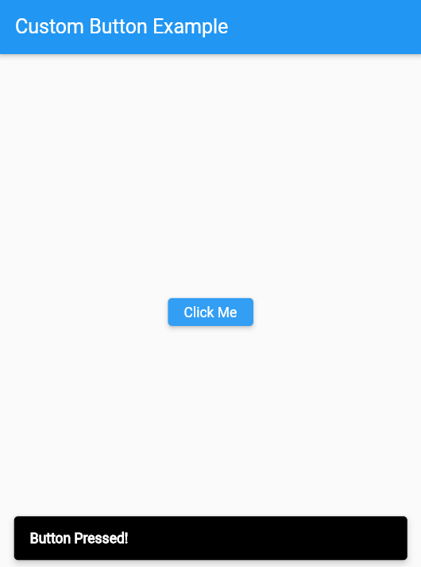

Result: Creating custom widgets for specific UI elements is successfully completed.

6.b) Apply styling using themes and custom styles.
Aim: Apply styling using themes and custom styles.
Description:
In Flutter, themes and custom styles provide a way to maintain a consistent look and feel across the entire application. Instead of styling individual widgets repeatedly, you can define global styles that can be applied throughout the app.
- Themes:
  - Defined using the ThemeData class in the MaterialApp widget.
  - Allows you to set primary colors, accent colors, text styles, button styles, and more globally.
  - Makes it easy to maintain a consistent design and quickly change the app’s appearance.
- Custom Styles:
  - Individual widgets can have customized properties like font size, font family, colors, padding, and borders.
  - Custom styles can be combined with themes to override global defaults for specific widgets.
- Benefits:
  - Consistency: Ensures uniform styling across all screens.
  - Maintainability: Changing a theme or style updates all associated widgets automatically.
  - Efficiency: Reduces repetitive code and improves scalability.

Program:
import 'package:flutter/material.dart';

void main() {
runApp(const MyApp());
}

class MyApp extends StatelessWidget {
const MyApp({super.key});

@override
Widget build(BuildContext context) {
return MaterialApp(
title: 'Theme & Custom Styles Demo',

// Global Theme
theme: ThemeData(
primaryColor: Colors.blue,
colorScheme: ColorScheme.fromSeed(
seedColor: Colors.blue,
brightness: Brightness.light,
),
textTheme: const TextTheme(
headline6: TextStyle(
fontSize: 24,
fontWeight: FontWeight.bold,
color: Colors.black,
),
bodyText2: TextStyle(
fontSize: 16,
color: Colors.black87,
),
),
),

home: const HomeScreen(),
);
}
}

class HomeScreen extends StatelessWidget {
const HomeScreen({super.key});

@override
Widget build(BuildContext context) {
return Scaffold(
appBar: AppBar(
title: Text(
'Theme & Custom Styles',
style: Theme.of(context).textTheme.headline6, // Using theme style
),
backgroundColor: Theme.of(context).colorScheme.primary,
),
body: Center(
child: Column(
mainAxisAlignment: MainAxisAlignment.center,
children: [
// Using global theme style
Text(
'Hello, Flutter!',
style: Theme.of(context).textTheme.bodyText2,
),
const SizedBox(height: 20),

// Custom style overriding the theme
Text(
'Custom Styled Text',
style: const TextStyle(
fontSize: 20,
fontWeight: FontWeight.bold,
color: Colors.green,
fontStyle: FontStyle.italic,
),
),
const SizedBox(height: 20),

// Button with custom style
ElevatedButton(
onPressed: () {},
style: ElevatedButton.styleFrom(
backgroundColor: Colors.orange, // custom color
foregroundColor: Colors.white, // custom text color
padding: const EdgeInsets.symmetric(horizontal: 24, vertical: 12),
),
child: const Text('Custom Button'),
),
],
),
),
);
}
}
Output:
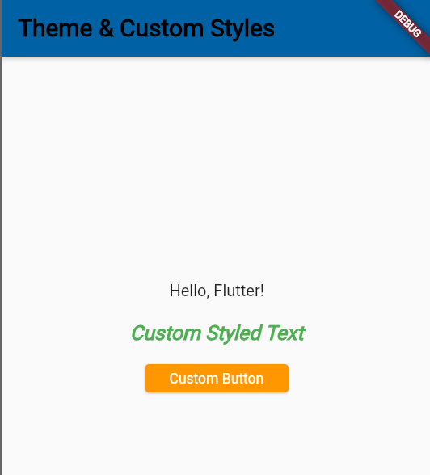
Result: Applying styling using themes and custom styles is successfully completed.

WEEK-7
7. a) Design a form with various input fields
Aim: Design a form with various input fields
Description:
In Flutter, forms are used to collect and validate user input. The Form widget acts as a container for input fields and uses a GlobalKey for validation.
- Common Input Fields:
  - TextFormField: Single or multi-line text input.
  - Password Fields: Obscured text for secure entry.
  - Email Fields: Text input with email-specific validation.
  - Checkboxes & Radio Buttons: For selecting options.
  - Dropdowns: Selecting values from a list.
  - Date/Time Pickers: For choosing dates or times.
- Validation:
  - Each field can have a validator to check correctness, e.g., empty fields, email format, or password length.
  - Form submission occurs only when all validations pass.
Using Flutter forms allows developers to create structured, interactive, and user-friendly input interfaces for mobile and web applications.
Program:
import 'package:flutter/material.dart';
void main() {
runApp(MyApp());
}
class MyApp extends StatelessWidget {
@override
Widget build(BuildContext context) {
return MaterialApp(
title: 'Form Example',
theme: ThemeData(
primarySwatch: Colors.blue,
),
home: MyForm(),
debugShowCheckedModeBanner: false,
);
}
}

class MyForm extends StatefulWidget {
@override
_MyFormState createState() => _MyFormState();
}

class _MyFormState extends State<MyForm> {
final _formKey = GlobalKey<FormState>();

// Controllers for all input fields
TextEditingController _nameController = TextEditingController();
TextEditingController _emailController = TextEditingController();
TextEditingController _passwordController = TextEditingController();
TextEditingController _phoneController = TextEditingController();
TextEditingController _genderController = TextEditingController();
TextEditingController _ageController = TextEditingController();

void _submitForm() {
if (_formKey.currentState!.validate()) {
// Show SnackBar on successful submission
ScaffoldMessenger.of(context).showSnackBar(
const SnackBar(
content: Text('Form Submitted Successfully!'),
backgroundColor: Colors.green,
duration: Duration(seconds: 2),
),
);

// Clear all input fields after submission
_nameController.clear();
_emailController.clear();
_passwordController.clear();
_phoneController.clear();
_genderController.clear();
_ageController.clear();
}
}

@override
Widget build(BuildContext context) {
return Scaffold(
appBar: AppBar(
title: const Text('Form Example'),
),
body: SingleChildScrollView(
child: Padding(
padding: const EdgeInsets.all(16.0),
child: Form(
key: _formKey,
child: Column(
crossAxisAlignment: CrossAxisAlignment.stretch,
children: <Widget>[
// Name
TextFormField(
controller: _nameController,
decoration: const InputDecoration(
labelText: 'Name',
border: OutlineInputBorder(),
),
validator: (value) {
if (value == null || value.isEmpty) {
return 'Please enter your name';
}
return null;
},
),
const SizedBox(height: 16),

// Email
TextFormField(
controller: _emailController,
keyboardType: TextInputType.emailAddress,
decoration: const InputDecoration(
labelText: 'Email',
border: OutlineInputBorder(),
),
validator: (value) {
if (value == null || value.isEmpty) {
return 'Please enter your email';
} else if (!RegExp(r'^[\w-]+(\.[\w-]+)*@[\w-]+(\.[\w-]+)+$')
.hasMatch(value)) {
return 'Please enter a valid email address';
}
return null;
},
),
const SizedBox(height: 16),

// Password
TextFormField(
controller: _passwordController,
obscureText: true,
decoration: const InputDecoration(
labelText: 'Password',
border: OutlineInputBorder(),
),
validator: (value) {
if (value == null || value.isEmpty) {
return 'Please enter your password';
} else if (value.length < 6) {
return 'Password must be at least 6 characters long';
}
return null;
},
),
const SizedBox(height: 16),

// Phone
TextFormField(
controller: _phoneController,
keyboardType: TextInputType.phone,
decoration: const InputDecoration(
labelText: 'Phone',
border: OutlineInputBorder(),
),
validator: (value) {
if (value == null || value.isEmpty) {
return 'Please enter your phone number';
} else if (!RegExp(r'^\d{10}$').hasMatch(value)) {
return 'Enter a valid 10-digit phone number';
}
return null;
},
),
const SizedBox(height: 16),

// Gender
TextFormField(
controller: _genderController,
decoration: const InputDecoration(
labelText: 'Gender',
border: OutlineInputBorder(),
),
validator: (value) {
if (value == null || value.isEmpty) {
return 'Please enter your gender';
}
return null;
},
),
const SizedBox(height: 16),

// Age
TextFormField(
controller: _ageController,
keyboardType: TextInputType.number,
decoration: const InputDecoration(
labelText: 'Age',
border: OutlineInputBorder(),
),
validator: (value) {
if (value == null || value.isEmpty) {
return 'Please enter your age';
} else if (int.tryParse(value) == null || int.parse(value) <= 0) {
return 'Enter a valid age';
}
return null;
},
),
const SizedBox(height: 16),

ElevatedButton(
onPressed: _submitForm,
child: const Text('Submit'),
),
],
),
),
),
),
);
}
}

Output:

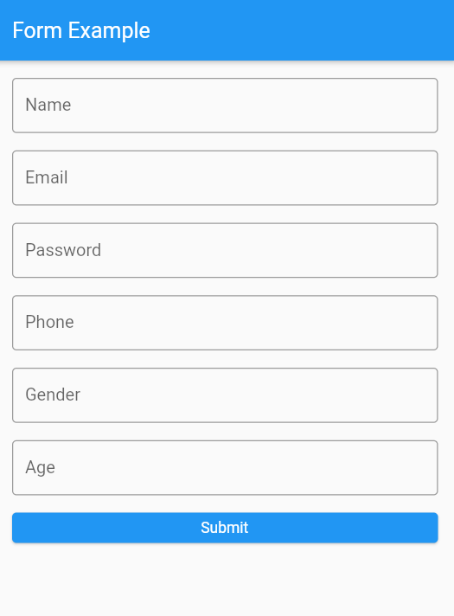
Result: Designing a form with various input fields is successfully completed.

7. b) Implement form validation and error handling
Aim: Implement form validation and error handling
Description:
In Flutter, form validation and error handling ensure that user input is accurate, complete, and consistent before being processed. Proper validation improves data integrity and enhances the user experience by providing immediate feedback.
- Form Widget:
  - The Form widget acts as a container for input fields and uses a GlobalKey to manage validation state.
- Validator Functions:
  - Each input field can have a validator function that checks the entered data.
  - Examples include checking for empty fields, valid email formats, password length, or custom business rules.
- Error Display:
  - Validation errors are typically shown below the input field using the errorText property in InputDecoration.
  - Users can immediately see what needs correction, making the app more user-friendly.
- Handling Submission:
  - Forms should only be submitted if all validations pass, ensuring safe and correct data is processed.
  - Developers can handle additional errors (e.g., network or server errors) and display appropriate messages using widgets like SnackBar or Dialogs.

Program:
import 'package:flutter/material.dart';
void main() {
runApp(MyApp());
}
class MyApp extends StatelessWidget {
@override
Widget build(BuildContext context) {
return MaterialApp(
title: 'Form Validation Example',
theme: ThemeData(
primarySwatch: Colors.blue,
),
home: MyForm(),
debugShowCheckedModeBanner: false,
);
}
}

class MyForm extends StatefulWidget {
@override
_MyFormState createState() => _MyFormState();
}

class _MyFormState extends State<MyForm> {
final _formKey = GlobalKey<FormState>();

TextEditingController _nameController = TextEditingController();
TextEditingController _emailController = TextEditingController();
TextEditingController _passwordController = TextEditingController();
TextEditingController _phoneController = TextEditingController();
TextEditingController _ageController = TextEditingController();
TextEditingController _genderController = TextEditingController();

void _submitForm() {
if (_formKey.currentState!.validate()) {
// Show SnackBar instead of printing to console
ScaffoldMessenger.of(context).showSnackBar(
const SnackBar(
content: Text('Form Submitted Successfully!'),
backgroundColor: Colors.green,
duration: Duration(seconds: 2),
),
);

// Clear fields
_nameController.clear();
_emailController.clear();
_passwordController.clear();
_phoneController.clear();
_ageController.clear();
_genderController.clear();
}
}

@override
Widget build(BuildContext context) {
return Scaffold(
appBar: AppBar(
title: const Text('Form Validation Example'),
),
body: Padding(
padding: const EdgeInsets.all(16.0),
child: Form(
key: _formKey,
child: SingleChildScrollView( // ensures no overflow on small screens
child: Column(
crossAxisAlignment: CrossAxisAlignment.stretch,
children: <Widget>[
// Name
TextFormField(
controller: _nameController,
decoration: const InputDecoration(
labelText: 'Name',
border: OutlineInputBorder(),
),
validator: (value) {
if (value == null || value.isEmpty) {
return 'Please enter your name';
}
return null;
},
),
const SizedBox(height: 16),

// Email
TextFormField(
controller: _emailController,
keyboardType: TextInputType.emailAddress,
decoration: const InputDecoration(
labelText: 'Email',
border: OutlineInputBorder(),
),
validator: (value) {
if (value == null || value.isEmpty) {
return 'Please enter your email';
} else if (!RegExp(r'^[\w-]+(\.[\w-]+)*@[\w-]+(\.[\w-]+)+$')
.hasMatch(value)) {
return 'Please enter a valid email address';
}
return null;
},
),
const SizedBox(height: 16),

// Password
TextFormField(
controller: _passwordController,
obscureText: true,
decoration: const InputDecoration(
labelText: 'Password',
border: OutlineInputBorder(),
),
validator: (value) {
if (value == null || value.isEmpty) {
return 'Please enter your password';
} else if (value.length < 6) {
return 'Password must be at least 6 characters long';
}
return null;
},
),
const SizedBox(height: 16),

// Phone
TextFormField(
controller: _phoneController,
keyboardType: TextInputType.phone,
decoration: const InputDecoration(
labelText: 'Phone',
border: OutlineInputBorder(),
),
validator: (value) {
if (value == null || value.isEmpty) {
return 'Please enter your phone number';
} else if (!RegExp(r'^\d{10}$').hasMatch(value)) {
return 'Enter a valid 10-digit phone number';
}
return null;
},
),
const SizedBox(height: 16),

// Age
TextFormField(
controller: _ageController,
keyboardType: TextInputType.number,
decoration: const InputDecoration(
labelText: 'Age',
border: OutlineInputBorder(),
),
validator: (value) {
if (value == null || value.isEmpty) {
return 'Please enter your age';
} else if (int.tryParse(value) == null || int.parse(value) <= 0) {
return 'Enter a valid age';
}
return null;
},
),
const SizedBox(height: 16),

// Gender
TextFormField(
controller: _genderController,
decoration: const InputDecoration(
labelText: 'Gender',
border: OutlineInputBorder(),
),
validator: (value) {
if (value == null || value.isEmpty) {
return 'Please enter your gender';
}
return null;
},
),
const SizedBox(height: 16),

ElevatedButton(
onPressed: _submitForm,
child: const Text('Submit'),
),
],
),
),
),
),
);
}
}

Output:

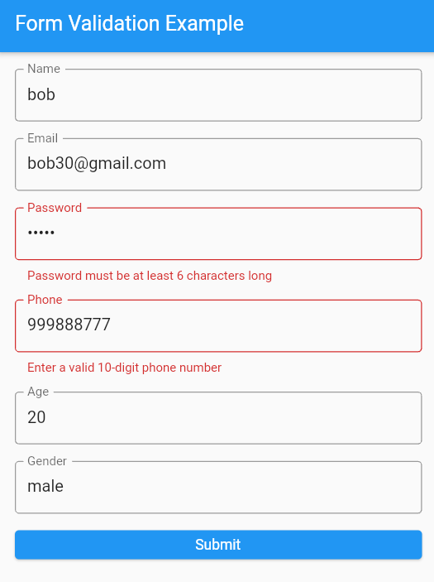
Result: Implementing form validation and error handling is successfully completed

WEEK-8
8. a) Add animations to UI elements using Flutter's animation framework.
Aim: Add animations to UI elements using Flutter's animation framework.
Description:
In Flutter, animations make apps interactive, engaging, and visually appealing. Flutter’s animation framework provides powerful tools to animate widgets, transitions, and UI elements.
- AnimationController:
  - The core class that controls the animation’s duration, start, stop, and repeat.
  - It generates values over time that can be applied to widgets.
- Tween & CurvedAnimation:
  - Tween defines the start and end values of an animation, such as opacity, size, or position.
  - CurvedAnimation adds easing effects like bounce, ease-in, or ease-out to make animations more natural.
- Animated Widgets:
  - Flutter provides built-in widgets like FadeTransition, SlideTransition, ScaleTransition, and RotationTransition.
  - These widgets simplify the process of animating changes in opacity, position, size, or rotation.
- Benefits:
  - Animations improve user experience by making interactions smoother.
  - They help draw attention to important elements and provide feedback on user actions.

Program:
import 'package:flutter/material.dart';
void main() {
runApp(MyApp());
}
class MyApp extends StatelessWidget {
@override
Widget build(BuildContext context) {
return MaterialApp(
title: 'Animation Example',
theme: ThemeData(
primarySwatch: Colors.blue,
),
home: MyAnimatedWidget(),
debugShowCheckedModeBanner: false,
);
}
}

class MyAnimatedWidget extends StatefulWidget {
@override
_MyAnimatedWidgetState createState() => _MyAnimatedWidgetState();
}

class _MyAnimatedWidgetState extends State<MyAnimatedWidget>
with SingleTickerProviderStateMixin {
late AnimationController _animationController;
late Animation<double> _opacityAnimation;

@override
void initState() {
super.initState();

// Create an AnimationController with a duration of 1 second
_animationController = AnimationController(
vsync: this,
duration: const Duration(seconds: 1),
);

// Create a Tween to animate opacity from 0.0 to 1.0
_opacityAnimation = Tween<double>(begin: 0.0, end: 1.0).animate(
CurvedAnimation(
parent: _animationController,
curve: Curves.easeInOut,
),
);

// Start the animation
_animationController.forward();
}

@override
Widget build(BuildContext context) {
return Scaffold(
appBar: AppBar(
title: const Text('Animation Example'),
),
body: Center(
child: FadeTransition(
opacity: _opacityAnimation,
child: Container(
width: 200,
height: 200,
color: Colors.blue,
child: const Center(
child: Text(
'Animated Widget',
style: TextStyle(
color: Colors.white,
fontSize: 20,
),
),
),
),
),
),
);
}

@override
void dispose() {
_animationController.dispose();
super.dispose();
}
}
Output:
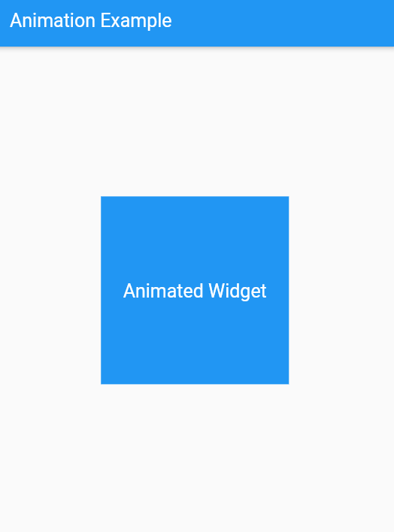
Result: Adding animations to UI elements using Flutter's animation framework is successfully completed.

8. b) Experiment with different types of animations (fade, slide, etc.).
Aim: Experiment with different types of animations (fade, slide, etc.).
Description:
Flutter’s animation framework allows developers to create interactive and engaging UI effects.
- Fade Animations: Use FadeTransition to animate opacity, for gradual appearance or disappearance.
- Slide Animations: Use SlideTransition to move widgets on or off screen, ideal for page transitions or menus.
- Scale Animations: Use ScaleTransition to animate size, useful for buttons or popups.
- Rotation Animations: Use RotationTransition to rotate widgets, like loading indicators or icons.
- Combination Animations: Combine multiple animations with AnimatedBuilder for complex effects.
Experimenting with these animations enhances visual appeal, user interaction, and overall app experience.
Program:
Fade Animation:
import 'package:flutter/material.dart';
void main() {
runApp(MyApp());
}
class MyApp extends StatelessWidget {
@override
Widget build(BuildContext context) {
return MaterialApp(
title: 'Fade Animation Example',
theme: ThemeData(
primarySwatch: Colors.blue,
),
home: FadeAnimationWidget(),
debugShowCheckedModeBanner: false,
);
}
}
class FadeAnimationWidget extends StatefulWidget {
@override
_FadeAnimationWidgetState createState() => _FadeAnimationWidgetState();
}

class _FadeAnimationWidgetState extends State<FadeAnimationWidget>
with SingleTickerProviderStateMixin {
late AnimationController _animationController;
late Animation<double> _opacityAnimation;

@override
void initState() {
super.initState();

_animationController = AnimationController(
vsync: this,
duration: const Duration(seconds: 10),
);

_opacityAnimation = Tween<double>(begin: 0.0, end: 1.0).animate(
CurvedAnimation(
parent: _animationController,
curve: Curves.easeInOut,
),
);

_animationController.forward();
}

@override
Widget build(BuildContext context) {
return Scaffold(
appBar: AppBar(
title: const Text('Fade Animation Example'),
),
body: Center(
child: FadeTransition(
opacity: _opacityAnimation,
child: Container(
width: 200,
height: 200,
color: Colors.blue,
child: const Center(
child: Text(
'Fade Animation',
style: TextStyle(
color: Colors.white,
fontSize: 20,
),
),
),
),
),
),
);
}

@override
void dispose() {
_animationController.dispose();
super.dispose();
}
}
Output:

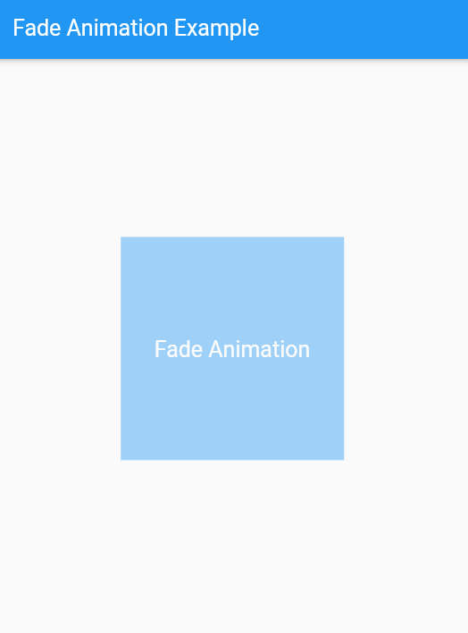
Slide Animation:
import 'package:flutter/material.dart';

void main() {
runApp(MyApp());
}

class MyApp extends StatelessWidget {
@override
Widget build(BuildContext context) {
return MaterialApp(
title: 'Slide Animation Example',
theme: ThemeData(
primarySwatch: Colors.blue,
),
home: SlideAnimationWidget(),
debugShowCheckedModeBanner: false,
);
}
}

class SlideAnimationWidget extends StatefulWidget {
@override
_SlideAnimationWidgetState createState() => _SlideAnimationWidgetState();
}

class _SlideAnimationWidgetState extends State<SlideAnimationWidget>
with SingleTickerProviderStateMixin {
late AnimationController _animationController;
late Animation<Offset> _slideAnimation;

@override
void initState() {
super.initState();

_animationController = AnimationController(
vsync: this,
duration: const Duration(seconds: 2),
);

_slideAnimation = Tween<Offset>(
begin: const Offset(-1.0, 0.0),
end: const Offset(0.0, 0.0),
).animate(
CurvedAnimation(
parent: _animationController,
curve: Curves.easeInOut,
),
);

_animationController.forward();
}

@override
Widget build(BuildContext context) {
return Scaffold(
appBar: AppBar(
title: const Text('Slide Animation Example'),
),
body: Center(
child: SlideTransition(
position: _slideAnimation,
child: Container(
width: 200,
height: 200,
color: Colors.blue,
child: const Center(
child: Text(
'Slide Animation',
style: TextStyle(
color: Colors.white,
fontSize: 20,
),
),
),
),
),
),
);
}

@override
void dispose() {
_animationController.dispose();
super.dispose();
}
}
Output:
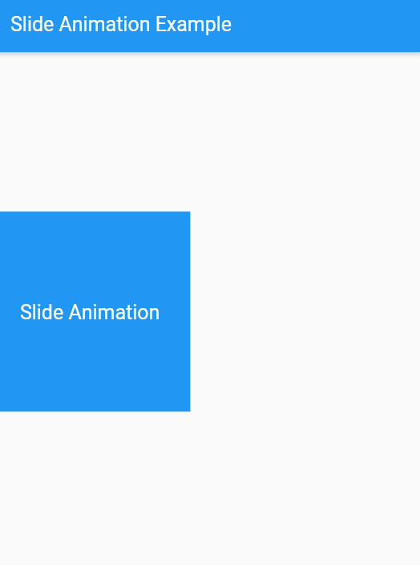
Scale Animation:
import 'package:flutter/material.dart';

void main() {
runApp(MyApp());
}

class MyApp extends StatelessWidget {
@override
Widget build(BuildContext context) {
return MaterialApp(
title: 'Rotation Animation',
theme: ThemeData(primarySwatch: Colors.blue),
home: RotationAnimationWidget(),
);
}
}

class RotationAnimationWidget extends StatefulWidget {
@override
_RotationAnimationWidgetState createState() => _RotationAnimationWidgetState();
}

class _RotationAnimationWidgetState extends State<RotationAnimationWidget>
with SingleTickerProviderStateMixin {
late AnimationController _animationController;

@override
void initState() {
super.initState();

// Initialize the animation controller
_animationController = AnimationController(
vsync: this,
duration: Duration(seconds: 3),
);

// Repeat the animation indefinitely
_animationController.repeat();
}

@override
Widget build(BuildContext context) {
return Scaffold(
appBar: AppBar(title: Text('Rotation Animation')),
body: Center(
child: RotationTransition(
turns: _animationController,
child: Container(
width: 150,
height: 150,
color: Colors.blue,
child: Center(
child: Text(
'Rotate',
style: TextStyle(color: Colors.white, fontSize: 20),
),
),
),
),
),
);
}

@override
void dispose() {
_animationController.dispose();
super.dispose();
}
}
Output:

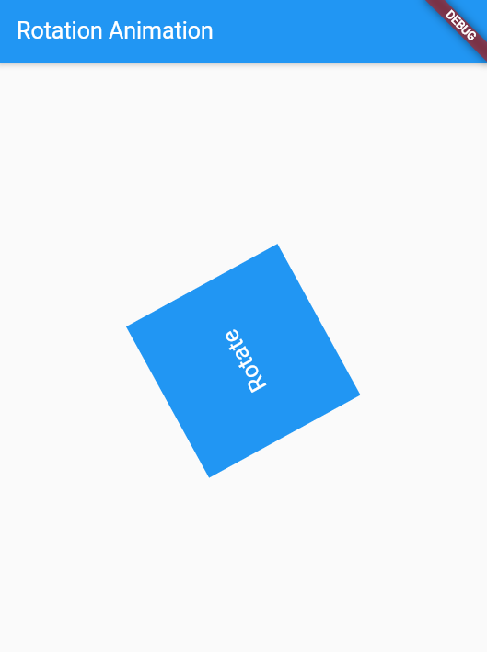

Result: Experimenting with different types of animations (fade, slide, etc.) is successfully completed.

WEEK-9
9.a) Fetch data from a REST API
import 'package:flutter/material.dart'; import 'package:http/http.dart' as http; import 'dart:convert';
void main() { runApp(MyApp());
}

class MyApp extends StatelessWidget { @override
Widget build(BuildContext context) { return MaterialApp(
title: 'API Fetch Example', theme: ThemeData( primarySwatch: Colors.blue,
),
home: MyApiFetchWidget(),
);
}
}

class MyApiFetchWidget extends StatefulWidget { @override
_MyApiFetchWidgetState createState() => _MyApiFetchWidgetState();
}
class _MyApiFetchWidgetState extends State<MyApiFetchWidget> { late Future<List<Post>> _posts;
@override
void initState() { super.initState();

_posts = fetchPosts();
}

Future<List<Post>> fetchPosts() async { final response =
await http.get(Uri.parse('https://jsonplaceholder.typicode.com/posts'));

if (response.statusCode == 200) {
// If the server returns a 200 OK response,

// parse the JSON and return a list of posts. List<dynamic> data = json.decode(response.body);
List<Post> posts = data.map((post) => Post.fromJson(post)).toList(); return posts;
} else {
// If the server did not return a 200 OK response,
// throw an exception.
throw Exception('Failed to load posts');
}
}

@override
Widget build(BuildContext context) { return Scaffold(
appBar: AppBar(
title: Text('API Fetch Example'),
),
body: FutureBuilder<List<Post>>( future: _posts,
builder: (context, snapshot) {
if (snapshot.connectionState == ConnectionState.waiting) { return CircularProgressIndicator();
} else if (snapshot.hasError) {

return Text('Error: ${snapshot.error}');
} else {
return ListView.builder( itemCount: snapshot.data!.length, itemBuilder: (context, index) { return ListTile(
title: Text(snapshot.data![index].title), subtitle: Text(snapshot.data![index].body),
);
},
);
}
},

),
);
}
}

class Post { final int userId; final int id;
final String title; final String body;

Post({
required this.userId, required this.id, required this.title, required this.body,
});

factory Post.fromJson(Map<String, dynamic> json) { return Post(
userId: json['userId'],
id: json['id'], title: json['title'],
body: json['body'],
);
}
}

Output:
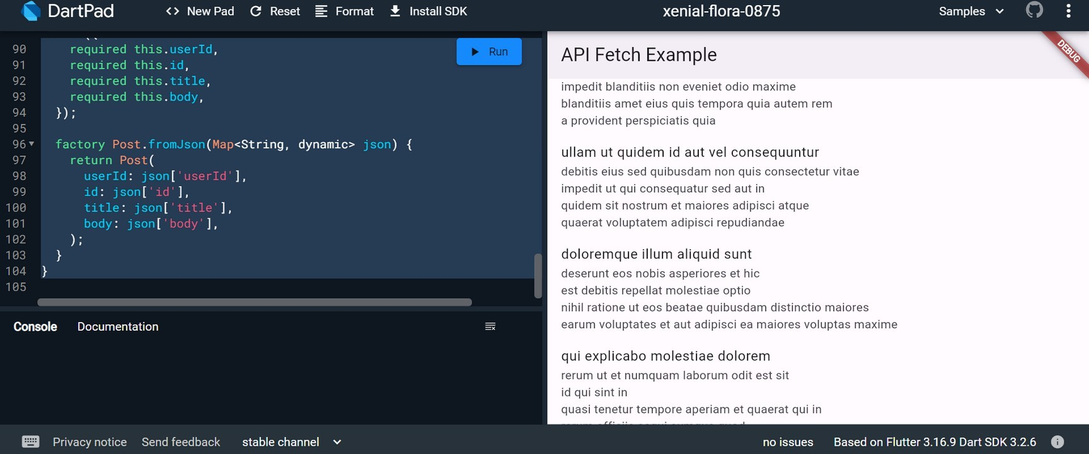

9 b) Display the fetched data in a meaningful way in the UI.

import 'package:flutter/material.dart'; import 'package:http/http.dart' as http; import 'dart:convert';

void main() { runApp(MyApp());
}

class MyApp extends StatelessWidget { @override
Widget build(BuildContext context) { return MaterialApp(
title: 'API Fetch Example', theme: ThemeData( primarySwatch: Colors.blue,
),
home: MyApiFetchWidget(),
);
}
}

class MyApiFetchWidget extends StatefulWidget { @override
_MyApiFetchWidgetState createState() => _MyApiFetchWidgetState();
}

class _MyApiFetchWidgetState extends State<MyApiFetchWidget> { late Future<List<Post>> _posts;

@override
void initState() { super.initState();
_posts = fetchPosts();
}

Future<List<Post>> fetchPosts() async { final response =
await http.get(Uri.parse('https://jsonplaceholder.typicode.com/posts'));
if (response.statusCode == 200) {
List<dynamic> data = json.decode(response.body);
List<Post> posts = data.map((post) => Post.fromJson(post)).toList(); return posts;
} else {
throw Exception('Failed to load posts');
}
}
@override
Widget build(BuildContext context) { return Scaffold(
appBar: AppBar(
title: Text('API Fetch Example'),
),
body: FutureBuilder<List<Post>>( future: _posts,
builder: (context, snapshot) {
if (snapshot.connectionState == ConnectionState.waiting) { return Center(child: CircularProgressIndicator());
} else if (snapshot.hasError) {
return Center(child: Text('Error: ${snapshot.error}'));
} else {
return PostList(posts: snapshot.data!);
}

},
),
);
}
}

class PostList extends StatelessWidget { final List<Post> posts;
PostList({required this.posts}); @override
Widget build(BuildContext context) { return ListView.builder(
itemCount: posts.length, itemBuilder: (context, index) { return PostItem(post: posts[index]);
},
);
}
}
class PostItem extends StatelessWidget { final Post post;
PostItem({required this.post}); @override
Widget build(BuildContext context) { return Card(
margin: EdgeInsets.all(10), elevation: 3,
child: Padding(
padding: EdgeInsets.all(15), child: Column(
crossAxisAlignment: CrossAxisAlignment.start, children: [
Text( post.title,
style: TextStyle( fontSize: 18,
fontWeight: FontWeight.bold,
),
),
SizedBox(height: 10), Text(
post.body,
style: TextStyle(fontSize: 16),
),

],
),
),
);
}
}

class Post { final int userId; final int id;
final String title; final String body;

Post({
required this.userId, required this.id, required this.title, required this.body,
});
factory Post.fromJson(Map<String, dynamic> json) { return Post(
userId: json['userId'], id: json['id'],
title: json['title'], body: json['body'],
);
}
}

Output:

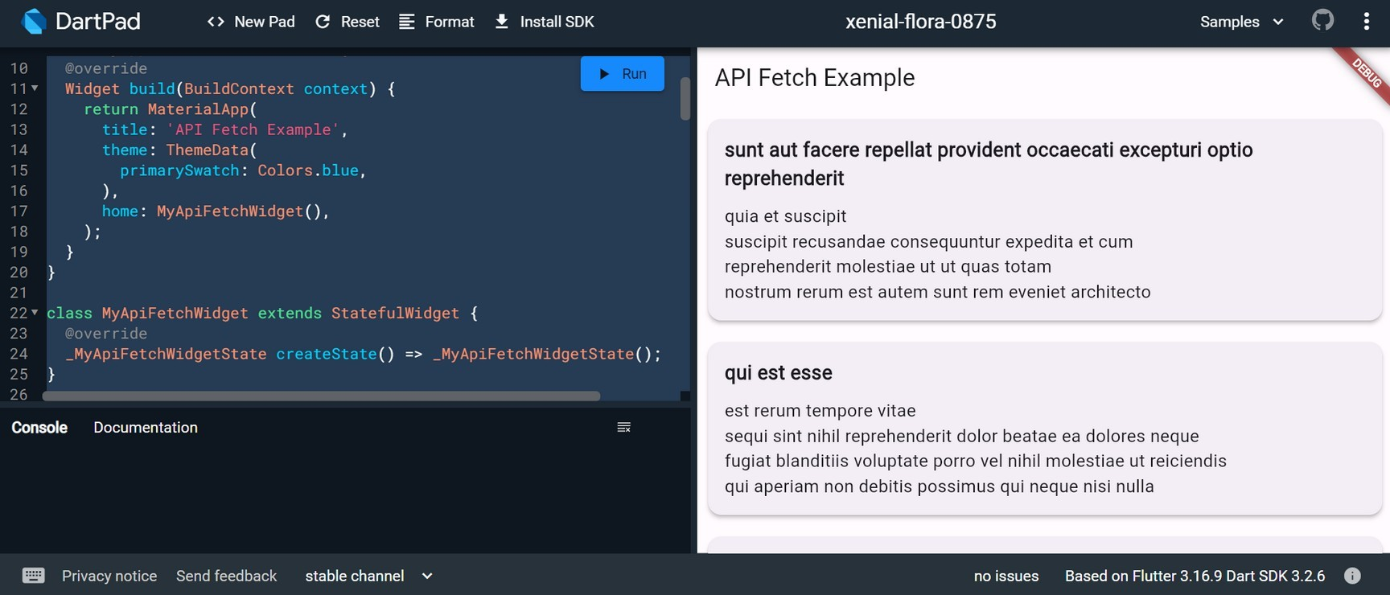

WEEK-10
10. a) Write unit tests for UI components.

Unit tests are handy for verifying the behavior of a single function, method, or class. The test package provides the core framework for writing unit tests, and the flutter_test package provides additional utilities for testing widgets.

This recipe demonstrates the core features provided by the test package using the following steps:

Add the test or flutter_test dependency.
Create a test file.
Create a class to test.
Write a test for our class.
Combine multiple tests in a group. Run the tests.
For more information about the test package, see the test package documentation.
Add the test dependency
The test package provides the core functionality for writing tests in Dart. This is the best approach when writing packages consumed by web, server, and Flutter apps.
To add the test package as a dev dependency, run flutter pub add: content_copy
flutter pub add dev:test
Create a test file
In this example, create two files: counter.dart and counter_test.dart.

The counter.dart file contains a class that you want to test and resides in the lib folder. The counter_test.dart file contains the tests themselves and lives inside the test folder.

In general, test files should reside inside a test folder located at the root of your Flutter application or package. Test files should always end with _test.dart, this is the convention used by the test runner when searching for tests.
When you’re finished, the folder structure should look like this: content_copy
counter_app/ lib/
counter.dart test/

counter_test.dart
Create a class to test
Next, you need a “unit” to test. Remember: “unit” is another name for a function, method, or class. For this example, create a Counter class inside the lib/counter.dart file. It is responsible for incrementing and decrementing a value starting at 0.

content_copy class Counter { int value = 0;

void increment() => value++;
void decrement() => value--;
}
Note: For simplicity, this tutorial does not follow the “Test Driven Development” approach. If you’re more comfortable with that style of development, you can always go that route.

Write a test for our class
Inside the counter_test.dart file, write the first unit test. Tests are defined using the top-level test function, and you can check if the results are correct by using the top- level expect function. Both of these functions come from the test package.

content_copy
// Import the test package and Counter class import 'package:counter_app/counter.dart'; import 'package:test/test.dart';

void main() {
test('Counter value should be incremented', () { final counter = Counter();

counter.increment();
expect(counter.value, 1);
});
}
Combine multiple tests in a group
If you want to run a series of related tests, use the flutter_test package group function to categorize the tests. Once put into a group, you can call flutter test on all tests in that group

with one command.

content_copy
import 'package:counter_app/counter.dart'; import 'package:test/test.dart';

void main() {
group('Test start, increment, decrement', () { test('value should start at 0', () { expect(Counter().value, 0);
});
test('value should be incremented', () { final counter = Counter();
counter.increment(); expect(counter.value, 1);
});
test('value should be decremented', () { final counter = Counter();

counter.decrement();

expect(counter.value, -1);
});
});
}
Run the tests
Now that you have a Counter class with tests in place, you can run the tests.

Run tests using IntelliJ or VSCode
The Flutter plugins for IntelliJ and VSCode support running tests. This is often the best option while writing tests because it provides the fastest feedback loop as well as the ability to set breakpoints.

IntelliJ

Open the counter_test.dart file

Go to Run > Run ‘tests in counter_test.dart’. You can also press the appropriate keyboard shortcut for your platform.
VSCode

Open the counter_test.dart file
Go to Run > Start Debugging. You can also press the appropriate keyboard shortcut for your platform.
Run tests in a terminal
To run the all tests from the terminal, run the following command from the root of the project:

content_copy
flutter test test/counter_test.dart
To run all tests you put into one group, run the following command from the root of the project:

content_copy
flutter test --plain-name "Test start, increment, decrement" This example uses the group created in section 5.
To learn more about unit tests, you can execute this command:

10.b) Use Flutter's debugging tools to identify and fix issues.
Flutter provides a set of debugging tools that can help you identify and fix issues in your app. Here's a step-by-step guide on how to use these tools:

Flutter DevTools:
Run your app with the flutter run command.
Open DevTools by running the following command in your terminal: bash
flutter pub global activate devtools flutter pub global run devtools

Open your app in a Chrome browser and connect it to DevTools by clicking on the "Open DevTools" button in the terminal or by navigating to http://127.0.0.1:9100/.
DevTools provides tabs like Inspector, Timeline, Memory, and more.

Flutter Inspector:
Use the Flutter Inspector in your integrated development environment (IDE) like Android Studio or Visual Studio Code.
Toggle the Inspector in Android Studio with the shortcut Alt + Shift + D (Windows/Linux) or Option + Shift + D (Mac).
Inspect the widget tree, modify widget properties, and observe widget relationships.
Hot Reload:
Leverage Hot Reload to see the immediate effect of code changes without restarting the entire app.
Press R in the terminal or use the "Hot Reload" button in your IDE.

Debugging with Breakpoints:
Set breakpoints in your code to pause execution and inspect variables. Use the debugger in your IDE to step through code and identify issues.

Logging:
Utilize the print function to log messages to the console.

print('Debugging message');
View logs in the terminal or the "Logs" tab in DevTools.

Debug Paint:
Enable debug paint to visualize the layout and rendering of widgets. Use the debugPaintSizeEnabled and debugPaintBaselinesEnabled flags.
void main() {
debugPaintSizeEnabled = true; // Shows bounding boxes of widgets runApp(MyApp());
}

Memory Profiling:
Use the "Memory" tab in DevTools to analyze memory usage and identify potential memory leaks.
Monitor object allocations and deallocations.

Performance Profiling (Timeline):
Analyze app performance using the "Timeline" tab in DevTools. Identify UI jank, slow frames, and performance bottlenecks.

Flutter Driver Tests:
Write automated UI tests using Flutter Driver.
Simulate user interactions and validate the correctness of your UI.

