Airport Navigation System

Overview
This provides an interactive web-based map interface for setting a robot's destination and waypoints for navigation within an airport environment. It integrates Google Maps with ROS2 via rosbridge to communicate route commands and receive updates.
Steps:
Set a destination on the map
Add multiple waypoints
View the current planned route
Confirm the route to the robot
Clear the current route and start over

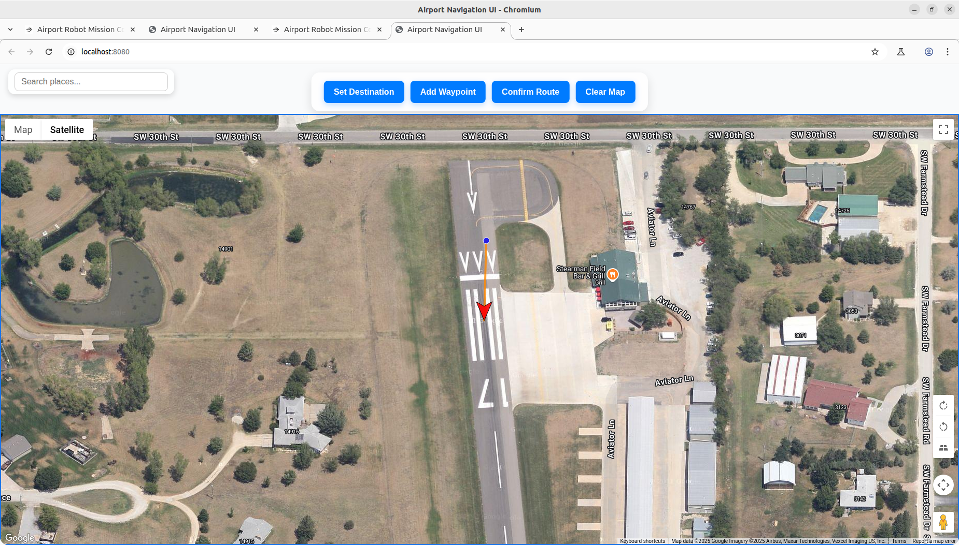

Web Interface Functionalities

Map Interaction: (Replace Google API with your Own API )
Set Destination:
Click the "Set Destination" button, then click a point on the map. This sets the target location where the robot should go. The system reverse geocodes the coordinates to show a human-readable place name.
Add Waypoints:
Click the "Add Waypoint" button, then click points on the map to add intermediate waypoints the robot should follow before reaching the destination.
Clear Map:
Removes all waypoints and the destination marker, allowing a fresh route to be planned.
Confirm Route:
Sends the selected waypoints and destination to the robot through ROS services.

Search Box
Allows users to search for places by name or address. Selecting a place sets it as the destination automatically.

ROS Communication
The web UI connects to ROS 2 via the rosbridge websocket running at:
ws:// jestson-ip:9090
Important: Need to configure the jestson_ip in config.js file (Path: airport_navigation_ws/web_ui/config.js)

ROS Services Used
- Set Destination Service
Name: /destination_node/set_destination
Type: airport_navigation_interfaces/srv/SetDestination
Request fields: latitude, longitude, altitude
Function: Sets the final destination for the robot navigation.
- Set Route Service
Name: /route_manager_node/set_route
Type: airport_navigation_interfaces/srv/SetRoute
Request fields: array of CustomWaypoint messages, each containing latitude, longitude, altitude, and a name.
Function: Sets the list of waypoints the robot must follow.

Published Topics and Messages
While the web UI mainly uses services to send commands, the robot's ROS nodes publish several topics useful for visualization and monitoring:

- /current_position (geometry_msgs/PointStamped)
The robot’s current local position in ENU coordinates.
- /destination_position (geometry_msgs/PointStamped)
The current target destination in ENU coordinates.
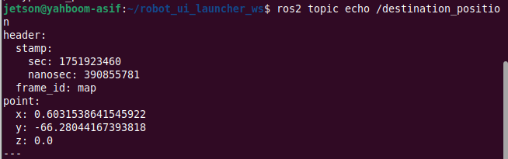

- /waypoints_enu (geometry_msgs/PointStamped)
Individual waypoints positions in ENU.

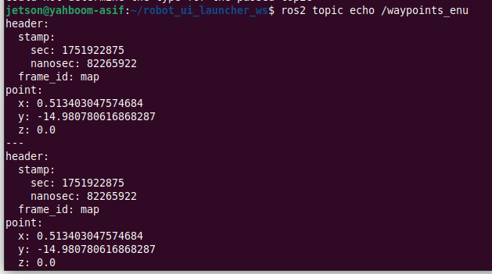

- /current_pose (geometry_msgs/PoseStamped)
Robot's current pose (position + orientation) published by the pose publisher node for visualization.
- /goal_pose (geometry_msgs/PoseStamped)
Destination pose published by the pose publisher node.
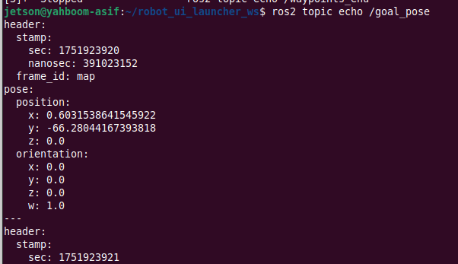

- /waypoints_pose (geometry_msgs/PoseArray)
Array of waypoints as poses, useful for visualization in RViz.
