EXPERIMENT 15
Hexadecimal to Decimal Conversion
AIM
To write an Embedded C program to convert a hexadecimal number into its decimal representation and display the decimal digits through the ports.
ALGORITHM
1. Initialize the hexadecimal input value.
2. Separate the hexadecimal value into its decimal equivalent using division by 10.
3. Store the units, tens, and hundreds digits separately.
4. Send the units, tens, and hundreds values to P0, P1, and P2.
5. Run the program continuously and observe the port values.
PROGRAM
#include <reg51.h>
void main(void)
{
unsigned char hexa, units, tens, hundreds;
hexa = 0x07;
units = hexa % 10;
hexa = hexa / 10;
tens = hexa % 10;
hexa = hexa / 10;
hundreds = hexa;
P0 = units;
P1 = tens;
P2 = hundreds;
while(1);
}
OUTPUT
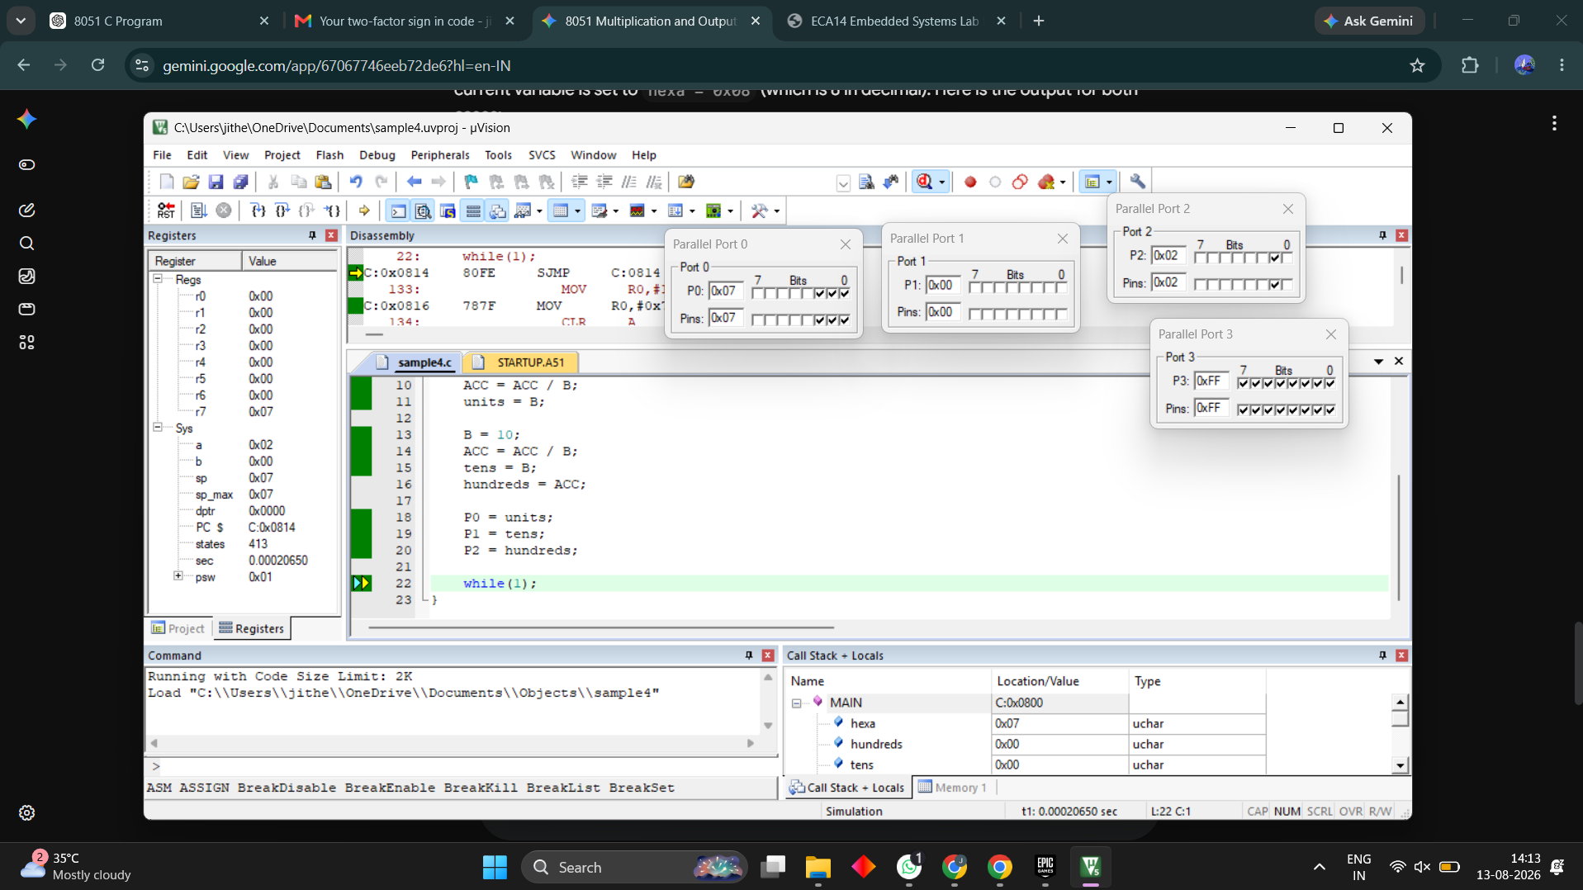
RESULT
The hexadecimal value was successfully converted into its decimal representation, and the decimal digits were displayed through P0, P1, and P2.

