EXPERIMENT NO. 16
AIM
To write and simulate an Embedded C program using serial interrupt in 8051 microcontroller such that while a message is continuously transmitted, any key pressed from the keyboard generates an interrupt and is displayed through UART.
ALGORITHM
- Configure UART in Mode 1 and Timer 1 for 9600 baud.
- Enable serial interrupts.
- Continuously transmit “Hello World”.
- When a character is received, the serial ISR reads SBUF.
- Display the received character through UART.
PROGRAM
#include <reg51.h>
#include <stdio.h>
void serial_ISR(void) interrupt 4
{
char ch;
if(RI)
{
RI = 0;
ch = SBUF;
printf("\n>>> INTERRUPT RECEIVED: ");
printf("%c\n", ch);
}
}
void delay(void)
{
unsigned int i;
for(i = 0; i < 50000; i++);
}
void main(void)
{
SCON = 0x50; /* UART mode 1, 8-bit, REN enabled */
TMOD = 0x20; /* Timer 1 mode 2 */
TH1 = 0xFD; /* Baud rate 9600 */
TR1 = 1;
IE = 0x90; /* EA = 1, ES = 1 */
TI = 1;
while(1)
{
printf("Hello World\n");
delay();
}
}
OUTPUT
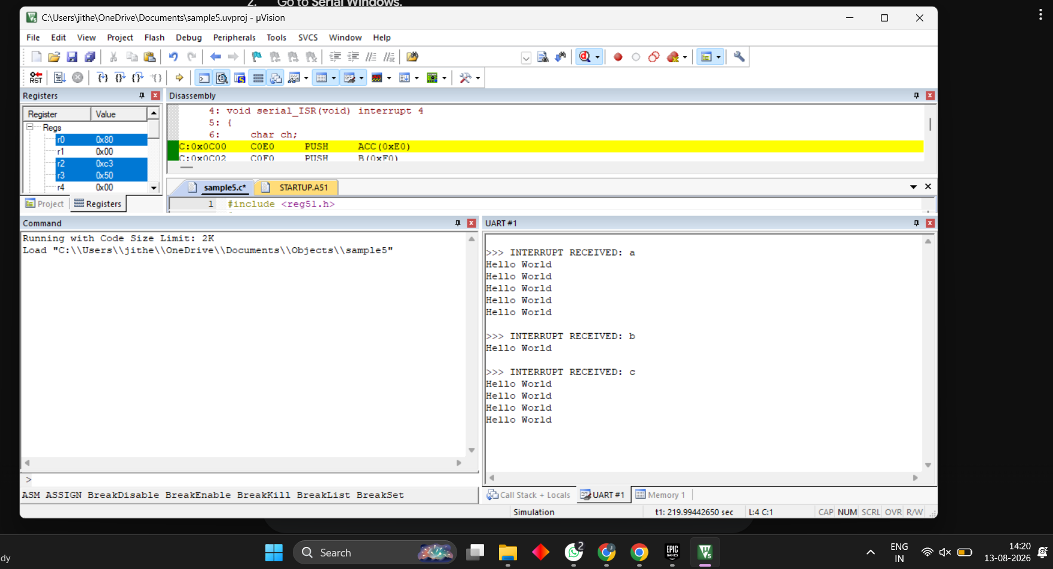
RESULT
Thus, the serial interrupt using UART was successfully implemented and verified in Keil simulator.

