EMBEDDED SYSTEMS LABORATORY
EXPERIMENT – 11
Title
16-bit Multiplication and 32-bit Result Storage using Embedded C
Aim
To develop an Embedded C program using Keil for an 8051-based system to multiply two 16-bit numbers and store the resulting 32-bit value.
Software / Tools Required
• Keil µVision
• 8051 microcontroller project
• Embedded C
Algorithm
1. Start the program.
2. Declare two 16-bit unsigned numbers.
3. Multiply the two numbers and store the result in a 32-bit variable.
4. Separate the 32-bit result into four 8-bit parts.
5. Store the four bytes in P0, P1, P2 and P3.
6. Stop.
Program
#include <reg51.h>
void main()
{
unsigned int num1 = 0x2222;
unsigned int num2 = 0xBBBB;
unsigned long int product;
product = (unsigned long int)num1 * num2;
P0 = product & 0xFF;
P1 = (product & 0xFF00) >> 8;
P2 = (product & 0xFF0000) >> 16;
P3 = (product & 0xFF000000) >> 24;
while(1);
}
Working
The two 16-bit hexadecimal numbers 0x2222 and 0xBBBB are multiplied. The result is stored in the 32-bit variable product. The four bytes of the result are then assigned to P0, P1, P2 and P3.
Expected Result
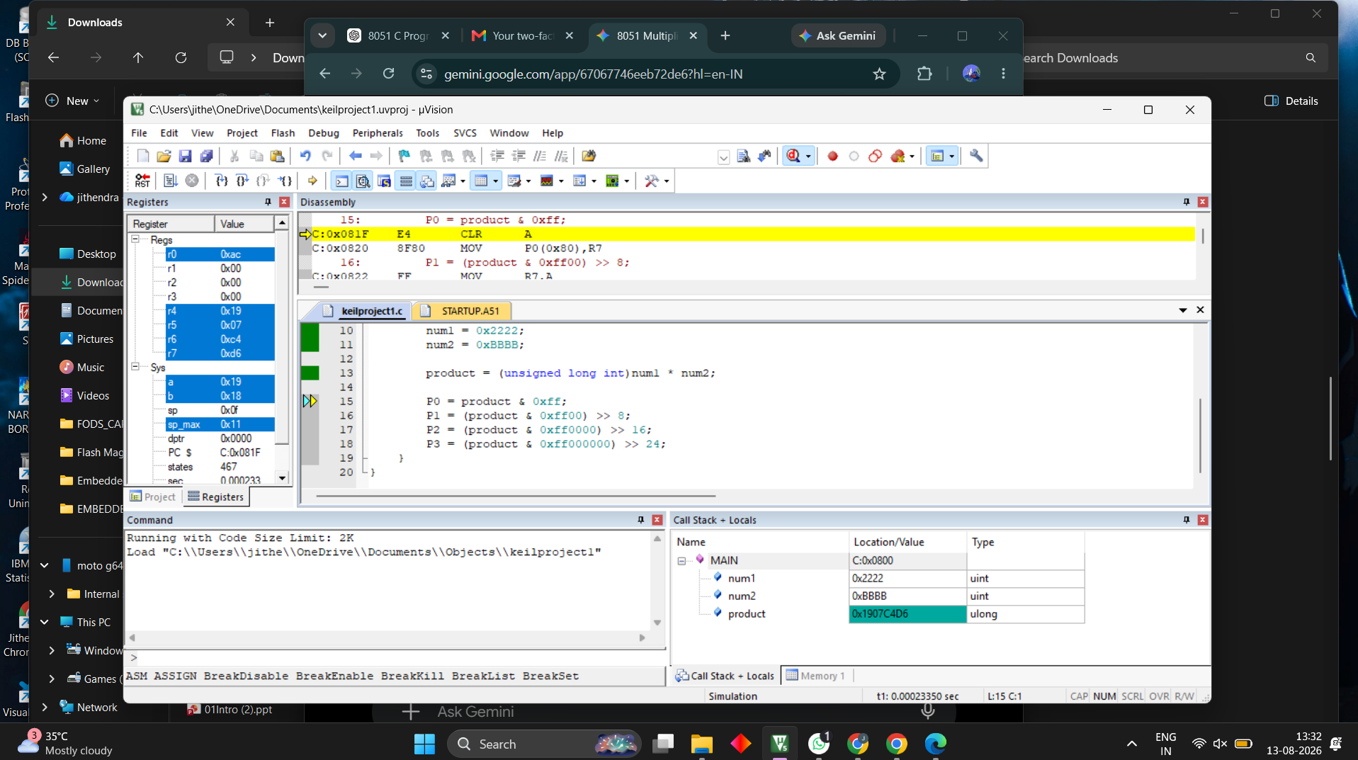

Result
The Embedded C program was successfully compiled and simulated in Keil. The 16-bit numbers were multiplied and the 32-bit result was obtained and distributed across P0–P3.

