EXPERIMENT NO. 14
AIM
To write an Embedded C program to display "HELLO WORLD" message using Keil software.
ALGORITHM
- Configure UART in Mode 1.
- Configure Timer 1 in Mode 2 and load the value for 9600 baud.
- Start Timer 1 and enable transmission.
- Continuously transmit the message “Hello World!” through UART.
PROGRAM
#include <reg51.h>
#include <stdio.h>
void main(void)
{
SCON = 0x50; /* SCON: mode 1, 8-bit UART, enable rcv */
TMOD = 0x20; /* Timer 1 mode 2, 8-bit reload */
TH1 = 0xFD; /* TH1: reload value for 9600 baudrate */
TR1 = 1; /* TR1: timer 1 run */
TI = 1; /* TI: set TI to send first char of UART */
while(1)
{
printf("Hello World! \n");
}
}
OUTPUT
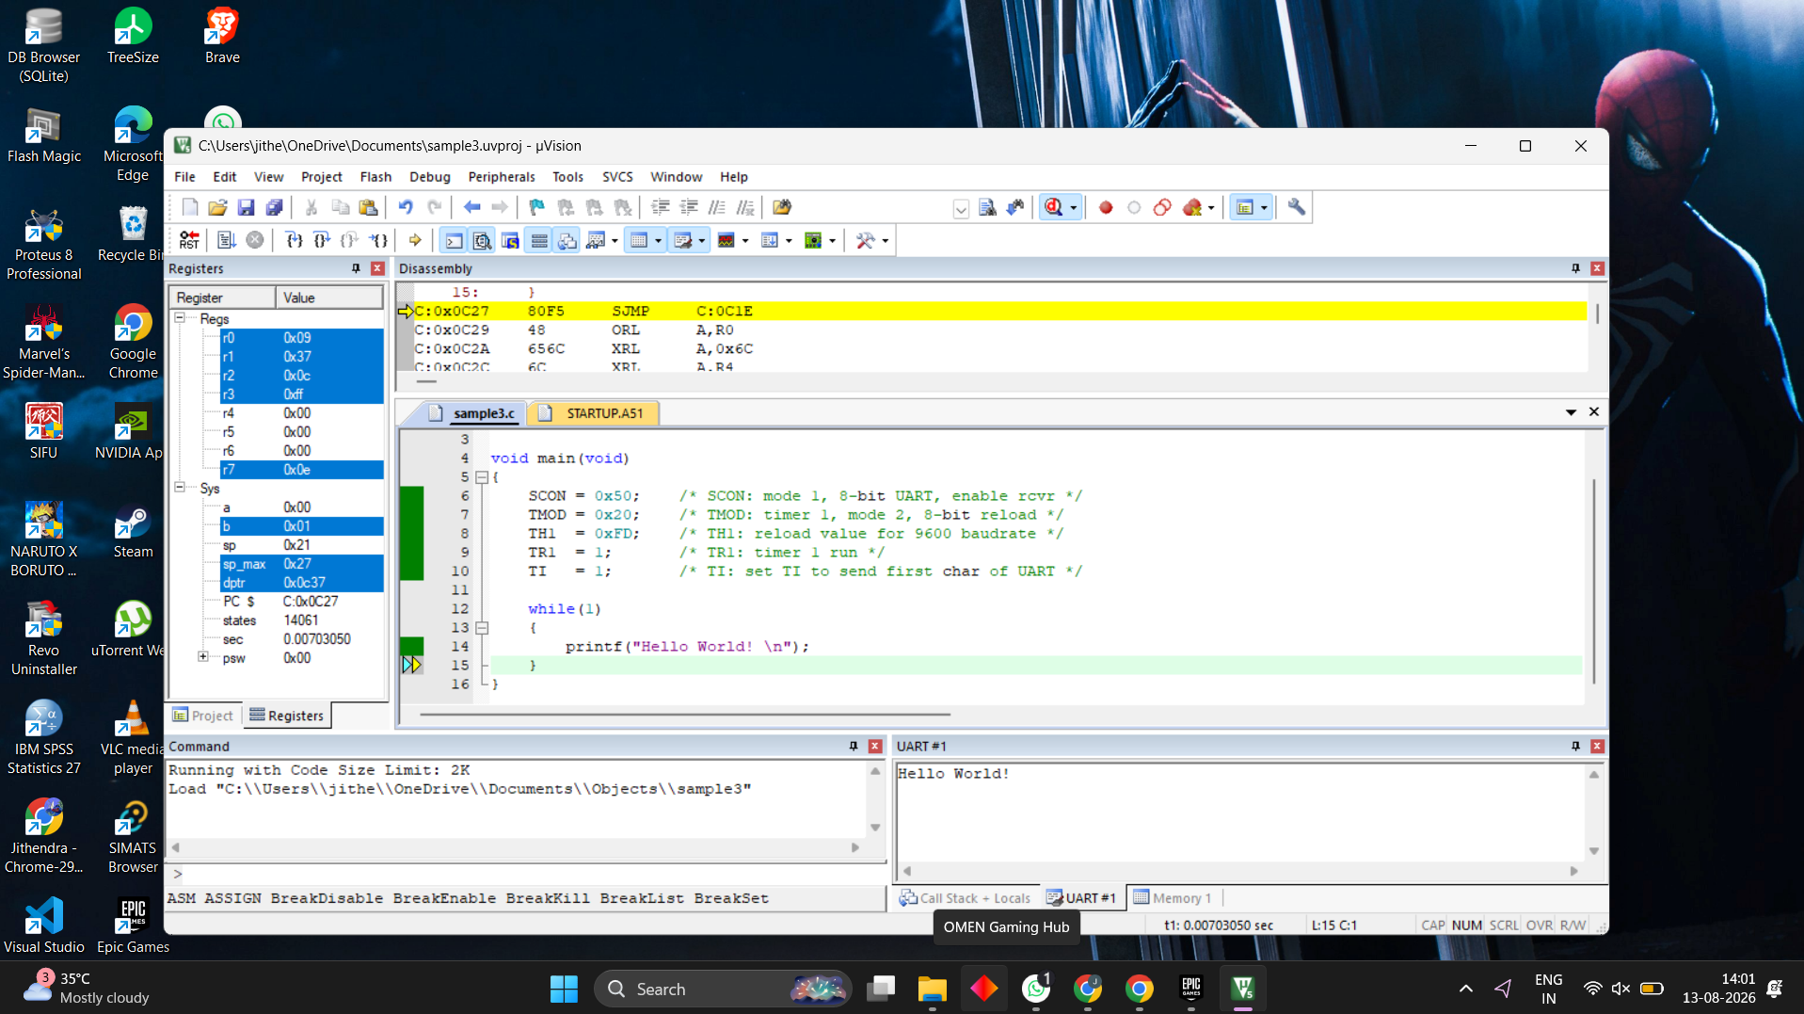
RESULT
Thus the program has been successfully verified and executed.

