Exp No: 3
AIM
STEPPER MOTOR USING AT89C51 USING PROTEUS
To write an assembly language program for Stepper Motor Using AT89C51 using Keil and Proteus
SOFTWARE REQUIRED
Proteus 8 software.
PROGRAM
ORG 0000H
UP: MOV P2,#09H
ACALL DELAY
MOV P2,#0CH
ACALL DELAY
MOV P2,#06H
ACALL DELAY
MOV P2,#03H
ACALL DELAY
SJMP UP
DELAY:MOV R4,#18
HI:MOV R3,#255
H2:DJNZ R3.H2
DJNZ R4.H1I
RET
END
ALGORITHM
1. Start the program.
2. Initialize Port 2 with the first step sequence 09H.
3. Call the DELAY subroutine.
4. Load the next step sequence 0CH into Port 2 and provide a delay.
5. Load the next step sequence 06H into Port 2 and provide a delay.
6. Load the next step sequence 03H into Port 2 and provide a delay.
7. Repeat the sequence continuously using SJMP UP.
8. The DELAY subroutine uses R3 and R4 to generate the required delay.
9. Continue the operation to rotate the stepper motor.
CIRCUIT DIAGRAM:
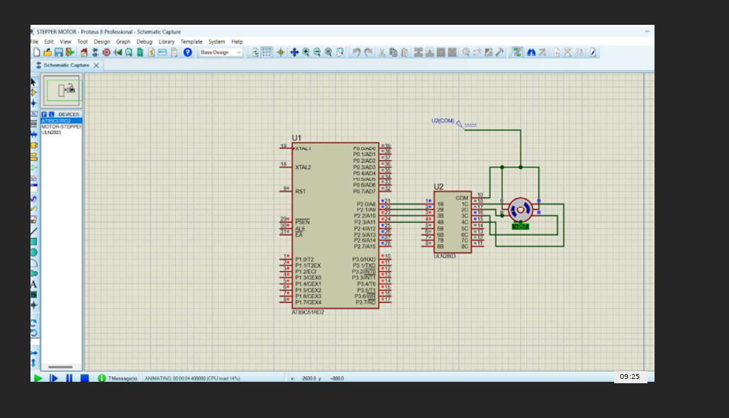
OUTPUT:

RESULT:
Thus the program has been successfully verified and executed.

