EXP NO. 29
PRIORITY-BASED INTERRUPT HANDLING
AIM:
To model priority-based interrupt servicing.
SOFTWARE REQUIRED:
- Ubuntu (or WSL Ubuntu)
- g++
- CMake
- SystemC
PROGRAM:
#include <systemc.h>
SC_MODULE(priority_interrupt) {
sc_event low_int, high_int;
void low_ISR() {
while(true) {
wait(low_int);
cout << "Low Priority Interrupt at "
<< sc_time_stamp() << endl;
wait(3, SC_SEC);
}
}
void high_ISR() {
while(true) {
wait(high_int);
cout << "High Priority Interrupt at "
<< sc_time_stamp() << endl;
wait(1, SC_SEC);
}
}
void generator() {
wait(1, SC_SEC);
low_int.notify();
wait(1, SC_SEC);
high_int.notify();
}
SC_CTOR(priority_interrupt) {
SC_THREAD(low_ISR);
SC_THREAD(high_ISR);
SC_THREAD(generator);
}
};
int sc_main(int argc, char* argv[]) {
priority_interrupt obj("Priority_INT");
sc_start(10, SC_SEC);
return 0;
}

OUTPUT:
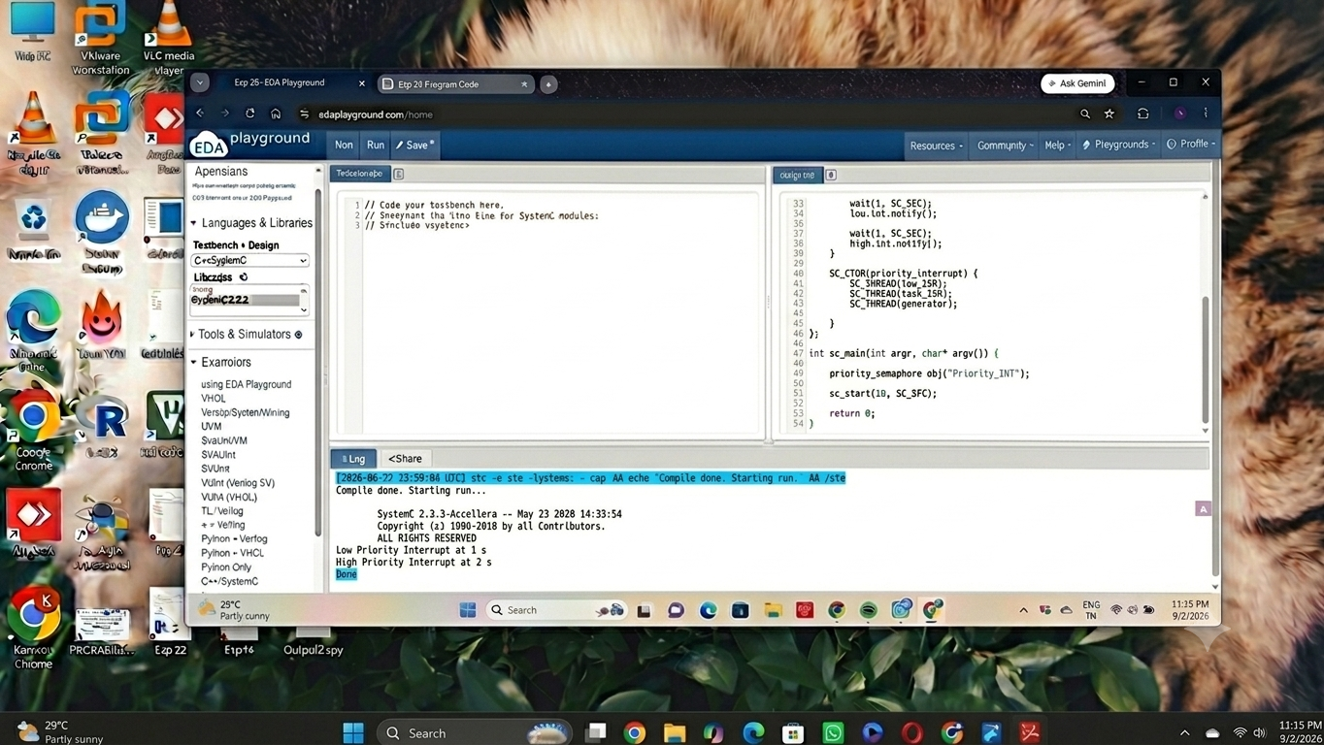

RESULT:
Thus the Priority based Interrupt handling was executed using SystemC and verified.

