EXPERIMENT NO. 10
PIR SENSOR IN PROTEUS USING ARDUINO
AIM:
To write an Embedded C program for interfacing PIR Sensor using Arduino Uno and Proteus.
SOFTWARE REQUIRED:
- Proteus 8 Professional
- Arduino IDE
ALGORITHM:
1. Configure the PIR sensor as input and status LED as output.
2. Read the PIR sensor state.
3. If HIGH, turn the LED ON and print motion detected.
4. If LOW, turn the LED OFF and print motion absent.
5. Repeat continuously.
PROGRAM:
int Status = 13;
int sensor = 12;
void setup(){
Serial.begin(9600);
pinMode(sensor, INPUT);
pinMode(Status, OUTPUT);
}
void loop(){
long state = digitalRead(sensor);
Serial.println(state);
if(state == HIGH){
digitalWrite(Status, HIGH);
Serial.println("Motion detected!");
delay(1000);
}
else{
digitalWrite(Status, LOW);
Serial.println("Motion absent!");
delay(1000);
}
}
OUTPUT:
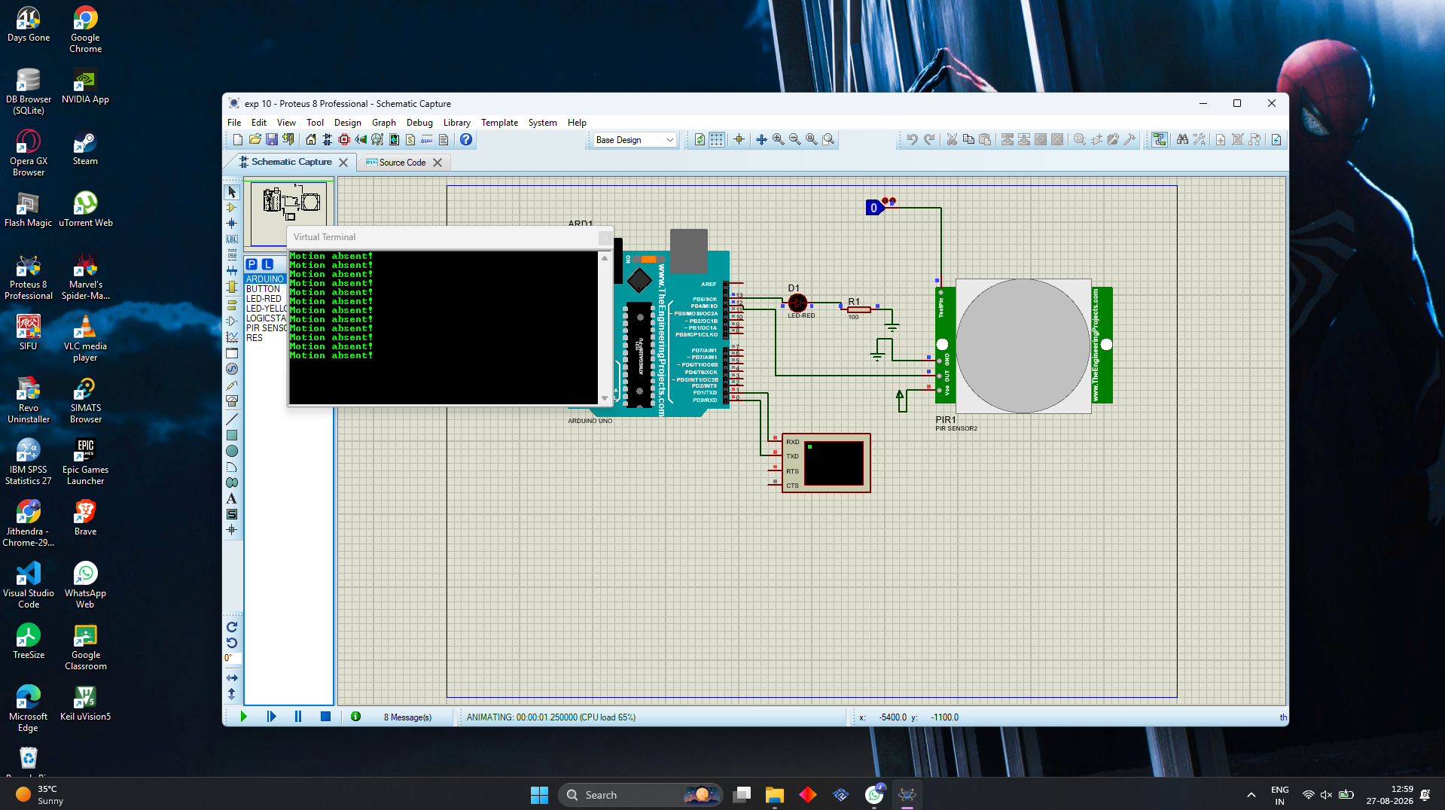
Output reference image supplied for this experiment.
OBSERVATION:
The Virtual Terminal displays the PIR sensor state and reports either motion detected or motion absent.
RESULT:
Thus, the program has been successfully verified and executed.

