EXP NO. 24
MODELING CLOCK-DRIVEN CONCURRENT PROCESSES USING SC_THREAD AND WAIT() IN SYSTEMC
AIM:
To understand and implement a clock-driven process using:
- sc_clock
- SC_THREAD
- wait()
- Event sensitivity (positive edge trigger)
in SystemC.
APPARATUS/SOFTWARE REQUIRED:
- Linux OS / WSL & Ubuntu
- systemC
PROGRAM:
#include <systemc.h>

SC_MODULE(ClockExample) {

sc_in<bool> clk;

void process() {
while (true) {
wait();

std::cout << "Time: " << sc_time_stamp()
<< " Clock Triggered" << std::endl;
}
}

SC_CTOR(ClockExample) {
SC_THREAD(process);
sensitive << clk.pos();
}
};

int sc_main(int argc, char* argv[]) {

sc_clock clock("clock", 1, SC_NS);

ClockExample module("module");
module.clk(clock);

sc_start(5, SC_NS);

return 0;
}

OUTPUT:
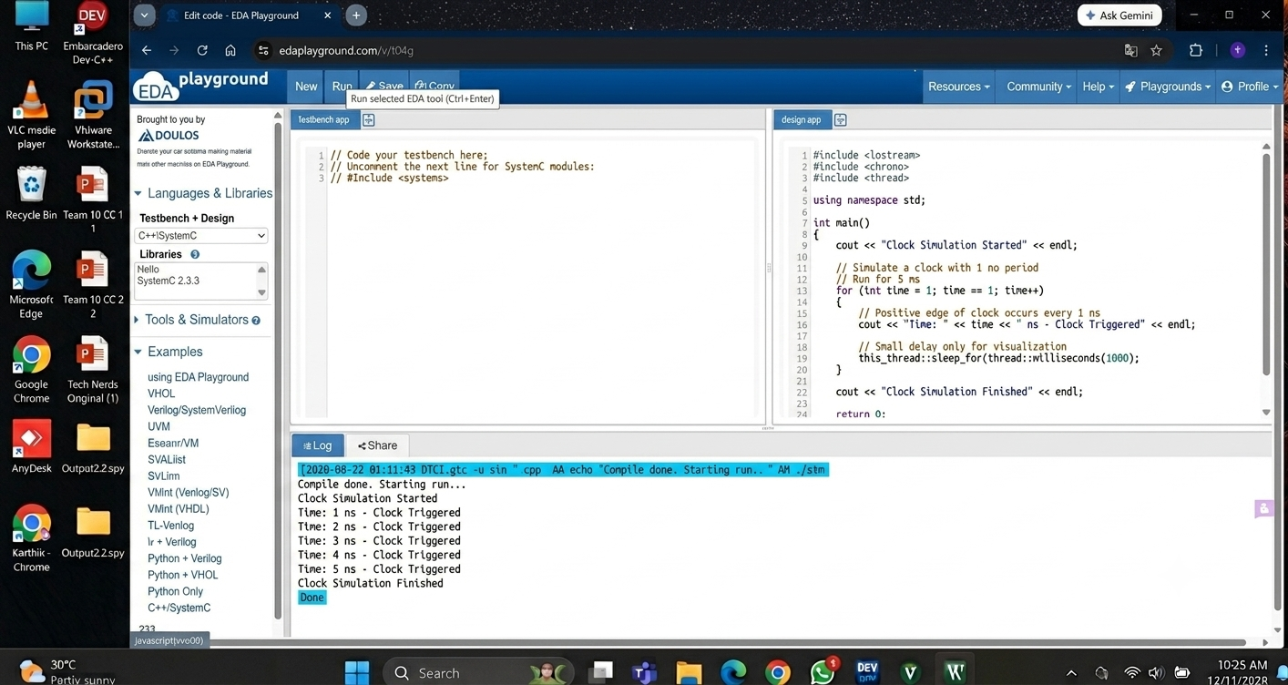

RESULT:
Thus, the clock-driven process using SC_THREAD and wait() was successfully implemented and verified in SystemC.

