GENERATION OF SQUARE WAVE USING PROTEUS
AIM
To write an assembly language program to Generate square wave using AT89C51.
SOFTWARE REQUIRED
Proteus 8 software.
PROGRAM
ORG 0000H
UP: SETB P2.0
ACALL DELAY
CLR P2.0
ACALL DELAY
SJMP UP
DELAY: MOV R4,#35
H1:MOV R3,#255
H2:DJNZ R3,H2
DJNZ R4,H1
RET
END
ALGORITHM
1. Start the program.
2. Set P2.0 high to generate the HIGH level of the square wave.
3. Call the DELAY subroutine.
4. Clear P2.0 to generate the LOW level of the square wave.
5. Call the DELAY subroutine again.
6. Repeat the HIGH and LOW levels continuously using SJMP UP.
7. The DELAY subroutine uses R3 and R4 to generate the required time delay.
8. Stop the program.
CIRCUIT DIAGRAM:
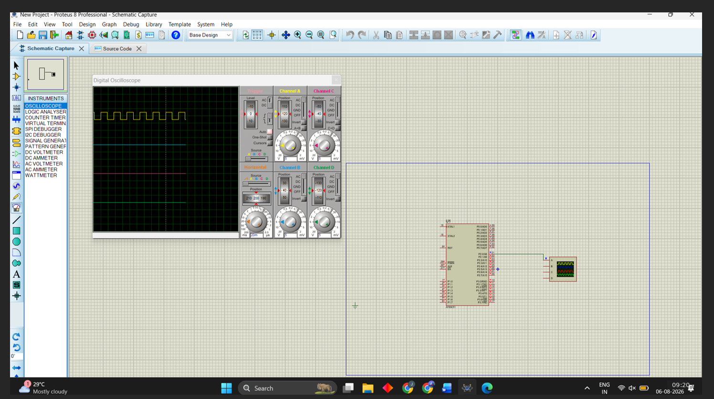
OUTPUT:

RESULT:
Thus the program has been successfully verified and executed.

