EXP NO. 28
COUNTING SEMAPHORE IN SYSTEMC
AIM:
To implement Counting Semaphore allowing multiple resource access.
SOFTWARE REQUIRED:
- Ubuntu (or WSL Ubuntu)
- g++
- CMake
- SystemC
PROGRAM:
#include <systemc.h>
SC_MODULE(counting_semaphore) {
int sem;
void task() {
while(true) {
wait(1, SC_SEC);
if(sem > 0)
sem--;
cout << "Task Accessing Resource at "
<< sc_time_stamp()
<< " Remaining: " << sem << endl;
wait(2, SC_SEC);
sem++;
}
}
SC_CTOR(counting_semaphore) {
sem = 2;
SC_THREAD(task);
SC_THREAD(task);
SC_THREAD(task);
}
};
int sc_main(int argc, char* argv[]) {
counting_semaphore obj("Counting");
sc_start(10, SC_SEC);
return 0;
}
OUTPUT:
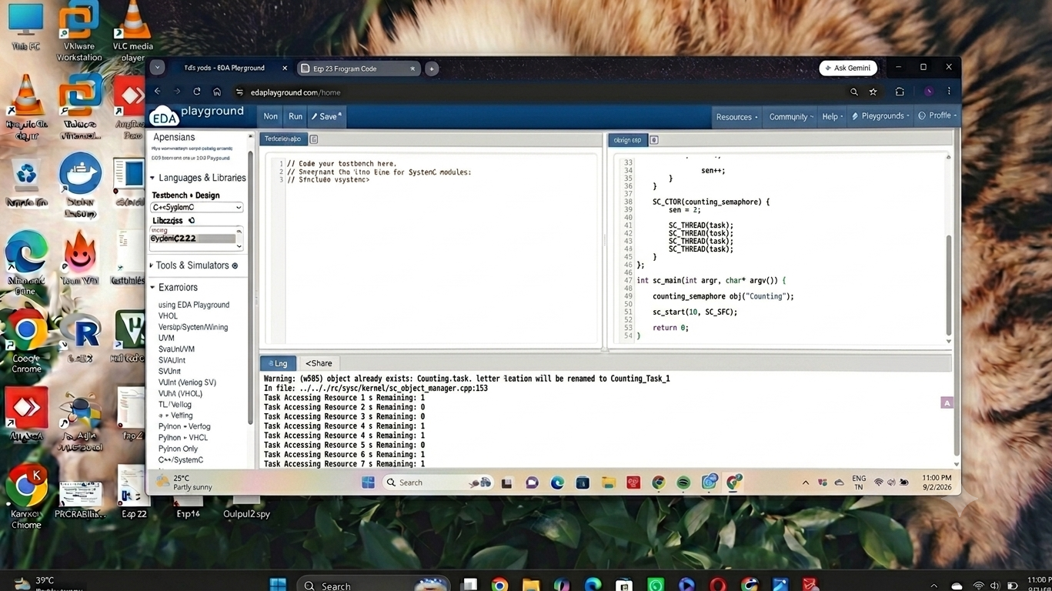

RESULT:
Thus the Counting Semaphore was created using SystemC and verified.

