A PROJECT REPORT ON

LSTM AUTOENCODER-BASED PERSISTENT AND TRANSIENT
ANOMALY CLASSIFICATION IN OPEN RAN KPIs

Submitted in partial fulfilment of the requirements for the course
MACHINE LEARNING
25SC2107E
A.Y.: 2026–27

Submitted by
Yaswanth Srikar | 2520040026
Omprakash Jena | 2520040057
Rishi Vardhan | 2520040078

Under the esteemed guidance of
Dr. Vinnakota Venu Balaji
Assistant Professor, Department of ECE
Koneru Lakshmaiah Education Foundation (KLEF)
Department of Electronics & Communication Engineering



ABSTRACT
The increasing complexity of 5G and Open Radio Access Networks (Open RAN) makes monitoring of network performance important for reliable communication. Open RAN systems generate large volumes of Key Performance Indicator (KPI) time-series data describing radio, platform, and network behaviour. Unusual KPI changes may result from traffic variation, interference, resource congestion, equipment degradation, or configuration problems. However, a short-lived deviation does not always indicate a continuing fault. Distinguishing temporary disturbances from persistent anomalies can help network operators prioritize problems and reduce unnecessary alarms.
This project proposes an LSTM (Long Short-Term Memory) Autoencoder-based approach for detecting anomalous patterns in Open RAN KPI time series and classifying events as transient or persistent. The SpotLight Open RAN dataset is used as the data source. The downloaded archives contain Baseline scenarios named 1UE, 5UE, and 7UE-Ping, and Anomaly categories named MAC, MIXED, NETWORK, PDCP, and RADIO. Before modelling, the files must be inspected to identify formats, timestamps, KPI columns, missing values, and available labels. Preprocessing includes data cleaning, timestamp handling, feature selection, scaling, and fixed-length time-window formation.
The LSTM Autoencoder will be trained primarily on baseline KPI sequences to learn patterns associated with normal operation. It will reconstruct input sequences, and reconstruction error will be used as an anomaly score. An anomaly threshold will be selected using validation data. After detection, temporal analysis of event duration, continuity, magnitude, and recovery will be used to distinguish short-lived events from persistent events. Evaluation may use precision, recall, F1-score, false-positive rate, ROC-AUC where suitable labels and scores are available, and detection delay. Comparisons with simpler detection methods may also be performed. The project aims to provide a practical machine-learning workflow for Open RAN KPI monitoring. The available labels must be inspected carefully; transient and persistent ground-truth labels must not be assumed unless the dataset explicitly provides them.
Keywords: Open RAN, KPI time series, anomaly detection, LSTM Autoencoder, reconstruction error, transient anomaly, persistent anomaly.
Signature of the Supervisor | Course Instructor

INDEX
Section | Page
Abstract | ii
1. Introduction | 1
1.1 Background | 1
1.2 Problem Statement | 1
1.3 Aim and Objectives | 1
1.4 Scope and Significance | 1
2. System Model | 2
2.1 Dataset Description | 2
2.2 KPI Data and Anomaly Categories | 2
2.3 Proposed System Architecture | 3
3. Proposed Methodology | 4
3.1 Data Inspection and Preprocessing | 4
3.2 Sliding-Window Preparation | 4
3.3 LSTM Autoencoder | 4
3.4 Anomaly Detection and Threshold Selection | 4–5
3.5 Transient/Persistent Classification | 5
3.6 Evaluation Plan | 5
3.7 Software and Hardware Requirements | 5
4. Results and Discussion | 6
5. Conclusion and Future Scope | 7
References | 8

1. INTRODUCTION

1.1 Background
Open Radio Access Network (Open RAN) is an approach to radio access networking that promotes disaggregation and interoperability among network components. A running network generates Key Performance Indicators (KPIs) that help describe radio quality, resource utilization, protocol processing, and network-link behaviour. Examples of KPI families include radio measurements, platform/thread measurements, and network counters. Analysing these measurements over time can help identify deviations that may be associated with network problems.
An anomaly is a measurement or sequence of measurements that differs from expected behaviour. A transient anomaly is a short-lived deviation followed by recovery, whereas a persistent anomaly continues over time. This distinction matters because a temporary disturbance may require observation, while a persistent degradation may need investigation. Simple fixed thresholds can be useful, but may not represent temporal patterns or relationships among multiple KPIs.

1.2 Problem Statement
The project addresses the problem of detecting unusual behaviour in Open RAN KPI time-series data and distinguishing short-lived anomalies from continuing anomalous behaviour. The challenge is to learn normal multivariate temporal patterns, identify deviations from those patterns, and then assess how long each detected deviation lasts. The proposed approach uses an LSTM Autoencoder for anomaly scoring and a temporal post-processing stage for transient/persistent classification.

1.3 Aim and Objectives
Aim: To develop and evaluate an LSTM Autoencoder-based workflow for detecting anomalies in Open RAN KPIs and analysing whether detected events are transient or persistent.
- Inspect the SpotLight dataset structure, KPI schemas, timestamps, and available labels.
- Preprocess KPI time-series data by handling missing values, selecting features, scaling values, and forming time windows.
- Train an LSTM Autoencoder primarily on baseline/normal KPI sequences.
- Calculate reconstruction errors and select an anomaly threshold using validation data.
- Analyse the duration and continuity of detected anomalies to classify events as transient or persistent.
- Evaluate the method using suitable detection metrics and compare it with a simpler baseline where feasible.

1.4 Scope and Significance
The project focuses on offline analysis of the supplied Open RAN KPI dataset and a software-based machine-learning prototype. It does not include live network deployment or automatic fault repair. The work investigates temporal anomaly detection and whether event duration can support transient-versus-persistent classification. Final results depend on verified data, labels, preprocessing, and validation.

2. SYSTEM MODEL

2.1 Dataset Description
The project uses the SpotLight Open RAN anomaly-detection dataset. The downloaded archives are named Anomaly and Baseline. According to the folder structure observed in the supplied screenshots, the Anomaly archive contains MAC, MIXED, NETWORK, PDCP, and RADIO folders, while the Baseline archive contains 1UE, 5UE, and 7UE-Ping folders. These names describe the visible organization of the local dataset; exact file formats, columns, units, and label meanings must be verified from the files and official schema documentation.

Dataset links:
Google Drive: https://drive.google.com/drive/folders/1x7WnU6q9EodacUdh3iXRmi9FWrMD3rME?usp=sharing

Official GitHub repository: https://github.com/netsys-edinburgh/SpotLight

2.2 KPI Data and Anomaly Categories
KPI stands for Key Performance Indicator. The SpotLight documentation describes radio, platform, and network KPI schema families. Radio KPIs describe radio/protocol behaviour; platform KPIs describe host, thread, or timing behaviour; network KPIs describe relevant network-link or switch-port measurements. The precise columns should be selected only after inspecting the schema files and data samples.

Category |  | Project-level interpretation
Baseline |  | Normal-operation data used primarily to learn typical KPI patterns.
MAC |  | Anomaly scenario associated with Medium Access Control/scheduler behaviour.
PDCP |  | Anomaly scenario associated with Packet Data Convergence Protocol processing.
NETWORK |  | Anomaly scenario associated with network/fronthaul behaviour.
RADIO |  | Anomaly scenario associated with radio/physical-layer interference.
MIXED |  | Scenario involving combinations of anomaly types.

2.3 Proposed System Architecture
The proposed processing pipeline is:
- SpotLight baseline and anomaly data
- File inspection, timestamp parsing, and KPI feature selection
- Missing-value treatment and feature scaling
- Fixed-length sliding-window generation
- LSTM Autoencoder training on baseline windows
- Reconstruction-error calculation and threshold-based anomaly detection
- Temporal grouping of consecutive anomalous windows
- Transient/persistent classification and evaluation

The pipeline begins with baseline data used to train the model. Baseline and anomalous data are then passed through the trained model during evaluation. Reconstruction errors are compared with the selected threshold, and consecutive anomalous windows are grouped into events for temporal classification.

3. PROPOSED METHODOLOGY

3.1 Data Inspection and Preprocessing
First, list the files in each scenario and identify the file format, timestamp column, KPI columns, and any separate label files. Consult the official repository schemas to interpret column names and units. Remove duplicate records if present, sort records chronologically, and investigate missing or invalid values. Missing values may be handled by a documented strategy such as interpolation for suitable continuous measurements or removal of unusable rows. The chosen strategy should be recorded rather than applied without inspection.
Select numerical KPI features relevant to the experiment. Scale features so that variables with larger numeric ranges do not dominate the reconstruction error. Fit the scaler using training data only, then apply the same transformation to validation and test data. If files are collected at different times or sampling intervals, align them carefully and state the chosen resampling or joining method.

3.2 Sliding-Window Preparation
An LSTM learns from sequences rather than isolated measurements. Convert the ordered KPI series into overlapping or non-overlapping windows of a fixed length. Each window contains a sequence of time steps and multiple KPI features. Choose the window length and stride through validation experiments. Split data chronologically or by complete scenario/run before creating final evaluation windows to reduce leakage from highly similar overlapping windows.

3.3 LSTM Autoencoder
An autoencoder learns to reconstruct its input. In an LSTM Autoencoder, an encoder made from LSTM layers compresses the temporal input into a representation, and a decoder reconstructs the KPI sequence. Train the model primarily on baseline windows so it learns patterns associated with normal operation. Use a reconstruction loss such as mean squared error (MSE) to measure the difference between input values and reconstructed values.
For a window with N values, a simple reconstruction-error expression is:
MSE = (1/N) × Σ (xᵢ − x̂ᵢ)²
Here, xᵢ is an observed KPI value and x̂ᵢ is the corresponding reconstructed value.

3.4 Anomaly Detection and Threshold Selection
After training, pass validation and test windows through the model and calculate their reconstruction errors. A window whose error exceeds a threshold is flagged as anomalous. Select the threshold using training/validation behaviour and the desired trade-off between missed detections and false alarms. Do not choose a threshold by inspecting the final test labels, because that would bias the evaluation.

3.5 Transient/Persistent Classification
Group consecutive anomalous windows into candidate events using timestamps and the anomaly decisions. A transient event is one that lasts briefly and is followed by recovery to normal behaviour. A persistent event continues across a longer period or across a defined number of consecutive windows. Set the duration threshold based on validation experiments, sampling interval, or a stated domain rationale. Consider short normal gaps, event magnitude, and recovery behaviour only if these rules are clearly defined and tested.
Important dataset note: verify whether the provided label files include event boundaries and whether they explicitly label transient and persistent events. If not, the project must define a duration-based rule and describe its limitations; do not present derived labels as original ground truth.

3.6 Evaluation Plan
Use precision, recall, F1-score, false-positive rate, and detection delay to evaluate anomaly detection. ROC-AUC may be reported if suitable continuous scores and reliable reference labels are available. Accuracy should be interpreted with care when normal and anomalous samples are imbalanced. For transient/persistent classification, report per-class metrics and a confusion matrix only when trustworthy event-level reference labels are available. Compare against a simple threshold-based detector or another baseline method if feasible.

3.7 Software and Hardware Requirements
Component | Requirement / tool
Operating system | Windows 10/11 or another supported OS
Programming language | Python 3.10 or later
Development environment | Visual Studio Code or Jupyter Notebook
Data processing | Pandas, NumPy
Visualization | Matplotlib; Seaborn if required
Machine learning | Scikit-learn
Deep learning | TensorFlow/Keras
Supporting tools | SciPy and a suitable CSV/parquet reader depending on actual files
Dataset | SpotLight Open RAN KPI dataset; verify actual file formats before loading
Hardware (suggested) | A computer capable of running Python and processing the dataset; a GPU is optional for a small prototype. Record the actual system used.

4. RESULTS AND DISCUSSION

4.1 Experimental Setup
The pipeline used the SpotLight Open RAN KPI dataset. The saved run reports 57 baseline recordings and 16 anomaly recordings. Baseline recordings were divided by recording into training, validation, and normal-test sets; the 16 anomaly recordings were evaluated separately. The split was 40 baseline recordings for training, 8 for validation, and 9 for normal testing.

Data group | Recording count | Evaluated windows (saved outputs)
Baseline training | 40 | Not recorded in final_results.json
Baseline validation | 8 | 31,786
Baseline normal test | 9 | 35,797
Anomaly test | 16 | 173,298
Total baseline recordings | 57 | —
The model used 12 radio KPI features: l1_pusch_count, l1_avg_pusch_count, l1_avg_UL_prbSize, l1_avg_UL_mcs, l1_avg_UL_tbs, l1_UL_tx, l1_ULMcsMin, l1_ULMcsMax, l1_ULTbsMax, l1_ULTbsMin, l1_ULPrbMax, and l1_ULPrbMin. Preprocessing allowed interpolation across gaps of up to 10 rows and treated timestamp gaps greater than 1 second as major gaps. The scaler was fitted on training rows only.

4.2 LSTM Autoencoder Configuration
Parameter | Configured value
Input window | 20 time steps × 12 KPI features
Window step | 1 time step (overlapping windows)
Encoder LSTM units | 64, then 32
Decoder LSTM units | 32, then 64
Output layer | TimeDistributed Dense layer with 12 outputs
Loss function | Mean squared error (MSE)
Optimizer | Adam
Initial learning rate | 0.001; reduced during training
Batch size | 64
Maximum epochs | 100
Training completion | 100 epochs completed
Early stopping setting | Patience = 10; best validation checkpoint saved
The autoencoder was trained to reconstruct baseline KPI windows. Reconstruction error was calculated as the mean squared difference between input and reconstructed values. A high reconstruction error indicates that a window differs from patterns learned from baseline data.

4.3 Training Performance
The saved training history contains 100 epochs. Training loss decreased from approximately 0.30791 in the first epoch to 0.02193 in the final epoch. Validation loss decreased from approximately 0.06023 to its minimum of 0.00990 at epoch 99 (1-based numbering); the final validation loss was approximately 0.00993. The curves show substantial reduction in both training and validation reconstruction loss.
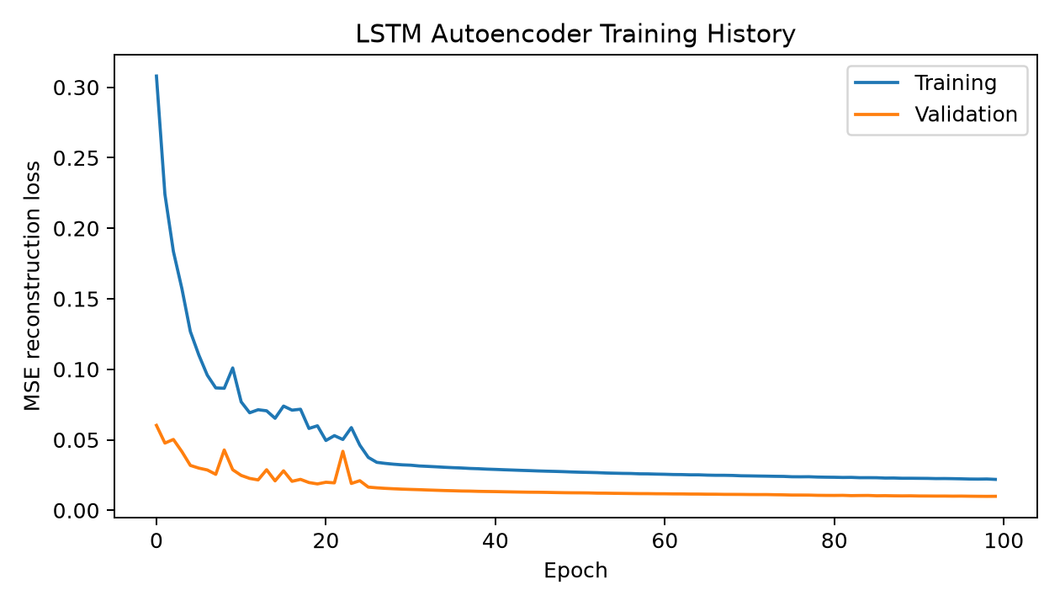
Figure 4.1. Training and validation reconstruction loss across 100 epochs.

4.4 Reconstruction Error and Threshold Selection
The saved threshold file and saved predictions use a reconstruction-error threshold of 0.028941, corresponding to the 95th percentile of validation reconstruction errors. At this threshold, the validation false-positive rate was 5.00%. On the unseen normal-test set, the false-alarm rate was 10.60%, showing that some normal KPI windows were incorrectly flagged as anomalous.
Validation percentile | Threshold | Validation false-positive rate | Normal-test false-alarm rate | Anomaly-test precision | Anomaly-test recall | Anomaly-test F1
95th | 0.028941 | 5.00% | 10.60% | 28.55% | 58.10% | 38.29%
97th | 0.035263 | 3.00% | 7.80% | 29.05% | 56.32% | 38.33%
99th | 0.055432 | 1.00% | 5.61% | 31.15% | 54.45% | 39.63%
The threshold-sensitivity table shows a trade-off: a higher threshold reduces false alarms and increases precision, but lowers recall. The results below use the saved 95th-percentile threshold because that is the threshold recorded in models/threshold.json and used to produce the saved predictions, event list, and figures.
Reproducibility note: config/config.yaml specifies selected_percentile = 99, but the saved threshold.json records percentile = 95 and threshold = 0.028941. The saved metrics are consistent with the 95th-percentile threshold, not the configured 99th percentile. Resolve this mismatch and rerun the pipeline before presenting the experiment as fully reproducible.
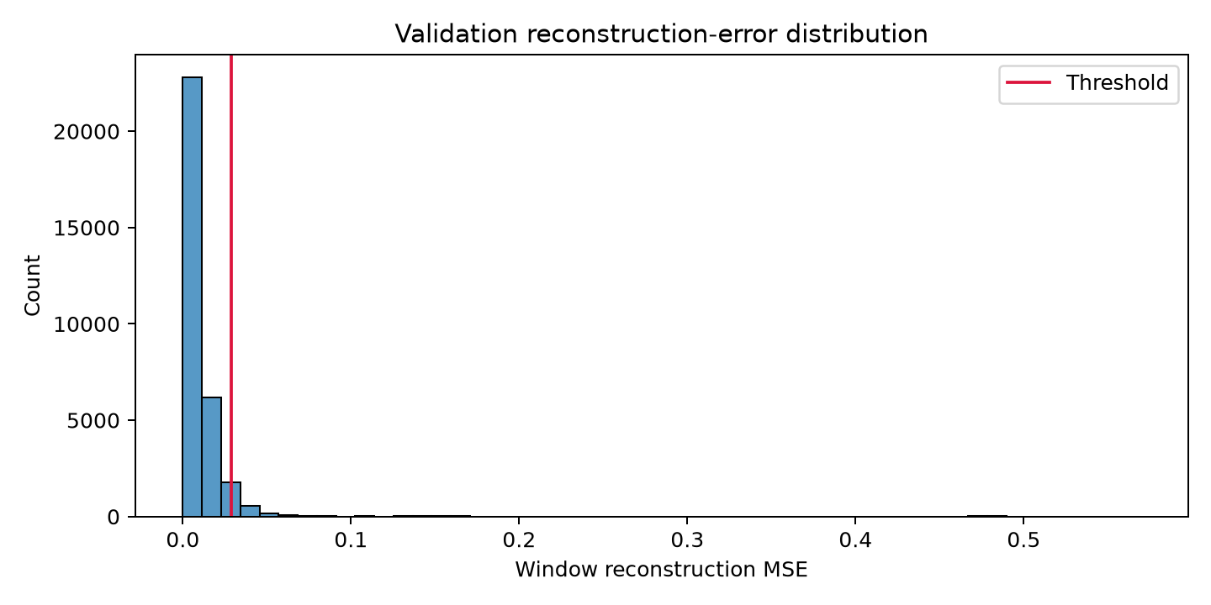
Figure 4.2. Validation reconstruction-error distribution and the saved threshold.

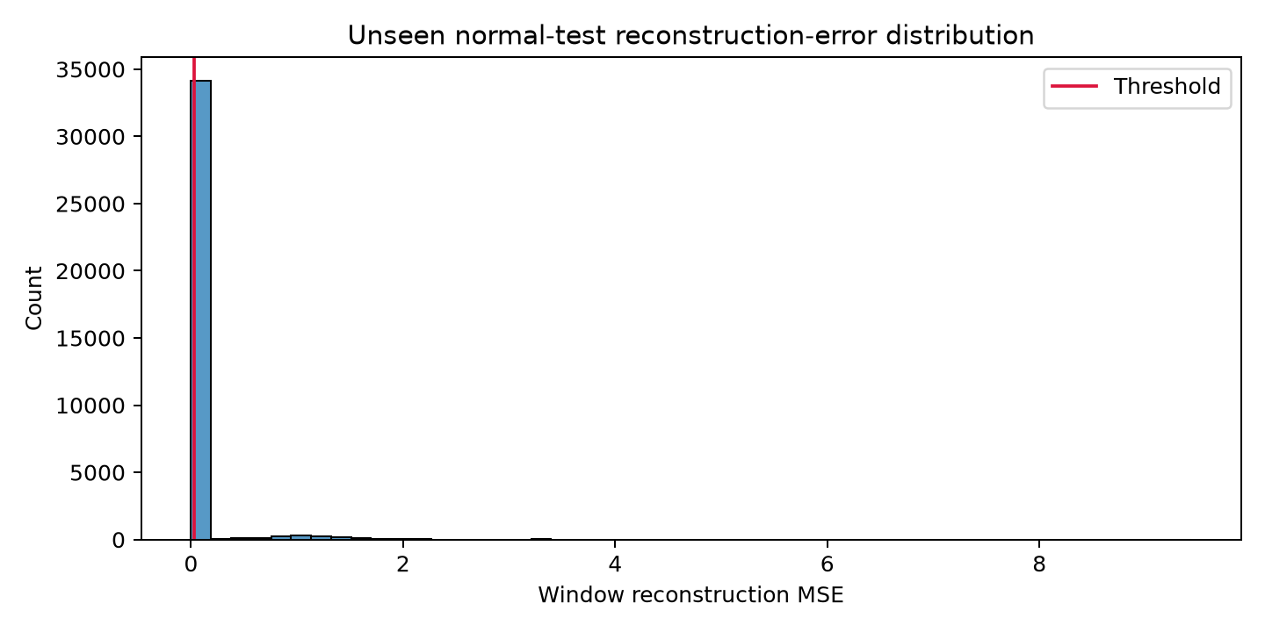
Figure 4.3. Reconstruction-error distribution for baseline normal-test windows.

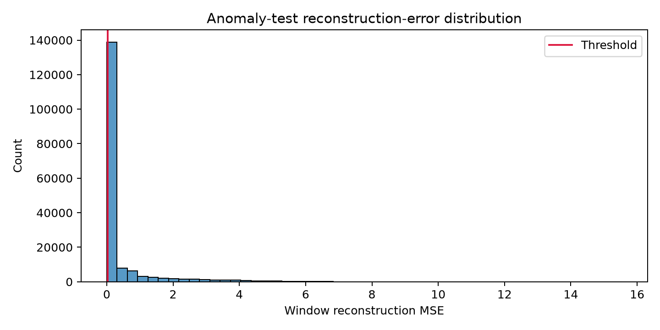
Figure 4.4. Reconstruction-error distribution for anomaly-test windows.

4.5 Anomaly Detection Performance
At the saved threshold of 0.028941, 173,298 anomaly-test windows were evaluated. The model achieved accuracy of 68.32%, precision of 28.55%, recall of 58.10%, and F1-score of 38.29%. ROC-AUC was 0.688 and PR-AUC was 0.356. The false-positive rate among ground-truth normal windows in the anomaly-test evaluation was 29.60%; the false-alarm rate across all evaluated anomaly-test windows was 24.59%. These rates use different denominators.
Metric (anomaly test) | Value
Evaluated windows | 173,298
Accuracy | 68.32%
Precision | 28.55%
Recall | 58.10%
F1-score | 38.29%
False-positive rate | 29.60%
False-alarm rate across evaluated windows | 24.59%
ROC-AUC | 0.688
PR-AUC | 0.356

4.6 Confusion Matrix
The following confusion matrix is derived from the saved anomaly-test metrics at the saved 95th-percentile threshold.
 | Predicted normal | Predicted anomaly
Ground-truth normal | TN = 101,371 | FP = 42,613
Ground-truth anomaly | FN = 12,283 | TP = 17,031
The model identified 17,031 true-positive anomalous windows, but it also produced 42,613 false positives and missed 12,283 labelled anomalous windows. This indicates useful anomaly sensitivity but a substantial false-alarm burden. Accuracy alone does not adequately describe this behaviour; precision, recall, F1-score, and false-alarm rates are also important.

4.7 Performance by Anomaly Scenario
Scenario | Evaluated windows | Precision | Recall | F1-score | Interpretation
MAC | 7,785 | 0.00% | 0.00% | 0.00% | No positive ground-truth windows appear in the saved labelled subset; these metrics do not establish anomaly recall for this category.
MIXED | 94,726 | 29.26% | 72.09% | 41.63% | Highest recall among reported scenarios, with a substantial false-positive rate.
NETWORK | 19,963 | 0.00% | 0.00% | 0.00% | No positive ground-truth windows appear in the saved labelled subset; interpret with caution.
PDCP | 23,715 | 18.74% | 15.19% | 16.78% | Weak detection performance on the labelled subset.
RADIO | 27,109 | 58.24% | 44.71% | 50.58% | Best F1-score among reported scenarios.
Results vary by scenario. RADIO has the highest reported F1-score (50.58%), while MIXED has the highest reported recall (72.09%). PDCP performance is weak. MAC and NETWORK have no positive ground-truth windows in the saved labelled subsets, so their zero precision/recall/F1 values must not be interpreted as proof that the model cannot detect those anomaly types. Label coverage for these categories should be investigated.

4.8 Example Detection Timeline and Event-Level Evaluation
The project saves a reconstruction-error timeline for the MAC/MAC2 recording. The plot shows intermittent high-error regions and many predicted-anomaly points. It is a qualitative example of threshold application over time, not proof of good event-level precision.
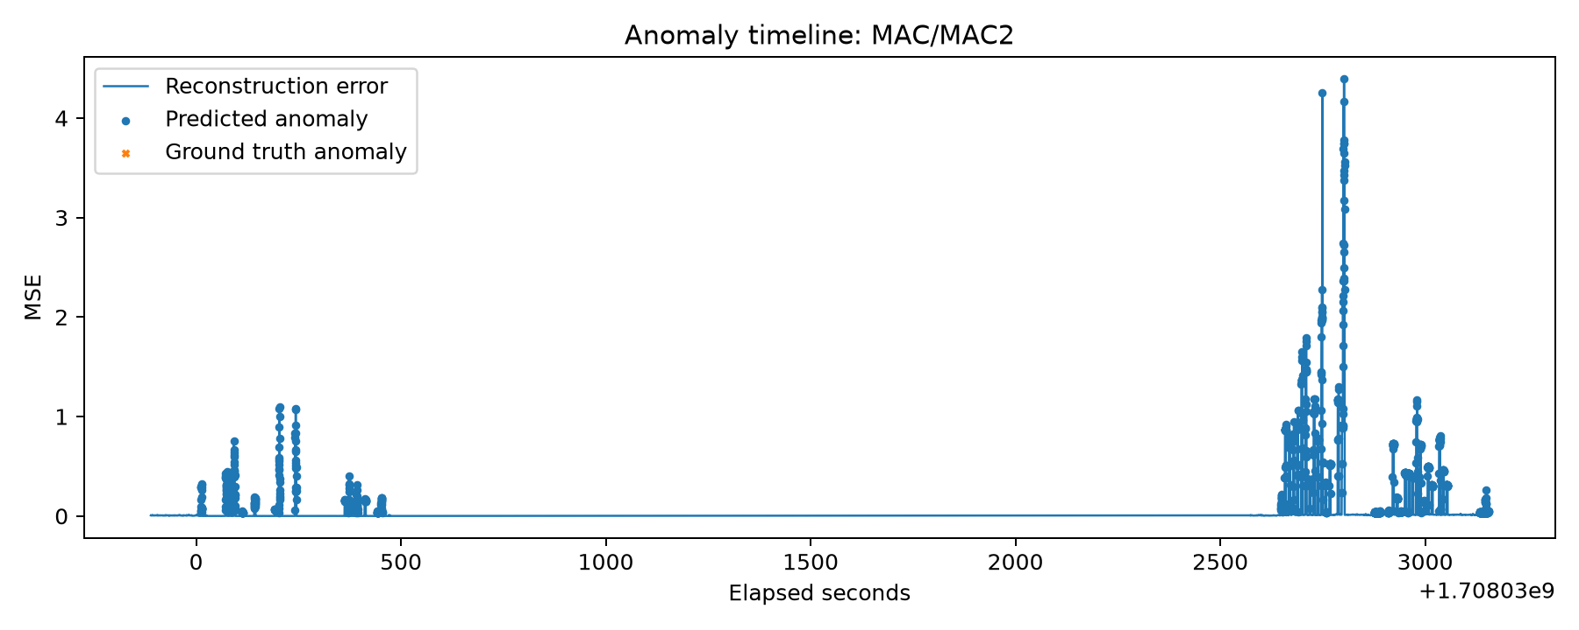
Figure 4.5. Saved anomaly timeline for the MAC/MAC2 recording.
The saved event-level evaluation reports 69 reference events, 1,719 predicted events, and 67 matched events. Event precision was 3.90%, event recall was 97.10%, and event F1-score was 7.49%. Although most reference events overlap at least one predicted event, the much larger number of predicted events results in very low event precision. The system appears to over-segment or over-trigger events, so event grouping and post-processing need improvement.

Event-level measure | Saved value
Reference events | 69
Predicted events | 1,719
Matched reference events | 67
Event precision | 3.90%
Event recall | 97.10%
Event F1-score | 7.49%

4.9 Transient and Persistent Classification
The pipeline applies a duration rule after anomaly detection rather than training a separate transient/persistent classifier. With the configured persistence threshold of three anomalous windows, the saved sensitivity analysis reports 335 transient events and 1,384 persistent events, out of 1,719 detected events.
Minimum anomalous windows | Reported approximate duration | Transient events | Persistent events
1 | 3 seconds | 0 | 1,719
2 | 6 seconds | 253 | 1,466
3 (selected) | 9 seconds (as written in config) | 335 | 1,384
4 | 12 seconds | 380 | 1,339
5 | 15 seconds | 413 | 1,306
Important methodological caution: the window size is 20 samples and the step size is 1 sample, so adjacent windows overlap heavily. The configured duration estimate (number of windows × 20 samples × 0.15 seconds) treats windows as if they did not overlap and can overstate elapsed duration. Recalculate persistence duration from timestamps or window stride before claiming that three windows represent a validated nine-second interval. The supplied outputs also do not demonstrate a separately validated ground-truth transient-versus-persistent classification score.

4.10 Discussion and Limitations
- The training and validation losses decreased substantially over the 100-epoch run, indicating that the model learned to reconstruct baseline sequences.
- The saved anomaly-test F1-score was 38.29%, with recall of 58.10% and precision of 28.55%. This reflects a trade-off between identifying labelled anomalous windows and generating false alarms.
- Scenario-level results are uneven, and label coverage is insufficient to interpret the MAC and NETWORK scores as full category-level recall measurements.
- Event-level recall is high but event precision is very low because 1,719 events were predicted against 69 reference events. Consecutive-window grouping and threshold calibration need refinement.
- The ZIP contains no reported comparison against an independently implemented baseline detector, and detection delay is not present in the saved metrics. Therefore, no comparative improvement or detection-delay claim is made here.
- The threshold configuration and saved threshold output disagree (99th percentile in config versus 95th percentile in the saved threshold file). The results above use the saved threshold that generated the stored outputs; rerun the pipeline after resolving this mismatch.
Overall, the saved experiment demonstrates that the LSTM Autoencoder can flag deviations in Open RAN KPI windows, but the false-alarm burden, low event precision, incomplete scenario label coverage, and threshold/persistence configuration issues mean the current implementation should be treated as a prototype requiring further validation rather than a final high-accuracy classifier.

5. CONCLUSION AND FUTURE SCOPE

5.1 Conclusion
This project proposes a time-series anomaly-detection workflow for Open RAN KPIs using an LSTM Autoencoder. The method learns typical KPI patterns from baseline data, uses reconstruction error to identify deviations, and applies temporal analysis to examine whether detected anomalies are short-lived or persistent. The SpotLight dataset provides baseline and anomaly scenarios suitable for investigating this workflow. The final conclusions about detection quality and classification performance must be written after the model is implemented and the experimental results are analyzed.

5.2 Future Scope
- Evaluate different window lengths, LSTM layer sizes, loss functions, and threshold-selection methods.
- Compare the LSTM Autoencoder with statistical thresholds, Isolation Forest, and other autoencoder architectures.
- Investigate early warning of anomalies that are likely to become persistent.
- Explore feature attribution or explainability methods to identify which KPIs contribute most to an anomaly score.
- Test the pipeline on additional Open RAN scenarios or live telemetry, subject to data availability and access.

REFERENCES
1. SpotLight Open RAN dataset and code repository.
https://github.com/netsys-edinburgh/SpotLight

2. SpotLight dataset download folder supplied for this project.
https://drive.google.com/drive/folders/1x7WnU6q9EodacUdh3iXRmi9FWrMD3rME?usp=sharing
3. Sun, C., Pawar, U., Khoja, M., Foukas, X., Marina, M. K., & Radunovic, B. “SpotLight: Accurate, Explainable and Efficient Anomaly Detection for Open RAN.” Proceedings of ACM MobiCom 2024.
https://doi.org/10.1145/3636534.3649380

