Project 1: Personal Portfolio Website
A one-page personal website showing profile, education, skills, hobbies, projects, achievements, resume download and contact details. It uses CSS animations (floating avatar, fading heading, growing skill bars), hover effects on the menu and cards, and a responsive layout.

Code: htmi/internal css

<!DOCTYPE html>
<html>
<head>
<meta charset="UTF-8">
<meta name="viewport" content="width=device-width, initial-scale=1.0">
<title>My Personal Portfolio</title>
<link rel="stylesheet" href="style.css">
</head>
<body>

<!-- Navigation -->
<header>
<nav class="navbar">
<h2 class="logo">MyPortfolio</h2>
<ul>
<li><a href="#home">Home</a></li>
<li><a href="#about">About</a></li>
<li><a href="#education">Education</a></li>
<li><a href="#skills">Skills</a></li>
<li><a href="#hobbies">Hobbies</a></li>
<li><a href="#projects">Projects</a></li>
<li><a href="#achievements">Achievements</a></li>
<li><a href="#resume">Resume</a></li>
<li><a href="#contact">Contact</a></li>
</ul>
</nav>
</header>

<!-- Home -->
<section id="home" class="hero">
<div class="hero-content">
<p>HELLO, WELCOME TO MY WEBSITE</p>
<h1>Hi, I'm <span>yaswanth</span></h1>
<h3>B.Tech AI & Machine Learning Student</h3>
<p>
I am passionate about technology, programming,
creativity, and learning new skills.
</p>
<a href="#projects" class="btn">Explore My Work</a>
</div>
<div class="profile">
<div class="avatar">Y</div>
<p>Profile</p>
</div>
</section>

<!-- About -->
<section id="about" class="section">
<h2>About Me</h2>
<p>
I am a motivated student interested in Artificial Intelligence,
Machine Learning, and Web Development. I enjoy solving problems
and building creative projects using modern technologies.
</p>
</section>

<!-- Education -->
<section id="education" class="section light">
<h2>Educational Qualifications</h2>
<div class="cards">
<div class="card">
<h3>B.Tech</h3>
<p>Artificial Intelligence & Machine Learning</p>
<p> Dr.RVR NRIuniversity </p>
<p>Year: 2026 – 2030</p>
</div>
<div class="card">
<h3>Intermediate </h3>
<p>Your sri chaytanya jr collage,rb2</p>
<p>Year: 2024-2026</p>
</div>
<div class="card">
<h3>School Education</h3>
<p>ST.THOMAS HIGH SCHOOL</p>
<p>Year: 2014-2024</p>
</div>
</div>
</section>

<!-- Skills -->
<section id="skills" class="section">
<h2>Technical Skills</h2>
<div class="skills">
<div class="skill">HTML</div>
<div class="skill">CSS</div>
<div class="skill">Python</div>
<div class="skill">Java</div>
<div class="skill">C Programming</div>
<div class="skill">Machine Learning</div>
<div class="skill">Git & GitHub</div>
</div>
</section>

<!-- Hobbies -->
<section id="hobbies" class="section light">
<h2>My Hobbies</h2>
<div class="cards">
<div class="card">Learning New Skills</div>
<div class="card">Coding</div>
<div class="card">Content Creation</div>
<div class="card">Listening to Music</div>
</div>
</section>

<!-- Projects -->
<section id="projects" class="section">
<h2>My Projects</h2>
<div class="cards">
<div class="card">
<h3>Personal Portfolio</h3>
<p>A website that displays my profile and skills.</p>
<span>HTML, CSS</span>
</div>
<div class="card">
<h3>Student Study Planner</h3>
<p>A concept for organizing study tasks and schedules.</p>
<span>HTML, CSS, JavaScript</span>
</div>
<div class="card">
<h3>AI Learning Assistant</h3>
<p>A project idea to help students learn AI concepts.</p>
<span>Python, AI</span>
</div>
</div>
</section>

<!-- Achievements -->
<section id="achievements" class="section light">
<h2>Achievements & Certificates</h2>
<div class="cards">
<div class="card">
<h3> Academic Achievement</h3>
<p>ESSAY WRITTING,POSTER PRASANTATION,PYTHON,etc</p>
</div>
<div class="card">
<h3> Certificates</h3>
<p>NCC-Agrade ,etc</p>
</div>
<div class="card">
<h3> Workshops</h3>
<p>Add hackathons, workshops, or competitions.</p>
</div>
</div>
</section>

<!-- Resume -->
<section id="resume" class="section">
<h2>My Resume</h2>
<p>Click below to download my resume.</p>
<a href="resume.pdf" download class="btn">Download Resume</a>
</section>

<!-- Contact -->
<section id="contact" class="section contact">
<h2>Contact Me</h2>
<p>Email: yaswanththatha759@gmail.com</p>
<p>Phone: +91 9177682112</p>
<p>
GitHub:
<a href="https://github.com/">Visit My GitHub</a>
</p>
<p>
LinkedIn:
<a href="https://www.linkedin.com/">Visit My LinkedIn</a>
</p>
</section>

<!-- Footer -->
<footer>
<p>© 2026 yaswanth | Personal Portfolio</p>
</footer>

</body>
</html>

Output (screenshots of the web page)

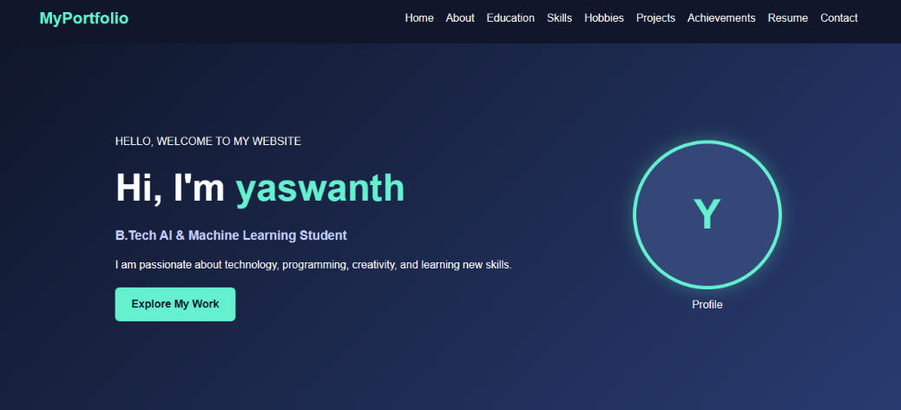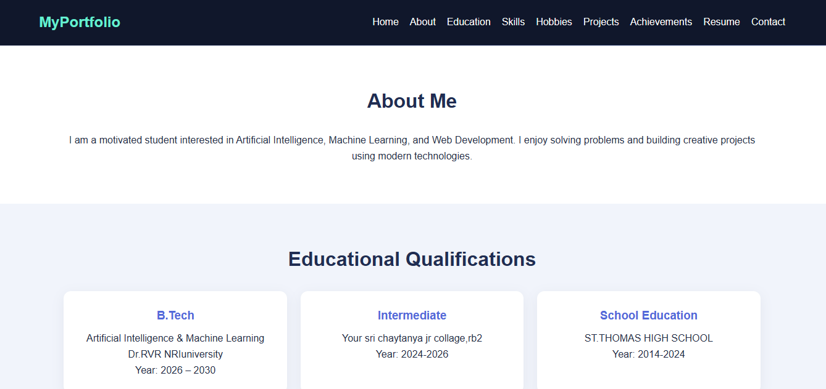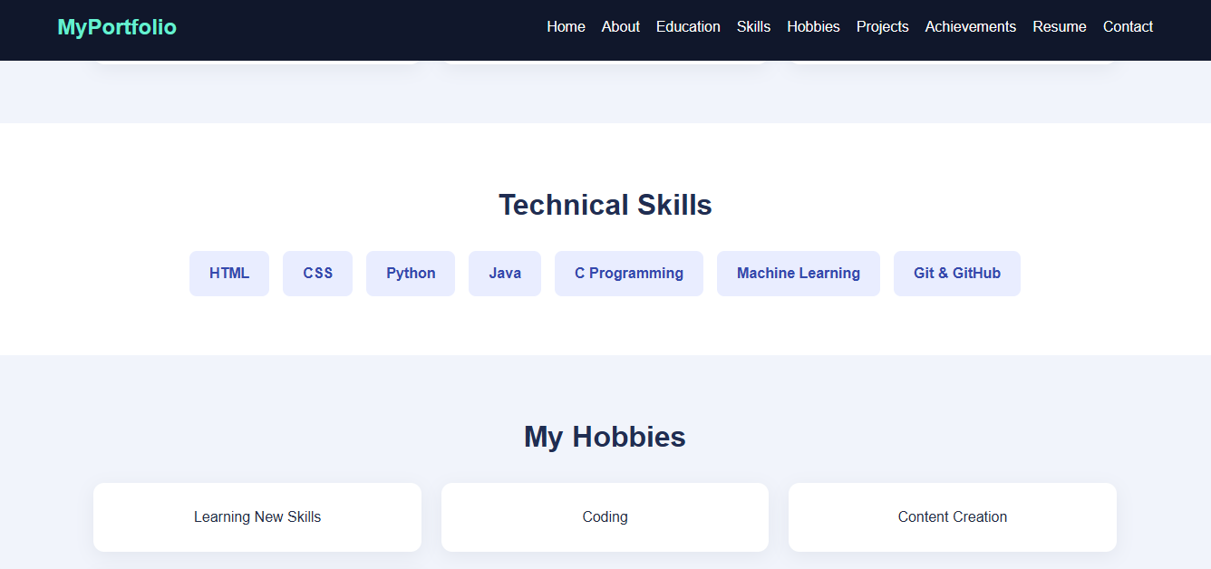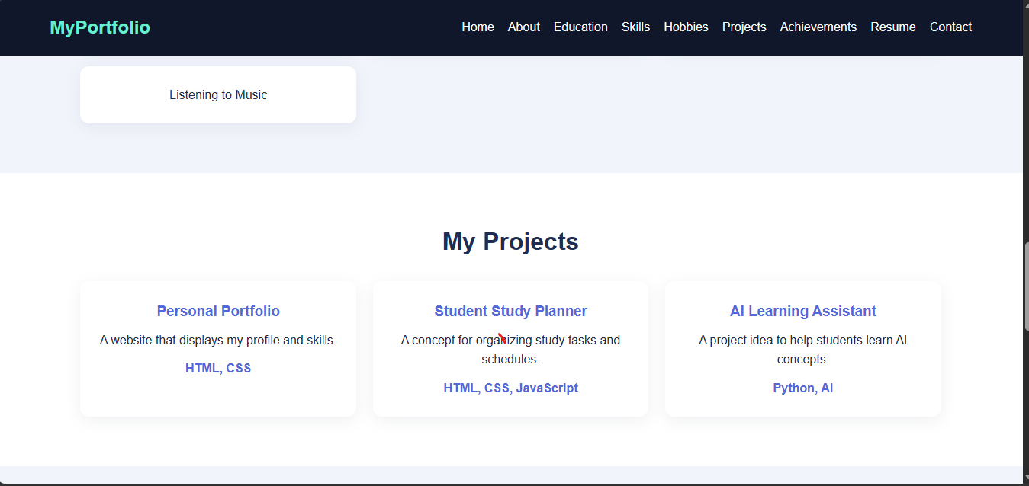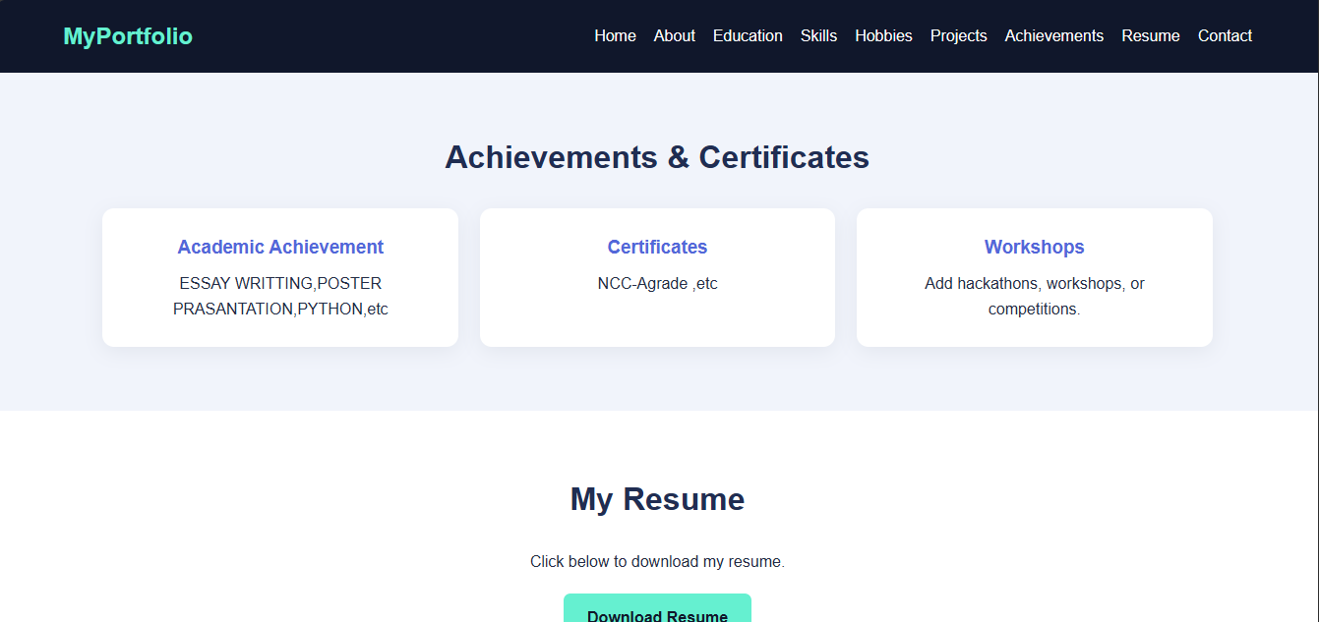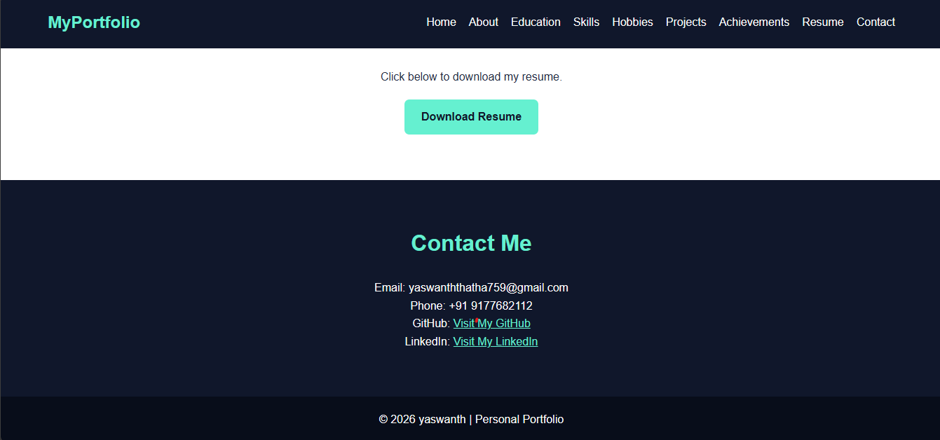 | 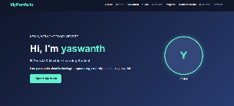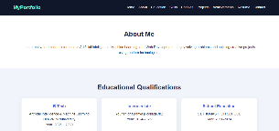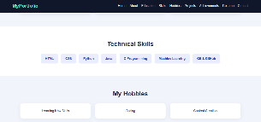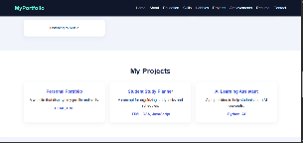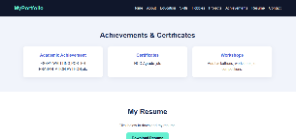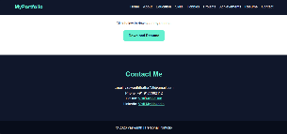
Desktop view (1200 px) Mobile view (400 px)

HTML tags used

Tag / Property | Purpose
<!DOCTYPE html> | Tells the browser this is an HTML5 document.
<html lang> | Root element that wraps the whole page.
<head> | Holds page information that is not displayed (title, links).
<meta> | Sets character encoding (UTF-8) and the viewport for mobile screens.
<title> | Text shown on the browser tab.
<link> | Connects the external style.css file to the page.
<body> | Contains everything visible on the page.
<header>, <nav> | Top bar and the navigation menu area.
<ul>, <li> | Menu items, hobbies list.
<a href="#id"> | Links that jump to a section on the same page (interactive navigation). The resume button links to a file.
<section id> | Groups each part of the page (About, Education, Skills ...).
<h1>, <h2>, <h3> | Headings of different importance.
<p> | Paragraph text.
<div class> | Generic box used for avatar, skill bars, cards.
<table>, <tr>,  <th>, <td> | Education qualifications in table form.
<ol> | Numbered list for achievements.
<footer> | Bottom copyright area.

CSS properties and features used

Tag / Property | Purpose
* { box-sizing } | Resets margins and makes widths easier to control.
display: flex | Places header items and cards in a row; flex-wrap lets them wrap on small screens.
linear-gradient() | Colourful hero background.
border-radius: 50% | Turns the avatar into a circle.
transition | Smooth change when hovering over links, buttons and cards.
:hover | Applies a style when the mouse is over an element.
transform | Moves or scales an element (card lifts, button grows).
@keyframes + animation | Defines and runs animations: float, fadeIn, grow.
@media (max-width: 700px) | Responsive rules that change the layout on phones.
box-shadow | Soft shadow around cards.

Explanation
- The navigation links use href="#about" etc. and the matching id on each section, so clicking a menu item scrolls smoothly to that section (scroll-behavior: smooth).
- The avatar uses the float animation, the heading uses fadeIn, and each skill bar uses grow from width 0 to its final width.

- Skill levels are shown with a grey .bar and a coloured .fill whose width equals the percentage.

- On screens narrower than 700 px, the media query stacks the header and reduces padding so the page fits a phone.
- To save a real resume, place your file as resume.pdf in the same folder as index.html.

Project 2: TechZone Electronics

Your One-Stop Online Electronics Catalog

Code: html/internal css

<!DOCTYPE html>
<html lang="en">
<head>
<meta charset="UTF-8">
<meta name="viewport" content="width=device-width, initial-scale=1.0">
<title>TechZone - Electronics Catalog</title>

<style>
body {
font-family: Arial, sans-serif;
margin: 0;
background-color: #f2f5f9;
color: #222;
}

header {
background-color: #142d4e;
color: white;
text-align: center;
padding: 20px;
}

nav {
background-color: #24476b;
padding: 12px;
text-align: center;
}

nav a {
color: white;
text-decoration: none;
margin: 12px;
font-weight: bold;
}

.banner {
text-align: center;
padding: 25px;
background-color: #dceaff;
}

.banner h2 {
color: #142d4e;
}

.filters {
text-align: center;
padding: 20px;
}

.filters a {
display: inline-block;
background-color: #24476b;
color: white;
padding: 10px 15px;
margin: 5px;
text-decoration: none;
border-radius: 5px;
}

.filters a:hover {
background-color: #397fc4;
}

.products {
display: flex;
flex-wrap: wrap;
justify-content: center;
gap: 20px;
padding: 20px;
}

.product {
background-color: white;
width: 230px;
padding: 15px;
border-radius: 10px;
box-shadow: 0 2px 8px #cccccc;
text-align: center;
position: relative;
}

.product img {
width: 100%;
height: 150px;
object-fit: contain;
}

.discount {
color: white;
background-color: #e63946;
padding: 5px 8px;
border-radius: 4px;
display: inline-block;
}

.old-price {
color: gray;
text-decoration: line-through;
}

.price {
color: #087443;
font-size: 20px;
font-weight: bold;
}

.details {
text-align: left;
font-size: 14px;
line-height: 1.8;
}

.button {
display: inline-block;
background-color: #142d4e;
color: white;
padding: 10px 15px;
text-decoration: none;
border-radius: 5px;
}

.button:hover {
background-color: #397fc4;
}

section {
padding: 20px;
}

h2 {
text-align: center;
}

table {
width: 100%;
border-collapse: collapse;
background-color: white;
margin-top: 20px;
}

th, td {
border: 1px solid #cccccc;
padding: 12px;
text-align: center;
}

th {
background-color: #24476b;
color: white;
}

tr:nth-child(even) {
background-color: #edf3fa;
}

footer {
background-color: #142d4e;
color: white;
text-align: center;
padding: 15px;
margin-top: 20px;
}

@media (max-width: 600px) {
nav a {
display: inline-block;
margin: 8px;
}

.product {
width: 85%;
}

table {
font-size: 12px;
}

th, td {
padding: 6px;
}
}
</style>
</head>

<body>

<!-- Website Header -->
<header>
<h1>TechZone Electronics</h1>
<p>Your One-Stop Online Electronics Catalog</p>
</header>

<!-- Navigation -->
<nav>
<a href="#home">Home</a>
<a href="#products">Products</a>
<a href="#comparison">Compare</a>
<a href="#contact">Contact</a>
</nav>

<!-- Welcome Banner -->
<div class="banner" id="home">
<h2>Discover the Latest Technology</h2>
<p>Explore laptops, smartphones, accessories and smart devices.</p>
<p><strong>Special Discounts on Selected Products!</strong></p>
</div>

<!-- Category Filters -->
<div class="filters">
<h2>Shop by Category</h2>
<a href="#laptops">Laptops</a>
<a href="#phones">Smartphones</a>
<a href="#accessories">Accessories</a>
<a href="#smart">Smart Devices</a>
</div>

<!-- Product Catalog -->
<section id="products">
<h2>Our Products</h2>

<div class="products">

<!-- Laptop -->
<div class="product" id="laptops">
<span class="discount">20% OFF</span>
<img src="https://placehold.co/300x200/e8eef7/142d4e?text=Laptop"
alt="Laptop">
<h3>PowerBook Laptop</h3>
<p class="old-price">₹60,000</p>
<p class="price">₹48,000</p>

<div class="details">
<strong>Specifications:</strong><br>
Processor: Intel Core i5<br>
RAM: 8 GB<br>
Storage: 512 GB SSD<br>
Display: 15.6 inches
</div>

<a class="button" href="#laptop-details">View Details</a>
</div>

<!-- Smartphone -->
<div class="product" id="phones">
<span class="discount">15% OFF</span>
<img src="https://placehold.co/300x200/e8eef7/142d4e?text=Smartphone"
alt="Smartphone">
<h3>SmartPhone X</h3>
<p class="old-price">₹30,000</p>
<p class="price">₹25,500</p>

<div class="details">
<strong>Specifications:</strong><br>
Display: 6.5 inches<br>
RAM: 8 GB<br>
Storage: 128 GB<br>
Camera: 50 MP
</div>

<a class="button" href="#phone-details">View Details</a>
</div>

<!-- Accessories -->
<div class="product" id="accessories">
<span class="discount">25% OFF</span>
<img src="https://placehold.co/300x200/e8eef7/142d4e?text=Headphones"
alt="Wireless headphones">
<h3>Wireless Headphones</h3>
<p class="old-price">₹4,000</p>
<p class="price">₹3,000</p>

<div class="details">
<strong>Specifications:</strong><br>
Type: Wireless<br>
Battery: 30 hours<br>
Connection: Bluetooth<br>
Feature: Noise reduction
</div>

<a class="button" href="#headphone-details">View Details</a>
</div>

<!-- Smart Device -->
<div class="product" id="smart">
<span class="discount">10% OFF</span>
<img src="https://placehold.co/300x200/e8eef7/142d4e?text=Smartwatch"
alt="Smartwatch">
<h3>FitSmart Watch</h3>
<p class="old-price">₹5,000</p>
<p class="price">₹4,500</p>

<div class="details">
<strong>Specifications:</strong><br>
Display: Touchscreen<br>
Battery: Up to 7 days<br>
Connectivity: Bluetooth<br>
Features: Fitness tracking
</div>

<a class="button" href="#watch-details">View Details</a>
</div>

</div>
</section>

<!-- Product Comparison Table -->
<section id="comparison">
<h2>Product Comparison Table</h2>

<table>
<tr>
<th>Feature</th>
<th>Laptop</th>
<th>Smartphone</th>
<th>Headphones</th>
<th>Smartwatch</th>
</tr>

<tr>
<td>Price</td>
<td>₹48,000</td>
<td>₹25,500</td>
<td>₹3,000</td>
<td>₹4,500</td>
</tr>

<tr>
<td>Memory</td>
<td>8 GB RAM</td>
<td>8 GB RAM</td>
<td>Not applicable</td>
<td>Not specified</td>
</tr>

<tr>
<td>Connectivity</td>
<td>Wi-Fi</td>
<td>5G / Wi-Fi</td>
<td>Bluetooth</td>
<td>Bluetooth</td>
</tr>

<tr>
<td>Main Use</td>
<td>Study and Work</td>
<td>Communication</td>
<td>Audio</td>
<td>Fitness</td>
</tr>
</table>
</section>

<!-- Product Detail Layouts -->
<section id="laptop-details">
<h2>Product Details: PowerBook Laptop</h2>
<p><strong>Category:</strong> Laptop</p>
<p><strong>Processor:</strong> Intel Core i5</p>
<p><strong>Memory:</strong> 8 GB RAM</p>
<p><strong>Storage:</strong> 512 GB SSD</p>
<p><strong>Display:</strong> 15.6-inch display</p>
<p><strong>Discounted Price:</strong> ₹48,000</p>
</section>

<section id="phone-details">
<h2>Product Details: SmartPhone X</h2>
<p><strong>Display:</strong> 6.5 inches</p>
<p><strong>Memory:</strong> 8 GB RAM</p>
<p><strong>Storage:</strong> 128 GB</p>
<p><strong>Camera:</strong> 50 MP</p>
<p><strong>Discounted Price:</strong> ₹25,500</p>
</section>

<section id="headphone-details">
<h2>Product Details: Wireless Headphones</h2>
<p><strong>Connection:</strong> Bluetooth</p>
<p><strong>Battery Life:</strong> 30 hours</p>
<p><strong>Feature:</strong> Noise reduction</p>
<p><strong>Discounted Price:</strong> ₹3,000</p>
</section>

<section id="watch-details">
<h2>Product Details: FitSmart Watch</h2>
<p><strong>Display:</strong> Touchscreen</p>
<p><strong>Battery Life:</strong> Up to 7 days</p>
<p><strong>Features:</strong> Fitness tracking</p>
<p><strong>Discounted Price:</strong> ₹4,500</p>
</section>

<!-- Contact -->
<footer id="contact">
<h3>TechZone Electronics</h3>
<p>Email: support@techzone.example</p>
<p>Phone: 98765 43210</p>
<p>© 2026 TechZone. Educational Demo Catalog.</p>
</footer>

</body>
</html>

Output (screenshots of the web page)

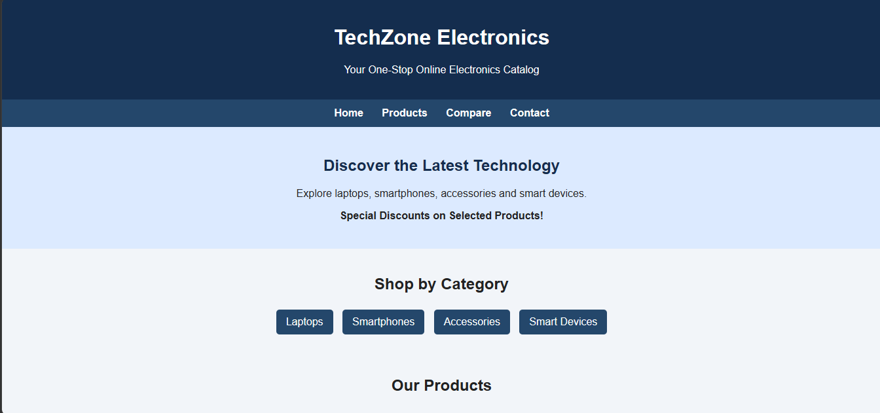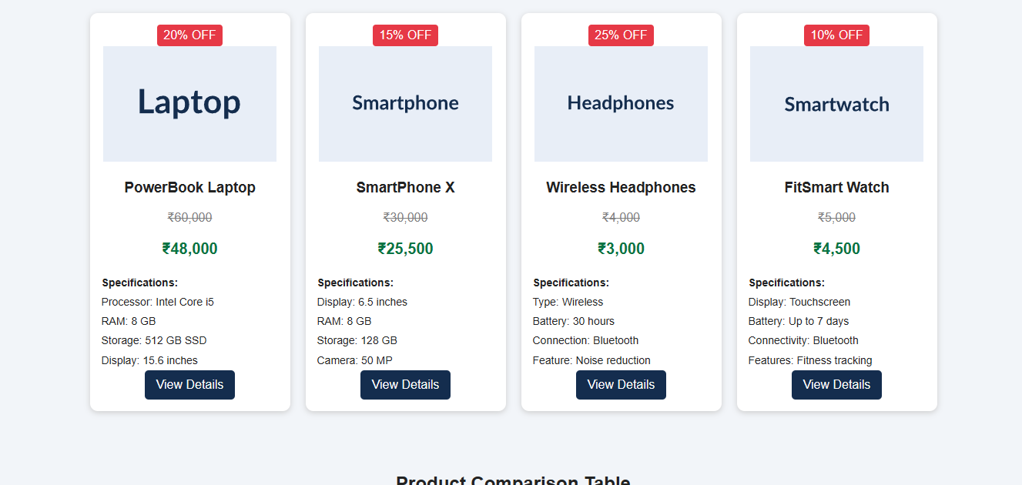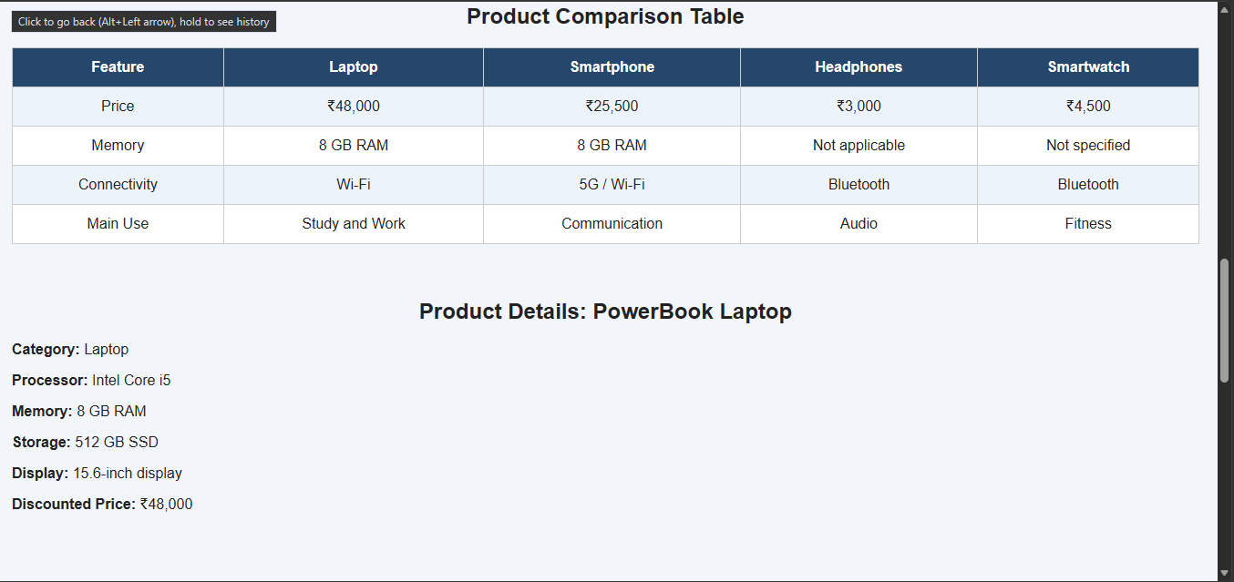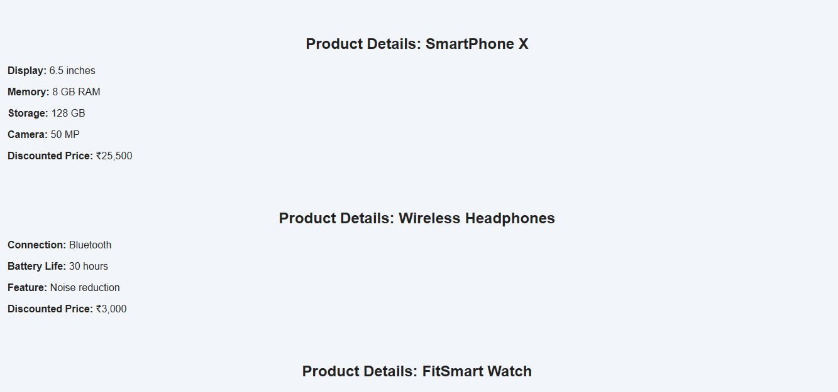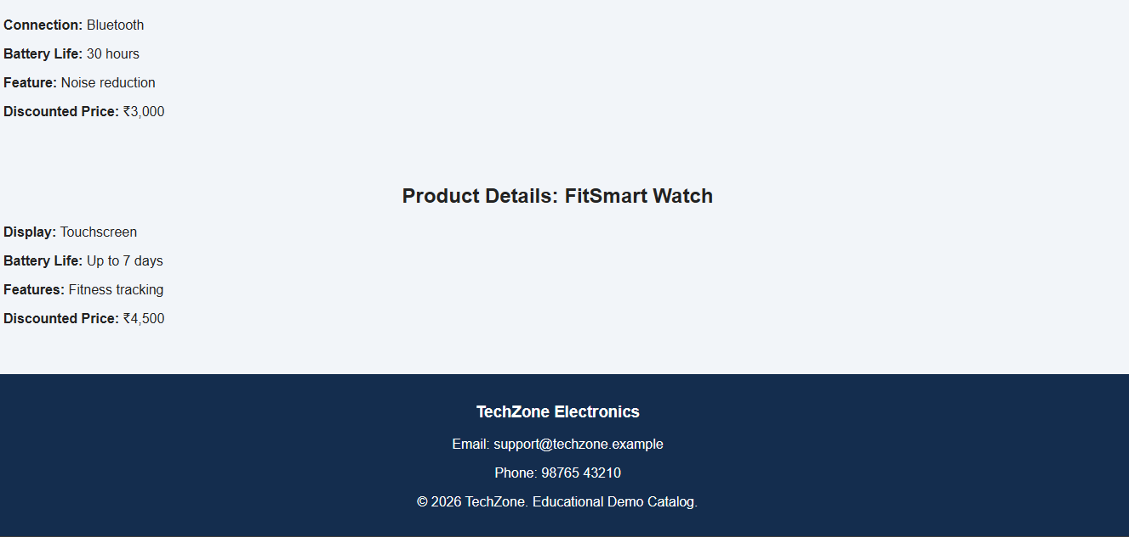 | 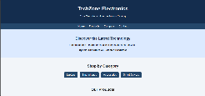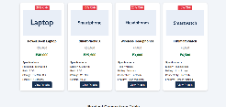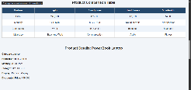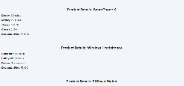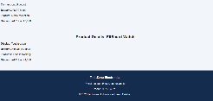

Desktop view (1200 px)
Mobile view (400 px)

HTML tags used

Tag / Property |  |  | Purpose
<!DOCTYPE html> |  |  | Tells the browser this is an HTML5 document.
<html lang> |  |  | Root element that wraps the whole page.
<head> |  |  | Holds page information that is not displayed (title, links).
<meta> |  |  | Sets character encoding (UTF-8) and the viewport for mobile screens.
<title> |  |  | Text shown on the browser tab.
<link> |  |  | Connects the external style.css file to the page.
<body> |  |  | Contains everything visible on the page.
<nav class="navbar"> |  |  | Main navigation bar with brand name and menu links.
<ul>, | <li>, | <a> | Menu list with links to each section.
<div class="banner"> |  |  | Large welcome banner with heading and button.
<section id> |  |  | Separate block for About, Departments, Faculty, etc.
<h1>,  <p> | <h2>, | <h3>, | Headings and paragraph text.
<div class="grid">  / <div class="info"> |  |  | Container and individual information cards.
<ol> |  |  | Numbered admission procedure steps.
<ul>, <strong> |  |  | Event list with bold dates.
<footer> |  |  | Page bottom.

CSS properties and features used

Tag / Property | Purpose
position: sticky | Keeps the navigation bar at the top while scrolling.
display: flex | Aligns navbar items and lays out cards.
flex: 1 1 200px | Each card can grow and shrink with a minimum width of 200 px: this makes cards responsive.
gap | Space between cards.
background: linear-gradient() | Banner background with a dark overlay.
border-top | Coloured top line on cards.
:hover + transition | Menu highlight and card lift effect.
@media (max-width: 700px) | Stacks the navbar and shrinks the banner text on phones.

Explanation
- The navbar uses flexbox with justify-content: space-between to put the brand on the left and the links on the right.
- The banner combines a semi-transparent dark gradient over a colour gradient, so the white text is easy to read.

- All cards share the class .info. Because of flex-wrap: wrap, four cards sit in a row on a computer and become one column on a phone.
- Faculty profiles use a circular .photo block with initials (replace it with an <img> tag for real photos).

Project 3: DreamHome Properties

Find Your Perfect Place to Live

Code: html/internal css

<!DOCTYPE html>

<html lang="en">

<head>

<meta charset="UTF-8">

<meta name="viewport" content="width=device-width, initial-scale=1.0">

<title>DreamHome - Property Website</title>

<style>

body {

font-family: Arial, sans-serif;

margin: 0;

background-color: #f4f6f8;

color: #333;

}

header {

background-color: #173b32;

color: white;

text-align: center;

padding: 20px;

}

nav {

background-color: #245747;

text-align: center;

padding: 12px;

}

nav a {

color: white;

text-decoration: none;

margin: 12px;

font-weight: bold;

}

.banner {

background-color: #dceee5;

text-align: center;

padding: 30px 15px;

}

.banner h2 {

color: #173b32;

}

.search {

background-color: white;

margin: 20px;

padding: 20px;

text-align: center;

border-radius: 10px;

}

.search input,

.search select {

padding: 10px;

margin: 5px;

border: 1px solid #aaa;

border-radius: 5px;

}

.search button {

background-color: #245747;

color: white;

border: none;

padding: 11px 20px;

border-radius: 5px;

cursor: pointer;

}

h2 {

text-align: center;

}

.properties {

display: flex;

flex-wrap: wrap;

justify-content: center;

gap: 20px;

padding: 20px;

}

.card {

background-color: white;

width: 280px;

border-radius: 10px;

overflow: hidden;

box-shadow: 0 3px 8px #ccc;

}

.card img {

width: 100%;

height: 180px;

object-fit: cover;

}

.card-content {

padding: 15px;

}

.tag {

background-color: #e0f3e8;

color: #17623e;

padding: 5px 10px;

border-radius: 5px;

font-size: 13px;

}

.price {

color: #17623e;

font-size: 22px;

font-weight: bold;

}

.details {

line-height: 1.8;

font-size: 14px;

}

.button {

display: inline-block;

background-color: #245747;

color: white;

padding: 10px 15px;

text-decoration: none;

border-radius: 5px;

}

.button:hover {

background-color: #387b60;

}

section {

padding: 15px;

}

table {

width: 100%;

border-collapse: collapse;

background-color: white;

margin: 20px 0;

}

th, td {

border: 1px solid #ccc;

padding: 12px;

text-align: center;

}

th {

background-color: #245747;

color: white;

}

tr:nth-child(even) {

background-color: #eaf3ee;

}

footer {

background-color: #173b32;

color: white;

text-align: center;

padding: 20px;

}

@media (max-width: 600px) {

nav a {

display: inline-block;

margin: 8px;

}

.card {

width: 95%;

}

.search input,

.search select {

width: 85%;

}

table {

font-size: 12px;

}

th, td {

padding: 6px;

}

}

</style>

</head>

<body>

<!-- Website Header -->

<header>

<h1>DreamHome Properties</h1>

<p>Find Your Perfect Place to Live</p>

</header>

<!-- Navigation Menu -->

<nav>

<a href="#home">Home</a>

<a href="#properties">Properties</a>

<a href="#compare">Compare</a>

<a href="#contact">Contact</a>

</nav>

<!-- Welcome Banner -->

<div class="banner" id="home">

<h2>Discover Your Dream Property</h2>

<p>Buy, rent, or explore homes that match your lifestyle.</p>

</div>

<!-- Search and Filter Interface -->

<div class="search">

<h2>Search Properties</h2>

<form action="#properties" method="get">

<input type="text" name="location"

placeholder="Enter city or location">

<select name="type">

<option value="">Property Type</option>

<option value="house">House</option>

<option value="apartment">Apartment</option>

<option value="rental">Rental Property</option>

</select>

<select name="purpose">

<option value="">Buy or Rent</option>

<option value="buy">Buy</option>

<option value="rent">Rent</option>

</select>

<button type="submit">Search</button>

</form>

<p><small>Demo search interface: live filtering requires JavaScript or a backend.</small></p>

</div>

<!-- Property Cards -->

<section id="properties">

<h2>Featured Properties</h2>

<div class="properties">

<!-- House -->

<div class="card">

<img src="https://placehold.co/600x400/dceee5/173b32?text=Family+House"

alt="Family house">

<div class="card-content">

<span class="tag">For Sale</span>

<h3>Green Villa</h3>

<p>Location: Vijayawada</p>

<p class="price">₹75,00,000</p>

<div class="details">

Property: Independent House<br>

Bedrooms: 3<br>

Bathrooms: 2<br>

Area: 1800 sq. ft.<br>

Amenities: Garden, Parking, Balcony

</div>

<a class="button" href="#house-details">View Details</a>

</div>

</div>

<!-- Apartment -->

<div class="card">

<img src="https://placehold.co/600x400/dceee5/173b32?text=Modern+Apartment"

alt="Modern apartment">

<div class="card-content">

<span class="tag">For Sale</span>

<h3>Skyline Apartments</h3>

<p>Location: Guntur</p>

<p class="price">₹55,00,000</p>

<div class="details">

Property: Apartment<br>

Bedrooms: 2<br>

Bathrooms: 2<br>

Area: 1200 sq. ft.<br>

Amenities: Lift, Gym, Security

</div>

<a class="button" href="#apartment-details">View Details</a>

</div>

</div>

<!-- Rental Property -->

<div class="card">

<img src="https://placehold.co/600x400/dceee5/173b32?text=Rental+Home"

alt="Rental home">

<div class="card-content">

<span class="tag">For Rent</span>

<h3>Comfort Nest</h3>

<p>Location: Hyderabad</p>

<p class="price">₹18,000/month</p>

<div class="details">

Property: Rental Apartment<br>

Bedrooms: 2<br>

Bathrooms: 1<br>

Area: 1000 sq. ft.<br>

Amenities: Parking, Wi-Fi, Balcony

</div>

<a class="button" href="#rental-details">View Details</a>

</div>

</div>

</div>

</section>

<!-- Property Comparison Table -->

<section id="compare">

<h2>Compare Properties</h2>

<table>

<tr>

<th>Feature</th>

<th>Green Villa</th>

<th>Skyline Apartments</th>

<th>Comfort Nest</th>

</tr>

<tr>

<td>Location</td>

<td>Vijayawada</td>

<td>Guntur</td>

<td>Hyderabad</td>

</tr>

<tr>

<td>Price</td>

<td>₹75 Lakhs</td>

<td>₹55 Lakhs</td>

<td>₹18,000/month</td>

</tr>

<tr>

<td>Bedrooms</td>

<td>3</td>

<td>2</td>

<td>2</td>

</tr>

<tr>

<td>Area</td>

<td>1800 sq. ft.</td>

<td>1200 sq. ft.</td>

<td>1000 sq. ft.</td>

</tr>

<tr>

<td>Parking</td>

<td>Yes</td>

<td>Yes</td>

<td>Yes</td>

</tr>

<tr>

<td>Purpose</td>

<td>Buy</td>

<td>Buy</td>

<td>Rent</td>

</tr>

</table>

</section>

<!-- Detailed Property Information -->

<section id="house-details">

<h2>Green Villa - Property Details</h2>

<p>Type: Independent House</p>

<p>Location: Vijayawada</p>

<p>Price: ₹75,00,000</p>

<p>Bedrooms: 3 | Bathrooms: 2</p>

<p>Amenities: Garden, parking and balcony.</p>

</section>

<section id="apartment-details">

<h2>Skyline Apartments - Property Details</h2>

<p>Type: Apartment</p>

<p>Location: Guntur</p>

<p>Price: ₹55,00,000</p>

<p>Bedrooms: 2 | Bathrooms: 2</p>

<p>Amenities: Lift, gym and security.</p>

</section>

<section id="rental-details">

<h2>Comfort Nest - Property Details</h2>

<p>Type: Rental Apartment</p>

<p>Location: Hyderabad</p>

<p>Rent: ₹18,000 per month</p>

<p>Bedrooms: 2 | Bathrooms: 1</p>

<p>Amenities: Parking, Wi-Fi and balcony.</p>

</section>

<!-- Footer -->

<footer id="contact">

<h3>DreamHome Properties</h3>

<p>Email: info@dreamhome.example</p>

<p>Phone: 98765 43210</p>

<p>© 2026 DreamHome Properties | Educational Demo</p>

</footer>

</body>

</html>

output (screenshots of the web page)

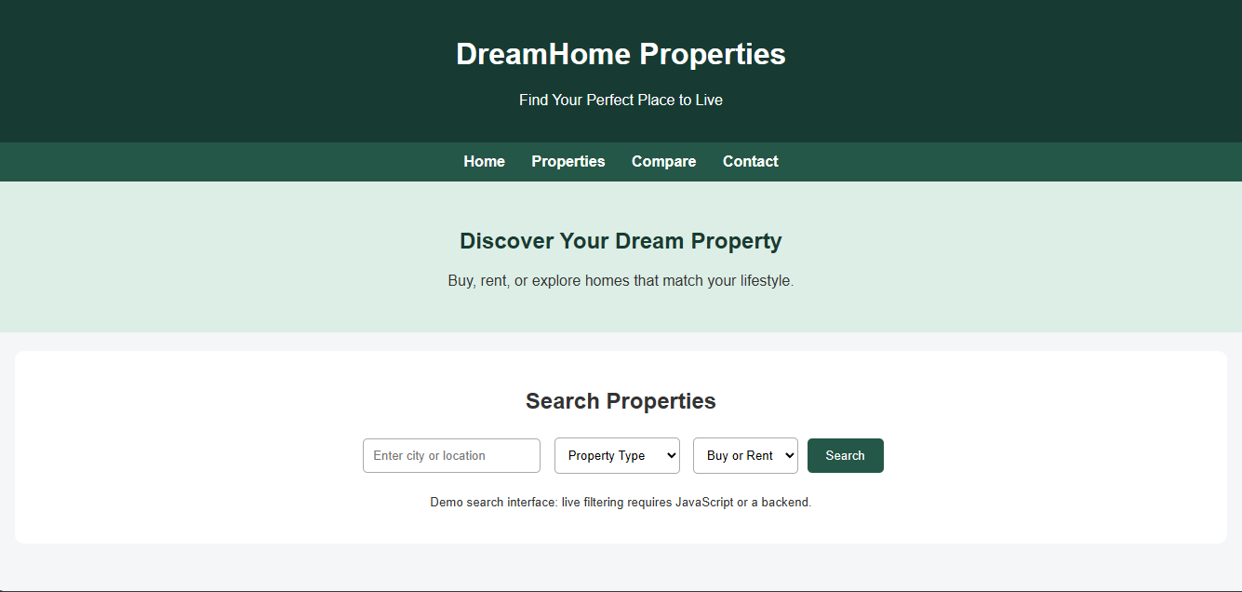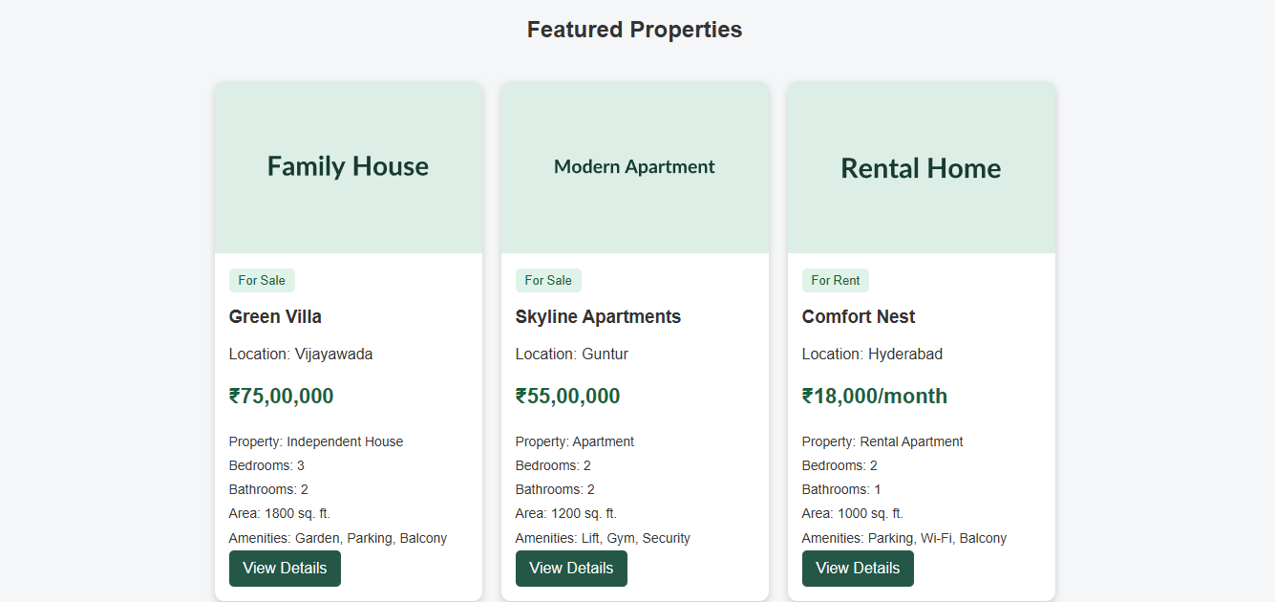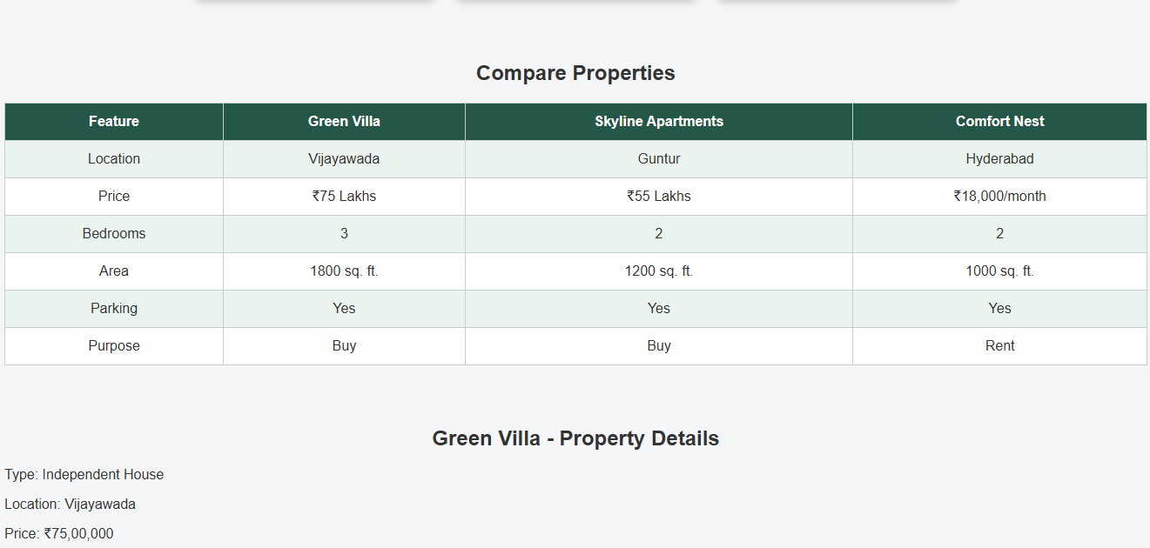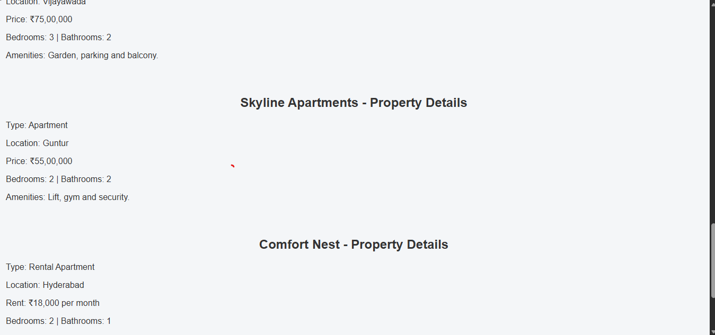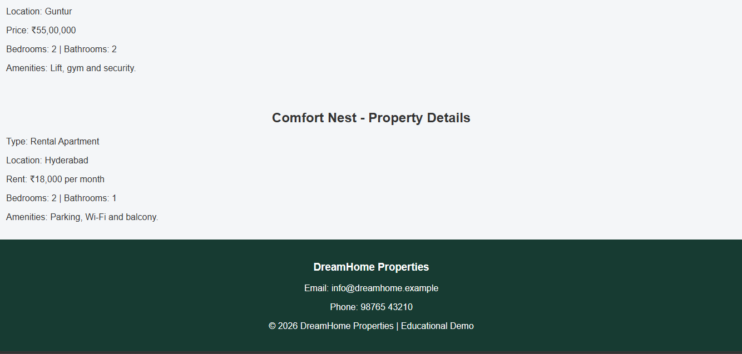 | 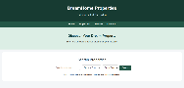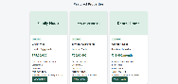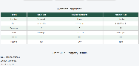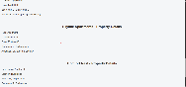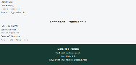

Desktop view (1200 px)
Mobile view (400 px)

HTML tags used

Tag / Property | Purpose
<!DOCTYPE html> | Tells the browser this is an HTML5 document.
<html lang> | Root element that wraps the whole page.
<head> | Holds page information that is not displayed (title, links).
<meta> | Sets character encoding (UTF-8) and the viewport for mobile screens.
<title> | Text shown on the browser tab.
<link> | Connects the external style.css file to the page.
<body> | Contains everything visible on the page.
<header>, <nav> | Site title and menu.
<section id> | Intro, Categories, Courses, Instructors.
<article class="course"> | One independent course card.
<div class="thumb"> | Video thumbnail area with a play symbol (&#9654;).
<h1> to <h4> | Headings; h4 is used for "You will learn".
<ul>, <li> | Category tags and learning objectives.
<p> | Course description, instructor name, progress text.
<div class="progress"> | Outer bar and inner .done bar form the progress indicator.
<a class="enroll"> | Enroll / Continue button.
<footer> | Page bottom.

CSS properties and features used

Tag / Property | Purpose
display: flex; flex-wrap | Lays out course cards and instructor cards in rows that wrap.
flex: 1 1 260px | Cards become 3 per row on desktop and 1 per row on mobile.
overflow: hidden | Keeps thumbnail and progress bar inside rounded corners.
width: 75% | Controls how full the progress bar is.
line-height | Centres the play icon and initials vertically.
display: block | Makes the enroll link a full-width button.
:hover + transform | Card lift and button colour change.
@media (max-width: 700px) | Adjusts header and spacing for phones.

Explanation
- Each course is an <article> because it is a self-contained piece of content.

- The progress indicator is made of two boxes: a grey track (.progress) and a green fill (.done). Changing the width class (p75, p40, p0) changes the progress shown.
- Video thumbnails are coloured blocks with a play symbol. To use real thumbnails, replace the .thumb div with an <img> tag.

- Courses already started show a "Continue" button; a new course shows "Enroll Now".

