Climate Zone Clustering & Extreme Weather Anomaly Detection

Team Members
Roll Number | Name
2023BCS0030 | A. Yaswant Sai
2023BCS0075 | Ch. Varun Chowdary
2023BCS0174 | P Mashub
2023BCD0045 | K Sai Nihal

Problem Statement
Global weather data is collected from hundreds of cities worldwide in large volumes but exists without any labels or classifications. No system automatically tells us which city belongs to which climate type, or when an extreme weather event is statistically occurring. This project addresses that gap by applying unsupervised machine learning to automatically classify global weather records into meaningful climate zones and detect extreme weather anomalies — without any pre-existing labels or human annotation.

Objectives
- Clean and preprocess 126,476 global weather records from the Global Weather Repository
- Apply K-Means clustering to classify city-level weather readings into distinct climate zones
- Determine the optimal number of clusters using the Elbow Method (WSS)
- Validate K-Means results using Hierarchical Clustering with Ward’s D2 linkage
- Detect extreme weather anomalies (heatwaves, coldwaves, heavy rainfall, strong winds, pollution spikes) using Z-score and percentile-based methods
- Perform seasonal trend analysis by parsing timestamps and aggregating weather metrics by season

Dataset
Name: Global Weather Repository
Source: Kaggle — Global Weather Repository
Number of observations: 126,476
Number of variables: 42
Format: CSV
File name: GlobalWeatherRepository.csv
The dataset is publicly available on Kaggle. Download it from the link above and place it in the data/ folder before running the scripts.

Dataset Structure (Sample Row)
country, location_name, latitude, longitude, timezone, last_updated_epoch,
last_updated, temperature_celsius, temperature_fahrenheit, condition_text,
wind_mph, wind_kph, wind_degree, wind_direction, pressure_mb, pressure_in,
precip_mm, precip_in, humidity, cloud, feels_like_celsius, feels_like_fahrenheit,
visibility_km, visibility_miles, uv_index, gust_mph, gust_kph,
air_quality_Carbon_Monoxide, air_quality_Ozone, air_quality_Nitrogen_dioxide,
air_quality_Sulphur_dioxide, air_quality_PM2.5, air_quality_PM10,
air_quality_us-epa-index, air_quality_gb-defra-index,
sunrise, sunset, moonrise, moonset, moon_phase, moon_illumination
Example record:
Afghanistan, Kabul, 34.52, 69.18, Asia/Kabul, 1715849100, 2024-05-16 13:15,
26.6, 79.8, Partly Cloudy, 8.3, 13.3, 338, NNW, 1012.0, 29.89, 0.0, 0.0,
24, 30, 25.3, 77.5, 10.0, 6.0, 7.0, 9.5, 15.3, 277.0, 103.0, 1.1, 0.2,
8.4, 26.6, 1, 1, 04:50 AM, 06:50 PM, 12:12 PM, 01:11 AM, Waxing Gibbous, 55

Key Attributes Description
Column | Type | Description
country | Text | Country of the city
location_name | Text | City name
latitude / longitude | Numeric | Geographic coordinates
last_updated | Datetime | Timestamp of reading (YYYY-MM-DD HH:MM)
temperature_celsius | Numeric | Air temperature in degrees Celsius
humidity | Numeric | Relative humidity (%)
wind_kph | Numeric | Wind speed in kilometres per hour
pressure_mb | Numeric | Atmospheric pressure in millibars
precip_mm | Numeric | Precipitation amount in millimetres
cloud | Numeric | Cloud cover percentage (0–100)
visibility_km | Numeric | Visibility distance in kilometres
uv_index | Numeric | UV radiation index (0–11+)
air_quality_PM2.5 | Numeric | Fine particulate matter in µg/m³ — most health-critical measure
air_quality_PM10 | Numeric | Coarse particulate matter in µg/m³
feels_like_celsius | Numeric | Perceived temperature accounting for humidity and wind
condition_text | Text | Human-readable weather condition description
sunrise / sunset | Text | Local sunrise and sunset times
moon_phase | Text | Current lunar phase name
Each row is one weather reading from one city at one timestamp. The same city appears multiple times across different time readings throughout the year.

Features Selected for Clustering (10 of 42)
Feature | Reason for selection
temperature_celsius | Primary climate indicator — defines hot vs cold zones
humidity | Separates arid from humid climates
wind_kph | Distinguishes exposed coastal/polar from sheltered inland areas
pressure_mb | Relates to weather systems — low = storms, high = clear
precip_mm | Separates desert zones (near 0) from rainy zones
cloud | Correlated with humidity and rain — high in overcast cluster
visibility_km | Drops sharply with pollution and fog
uv_index | High in sunny low-latitude zones
air_quality_PM2.5 | Defining feature of pollution cluster (231 µg/m³)
air_quality_PM10 | Companion pollution measure
Features dropped: Fahrenheit/mph/inch duplicates, feels_like (derived), condition_text (categorical), moon/sun columns (irrelevant to climate clustering), EPA/DEFRA indices (derived scores).

Methodology

1. Data Preprocessing
- Loaded raw CSV with 126,476 records and 42 columns
- Selected 10 numerical meteorological features for clustering
- Dropped redundant duplicate columns (unit conversions, derived indices)
- Replaced all NA values with column mean — result: 0 missing values
- Applied Z-score standardization using scale() — normalizes all features to mean=0, SD=1 so no single feature dominates due to scale differences

2. Exploratory Analysis
- Inspected data dimensions, column types, and missing value counts
- Plotted temperature distribution boxplot: range -27°C to +47°C, median ~22°C
- Identified right-skewed distributions in precipitation and pollution variables

3. K-Means Clustering
- Elbow Method: tested K=1 to K=10, plotted Total Within-Cluster Sum of Squares (WSS)
- Identified K=4 as the optimal number — clear elbow with diminishing returns beyond 4
- Final model: kmeans(scaled_data, centers=4, nstart=25, set.seed(123))
- Computed cluster profile means using aggregate()
- Assigned climate zone labels based on cluster characteristics:
  - Cluster 1 → High Pollution Zone (PM2.5 = 231 µg/m³, 9× other clusters)
  - Cluster 2 → Cool Temperate (avg 16.4°C, cleanest air PM2.5 = 25 µg)
  - Cluster 3 → Humid & Overcast (humidity 83%, cloud 74%, rain 0.31mm)
  - Cluster 4 → Hot & Sunny (avg 28.6°C, UV index 7.5)

4. Hierarchical Clustering (Validation)
- Random sample of 2,000 records used (full dataset exceeds RAM for distance matrix)
- Euclidean distance matrix computed with dist()
- hclust(method = "ward.D2") applied — minimizes within-cluster variance at each merge
- Dendrogram shows 2 major super-clusters at height ~65, each subdividing into 2 = 4 total
- Independently confirms K=4 from the Elbow Method

5. Anomaly Detection
- Z-Score method for rainfall, wind, pollution: threshold |Z| > 3
- Percentile method for temperature: Z-score was unsuitable (threshold would require >58°C which no city reaches, returning 0 heatwaves). Used top 5% (>34°C) as heatwave and bottom 5% (<2.7°C) as coldwave thresholds instead

6. Seasonal Trend Analysis
- Parsed last_updated timestamp using as.POSIXct()
- Extracted month, assigned meteorological seasons (Spring/Summer/Autumn/Winter)
- Aggregated mean temperature, humidity, precipitation, wind, PM2.5 per season
- Counted heatwave and coldwave events per season

Results

Climate Zone Distribution
Climate Zone | Records | Avg Temp | Humidity | PM2.5 | Sample Cities
High Pollution Zone | 1,571 | 26.5°C | 35.5% | 231 µg/m³ | Beijing, Jakarta, Hanoi
Cool Temperate | 36,245 | 16.4°C | 69.2% | 25 µg/m³ | Buenos Aires, Canberra, Baku
Humid & Overcast | 49,203 | 19.5°C | 83.0% | 16 µg/m³ | Nassau, Bridgetown, Vienna
Hot & Sunny | 39,457 | 28.6°C | 43.9% | 27 µg/m³ | Algiers, Luanda, Manama

Anomaly Detection Results
Event Type | Method | Threshold | Events Detected
Heatwaves | Percentile | Temp > 34°C (95th percentile) | 6,221
Coldwaves | Percentile | Temp < 2.7°C (5th percentile) | 6,317
Heavy Rainfall | Z-score | Z > 3 | 1,774
Strong Wind | Z-score | Z > 3 | 198
Dangerous Pollution | Z-score | PM2.5 Z > 3 | 1,953

Seasonal Summary
Season | Avg Temp | Humidity | Precipitation | PM2.5 | Records
Spring | 22.3°C | 63.0% | 0.14 mm | 27.8 µg | 21,216
Summer | 25.8°C | 62.1% | 0.15 mm | 21.2 µg | 35,365
Autumn | 21.6°C | 68.4% | 0.14 mm | 22.7 µg | 35,435
Winter | 16.6°C | 70.2% | 0.11 mm | 27.8 µg | 34,460

Seasonal Anomaly Counts
Season | Heatwaves | Coldwaves
Spring | 1,319 | 296
Summer | 3,790 | 81
Autumn | 848 | 896
Winter | 264 | 5,044

Key Visualizations

Elbow Method — Selecting K=4
Elbow Method
Elbow Method

K-Means Cluster Visualization (PCA-reduced)
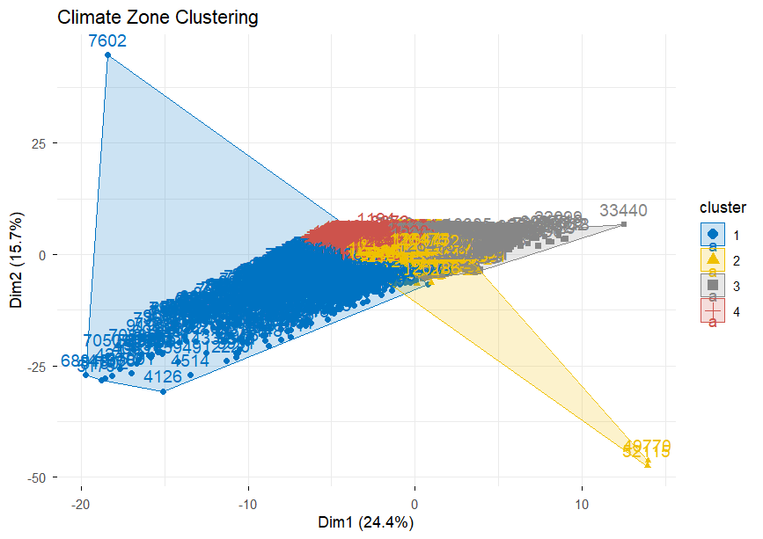
K-Means Clustering

Hierarchical Clustering Dendrogram
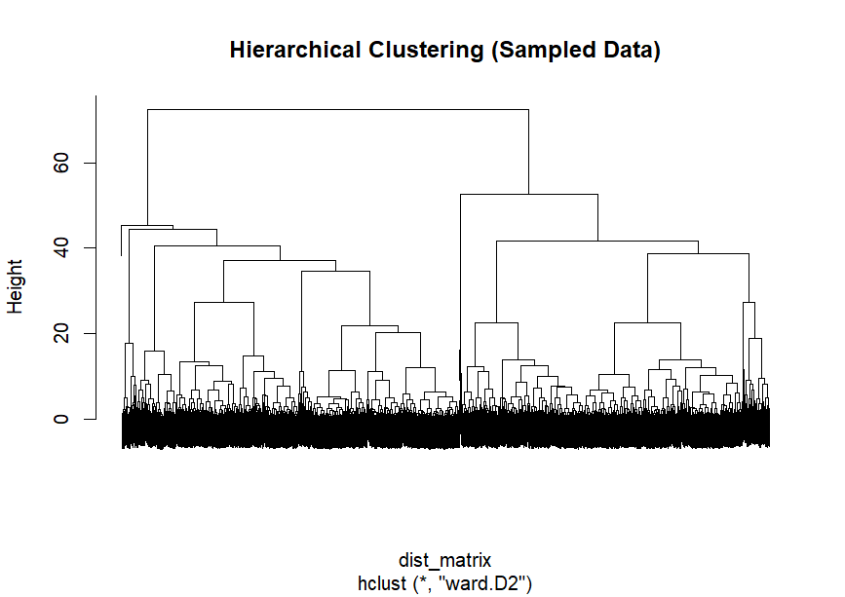
Dendrogram

Temperature Distribution (Overall)
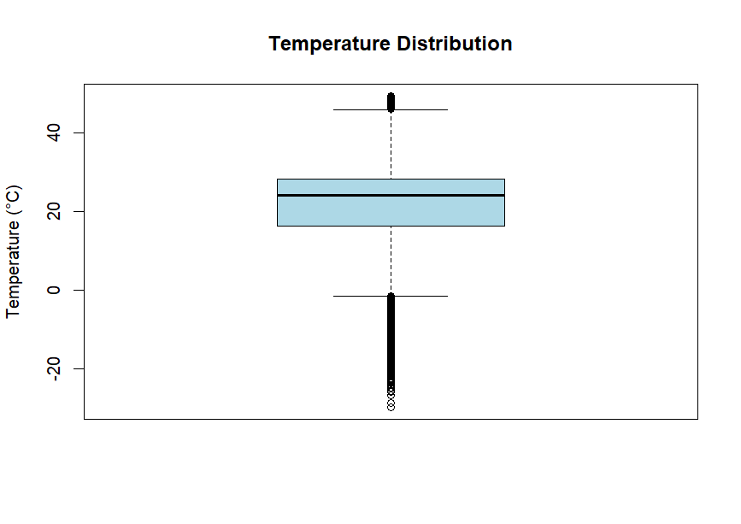
Temperature Distribution

Average Temperature by Season
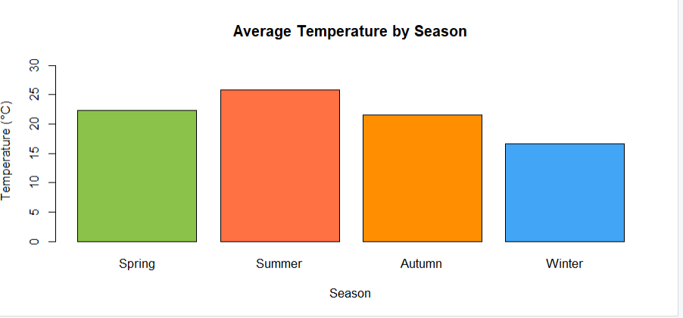
Avg Temp by Season

Monthly Average Temperature Trend
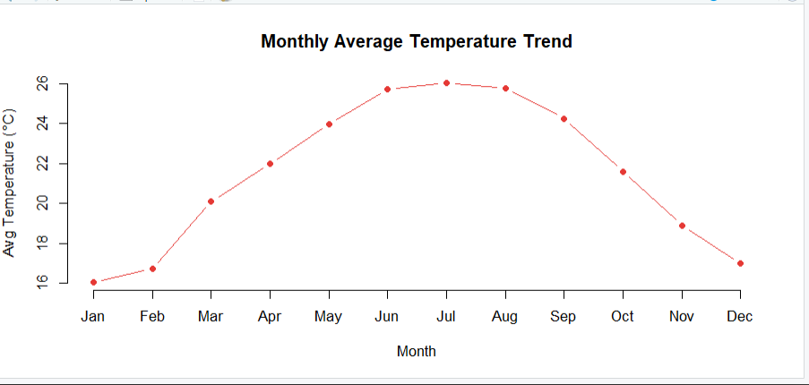
Monthly Temp Trend

Temperature Distribution by Season
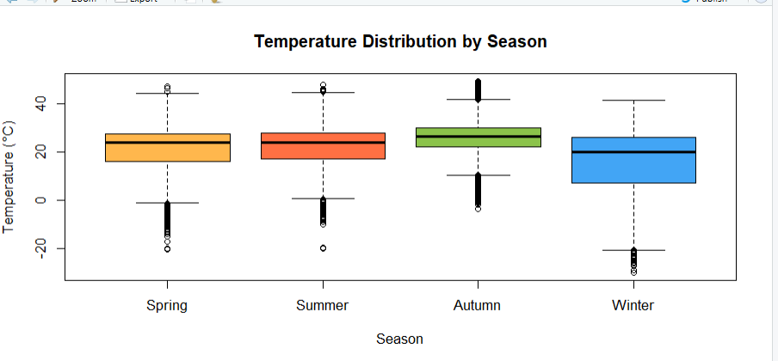
Temp by Season

Average Precipitation by Season
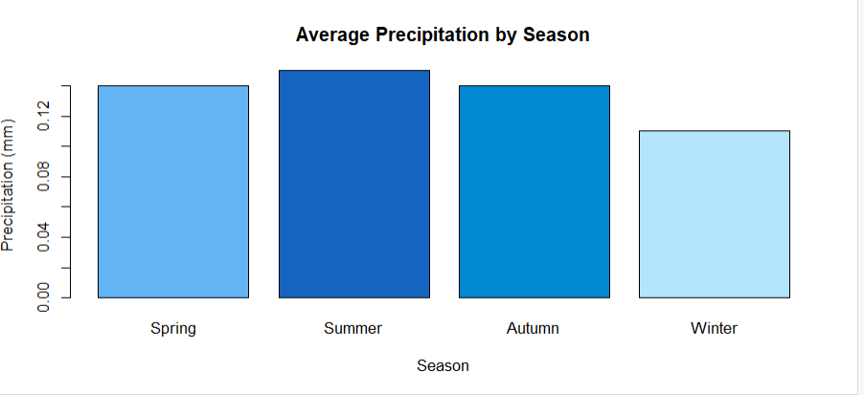
Precipitation by Season

Seasonal Anomaly Counts — Heatwaves vs Coldwaves
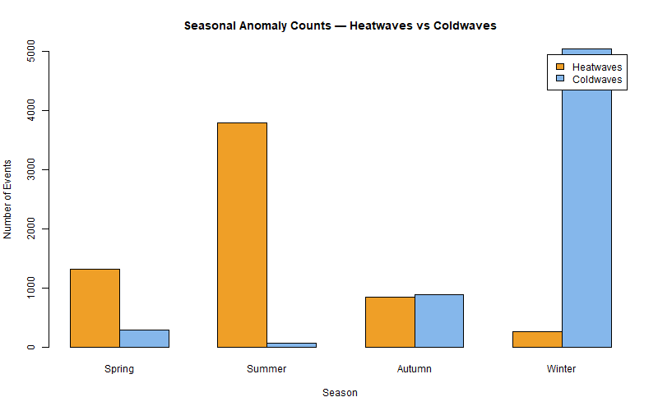
Seasonal Anomalies

How to Run the Project

Prerequisites
- R version 4.0 or above: https://cran.r-project.org
- RStudio (recommended): https://posit.co/download/rstudio-desktop/

Step 1 — Clone the repository
git clone https://github.com/YOUR_USERNAME/ClimateZoneClustering_Team4.git
cd ClimateZoneClustering_Team4

Step 2 — Download the dataset
Download GlobalWeatherRepository.csv from Kaggle: https://www.kaggle.com/datasets/nelgiriyewithana/global-weather-repository
Place the file here:
data/GlobalWeatherRepository.csv

Step 3 — Install required packages
source("requirements.R")

Step 4 — Run scripts in order
source("scripts/01_data_preparation.R")
source("scripts/02_exploratory_analysis.R")
source("scripts/03_modeling.R")
source("scripts/04_evaluation.R")
Or run the complete pipeline in one go:
source("scripts/climate_project.R")

Folder Organization
ClimateZoneClustering_Team4/
│
├── README.md # Project documentation (this file)
├── requirements.R # Package installation script
│
├── data/
│ └── dataset_description.md # Dataset info — CSV not uploaded
│
├── scripts/
│ ├── 01_data_preparation.R # Data loading, cleaning, scaling
│ ├── 02_exploratory_analysis.R # EDA, structure inspection, boxplot
│ ├── 03_modeling.R # K-Means, Elbow, Hierarchical clustering
│ ├── 04_evaluation.R # Anomaly detection, seasonal analysis
│ └── climate_project.R # Full pipeline (all parts combined)
│
├── results/
│ ├── figures/
│ │ ├── Elbow_method_image.png
│ │ ├── K_clustering_visualization.png
│ │ ├── Dendogram.png
│ │ ├── Temp_distribn_Plot.png
│ │ ├── avg_temp_by_season.png
│ │ ├── monthly_avg_temp_trend.png
│ │ ├── temp_distribution_by_season.png
│ │ ├── precipitation_by_season.png
│ │ └── seasonal_anomaly_chart.png
│ │
│ └── tables/
│ ├── cluster_profiles.csv # Aggregate means per cluster
│ ├── seasonal_summary.csv # Seasonal averages
│ └── anomaly_counts.csv # All anomaly event counts
│
└── presentation/
└── project_presentation.pptx # Final slides

Conclusion
This project successfully applied unsupervised machine learning to 126,476 global weather records, producing four well-defined climate zones and comprehensive extreme event detection:
- The High Pollution Zone cluster (PM2.5 = 231 µg/m³) is the most critical finding — the algorithm automatically identified a global air quality crisis grouping cities like Beijing, Jakarta, and Hanoi with no human input
- A methodological flaw in Z-score temperature detection was diagnosed (threshold of ~58°C unreachable) and corrected using percentile-based detection, yielding 6,221 valid heatwave events
- Both K-Means and Hierarchical Clustering independently converged on the same 4-cluster structure, confirming result robustness
- Seasonal analysis revealed Summer as the dominant heatwave season (3,790 events) and Winter as the dominant coldwave season (5,044 events), with Autumn uniquely balanced between both extremes
- Pollution peaks in Spring and Winter — consistent with agricultural burning and home heating emissions respectively

Contribution
Roll No | Name | Contribution
001 | A. Yaswant Sai | Data preprocessing, feature selection, Z-score standardization, exploratory analysis
002 | Ch. Varun Chowdary | K-Means clustering, Elbow method, cluster profiling, climate zone labeling
003 | P Mashub | Hierarchical clustering, dendrogram analysis, anomaly detection, visualizations
004 | K Sai Nihal | Seasonal trend analysis, report writing, presentation preparation

References
- Kaggle Dataset: https://www.kaggle.com/datasets/nelgiriyewithana/global-weather-repository
- R kmeans() documentation: https://stat.ethz.ch/R-manual/R-devel/library/stats/html/kmeans.html
- R hclust() documentation: https://stat.ethz.ch/R-manual/R-devel/library/stats/html/hclust.html
- factoextra R package: https://rpkgs.datanovia.com/factoextra/
- tidyverse documentation: https://www.tidyverse.org/
- WHO Air Quality Guidelines (PM2.5): https://www.who.int/news-room/fact-sheets/detail/ambient-(outdoor)-air-quality-and-health
- MacQueen, J. (1967). Some methods for classification and analysis of multivariate observations. Proceedings of the Fifth Berkeley Symposium on Mathematical Statistics and Probability.
- Ward, J.H. (1963). Hierarchical grouping to optimize an objective function. Journal of the American Statistical Association, 58(301), 236–244.

