DR. RVR NRI INSTITUTE OF TECHNOLOGY
Pothavarappadu, Agiripalli, Eluru Dist.
PYTHON PROGRAMMING - ABL ASSIGNMENT REPORT
Name : | Yaswitha Reddy Avuthu
Roll No : | 26000862
Year / Sem : | I B.Tech - I Sem
Branch & Section : | CSM - 1
Github Repo Name : | Python-Activity-Based-Learning
Selected 10 Case Studies List :-
S.no | Case Study No | Topic Name | File name
1. | Case Study 1 | Simple Interest Calculator | Case_01_Simple_Interest_Calculator.py
2. | Case Study 2 | Temperature Converter | Case_02_Temperature_Converter.py
3. | Case Study 3 | Shopping Discount Calculator | Case_03_Shopping_Discount_Calculator.py
4. | Case Study 4 | Student Grade Calculator | Case_04_Student_Grade_Calculator.py
5. | Case Study 5 | Library Late-Fee Calculator | Case_05_Library_Late_Fee_Calculator.py
6. | Case Study 6 | Bus Fare Calculator | Case_06_Bus_Fare_Calculator.py
7. | Case Study 7 | Daily Expense Tracker | Case_07_Daily_Expense_Tracker.py
8. | Case Study 8 | Number Property Checker | Case_08_Number_Property_Checker.py
9. | Case Study 9 | Water Usage Bill | Case_09_Water_Usage_Bill.py
10. | Case Study 10 | Multiplication Table Generator | Case_10_Multiplication_Table_Generator.py

1) Case Study 1: Simple Interest Calculator
Problem Statement: Write a Python program to calculate simple interest and the total amount payable from principal, annual rate, and time.
Objectives: To validate monetary inputs and calculate interest and final sum using arithmetic operators and conditional checks.
Assumptions: Principal, rate, and time must be non-negative real numbers.
Algorithm :-
Step 1: Start
Step 2: Read principal, rate, and time from user
Step 3: If any input < 0, print error message
Step 4: Else calculate interest = (principal * rate * time) / 100, total = principal + interest
Step 5: Display interest and total amount rounded to 2 decimal places
Step 6: Stop
Pseudocode:
BEGIN
INPUT principal, rate, time
IF principal < 0 OR rate < 0 OR time < 0 THEN
PRINT "Invalid input: values cannot be negative."
ELSE
interest = (principal * rate * time) / 100
total = principal + interest
PRINT "Simple interest: Rs.", interest
PRINT "Total amount: Rs.", total
END IF
END
Flowchart :-
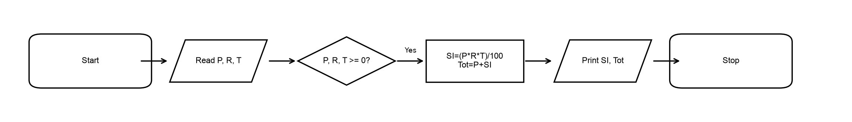
Python Code (Case_01_Simple_Interest_Calculator.py) :
principal = float(input("Enter principal amount (Rs.): "))
rate = float(input("Enter annual rate (%): "))
time = float(input("Enter time (years): "))
if principal < 0 or rate < 0 or time < 0:
print("Invalid input: values cannot be negative.")
else:
interest = principal * rate * time / 100
total = principal + interest
print("Simple interest: Rs.", round(interest, 2))
print("Total amount: Rs.", round(total, 2))
Output (Windows Command Prompt Screenshot) :
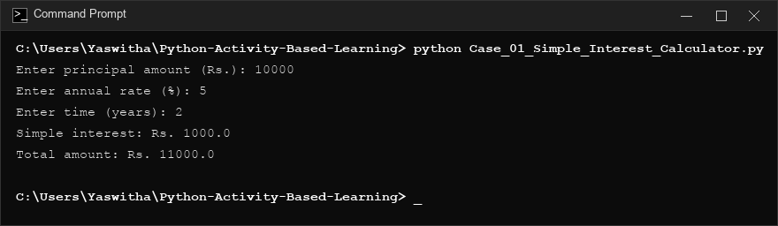
Conclusion: The program successfully validates input parameters and accurately computes simple interest and total maturity amount.

2) Case Study 2: Temperature Converter
Problem Statement: Create a program that converts a temperature from Celsius to Fahrenheit or Fahrenheit to Celsius based on the user's choice.
Objectives: To utilize conditional branching (if-elif-else) to perform temperature unit conversion formulas.
Assumptions: Input temperature can be any real number; user selects choice 1 or 2.
Algorithm :-
Step 1: Start
Step 2: Display conversion choices (1: C to F, 2: F to C)
Step 3: Read choice and temperature value
Step 4: If choice == '1', result = (temperature * 9 / 5) + 32 and print Fahrenheit
Step 5: Elif choice == '2', result = (temperature - 32) * 5 / 9 and print Celsius
Step 6: Else print 'Invalid choice.'
Step 7: Stop
Pseudocode:
BEGIN
PRINT menu choices
INPUT choice, temperature
IF choice == "1" THEN
result = (temperature * 9 / 5) + 32
PRINT "Temperature in Fahrenheit:", result
ELSE IF choice == "2" THEN
result = (temperature - 32) * 5 / 9
PRINT "Temperature in Celsius:", result
ELSE
PRINT "Invalid choice."
END IF
END
Flowchart :-
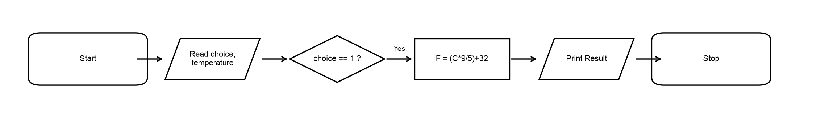
Python Code (Case_02_Temperature_Converter.py) :
print("1. Celsius to Fahrenheit")
print("2. Fahrenheit to Celsius")
choice = input("Choose 1 or 2: ")
temperature = float(input("Enter temperature: "))
if choice == "1":
result = temperature * 9 / 5 + 32
print("Temperature in Fahrenheit:", round(result, 2))
elif choice == "2":
result = (temperature - 32) * 5 / 9
print("Temperature in Celsius:", round(result, 2))
else:
print("Invalid choice.")
Output (Windows Command Prompt Screenshot) :
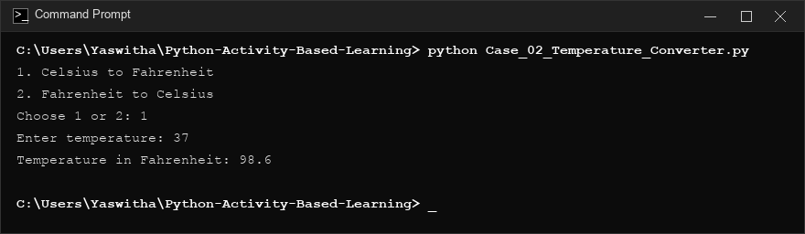
Conclusion: The program provides accurate bidirectional temperature conversion between Celsius and Fahrenheit.

3) Case Study 3: Shopping Discount Calculator
Problem Statement: Calculate a customer's discount and final shopping bill according to the total purchase amount using tiered discount slabs.
Objectives: To implement tiered discount slabs using relational and logical operators in Python.
Assumptions: Purchase amount must be non-negative; discount rates: >=3000 -> 10%, >=1000 -> 5%, else 0%.
Algorithm :-
Step 1: Start
Step 2: Read purchase amount
Step 3: If amount < 0, print 'Invalid amount.'
Step 4: Else if amount >= 3000 set rate = 10; elif amount >= 1000 set rate = 5; else set rate = 0
Step 5: Calculate discount = amount * rate / 100, final_bill = amount - discount
Step 6: Display discount rate, discount amount, and final bill
Step 7: Stop
Pseudocode:
BEGIN
INPUT amount
IF amount < 0 THEN
PRINT "Invalid amount."
ELSE
IF amount >= 3000 THEN rate = 10
ELSE IF amount >= 1000 THEN rate = 5
ELSE rate = 0
discount = amount * rate / 100
final_bill = amount - discount
PRINT rate, discount, final_bill
END IF
END
Flowchart :-
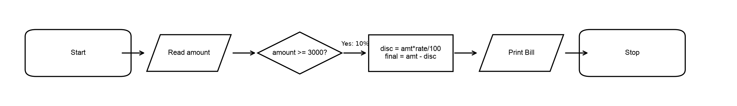
Python Code (Case_03_Shopping_Discount_Calculator.py) :
amount = float(input("Enter shopping amount (Rs.): "))
if amount < 0:
print("Invalid amount.")
else:
if amount >= 3000:
rate = 10
elif amount >= 1000:
rate = 5
else:
rate = 0
discount = amount * rate / 100
final_bill = amount - discount
print("Discount rate:", rate, "%")
print("Discount: Rs.", round(discount, 2))
print("Final bill: Rs.", round(final_bill, 2))
Output (Windows Command Prompt Screenshot) :
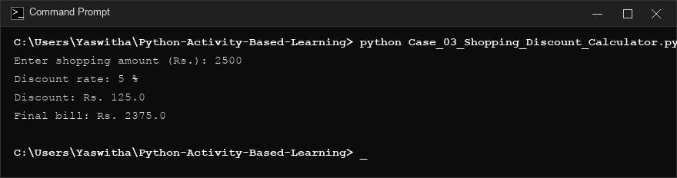
Conclusion: The program correctly calculates tiered savings and prints the net payable shopping bill.

4) Case Study 4: Student Grade Calculator
Problem Statement: Read marks in five subjects, calculate the average, and assign a grade based on the average.
Objectives: To process lists, compute aggregate statistics, and classify marks using multi-way selection.
Assumptions: Each mark is between 0 and 100; grades: A (>=90), B (>=75), C (>=60), D (>=40), F (<40).
Algorithm :-
Step 1: Start
Step 2: Read marks for 5 subjects into list
Step 3: If any mark < 0 or mark > 100, print error message
Step 4: Else average = sum(marks) / 5
Step 5: Assign grade (>=90: A, >=75: B, >=60: C, >=40: D, else: F)
Step 6: Display average and grade, Stop
Pseudocode:
BEGIN
INPUT marks[1..5]
IF any mark < 0 OR mark > 100 THEN
PRINT "Invalid marks: enter values from 0 to 100."
ELSE
average = sum(marks) / 5
IF average >= 90 THEN grade = 'A'
ELSE IF average >= 75 THEN grade = 'B'
ELSE IF average >= 60 THEN grade = 'C'
ELSE IF average >= 40 THEN grade = 'D'
ELSE grade = 'F'
PRINT average, grade
END IF
END
Flowchart :-
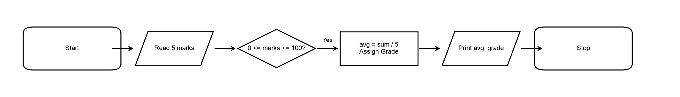
Python Code (Case_04_Student_Grade_Calculator.py) :
marks = []
for i in range(1, 6):
mark = float(input("Enter mark for subject " + str(i) + ": "))
marks.append(mark)
if any(mark < 0 or mark > 100 for mark in marks):
print("Invalid marks: enter values from 0 to 100.")
else:
average = sum(marks) / len(marks)
if average >= 90:
grade = "A"
elif average >= 75:
grade = "B"
elif average >= 60:
grade = "C"
elif average >= 40:
grade = "D"
else:
grade = "F"
print("Average:", round(average, 2))
print("Grade:", grade)
Output (Windows Command Prompt Screenshot) :
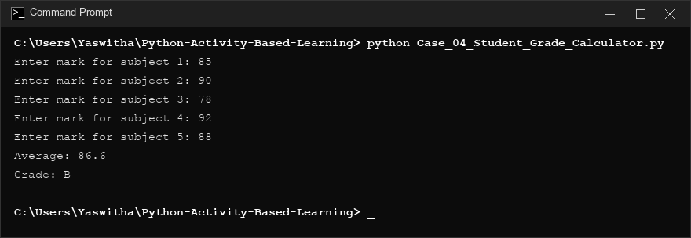
Conclusion: The program aggregates subject marks, computes the percentage average, and assigns academic grades accurately.

5) Case Study 5: Library Late-Fee Calculator
Problem Statement: Calculate late return fines for library books based on the number of days overdue using progressive penalty rates.
Objectives: To implement progressive penalty slabs using conditional branching logic.
Assumptions: Days overdue is non-negative; 0 days = Rs. 0; <=5 days = Rs. 2/day; >5 days = Rs. 10 + Rs. 5/additional day.
Algorithm :-
Step 1: Start
Step 2: Read overdue days
Step 3: If days < 0, print error message
Step 4: If days == 0, fee = 0; elif days <= 5, fee = days * 2; else fee = 10 + (days - 5) * 5
Step 5: Display late fee, Stop
Pseudocode:
BEGIN
INPUT days
IF days < 0 THEN PRINT "Invalid input: days cannot be negative."
ELSE IF days == 0 THEN fee = 0
ELSE IF days <= 5 THEN fee = days * 2
ELSE fee = 10 + (days - 5) * 5
PRINT fee
END
Flowchart :-
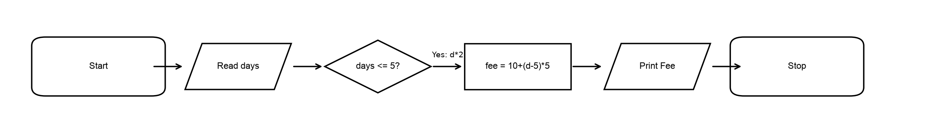
Python Code (Case_05_Library_Late_Fee_Calculator.py) :
days = int(input("Enter number of late days: "))
if days < 0:
print("Invalid input: days cannot be negative.")
elif days == 0:
fee = 0
elif days <= 5:
fee = days * 2
else:
fee = 5 * 2 + (days - 5) * 5
if days >= 0:
print("Library late fee: Rs.", fee)
Output (Windows Command Prompt Screenshot) :
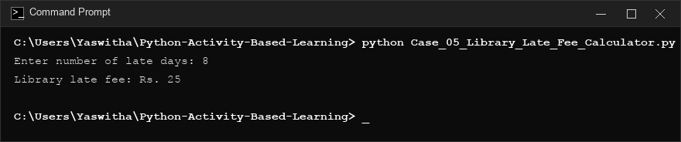
Conclusion: The program enforces progressive daily library fines depending on the overdue duration.

6) Case Study 6: Bus Fare Calculator
Problem Statement: Calculate a passenger's bus fare based on travel distance, with a minimum fare and a per-kilometre rate.
Objectives: To calculate transport fare incorporating minimum base pricing and marginal distance charges.
Assumptions: Distance is non-negative; distance <= 1 km costs Rs. 10; additional km costs Rs. 5/km.
Algorithm :-
Step 1: Start
Step 2: Read travel distance in km
Step 3: If distance < 0, print 'Invalid distance.'
Step 4: If distance <= 1, fare = 10; else fare = 10 + (distance - 1) * 5
Step 5: Display total fare, Stop
Pseudocode:
BEGIN
INPUT distance
IF distance < 0 THEN PRINT "Invalid distance."
ELSE IF distance <= 1 THEN fare = 10
ELSE fare = 10 + (distance - 1) * 5
PRINT fare
END
Flowchart :-
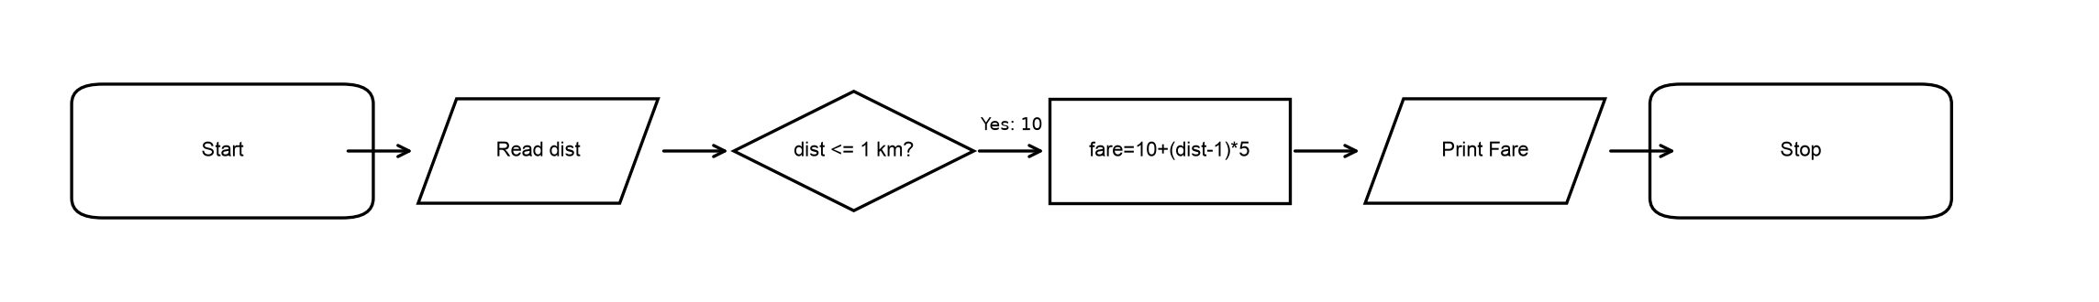
Python Code (Case_06_Bus_Fare_Calculator.py) :
distance = float(input("Enter distance in kilometres: "))
if distance < 0:
print("Invalid distance.")
elif distance <= 1:
fare = 10
print("Bus fare: Rs.", fare)
else:
fare = 10 + (distance - 1) * 5
print("Bus fare: Rs.", round(fare, 2))
Output (Windows Command Prompt Screenshot) :
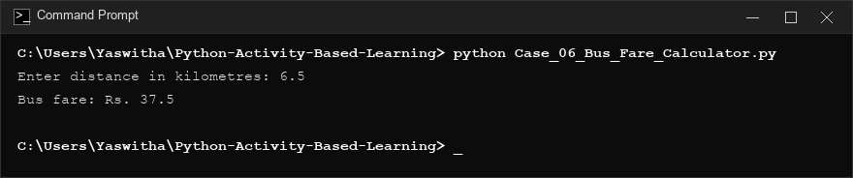
Conclusion: The program calculates transit fees based on distance with minimum base protection.

7) Case Study 7: Daily Expense Tracker
Problem Statement: Record expenses for a day, calculate the total spent, and compare the total with a daily budget.
Objectives: To use loops for iterative data collection and accumulator logic with threshold monitoring.
Assumptions: Budget and expense count are non-negative; each expense must be non-negative.
Algorithm :-
Step 1: Start
Step 2: Read budget and expense count
Step 3: If budget < 0 or count < 0, print error
Step 4: Loop count times to sum expenses; if any expense < 0, print error and break
Step 5: Display total spent; check if total > budget and print budget status
Step 6: Stop
Pseudocode:
BEGIN
INPUT budget, count
IF budget < 0 OR count < 0 THEN PRINT error
ELSE
total = 0
FOR i = 1 TO count DO
INPUT expense
IF expense < 0 THEN PRINT error, total = None, BREAK
total = total + expense
END FOR
IF total != None THEN
PRINT total
IF total > budget THEN PRINT "Budget exceeded."
ELSE PRINT "Within budget."
END IF
END IF
END
Flowchart :-
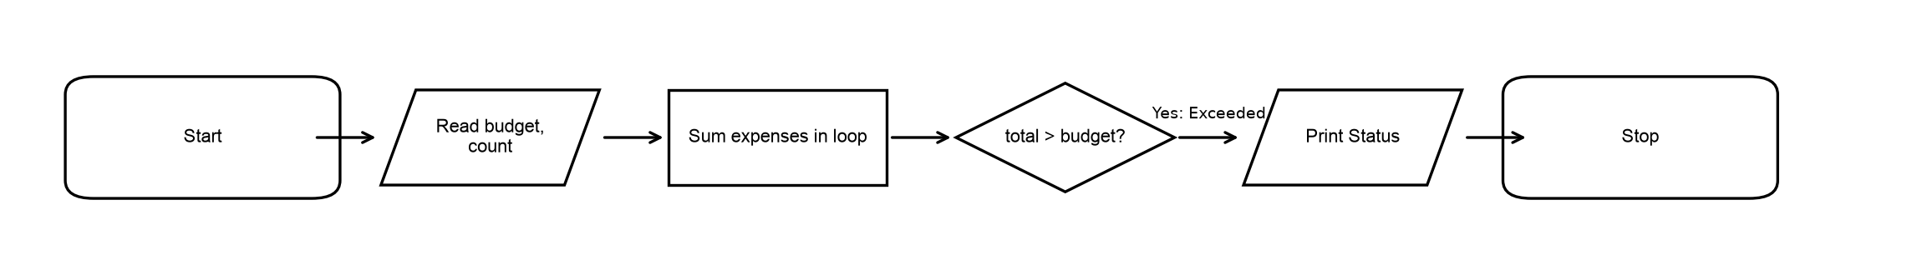
Python Code (Case_07_Daily_Expense_Tracker.py) :
budget = float(input("Enter daily budget (Rs.): "))
count = int(input("How many expenses? "))
if budget < 0 or count < 0:
print("Invalid budget or number of expenses.")
else:
total = 0
for i in range(count):
expense = float(input("Enter expense amount (Rs.): "))
if expense < 0:
print("Expense cannot be negative.")
total = None
break
total += expense
if total is not None:
print("Total spending: Rs.", round(total, 2))
if total > budget:
print("Status: Budget exceeded.")
else:
print("Status: Within budget.")
Output (Windows Command Prompt Screenshot) :
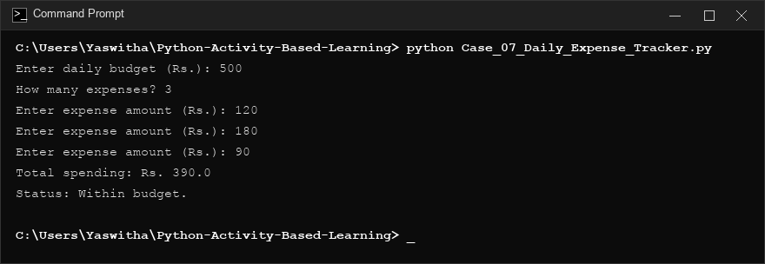
Conclusion: The program successfully tracks daily expenses and flags whether spending remains within budget.

8) Case Study 8: Number Property Checker
Problem Statement: Evaluate an integer to determine its sign (positive, negative, or zero) and parity (even or odd).
Objectives: To check algebraic and parity properties using modulo operators and conditional logic.
Assumptions: Input is any valid integer.
Algorithm :-
Step 1: Start
Step 2: Read integer number
Step 3: If number > 0 print 'positive'; elif number < 0 print 'negative'; else print 'zero'
Step 4: If number % 2 == 0 print 'even'; else print 'odd'
Step 5: Stop
Pseudocode:
BEGIN
INPUT number
IF number > 0 THEN PRINT "The number is positive."
ELSE IF number < 0 THEN PRINT "The number is negative."
ELSE PRINT "The number is zero."
IF number % 2 == 0 THEN PRINT "The number is even."
ELSE PRINT "The number is odd."
END
Flowchart :-
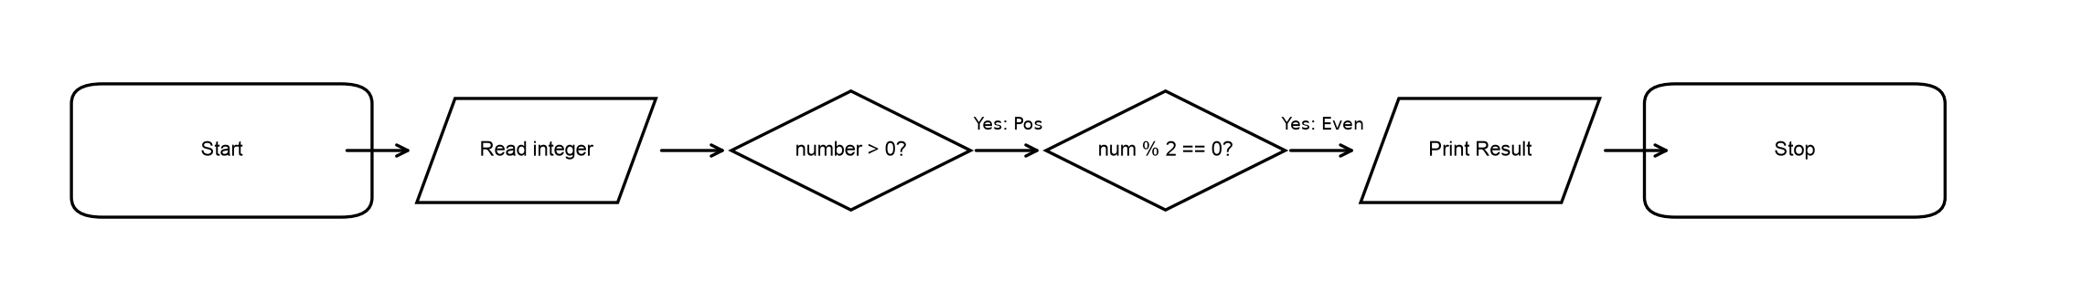
Python Code (Case_08_Number_Property_Checker.py) :
number = int(input("Enter an integer: "))
if number > 0:
print("The number is positive.")
elif number < 0:
print("The number is negative.")
else:
print("The number is zero.")
if number % 2 == 0:
print("The number is even.")
else:
print("The number is odd.")
Output (Windows Command Prompt Screenshot) :
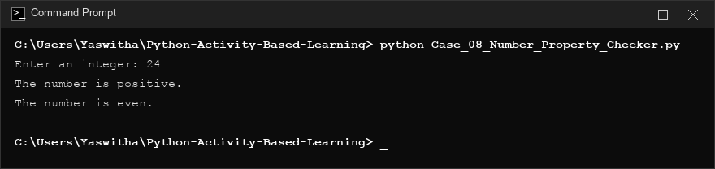
Conclusion: The program determines both sign and parity for any supplied integer.

9) Case Study 9: Water Usage Bill
Problem Statement: Calculate a sample household water bill using a basic per-unit charge and a fixed service fee.
Objectives: To implement utility consumption billing with fixed fees and tiered tariff rates.
Assumptions: Units consumed >= 0; first 20 units @ Rs. 3/unit; units > 20 @ Rs. 5/unit; fixed service fee = Rs. 30.
Algorithm :-
Step 1: Start
Step 2: Read water units consumed
Step 3: If units < 0, print error message
Step 4: If units <= 20, usage = units * 3; else usage = (20 * 3) + ((units - 20) * 5)
Step 5: total_bill = usage + 30
Step 6: Display usage charge, fixed service fee, and total water bill, Stop
Pseudocode:
BEGIN
INPUT units
IF units < 0 THEN PRINT error
ELSE
IF units <= 20 THEN usage = units * 3
ELSE usage = 20 * 3 + (units - 20) * 5
fixed_fee = 30
total_bill = usage + fixed_fee
PRINT usage, fixed_fee, total_bill
END IF
END
Flowchart :-
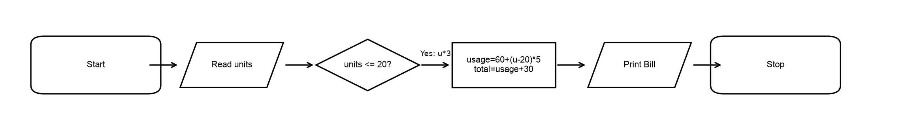
Python Code (Case_09_Water_Usage_Bill.py) :
units = int(input("Enter water units consumed: "))
if units < 0:
print("Invalid input: units cannot be negative.")
else:
if units <= 20:
usage_charge = units * 3
else:
usage_charge = 20 * 3 + (units - 20) * 5
fixed_fee = 30
total_bill = usage_charge + fixed_fee
print("Usage charge: Rs.", usage_charge)
print("Fixed service fee: Rs.", fixed_fee)
print("Total water bill: Rs.", total_bill)
Output (Windows Command Prompt Screenshot) :
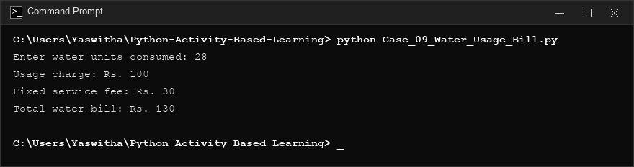
Conclusion: The program calculates water consumption bills using progressive slab rates and fixed service charges.

10) Case Study 10: Multiplication Table Generator
Problem Statement: Generate the multiplication table of a number up to a user-selected limit.
Objectives: To demonstrate bounded iterative execution and formatted mathematical output.
Assumptions: Limit must be an integer between 1 and 20.
Algorithm :-
Step 1: Start
Step 2: Read number and limit
Step 3: If limit < 1 or limit > 20, print error message
Step 4: Else run loop i from 1 to limit and print: number x i = (number * i)
Step 5: Stop
Pseudocode:
BEGIN
INPUT number, limit
IF limit < 1 OR limit > 20 THEN
PRINT "Invalid limit. Enter a value from 1 to 20."
ELSE
FOR i = 1 TO limit DO
PRINT number, "x", i, "=", number * i
END FOR
END IF
END
Flowchart :-
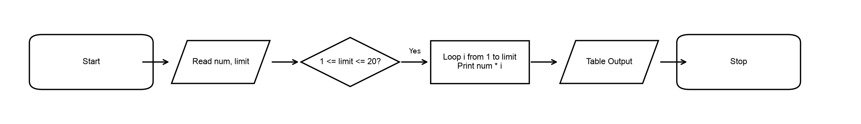
Python Code (Case_10_Multiplication_Table_Generator.py) :
number = int(input("Enter a number: "))
limit = int(input("Enter table limit (1 to 20): "))
if limit < 1 or limit > 20:
print("Invalid limit. Enter a value from 1 to 20.")
else:
for i in range(1, limit + 1):
print(number, "x", i, "=", number * i)
Output (Windows Command Prompt Screenshot) :
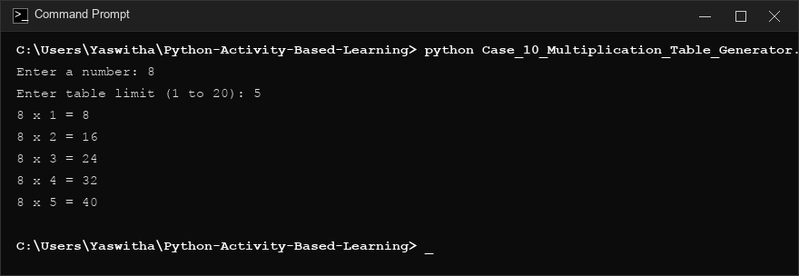
Conclusion: The program validates boundary conditions and generates clear arithmetic tables up to the specified limit.

