Name: Yatendra pratap singh
Registration No:11601994
Email: yatendraetoos@gmail.com
GitHub Link: -https://github.com/yatendrapratap/CA3
Code:

Description:
Given that Sudha Sharma is a linux expert who wants an online system to handle student and lecturer queries .There may be multiple requests so he want to dedicate fixed amount of time to every request .It means we have to use round robin algorithm and given that he wants separate request queues for faculty and students ,it means we have to use multilevel queue by giving priorty to the queues and inside the queues we have to implement round robin algorithm.He is going to log in the system from 10 am to 12 pm ,it means the burst time should not be greater than 120 minutes.Here priority 1 is to the faculty and 2 is to the students

Process | Arrival time | Burst time(min) | Priority
P1 | 0 | 5 | 1
P2 | 3 | 10 | 1
P1’ | 2 | 4 | 2
P2’ | 1 | 15 | 2

Algorithm:
Mlqr(burst_time ,arrival_time ,priority,totaltime,avgtime,timequantum) Step 1:enter the no of process
Step 2:enter the time quantum,burst_time,arrival_time,priority. Step 3:If arrival time=low and priority=high
Then process that process
i.e burst_time=burst_time-timequantum Step 4: Continue step 3 until burst_time=0 Step 5:Calculate totaltime and avgtime
Step 6:Exit

Complexities:
For traversing queues complexity is 2(n*n) For processing complexity is 2n
Overall complexity is 2(n*n)+2n

Code snippet:
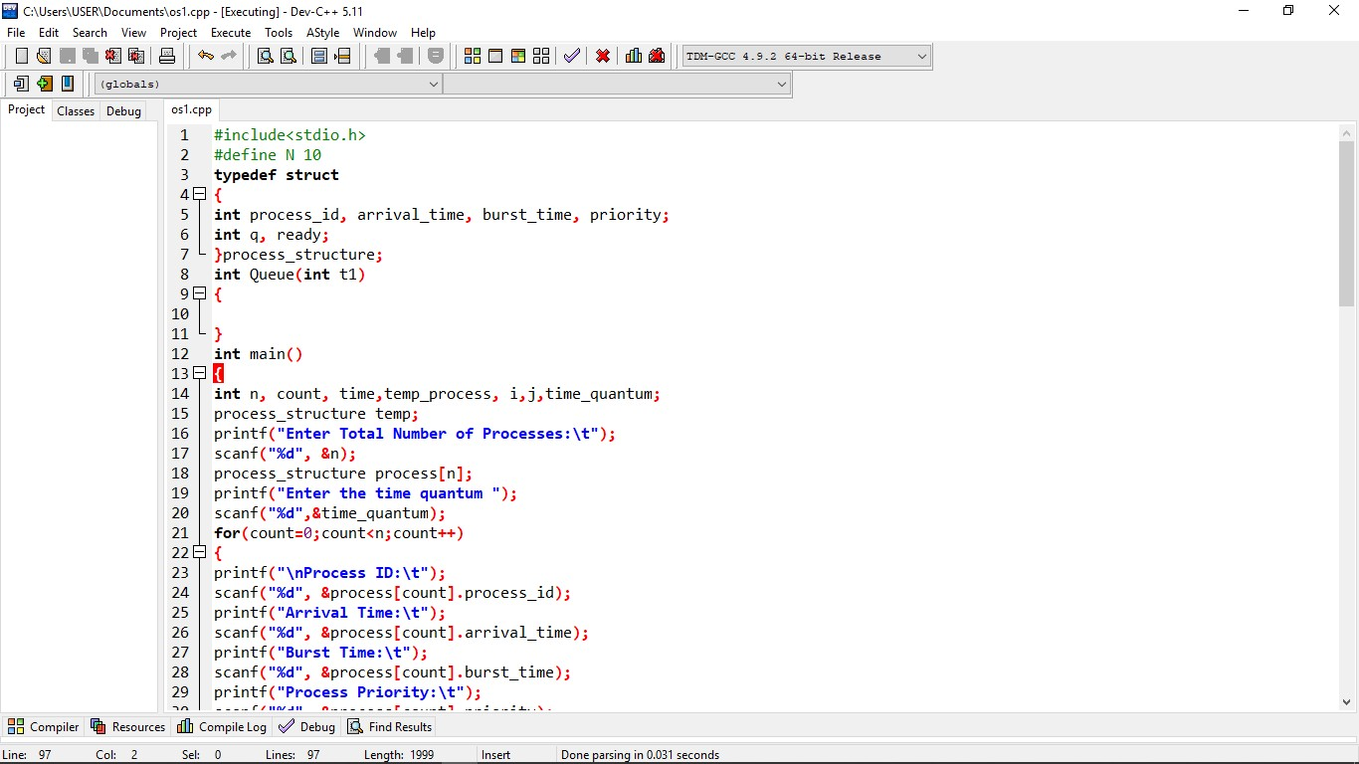
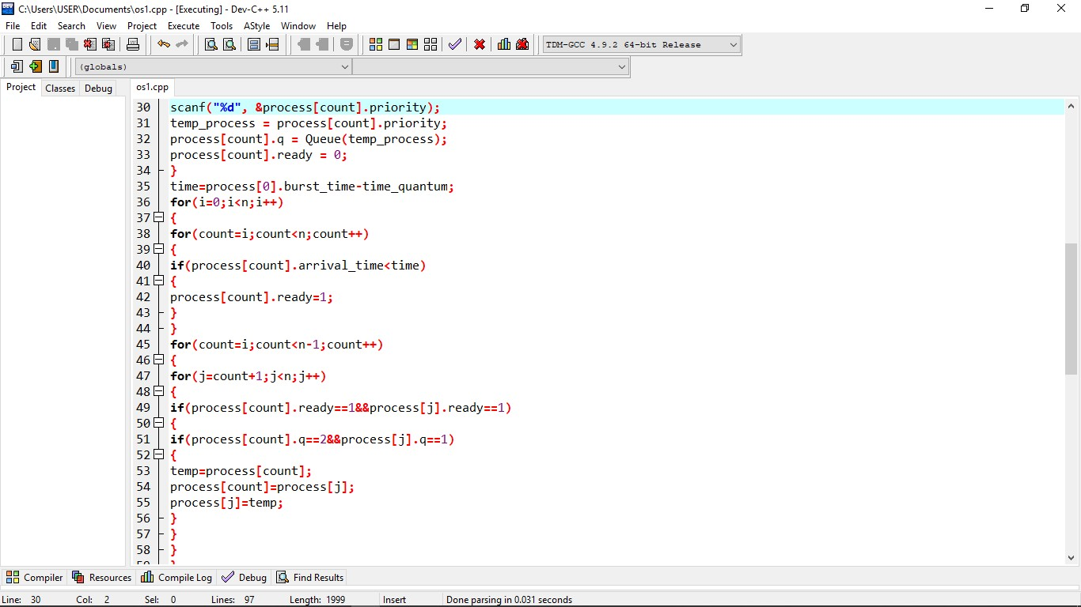
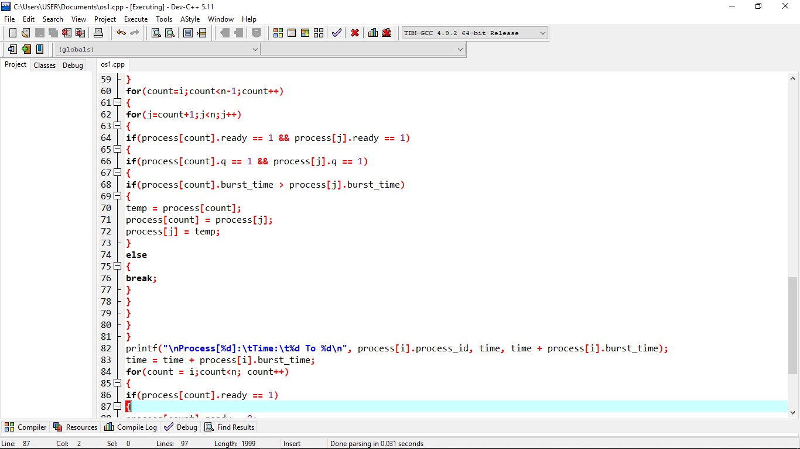
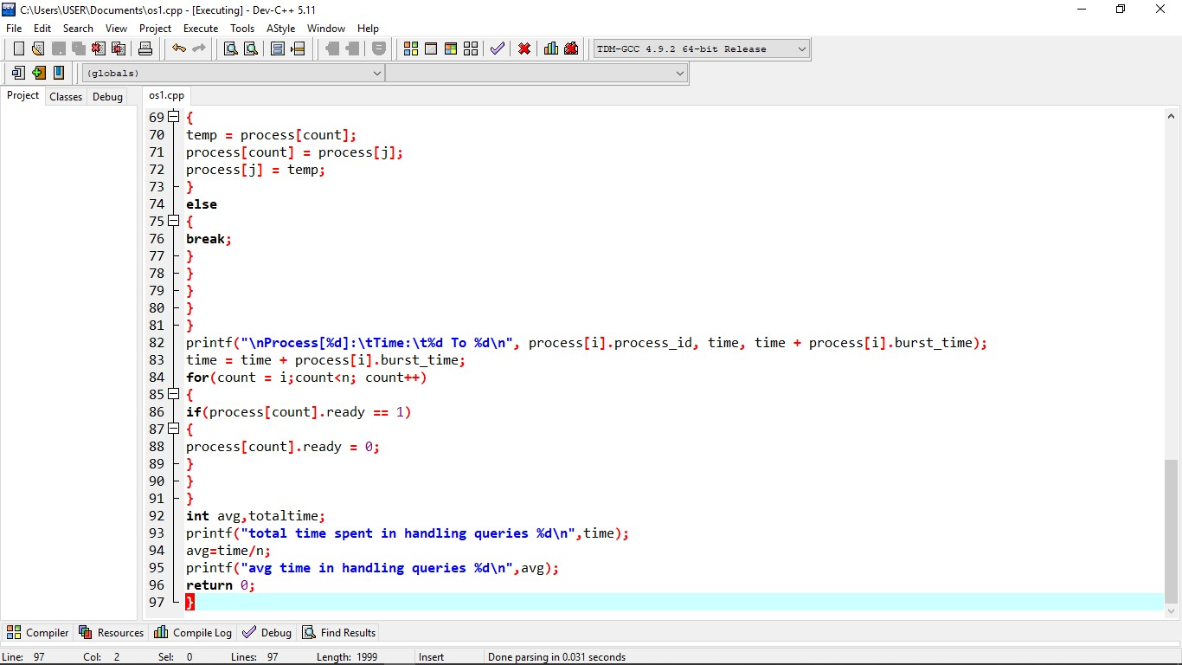

Boundary conditions:
The total burst time should be lessthan 120 minutes The time has to be fair to all

Test Cases:
