**Bind with Pointers, Structures, Functions and Arrays**

**Project Title: Full Score Board: Indian Premier League – 2K20**

The Indian Premier League (IPL) is a professional league for Twenty20 cricket championship in India. It was initiated by the Board of Control for Cricket in India (BCCI), headquartered in Mumbai and is supervised by BCCI Vice President Rajeev Shukla, who serves as the league's Chairman and Commissioner. It is currently contested by nine teams, consisting of players from around the world. It was started after an altercation between the BCCI and the Indian Cricket League

IPL is the most popular cricket league in India with players from across the world. The 2020 Indian Premier League, also known as IPL 13 is the thirteenth season of the [IPL](https://en.wikipedia.org/wiki/Indian_Premier_League), a professional [Twenty20 cricket](https://en.wikipedia.org/wiki/Twenty20_cricket) (T20) league established by the [Board of Control for Cricket in India](https://en.wikipedia.org/wiki/Board_of_Control_for_Cricket_in_India) (BCCI) in 2007.

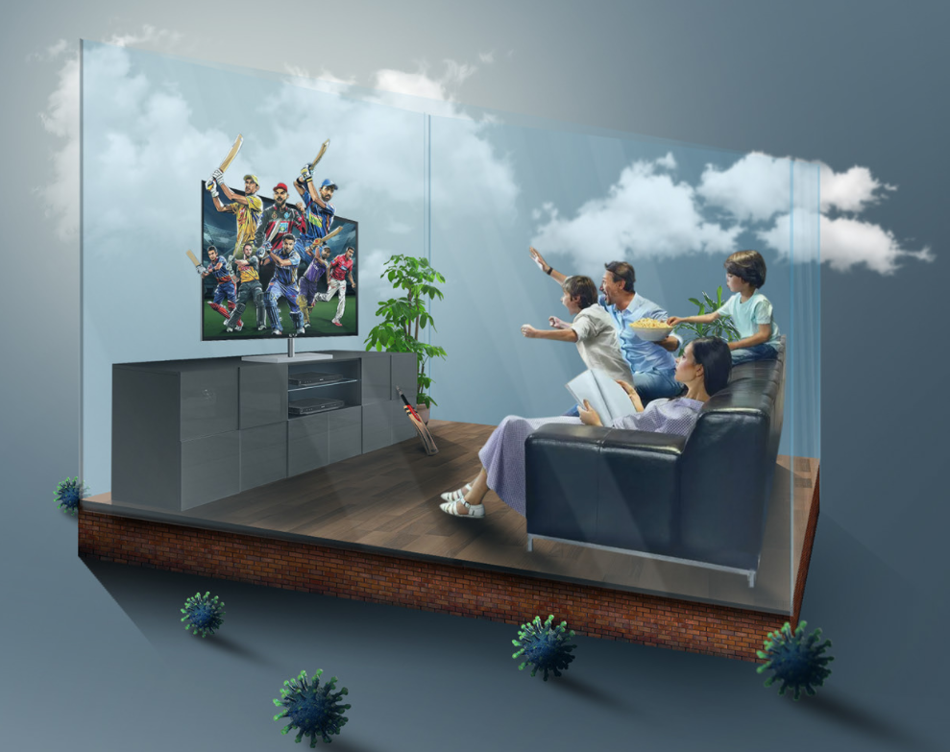

Here our task is to display IPL Score board on 19th September 2020. Here are we have five tasks to do.

1. Read match details:

Venue, Toss, elected to, Series, Player of the match, season, hours of play, matchdays, Points

|  |  |  |  |
| --- | --- | --- | --- |
| S.No | Input parameter | Data type | Constraint |
| 1 | venue | String-100 | First letter must Capital case(after white space also)  EX: [Sheikh Zayed Stadium](https://www.espncricinfo.com/ci/content/ground/59396.html) |
| 2 | Toss | String-100 | First letter must Capital case(after white space also)  EX: Chennai Super Kings |
| 3 | Elected to | String-50 | - |
| 4 | Player of the match | String-100 | First letter must Capital case(after white space also) |
| 5 | Season | int | 2020 |
| 6 | Hours of play | int | Must be HH:MM format(Hours must be between 0-24, Minutes must be between 0-60) |
| 7 | Match Days | int | Must be in dd/mm/yyyy format  check range of year,month and day |
| 8 | Points | String, int | Team, points |

1. Read innings of Team-1: MI(Mumbai Indians)

Target

Batsman Name, Runs,Balls,4s,6s, Batting strike rate, Total runs,

Bowlers name, overs, runs, wickets

|  |  |  |  |
| --- | --- | --- | --- |
| S.No | Input parameter | Data type | Constraint |
| 1 | Batsman Name, Bowler name | String -100 | First letter must Capital case(after white space also) |
| 2 | Runs, balls, fours, sixes, Batting stroke rate, overs, runs, wickets | int | - |

1. Read innings of Team-2: CSK(Chennai Super Kings)

Target

Batsman Name,Runs,Balls,4s,6s, Batting strike rate, Total runs,

Bowlers name, overs, runs, wickets

|  |  |  |  |
| --- | --- | --- | --- |
| S.No | Input parameter | Data type | Constraint |
| 1 | Batsman Name, Bowler name | String -100 | First letter must Capital case (after white space also) |
| 2 | Runs, balls, fours, sixes, Batting stroke rate, overs, runs, wickets | int | - |

1. Display Full Score board of IPL 2020 on Day-1 i.e., 19th September 2020.

Match Details

Team-1 Innings

Team-2 Innings

1. Give a comparison between the top scorers of two teams

Team name, Batsman name, runs, balls, 4s, 6s,batting stroke rate

|  |  |  |  |
| --- | --- | --- | --- |
| S.No | Input parameter | Data type | Constraint |
| 1 | Batsman Name, Status | String -100 | First letter must Capital case (after white space also) |
| 2 | Runs, balls, fours, sixes, Batting stroke rate | int | - |

**Sample Output format:**

Match Details:

|  |  |
| --- | --- |
| Venue |  |
| Toss |  |
| Elected to |  |
| Series |  |
| Player of the match |  |
| Season |  |
| Hours of paly |  |
| Match days |  |
| Points |  |

Innings of Team-1

|  |  |  |  |  |  |  |
| --- | --- | --- | --- | --- | --- | --- |
| S.No | Batsman | Runs | Balls | Fours | Sixes | Batting stroke rate |
|  |  |  |  |  |  |  |
|  |  |  |  |  |  |  |
|  |  |  |  |  |  |  |

Totals Runs:

|  |  |  |  |  |
| --- | --- | --- | --- | --- |
| S.No | Bowler | Overs | Runs | Wickets |
|  |  |  |  |  |
|  |  |  |  |  |

Innings of Team-2

|  |  |  |  |  |  |  |
| --- | --- | --- | --- | --- | --- | --- |
| S.No | Batsman | Runs | Balls | Fours | Sixes | Batting stroke rate |
|  |  |  |  |  |  |  |
|  |  |  |  |  |  |  |
|  |  |  |  |  |  |  |

Total Runs:

|  |  |  |  |  |
| --- | --- | --- | --- | --- |
| S.No | Bowler | Overs | Runs | Wickets |
|  |  |  |  |  |
|  |  |  |  |  |

Comparison between Top Scorers

|  |  |  |
| --- | --- | --- |
| Parameters | Team-1 | Team-2 |
| Batsman name |  |  |
| Runs |  |  |
| Balls |  |  |
| Fours |  |  |
| Sixes |  |  |
| Batting Stroke rate |  |  |
| Status |  |  |