**Step By Step Installation**

1.Download VirtualBox-5.0.24-108355-Win

2.http://filehippo.com/download_virtualbox/tech/68824/

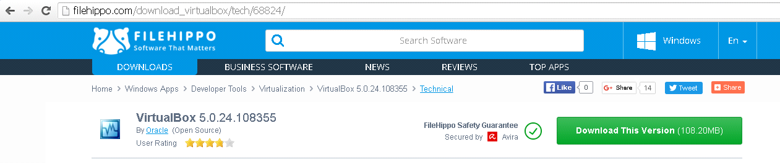

3.Download vagrant file for windows .MSI file

4.https://releases.hashicorp.com/vagrant/1.7.4/

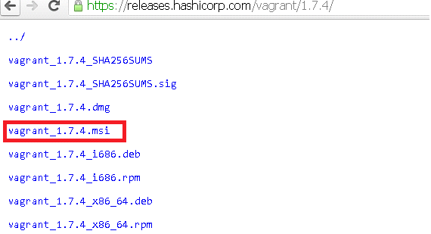

5.Goto desktop and create one empty folder name it as vagrant and click on the path and open cmd.

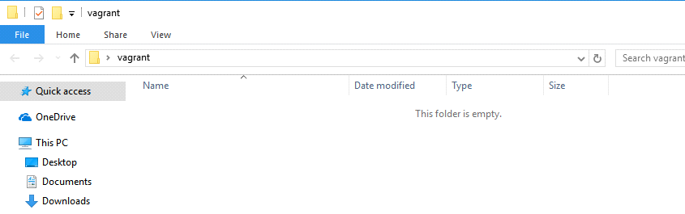

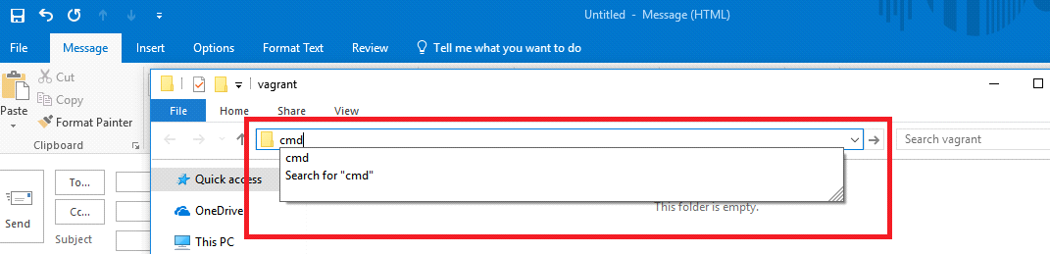

6 run the command in vagrant folder in command prompt vagrant init geerlingguy/centos6

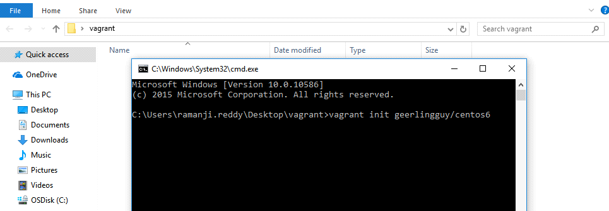

7. After that you will get the below file then open that file in notepad go to 29th line and remove the # and save the file.

7.1 add one line 15th line centos6 enter add this link then save

config.vm.box_url = "<https://app.vagrantup.com/geerlingguy/boxes/centos6>"

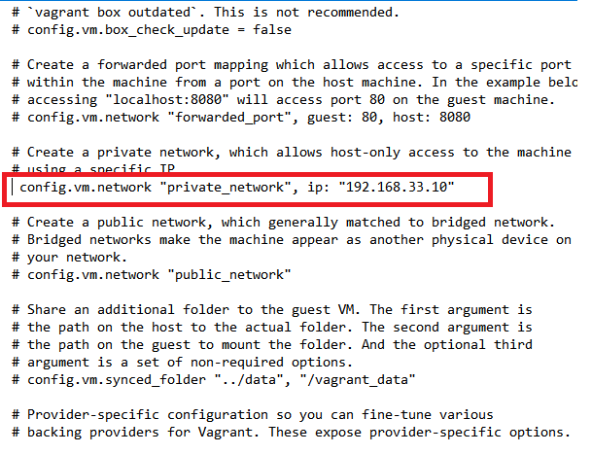

8. Now goto same command prompt and run the command vagrant up

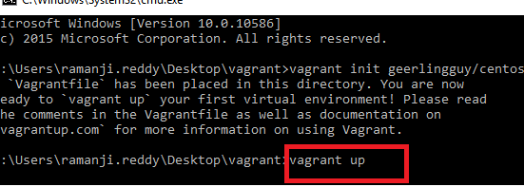

9.It will take 15min may be in that process you will get the error like connection time out error that is not issue that is default error please wait to complete the process.

config.vm.box_url = "<https://app.vagrantup.com/geerlingguy/boxes/centos6>"



10.Once it is done go to google and download putty click 1st option



11. click on Putty here.

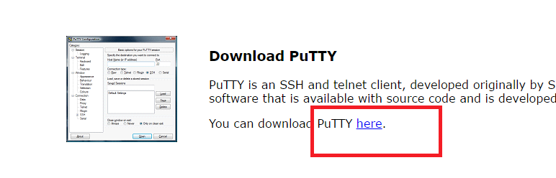

11. Go to putty login : 192.168.33.10 user name : vagrant password : vagrant

1.SVN installation :

go to google and search bitnami subversion and go to link

<https://bitnami.com/stack/subversion/installer#linux>

Now right click on svn and click on copy address link.

Now go to putty run the command :

wget <https://bitnami.com/redirect/to/127862/bitnami-subversion-1.9.4-1-linux-x64-installer.run>

Run the commands

ls -l

copy the file : bitnami-subversion-1.9.4-1-linux-x64-installer.run

run the command

./bitnami-subversion-1.9.4-1-linux-x64-installer.run

Then it showing perssion error so you need to run the below command

chmod 777 bitnami-subversion-1.9.4-1-linux-x64-installer.run

Run the command : ls -l

./bitnami-subversion-1.9.4-1-linux-x64-installer.run

Click on enter two times

run the command ls -l

cd subversion-1.9.4-1

ls -l

sh ctlscript.sh

sh ctlscript.sh status

Go to browser <http://192.168.33.10:8080/subversion/>

**Svn Client installation :**

Go to google and search subversion download

<https://subversion.apache.org/download.cgi> go to binary packages

<https://subversion.apache.org/packages.html>

once page will open go down select windows

<https://sourceforge.net/projects/win32svn/>

1. go to build 2

build afer other projet - build1

Go to build 3

build afer other projet - build 2