Unit-5
Accessing Native Services using Iconic and Application Signing and Development

Iconic-cordova integration
Cordova offers ngCordova, which is set of wrappers specifically designed to work with AngularJS.

Installing ngCordova
When you the start Ionic app, you will notice that it is usingbower. It can be used for managing ngCordova plugins. If you have bower installed skip this step, if you do not have it, then you can install it in the command prompt window.
C:\Users\Username\Desktop\MyApp> npm install -g bower
Now we need to install ngCordova. Open your app in the command prompt window. The following example is used for the app that is located on the desktop and is named MyApp.
C:\Users\Username\Desktop\MyApp> bower install ngCordova
Next, we need to include ngCordova to our app. Open index.htmlfile and add the following scripts. It is important to add these scripts before cordova.js and after ionic scripts.
<script src = "lib/ngCordova/dist/ng-cordova.js"></script>
Now, we need to inject ngCordova as angular dependency. Open your app.js file and add the ngCordova to angular module. If you have used one of the Ionic template apps, you will notice that there is injected ionic, controllers and services. In that case, you will just add ngCordova at the end of the array.
angular.module('myApp', ['ngCordova'])
You can always check the plugins that are already installed by typing the following command.
C:\Users\Username\Desktop\MyApp> cordova plugins ls
Now, we can use the Cordova plugins.

Ionic - Cordova Camera
The Cordova camera plugin uses the native camera for taking pictures or getting images from the image gallery.

Using Camera
Open your project root folder in command prompt, then download and install the Cordova camera plugin with the following command.
C:\Users\Username\Desktop\MyApp> cordova plugin add org.apache.cordova.camera
Now, we will create a service for using a camera plugin. We will use the AngularJS factory and promise object $q that needs to be injected to the factory.

services.js Code
.factory('Camera', function($q) {

return {
getPicture: function(options) {
var q = $q.defer();

navigator.camera.getPicture(function(result) {
q.resolve(result);
}, function(err) {
q.reject(err);
}, options);

return q.promise;
}
}
});
To use this service in the app, we need to inject it to a controller as a dependency. Cordova camera API provides the getPicturemethod, which is used for taking photos using a native camera.
The native camera settings can be additionally customized by passing the options parameter to the takePicture function. Copy the above-mentioned code sample to your controller to trigger this behavior. It will open the camera application and return a success callback function with the image data or error callback function with an error message. We will also need two buttons that will call the functions we are about to create and we need to show the image on the screen.

HTML Code
<button class = "button" ng-click = "takePicture()">Take Picture</button>
<button class = "button" ng-click = "getPicture()">Open Gallery</button>
<img ng-src = "{{user.picture}}">

Controller Code
.controller('MyCtrl', function($scope, Camera) {

$scope.takePicture = function (options) {

var options = {
quality : 75,
targetWidth: 200,
targetHeight: 200,
sourceType: 1
};

Camera.getPicture(options).then(function(imageData) {
$scope.picture = imageData;;
}, function(err) {
console.log(err);
});

};
})
The output will look as shown in the following screenshot.
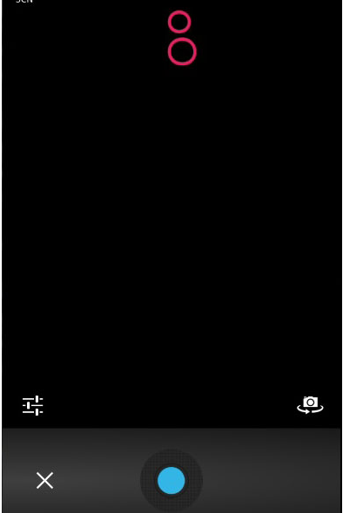
If you want to use images from your gallery, the only thing you need to change is the sourceType method from your options parameter. This change will open a dialog popup instead of camera and allow you to choose the image you want from the device.
You can see the following code, where the sourceType option is changed to 0. Now, when you tap the second button, it will open the file menu from the device.

Controller Code
.controller('MyCtrl', function($scope, Camera) {

$scope.getPicture = function (options) {

var options = {
quality : 75,
targetWidth: 200,
targetHeight: 200,
sourceType: 0
};

Camera.getPicture(options).then(function(imageData) {
$scope.picture = imageData;;
}, function(err) {
console.log(err);
});
};
})
The output will look as shown in the following screenshot.
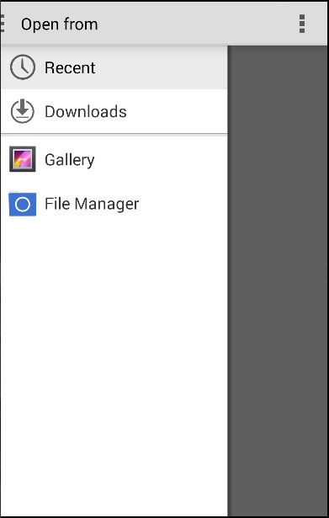
When you save the image you took, it will appear on the screen. You can style it the way you want.
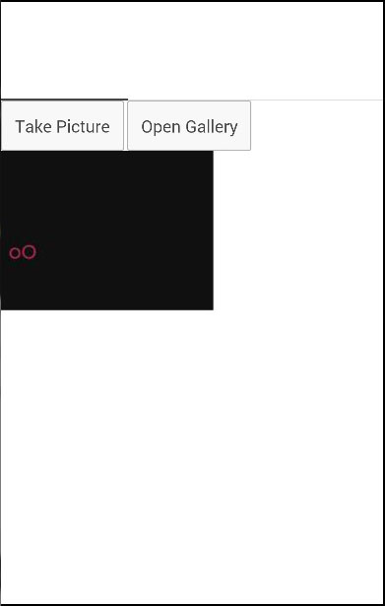

Ionic - Cordova Native Audio
This plugin is used for adding native audio sounds to the Ionic app.

Using Native Audio
To be able to use this plugin, we first need to install it. Open the command prompt window and add the Cordova plugin.
C:\Users\Username\Desktop\MyApp>cordova plugin add cordova-plugin-nativeaudio
Before we start using this plugin, we will need audio file. For simplicity, we will save our click.mp3 file inside the js folder, but you can place it wherever you want.
The next step is to preload the audio file. There are two options available, which are −
- preloadSimple − It is used for simple sounds that will be played once.
- preloadComplex − It is for sounds that will be played as looping sounds or background audio.
Add the following code to your controller to preload an audio file. We need to be sure that the Ionic platform is loaded before we can preload the audio file.

Controller Code
$ionicPlatform.ready(function() {
$cordovaNativeAudio
.preloadSimple('click', 'js/click.mp3')

.then(function (msg) {
console.log(msg);
}, function (error) {
console.log(error);
});

$cordovaNativeAudio.preloadComplex('click', 'js/click.mp3', 1, 1)

.then(function (msg) {
console.log(msg);
}, function (error) {
console.error(error);
});
});
In the same controller, we will add code for playing audio. Our$timeout function will stop and unload looping audio after five seconds.
$scope.playAudio = function () {
$cordovaNativeAudio.play('click');
};

$scope.loopAudio = function () {
$cordovaNativeAudio.loop('click');

$timeout(function () {
$cordovaNativeAudio.stop('click');
$cordovaNativeAudio.unload('click');
}, 5000);
}
The last thing we need is to create buttons for playing and looping audio.

HTML Code
<button class = "button" ng-click = "playAudio()">PLAY</button>

<button class = "button" ng-click = "loopAudio()">LOOP</button>
When we tap on play button, we will hear the sound once and when we tap on the loop button, the sound will loop for five seconds and then stop. This plugin works only on an emulator or a mobile device.

Ionic - Cordova Media
This plugin allows us to record and playback audio files on a device.

Using Media
As with all the other Cordova plugins, the first thing we need to do is to install it from the command prompt window.
C:\Users\Username\Desktop\MyApp>cordova plugin add cordova-plugin-media
Now, we are ready to use the plugin. In the following code sample, src is the source mp3 file that we will use for this tutorial. It is placed in js folder, but we need to add/android_asset/www/ before it, so it can be used on android devices.
The complete functionality is wrapped inside the$ionicPlatform.ready() function to assure that everything is loaded before the plugin is used. After that, we are creating themedia object by using the newMedia(src) method. The mediaobject is used for adding play, pause, stop and release functionalities.

Controller Code
.controller('MyCtrl', function($scope, $ionicPlatform, $cordovaMedia) {

$ionicPlatform.ready(function() {
var src = "/android_asset/www/js/song.mp3";
var media = $cordovaMedia.newMedia(src);

$scope.playMedia = function() {
media.play();
};

$scope.pauseMedia = function() {
media.pause();
};

$scope.stopMedia = function() {
media.stop();
};

$scope.$on('destroy', function() {
media.release();
});

});
}
We will also create three buttons for calling play, pause and stop functions.
<button class = "button" ng-click = "playMedia()">PLAY</button>

<button class = "button" ng-click = "pauseMedia()">PAUSE</button>

<button class = "button" ng-click = "stopMedia()">STOP</button>
We need to run it on an emulator or a mobile device for this plugin to work. When the user’s tap on the play button, the song.mp3will start playing.
You can see in the above example that we use src as an option parameter. There are other optional parameters that can be used for the newMedia method.

Optional Parameters
The following table will show all the optional parameters available.
Parameter | Type | Details
mediaSuccess | function | Called after current play/record or stop action has completed.
mediaError | function | Invoked when there is an error.
mediaStatus | function | Invoked to show status changes.
The next table will show all the methods available.

Available Methods
The following table will show all the methods available.
Method | Parameters | Details
newMedia(parameter1) | src | Returns media object that will be used for future methods. src is an URI of the audio content.
getCurrentPosition | / | Returns the current position within an audio file.
getDuration | / | Returns the duration of an audio file.
play | / | Used to start or resume playing.
pause | / | Used to pause playback.
stop | / | Used to stop playing.
release | / | Used to release audio resources.
seekTo(parameter1) | milliseconds | Used to set the playback position in milliseconds.
setVolume(parameter1) | volume | Used to change volume. Range is from 0 to 1
startRecord() | / | Used to start recording.
stopRecord | / | Used to stop recording.

Ionic - Cordova InAppBrowser
The Cordova InAppBrowser plugin is used to open external links from your app inside a web browser view.

Using Browser
It is very easy to start working with this plugin. All you need to do is to open the command prompt window and install the Cordova plugin.
C:\Users\Username\Desktop\MyApp>cordova plugin add org.apache.cordova.inappbrowser
This step allows us to start using the inAppBrowser. We can now create a button that will lead us to some external link, and add a simple function for triggering the plugin.

HTML Code
<button class = "button" ng-click = "openBrowser()">OPEN BROWSER</button>

Controller Code
.controller('MyCtrl', function($scope, $cordovaInAppBrowser) {

var options = {
location: 'yes',
clearcache: 'yes',
toolbar: 'no'
};

$scope.openBrowser = function() {
$cordovaInAppBrowser.open('http://ngcordova.com', '_blank', options)

.then(function(event) {
// success
})

.catch(function(event) {
// error
});
}
})
When the user taps the button the InAppBrowser will open the URL we provided.
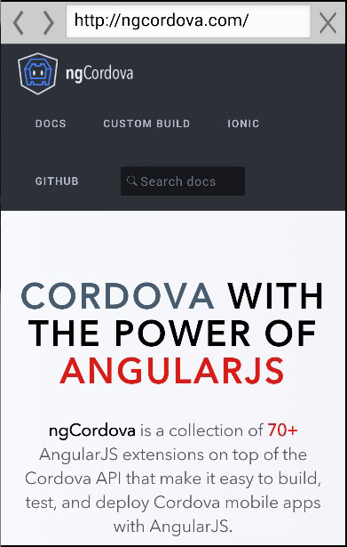
Several other methods can be used with this plugin, some of which are in the following table.

Cordova $inAppBrowser Methods
Method | Parameters | Type | Details
setDefaultOptions(parameter1) | options | object | Used to set global options for all InAppBrowsers.
open(parameter1, parameter2, parameter3) | URL, target, options | string, string, object | There are three targets available._blank will open new inAppBrowser instance._system will open system browser and_self will use current browser instance.
close | / | / | Used to close InAppBrowser.

Cordova InAppBrowser Events
This plugin also offers events that can be combined with$rootScope.
Example | Details
$rootScope.$on('$cordovaInAppBrowser:loadstart', function(e, event)); | Called when inAppBrowser start loading the page.
$rootScope.$on('$cordovaInAppBrowser:loadstop', function(e, event)); | Called when inAppBrowser has finished loading the page.
$rootScope.$on('$cordovaInAppBrowser:loaderror', function(e, event)); | Called when inAppBrowser has encountered error.
$rootScope.$on('$cordovaInAppBrowser:exit', function(e, event)); | Called when inAppBrowser window is closed.
Introduction to git
Git is a version control system for tracking changes in computer files and coordinating work on those files among multiple people. It is primarily used for source code management in software development, but it can be used to keep track of changes in any set of files. As a distributed revision control system it is aimed at speed, data integrity, and support for distributed, non-linear workflows.
Git was created by Linus Torvalds in 2005 for development of the Linux kernel, with other kernel developers contributing to its initial development. Its current maintainer since 2005 is Junio Hamano.
As with most other distributed version control systems, and unlike most client–server systems, every Git directory on every computer is a full-fledged repository with complete history and full version tracking abilities, independent of network access or a central server.
Git is free software distributed under the terms of the GNU General Public License version 2.

Version Control System
Version Control System (VCS) is a software that helps software developers to work together and maintain a complete history of their work.
Listed below are the functions of a VCS:
- Allows developers to work simultaneously.
- Does not allow overwriting each other’s changes.
- Maintains a history of every version.
Following are the types of VCS:
- Centralized version control system (CVCS).
- Distributed/Decentralized version control system (DVCS).

The Three States
Git has three main states that your files can reside in: committed, modified, and staged:
- Committed means that the data is safely stored in your local database.
- Modified means that you have changed the file but have not committed it to your database yet.
- Staged means that you have marked a modified file in its current version to go into your next commit snapshot.
This leads us to the three main sections of a Git project: the Git directory, the working tree, and the staging area.
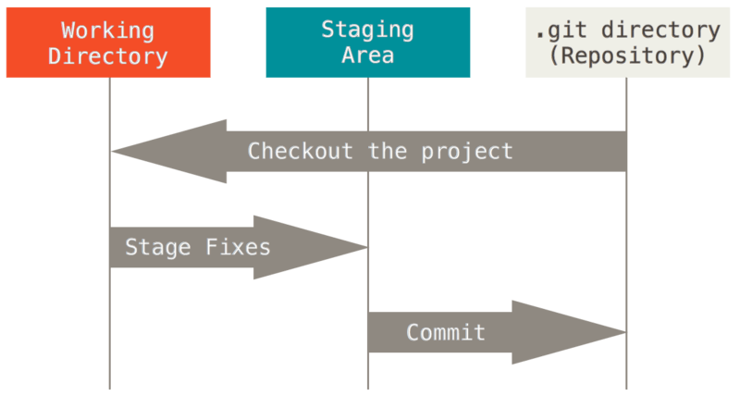
Figure . Working tree, staging area, and Git directory.

The Git directory is where Git stores the metadata and object database for your project. This is the most important part of Git, and it is what is copied when you clone a repository from another computer.
The working tree is a single checkout of one version of the project. These files are pulled out of the compressed database in the Git directory and placed on disk for you to use or modify.
The staging area is a file, generally contained in your Git directory, that stores information about what will go into your next commit. Its technical name in Git parlance is the “index”, but the phrase “staging area” works just as well.
The basic Git workflow goes something like this:
- You modify files in your working tree.
- You selectively stage just those changes you want to be part of your next commit, which adds onlythose changes to the staging area.
- You do a commit, which takes the files as they are in the staging area and stores that snapshot permanently to your Git directory.

Basic commands in git
Push
Sends local commits to the remote repository. git push requires two parameters: the remote repository and the branch that the push is for.
Usage:
$ git push <remote_URL/remote_name> <branch>
# Push all local branches to remote repository
$ git push —all
Pull
To get the latest version of a repository run git pull. This pulls the changes from the remote repository to the local computer.
Usage:
$ git pull <branch_name> <remote_URL/remote_name>

Commit
Commit changes to head (but not yet to the remote repository):
git commit -m "Commit message"
Commit any files you've added with git add, and also commit any files you've changed since then:
git commit -a

Rollback (undoing changes)
Using the git revert Command to Rollback a Commit
The command syntax for git revert is:
git revert
Where the <commit> is described in any of the supported commit ID forms Git understands.

Status
This command returns the current state of the repository.
git status will return the current working branch. If a file is in the staging area, but not committed, it shows with git status. Or, if there are no changes it’ll return nothing to commit, working directory clean.
git status

Init
This command turns a directory into an empty Git repository. This is the first step in creating a repository. After running git init, adding and committing files/directories is possible.
Usage:
# change directory to codebase
$ cd /file/path/to/code

# make directory a git repository
$ git init

git add
Adds files in the to the staging area for Git. Before a file is available to commit to a repository, the file needs to be added to the Git index (staging area). There are a few different ways to use git add, by adding entire directories, specific files, or all unstaged files.
Usage:
$ git add <file or directory name>

branch
To determine what branch the local repository is on, add a new branch, or delete a branch.
Usage:
# Create a new branch
$ git branch <branch_name>

# List all remote or local branches
$ git branch -a

# Delete a branch
$ git branch -d <branch_name>
In Practice:
# Create a new branch
$ git branch new_feature

# List branches
$ git branch -a
* SecretTesting
new_feature
remotes/origin/stable
remotes/origin/staging
remotes/origin/master -> origin/SecretTesting

# Delete a branch
$ git branch -d new_feature
Deleted branch new_feature (was 0254c3d).

Git branches
Branch operation allows creating another line of development. We can use this operation to fork off the development process into two different directions. For example, we released a product for 6.0 version and we might want to create a branch so that the development of 7.0 features can be kept separate from 6.0 bug fixes.

Create a new branch and switch to it: | git checkout -b <branchname>
Switch from one branch to another: | git checkout <branchname>
List all the branches in your repo, and also tell you what branch you're currently in: | git branch
Delete the feature branch: | git branch -d <branchname>
Push the branch to your remote repository, so others can use it: | git push origin <branchname>
Push all branches to your remote repository: | git push --all origin
Delete a branch on your remote repository: | git push origin :<branchname>

Git push operations
The Push operation stores data permanently to the Git repository. After a successful push operation, other developers can see changes.

The git log command to view the commit details.

git log

The above command will produce the following result:
commit d1e19d316224cddc437e3ed34ec3c931ad803958
Author: Jerry Mouse <jerry@tutorialspoint.com>
Date: Wed Sep 11 08:05:26 2013 +0530

Changed return type of my_strlen to size_t
Before push operation, he wants to review his changes, so he uses the git show command to review his changes.

Git pull operation
git pull, is used with a different goal in mind: to update your current HEAD branch with the latest changes from the remote server. This means that pull not only downloads new data; it also directly integrates it into your current working copy files. This has a couple of consequences:
- Since "git pull" tries to merge remote changes with your local ones, a so-called "merge conflict" can occur.
- Like for many other actions, it's highly recommended to start a "git pull" only with a clean working copy. This means that you should not have any uncommitted local changes before you pull. Use Git's Stash feature to save your local changes temporarily.

Significance and importance of git in development of applications
As you may be aware, Git is a version control software application created by Linus Torvalds (the creator of Linux) with the collaboration of many other developers.
A version control application keeps track of all the changes that you do in the files of your project. Every time you make changes to files of a project, you can push those changes to a repository. Other developers can pull your changes from the repository and continue to work with the improvements that you added to the project files.
There are many version control applications. This article focus on the benefits of using Git.

The Benefits of Working with Git

Working offline
Some version control applications popular in the past like CVS and SubVersion used the concept of central repository accessible somewhere in the network where all the changes needed to be commited.
Git uses the concept of local repository where you have a copy of the “complete repository” of your project. You can commit the changes you make to the files of your project to the local repository. So Git allows you to work completely offline, i.e. even when you do not have access to a remote repository.
Later you can synchronize or sharing the changes you made when you have online access to the remote repository.

Fast to Work With
Most of the Git operations are fast, mainly because they are performed on your local repository copy.

Repositories Are Smaller
A typical Git repository is smaller than for instance one using SubVersion. If you want to compare, you can try this test page. You can read more about this learning how Git packs information.

Moving or Adding files
If you want to move a file inside your repository Git automatically track the moves. This was not possible in old version control applications like CVS. Moving a file would typically require to create a new file and remove the old one, thus losing the changes history.
Also if you want to add only certain files with some extension with Git you can use wildcards. For example to add only .php files you can run:
git add '*.php'

Ignore Certain Files
Sometimes you have files being generated by your project, like for instance log files or files generated by your IDE, that you do not want to store in project repository because they are not really part of your source code.
You can tell Git to ignore certain files in the local repository directories using a file named .gitignore. The files listed in .gitignore are excluded from the version control process as if they are not there. You can share those rules committing the file or just keep it locally.

Branches
Sometimes you need to work on new experimental features without interfering with the main code of your project.
You can achieve this by creating new branches to try the code of those experimental features.
Branches also allow different developers to work on different features without interfering with each other work. Then when the features are ready, they can merge the branch changes in the main branch.

Check the Status of Your Changes
Check the status of the changes you made to your repository is pretty straightforward. The git status command lets you see what would happen if you committed your changes at a given moment. It can help to avoid the mistakes of using different externals branches of your project.

Stash Branches
If you are working on a branch of your project but you do not want to commit the changes, you can save the current status of that branch to return to it in the future. You can switch your work to another branch and insert the stashed modification in it.
With git stash command, you can save the current status. With git stash pop command you will apply the stashed modifications.

Cherry Pick Changes from Branches
Git allows to pick one commit from some branch and apply it into the current branch. This operation is helpful for testing purposes. Imagine you want to test some temporary modification or pick some commits done in other branches.

Find version that Introduced a bug using Binary Search
If you have an issue in your code and you want to know when it was introduced and what it is, with the git bisect command you could go back to every commit till you will find the bad one one which the issue was introduced. You can learn more about this on the documentation about Git tools for debugging.
Maintaining version of applications using git

From your master branch since you are done v1.0 add a tag called v1.0.
git tag -a -m "Tagging release 1.0" v1.0
This way you can always come back to a specific version at any time by calling git checkout [tag_name]
Another common practice is to use branches to work on features until they are stable.
git checkout -b [feature-branch]
That creates a new branch named whatever is in [feature-branch] and checks it out. Be sure to do this from where you want to start working on the feature (typically from master).
Once stable they can then be safely merged into master. From master run:
git merge [feature-branch]
This way your master branch always stays in a working state and only completed items get added once ready. This will allow you to keep a working copy of the app at all times (ideally anyways) for testing, etc.
You could use branches for each version of the application however using tags makes it so you can't merge into another branch version by accident.
Building Android apps and publishing to Google Play
Now that your app is ready to be built for production, you’ve got a few steps to run through to build for Android. You’ll have to build the app using Cordova, sign the app to verify the source, and optimize the built app. You’ll use the command line to run all of the steps for Android, but you could also read about how to use Android Studio at http://mng.bz/T7G4. You’ll use the command-line process, as outlined in figure 10.4, because it’s simpler for Android.

The Google Play Store is the primary place to publish your apps for Android. You’ll need to create or link an existing Google account with the Play Store Developer Console. Then you’ll be able to create a listing for your app that includes the title, description, images, and other details used to categorize and list the app. Once that’s done, you’ll upload the built Android app APK file you generated and submit the app for review.

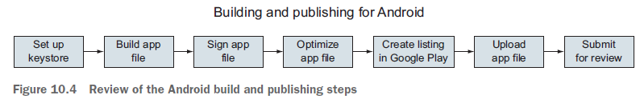

1 Setting up for signing your apps
Start by setting up a keystore—a file that securely stores the security key that you’ll use later to add a signature to your app. With the signature, the author of the app can be verified over time. You can read more about signing at http://mng.bz/T7G4.

To generate a new keystore, you’ll use a command-line utility keytool. This generates a keystore that’s valid for 10,000 days, which should be more than enough to cover the lifetime of your app (and you shouldn’t make it shorter, or it might expire!). You’ll replace know_your_brew with the name of your app (use underscores) in this command:

$ keytool -genkey -v -keystore know_your_brew.keystore -alias know_your_brew
-keyalg RSA -keysize 2048 -validity 10000

This generates a new file called, in this case, know_your_brew.keystore, and you can place it anywhere on your computer. Later you’ll need to know the location of the file, so make sure you can access it.

You’ll reuse the same keystore for the entire life of the app, so you need to keep it for as long as you plan to support the app. You also need to keep it safe and private because it could be used by others for malicious purposes. Every version of the app must be signed with the same keystore or the updates will be rejected. If a team needed to sign an app, the same keystore would need to be used regardless of who builds the app. You should also generate a different keystore for every app you produce.

2 Build the release app file
Next you’ll build the app with Cordova. The following build command will build a release-ready version of your app:

$ cordova build --release android

This will generate a new APK file, which is the Android app file type, inside of platforms/ android/ant-build/CordovaApp-release-unsigned.apk. The command line should report the exact file path to the APK file. This is an unsigned, release-ready version of your app.

3 Signing the APK file
Now you’re ready to use the keystore you created earlier to sign the unsigned version of the APK you just generated. Android comes with a tool called jarsigner that will help you with this task.

You’ll need to know the file path to both the unsigned APK and the keystore from the previous two steps. I recommend moving them into the same directory so the command is easier to type. In the command you’ll replace know_your_brew with the same values you used to generate the keystore for your app, and update the name of the app if it’s something other than CordovaApp-release-unsigned.apk:

$ jarsigner -verbose -sigalg SHA1withRSA -digestalg SHA1 -keystore
know_your_brew.keystore CordovaApp-release-unsigned.apk know_your_brew

This takes just a moment, and it will prompt you for the password for the keystore and key. It will modify the APK in place. You can test that the app is now signed properly using jarsigner again, and replace the name with your app filename:

$ jarsigner -verify -verbose -certs CordovaApp-release-unsigned.apk
If you have any signing errors, you might want to rebuild the app using Cordova and try again to ensure you don’t have a lingering problem.

4 Optimize the APK
The last step is to optimize the APK file so that it reduces the amount of space and RAM required by the app on a device. The zipalign tool is the utility for the job: it will take your signed APK file and create a new optimized APK version that you’ll want to use for uploading. Under the hood, zipalign will optimize the bytes inside of the package for optimal reading by the operating system processes. The technical details can be found at http://mng.bz/vWfu.

The zipalign tool just takes the name of the signed file (remember, you signed the file in place and haven’t changed the filename in this example) and the name of the file to generate. Change KnowYourBrew.apk to the name of your app:

$ zipalign -v 4 CordovaApp-release-unsigned.apk KnowYourBrew.apk
When the new file is generated, you now have a final version of your Android app that you can use to submit to any Android store. You’ve finished with the initial build, but let’s talk quickly about how to update your app.

5 Building an updated version of your app
Almost certainly you’ll eventually want to update your app with new features and bug fixes. The process to build an update to an existing app is the same as building the release, except you don’t need to create another keystore. A few details are worth emphasizing:

○ You must use the same keystore to sign the app for every update; otherwise, the update will be rejected for not having the same signature and you’ll be required to create a new app listing.
○ You must update the version and build number in the project config.xml file for the next release. If the numbers aren’t changed, then the app will not properly update on your users’ devices.
○ If you build frequently, you might want to improve the steps by making the commands into a shell script that can be automated.

6 Creating the app listing and uploading the app to the Play Store
The first step is to make sure you have access to the Developer Console for the Play Store. It requires a Google account. It’s recommended that you create a separate Google account for your apps from any personal accounts, so you avoid any situations where your personal account (and perhaps your name) becomes tied to your apps. You can create the Google account at https://play.google.com/apps/publish/ signup/.

There’s a one-time US $25 fee to update your account to a developer account. You’ll also have to agree to some terms and conditions as part of the registration process. You should walk through the steps and complete the account registration and payment before continuing.

Once you’re logged in to your developer account, you can begin the process of creating a listing. You’re able to start a listing and finish it later, which is handy when you’re trying to track down all of the details for the app. You can review the most upto- date details about the Google Play publish process at http://mng.bz/6ZDC.

In the process of creating the listing, you’ll need to provide the app name and default language, description, title, screenshots, and other metadata. Google Play requires several screenshots, an icon, and a feature graphic. You’ll need to use your preferred image editing program to design and size these images accordingly.

Once you’ve created the full listing, you can upload the app APK file. Google Play has alpha, beta, and production versions that you can use with your app. The alpha and beta versions allow you to push updates before they go into the public Play Store, and get feedback. This can be a great way to roll out updates first to alpha, then beta, and finally to production. Alpha and beta testing might not be very useful until you’ve gotten a loyal following or have users willing to help you out. But you could be the only member of the beta group so that you can test that your app updates correctly from the Play Store before pushing to production. You can see more details at http://mng.bz/s6s8.
You can also upload an app APK file directly to production mode. This means your app can go live in the Play Store, and anyone is able to find and download it without having to opt-in to the alpha/beta process.

After you have the listing filled in and APK file uploaded, your app should be ready for publishing. Once you’ve submitted the app, it will be reviewed through both automatic and some manual processes to verify the app doesn’t violate any store guidelines.

This can take hours or days, but if the app is rejected for any reason, you’ll be notified. If you violate any of the Google Play policies, you’ll be notified so you can resolve them and resubmit your app.

Building iOS apps and publishing to the AppStore
To build for iOS using this process, you’ll need to use a Mac and Xcode, and have your Apple developer account set up for iOS development.

Apple uses iTunes Connect as the way to create a listing in the AppStore and manage the app. You’ll add your app listing to iTunes Connect, fill in a lot of details such as screenshots and metadata, connect Xcode to build and upload your app, and submit it for review, as shown in figure 10.5.

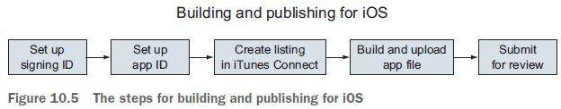

If you haven’t set up your Apple developer account yet and registered for the iOS
Developer Program, you need to do that first. Go to https://developer.apple
.com/programs/ to sign up; it costs US $99/year to be part of the iOS Developer Program.
You can set up a new account for your apps if you have a personal account with
Apple already.

1 Set up certificates and ID
Once you have your account, open Xcode on your Mac and go to the preferences. If you haven’t already added your account to Xcode on the Accounts tab, do so now. This will sync Xcode with your account.

Let’s start with getting a signing identity (also called distribution certificate). This is used to sign an app and verify that the app was built and submitted by the account owner. You can review the official documentation about managing certificates and IDs at http://mng.bz/64k9. The basic steps are these:

1 Log into your Apple developer account in Xcode if you haven’t already.
2 In Preferences, manage your account and certificates.
3 Create a new signing identity specifically for distribution (not development).

Once the signing identity has been resolved, it should appear in the list as iOS Distribution. You may already have an iOS Development identity as well from testing.

2 Set up an app ID identifier
Now you’ll set up the app ID identifier details through the Apple Developer Member Center. Identifiers are used to allow an app to have access to certain app services, such as Apple Pay or HealthKit. Multiple identifiers might be used in the same app for different services, but in this case you’ll use just one.

Go to https://developer.apple.com/membercenter and log in with your Apple ID. Then choose Certificates, Identifiers, and Profiles. You want to set up a new app ID for your app, which is used to keep track of the app throughout the Apple ecosystem. See official documentation about app IDs at http://mng.bz/8hj1. The basic steps are these:

1 Start to register a new app ID.
2 Supply the name of your app, and use the Explicit App ID option. Provide the bundle ID from your app, which is by default the ID in the <widget> tag you specified in the Cordova config.xml file of your app (or if you modified the bundle ID value in your Xcode project). It must match your app bundle ID.
3 Choose any of the services that need to be enabled. For example, if you use HealthKit in your app, you need to choose that option. Apps often have no additional services, so if you don’t think you need it, just leave them as default values.
4 Submit to register the app ID.

That will take care of the ID registration for your app, and it will be used by iTunes
Connect and Xcode in the following steps.
3 Create listing in iTunes Connect
You now need to make your listing in iTunes Connect, which is the portal that Apple uses to manage app submissions. You’ll use your app ID that you generated to create a new record. Log into iTunes Connect at https://itunesconnect.apple.com to get started. Detailed documentation about iTunes Connect can be found at http:// mng.bz/92eZ. The general steps are these:

1 Add a new iOS app.
2 Fill in the app details, and choose the correct bundle ID (the name of the app
ID you made earlier) for the app.
3 Create the app listing. You’ll fill out more details later.

Now you’ve generated a new app listing that will eventually be ready to submit to the
AppStore. You’ve taken the app ID you created before and connected it to this app listing. Before you fill out everything in the listing, you’ll build your app and get it uploaded first using Xcode. Then you’ll come back to finish the listing.

4 Build and upload app with Xcode
Now that you have an app ID and iTunes Connect app listing started, Xcode can help you build and upload the app. You first have to make sure that the Xcode project is up to date with your Cordova project. Run the Cordova build task from the project root in the command line:

$ cordova build ios –release

This will ensure the latest changes from your project are set up in the iOS project. Open the platforms/ios/AppName.xcodeproj file in Xcode. It should allow you to see details about your app in the general view, where you want to confirm things look correct:
○ The bundle identifier should match the value you specified earlier in the app ID.
○ The version and build numbers should reflect what you intend them to be.
○ Team should be set to your Apple account.
○ Deployment target and devices should reflect which versions and devices you intend to support.

Xcode is good about prompting you to fix certain errors if you haven’t set up something correctly. Review any error messages, and in some cases Xcode can even resolve them for you. You’ll also need to make sure you don’t have a device connected to the computer.

You can now build the app as an archive (which is the app bundled for uploading), and then you’ll upload it. The full documentation is found at http://mng.bz/20m2.

The general steps are these:
1 Create a new archive of your app, which will make a build of your app that can be later submitted.
2 Validate the archive you just created, which will ensure the archive can be uploaded correctly and passes validation tests.
3 Submit the app, which will actually submit the file to iTunes Connect.
Now that you’ve got your app finished and uploaded, you just need to complete the iTunes Connect listing and submit it for review!

5 Complete the iTunes Connect app listing
There are a lot of details to provide for the app listing, which are documented in the app listing form for you. If you try to submit your app without providing some required information, it will let you know what’s missing or needs to be fixed. When you uploaded your archived app, iTunes Connect determined which device sizes it supported. You’ll need to upload at least one screenshot image for each of the various app sizes iTunes Connect detected. The easiest way to generate these images is to emulate the app in different versions of the iPhone simulator. The exact sizes and rules can be found by choosing the help icon near the screenshots. You could also upload a short video preview of the app.

Much of the listing is information you’ll have to fill out based on your app, such as the description, keywords, support URL, and icon. You can work through these details and consider how to maximize clarity and marketing for your app.

In the build section, you can view the uploaded build versions for your app uploaded from Xcode, and if this is your first app and build, then you’d expect only one. Choose the build from the list and save.

Just like for Android, iOS has the ability to submit an alpha or beta version of your app and release it to that select group. There’s a limit to how many users can test a prerelease version, and you can invite them over email. See more details in the documentation at http://mng.bz/1Yp4.

Once you’ve finished adding the rest of the details to the app listing, you can press Save and then Submit for Review. If any errors are displayed, fix them and you can try again.
Apple has a manual review process, which means it can take several days for your app changes to be fully reviewed and reflected in the App Store. You’ll be notified of any issues or updates to your app status.

6 Updating the app
To update an app, start by updating the build and version numbers. This can be done in the Xcode project file, or you can update the Cordova config.xml file and then regenerate the iOS platform files with Cordova by removing the ios platform and adding it again.

With the new version and build numbers, you can then follow the same steps to build and upload a new version to your account. If the numbers aren’t updated, then the build will not upload.

Once the new package has been uploaded, you’ll see a new number in the top bar for the release. Make any changes to the app listing, such as new screenshots or changing other metadata, press Save, and then press Submit for Review. The changes will go through the same review process, and the existing app will remain in place until the review is complete.

If you choose to release the version automatically, as soon as the review is completed successfully the app will go live. Otherwise, you must manually log in after the review to release a new version. Manual release might be useful if you want to trigger the release of a new version yourself at a certain time.

