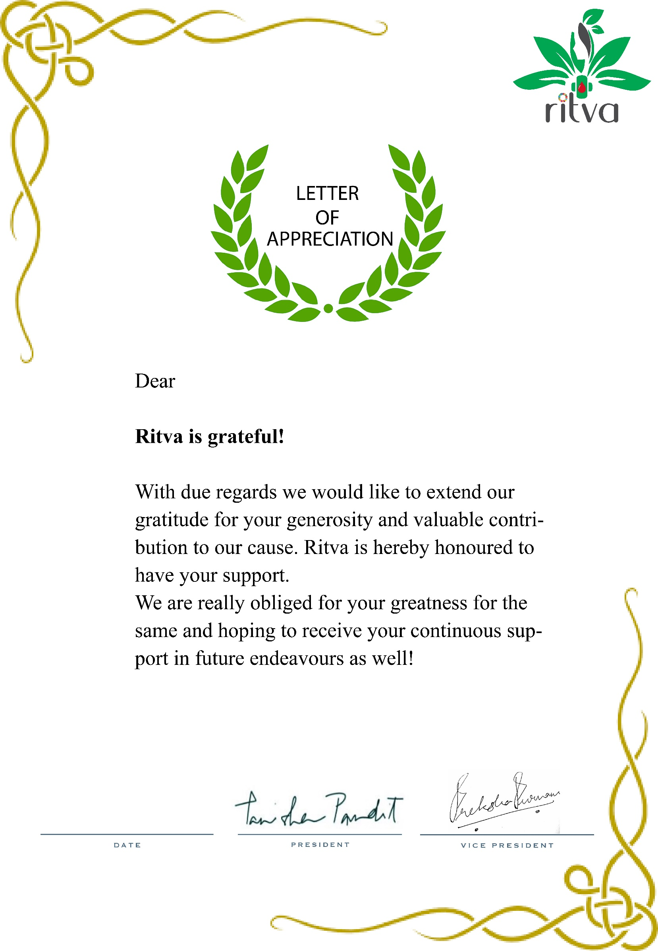

**TO WHOMSOEVER IT MAY CONCERN**

Dearest **$$$$$**,

I am pleased to express my appreciation for the wonderful work that you’re doing here at RITVA.

In your role as a bona-fide RITVA member, you’ve demonstrated your ability to add value to everything that we are doing with your dedication, creativity and resourcefulness. Thanks to your hard work, teamwork and positive contribution towards sustainable menstruation, support to the LGBTQ Community, awareness about Period Talks and much more!

But it’s not just your work — your attitude and fit with the team are exceptional. Your contributions to the team are a reflection of your priorities as an individual and the importance that you place on doing a good job. I am grateful for everything that you have done in your role up to this point, and I look forward to seeing what you will accomplish here at RITVA in the future.

It’s been a privilege to work with you, and I’m looking forward to seeing you continue to do great things here. Thanks again for hitting the ground running.



24th June 2021