AUTOMATION TEST EXECUTION
Executive Test Summary
Project | Environment | Execution Date
Payment Platform | QA | 2026-03-09
Execution Summary
Total Tests | Passed | Failed | Not Executed
3 | 1 | 1 | 1
Execution Distribution
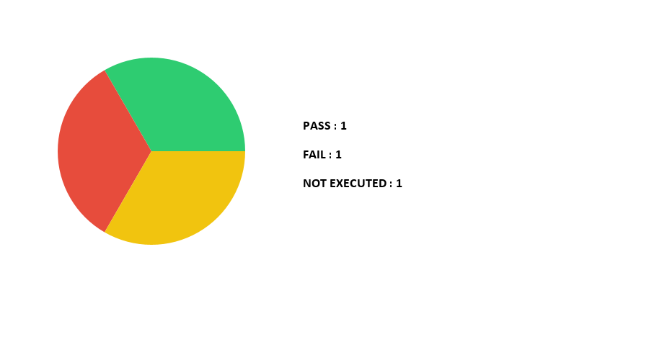

Detailed Test Results
S.No | Test Item | Status | Comments
1 | Login Functionality | PASS | User login successful
2 | Checkout Flow | FAIL | Payment service returned error
3 | Profile Update | NOT_EXECUTED | Blocked by environment issue

