**Ishika Khurana WC-Assignment-2**

**00996203118**

**Ans:1**

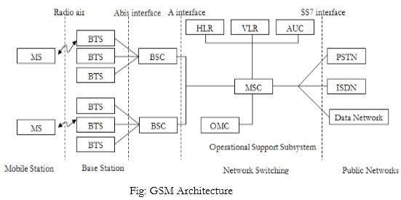

The GSM architecture consists of three major interconnected subsystems that interact with themselves and with users through certain network interface. The subsystems are Base Station Subsystem (BSS), Network Switching Subsystem (NSS) and Operational Support Subsystem (OSS). Mobile Station (MS) is also a subsystem but it is considered as a part of BSS.

****1. Mobile Station (MS):**** Mobile Station is made up of two entities.

****A. Mobile equipment (ME):****

* It is a portable, vehicle mounted, hand held device.
* It is uniquely identified by an IMEI number.
* It is used for voice and data transmission. It also monitors power and signal quality of surrounding cells foe optimum handover. 160 characters long SMS can also be sent using Mobile Equipment.

****B. Subscriber Identity module (SIM):****

* It is a smart card that contains the International Mobile Subscriber Identity (IMSI) number.
* It allows users to send and receive calls and receive other subscriber services. - It is protected by password or PIN.
* It contains encoded network identification details. it has key information to activate the phone.
* It can be moved from one mobile to another.

****2. Base Station Subsystem (BSS):**** It is also known as radio subsystem, provides and manages radio transmission paths between the mobile station and the Mobile Switching Centre (MSC). BSS also manages interface between the mobile station and all other subsystems of GSM. It consists of two parts.

****A. Base Transceiver Station (BTS):****

* It encodes, encrypts, multiplexes, modulates and feeds the RF signal to the antenna.
* It consists of transceiver units.
* It communicates with mobile stations via radio air interface and also communicates with BSC via Abis interface.

****B. Base Station Controller (BSC):****

* It manages radio resources for BTS. It assigns frequency and time slots for all mobile stations in its area.
* It handles call set up, transcoding and adaptation functionality handover for each MS radio power control.
* It communicates with MSC via A interface and also with BTS.

****3. Network Switching Subsystem (NSS):**** it manages the switching functions of the system and allows MSCs to communicate with other networks such as PSTN and ISDN. It consist of

****A. Mobile switching Centre:****

* It is a heart of the network. It manages communication between GSM and other networks.
* It manages call set up function, routing and basic switching.
* It performs mobility management including registration, location updating and inter BSS and inter MSC call handoff.
* It provides billing information.
* MSC does gateway function while its customers roam to other network by using HLR/VLR.

****B. Home Location Registers (HLR):**** - It is a permanent database about mobile subscriber in a large service area. - Its database contains IMSI, IMSISDN, prepaid/post-paid, roaming restrictions, supplementary services.

****C. Visitor Location Registers (VLR):**** - It is a temporary database which updates whenever new MS enters its area by HLR database. - It controls mobiles roaming in its area. It reduces number of queries to HLR. - Its database contains IMSI, TMSI, IMSISDN, MSRN, location, area authentication key.

****D. Authentication Centre:**** - It provides protection against intruders in air interface. - It maintains authentication keys and algorithms and provides security triplets (RAND, SRES, Ki).

****E. Equipment Identity Registry (EIR):****

* It is a database that is used to track handset using the IMEI number.
* It is made up of three sub classes- the white list, the black list and the gray list.

****4. Operational Support Subsystem (OSS):**** It supports the operation and maintenance of GSM and allows system engineers to monitor, diagnose and troubleshoot all aspects of GSM system. It supports one or more Operation Maintenance Centres (OMC) which are used to monitor the performance of each MS, Bs, BSC and MSC within a GSM system. It has three main functions:

* To maintain all telecommunication hardware and network operations with a particular market.
* To manage all charging and billing procedures
* To manage all mobile equipment in the system.

****Interfaces used for GSM network : (ref fig 2)****  
1)UM Interface –Used to communicate between BTS with MS  
2)Abis Interface— Used to communicate BSC TO BTS  
3)A Interface-- Used to communicate BSC and MSC  
4) Singling protocol (SS 7)- Used to communicate MSC with other network .

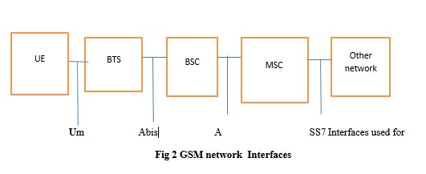

**Ans:2**

## HLR – Home Location Register in telecom

Home Location Register – HLR in gsm is main database which save all permanent information about subscriber for network which having billing details, subscriber identity, current status in network and many more for all type of technology either 2g, 3g, 4g or 5g.

The HLR in telecom is the reference database for subscriber parameters. Actually HLR Having all the detail like customer ID, customer number, billing detail and for prepaid with IN intelligent network.

It has detail of current recharge of prepaid user so far its is very complex but i just make it in simple word for you.

Various identification numbers and addresses are stored, as well as authentication parameters. This information is entered into the database by the network provider when a new subscriber is added to the system.

## VLR - Visitor Location Register

Visitor Location Register – VLR is temporary database which save temporary information about subscriber like current subscriber location, subscriber mobile status on or off and many more, vlr is also required in all technology 2g, 3g, 4g and 5g.

The VLR contains a copy of most of the data stored at the HLR. It is, however, temporary data which exists for only as long as the subscriber is “active” in the particular area covered by the VLR.

The VLR database will therefore contain some duplicate data as well as more precise data relevant to the subscriber remaining within the VLR coverage (here coverage means status of customer of last lac location area code updation )

**Ans:3**

Spread spectrum is a technique used for wireless communications in telecommunication and radio communication. In this technique, the frequency of the transmitted signal, i.e., an electrical signal, electromagnetic signal, or acoustic signal, is deliberately varied and generates a much greater bandwidth than the signal would have if its frequency were not varied.

**Need of Spread Spectrum**

* Spread spectrum signals are distributed over a wide range of frequencies and then collected and received back to the receiver. On the other hand, wide-band signals are noise-like and challenging to detect.
* Initially, the spread spectrum was adopted in military applications because of its resistance to jamming and difficulty intercepting.
* Now, this is also used in commercial wireless communication.
* It is most preferred because of its useful bandwidth utilization ability.

**Ans:4**

### Salient Features of CDMA

CDMA, which is based on the spread spectrum technique has following salient features −

1.In CDMA, every channel uses the full available spectrum.

2.Individual conversations are encoded with a pseudo-random digital sequence and then transmitted using a wide frequency range.

3.CDMA consistently provides better capacity for voice and data communications, allowing more subscribers to connect at any given time.

4.CDMA is the common platform on which 3G technologies are built. For 3G, CDMA uses 1x EV-DO and EV-DV.