sudo update-alternatives --config java
sudo apt remove openjdk-17-jdk
sudo rm -rf /path/to/java-17-directory
Update Alternatives: After removing Java 17, update the alternatives system to set the default Java version to a different installed version (if needed):
sudo update-alternatives --config java
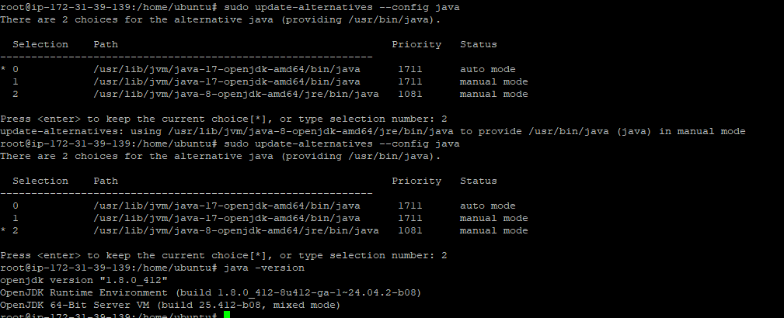

Nexus
Server with t2small,ubuntu 22, security inbound rule enable port no 8081
Step1
apt-get install openjdk-8-jdk -y
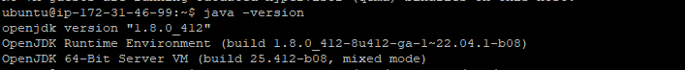
Step2
Before starting, you will need to create a separate user to run Nexus.
useradd -M -d /opt/nexus -s /bin/bash -r nexus

allows nexus user to run all user with sudo without any password
sudo bash -c 'echo "nexus ALL=(ALL) NOPASSWD: ALL" > /etc/sudoers.d/nexus'
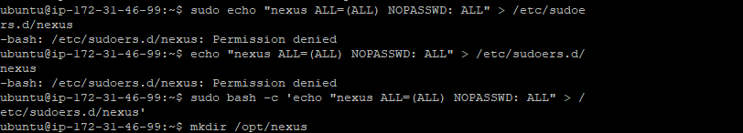
Step3
create a directory for Nexus and download the latest version of Nexus
mkdir /opt/nexus

Once the download is completed, extract the downloaded file to the /opt/nexus directory
tar xzf nexus-3.29.2-02-unix.tar.gz -C /opt/nexus --strip-components=1
set proper ownership to the nexus directory
chown -R nexus:nexus /opt/nexus
step4
edit the nexus.vmoptions configuration file and define max memory size:
nano /opt/nexus/bin/nexus.vmoptions
vim /opt/nexus/bin/nexus.vmoptions
Set Java max memory size and replaced "../sonatype-work" with "./sonatype-work":
-Xms1024m
-Xmx1024m
-XX:MaxDirectMemorySize=1024m

-XX:LogFile=./sonatype-work/nexus3/log/jvm.log
-XX:-OmitStackTraceInFastThrow
-Djava.net.preferIPv4Stack=true
-Dkaraf.home=.
-Dkaraf.base=.
-Dkaraf.etc=etc/karaf
-Djava.util.logging.config.file=/etc/karaf/java.util.logging.properties
-Dkaraf.data=./sonatype-work/nexus3
-Dkaraf.log=./sonatype-work/nexus3/log
-Djava.io.tmpdir=./sonatype-work/nexus3/tmp
Step5
vim /opt/nexus/bin/nexus.rc
Uncomment and change the following line with nexus user:
run_as_user="nexus"
start the Nexxus service
sudo -u nexus /opt/nexus/bin/nexus start
verift the nexus
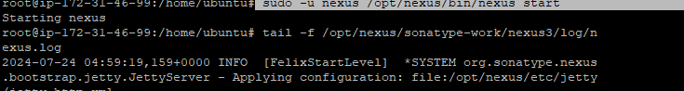
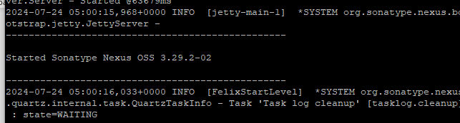
Nexus is started and listening on port 8081
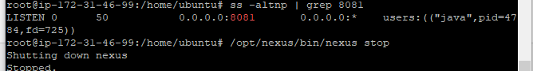

stop the Nexus service
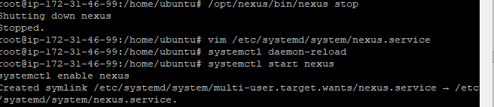
Step6

Create a Systemd Service File for Nexus
create a systemd service file to manage the Nexus service.
nano /etc/systemd/system/nexus.service
[Unit]
Description=nexus service
After=network.target

[Service]
Type=forking
LimitNOFILE=65536
ExecStart=/opt/nexus/bin/nexus start
ExecStop=/opt/nexus/bin/nexus stop
User=nexus
Restart=on-abort

[Install]
WantedBy=multi-user.target

Step7
reload the systemd daemon
systemctl daemon-reload

start the Nexus service and enable it to start at system reboot
systemctl enable nexus
systemctl start nexus
verify the status of the Nexus service
systemctl status nexus



