Ssl-nginx configuration,
First we go to the our application,
Cd /d
Ls
Cd ems_practise
Sudo mkdir
Name = ssl
openssl req -nodes -new -x509 -keyout server.key -out server.cert
sudo npm install
now install to the nginx
cd /opt/
sudo apt update
sudo apt install nginx
sudo vim /etc/nginx/sites-available/your-app

server {
listen 80;
server_name localhost; # Change this if needed # Redirect HTTP to HTTPS
return 301 https://$host$request_uri;
}server {
listen 443 ssl;
server_name localhost; # Change this if needed ssl_certificate /home/vagrant/ ems_practise /ssl/server.cert;
ssl_certificate_key /home/vagrant/ems_practise/ssl/server.key; location / {
root /var/www/html;
try_files $uri $uri/ /index.html;
}
}
[or]

server {
listen 80;
server_name localhost; # Change this if needed # Redirect HTTP to HTTPS
return 301 https://$host$request_uri;
}server {
listen 443 ssl;
server_name localhost; # Change this if needed ssl_certificate /home/vagrant/ ems_practise/ssl/server.cert;
ssl_certificate_key /home/vagrant/ ems_practise /ssl/server.key; location / {
root /home/vagrant/ ems_practise /ui/build;
try_files $uri $uri/ /index.html;
}
}

sudo ln -s /etc/nginx/sites-available/your-app /etc/nginx/sites-enabled/
sudo /etc/nginx/nginx.conf

http { ##
# Basic Settings
## sendfile on;
tcp_nopush on;
types_hash_max_size 2048;
# server_tokens off; # server_names_hash_bucket_size 64;
# server_name_in_redirect off;
#client_header_buffer_size 1k; # Default is 1k
#large_client_header_buffers 4 16k; # Increase as needed include /etc/nginx/mime.types;
default_type application/octet-stream; ##

here comment this two line from the file

sudo chown -R www-data:www-data /home/vagrant/ ems_practise /ui/build
sudo chmod -R 755 /home/vagrant/ ems_practise /ui/build

sudo chown -R www-data:www-data /home/vagrant/ ems_practise /ui
sudo chmod -R 755 /home/vagrant/ ems_practise /ui

sudo chown www-data:www-data /home/vagrant/ ems_practise /ssl/server.cert
sudo chown www-data:www-data /home/vagrant/ ems_practise /ssl/server.key
sudo chmod 644 /home/vagrant/ ems_practise /ssl/server.cert
sudo chmod 600 /home/vagrant/ ems_practise /ssl/server.key

cd ui/build
sudo cp * -R /var/www/html

sudo nginx -t
sudo systemctl restart nginx
sudo systemctl start nginx
sudo systemctl status nginx
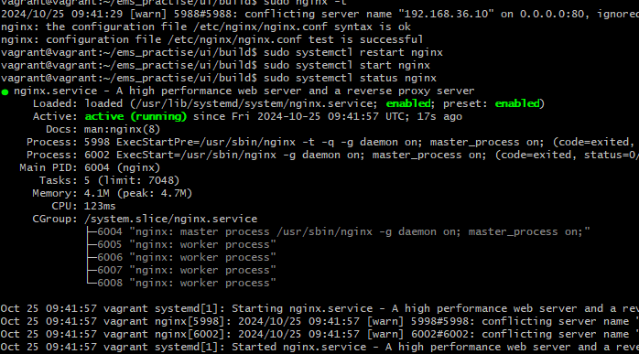
Run the https://192.168.36.10 in the browser


